TASK # 01:
Cricket Statistics - There is cricket fever out there everywhere in Pakistan. Consider Babar Azam statistics for the last few world cups. Take the number of matches he has played in world cups. Now take the runs scored by Babar Azam in each match along with the balls he faced. At the end your program should print the following for Babar Azam:
- strike rate,
- batting average
- minimum score
- maximum score
- number of centuries
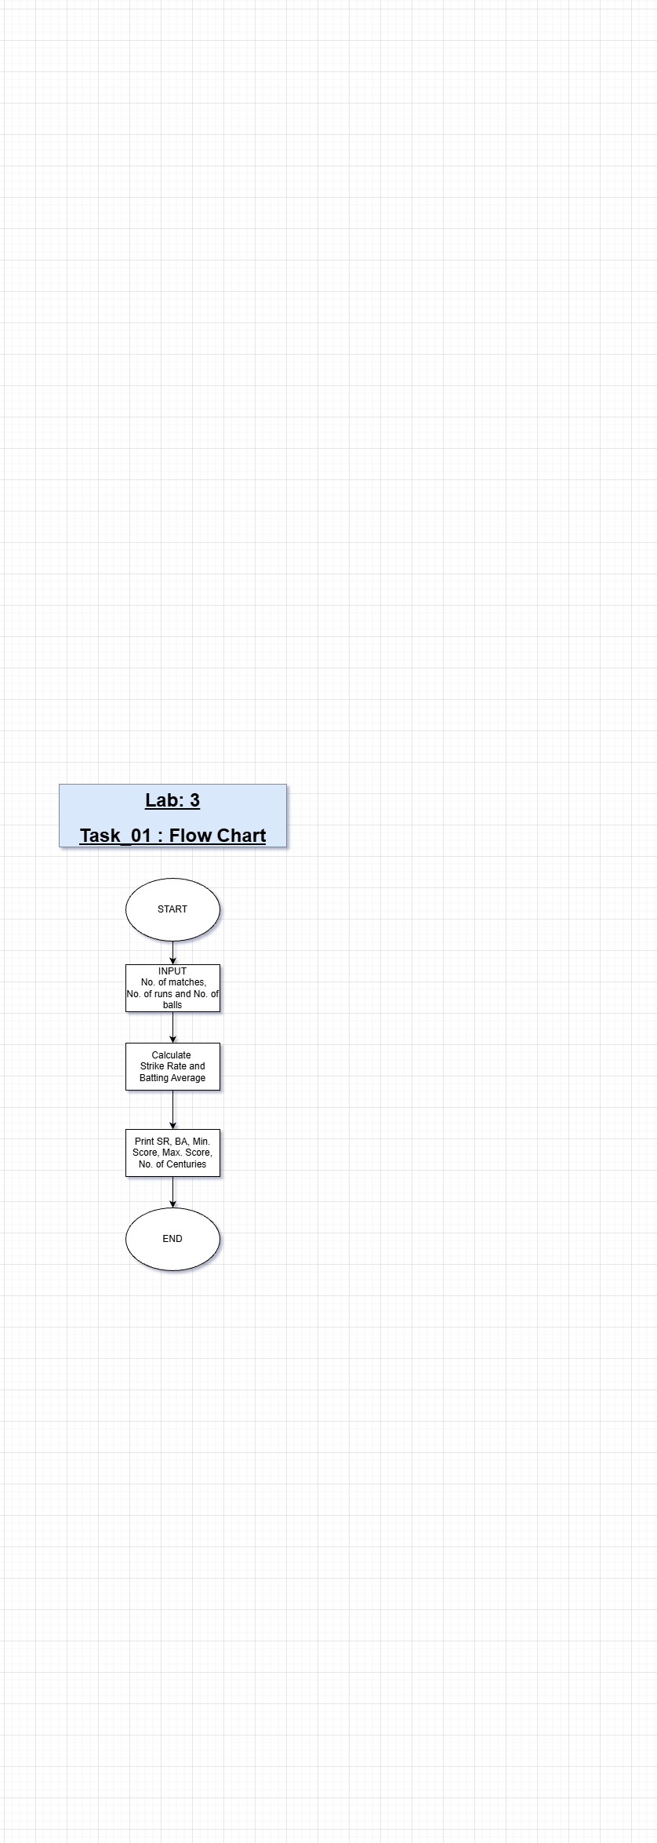

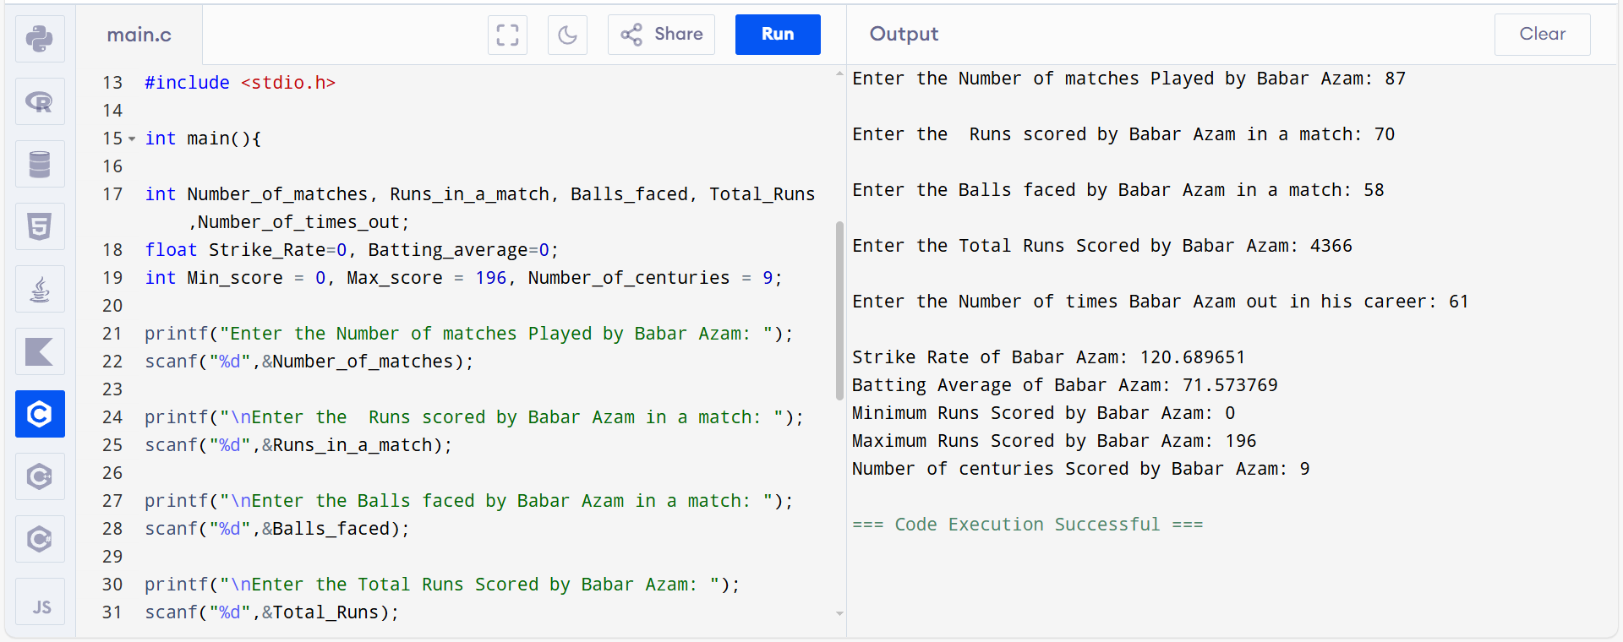

TASK # 02:

Number Converter
Take a number N in decimal format from the user and convert it into
- Hexadecimal format
- Binary Format
- Octal Format



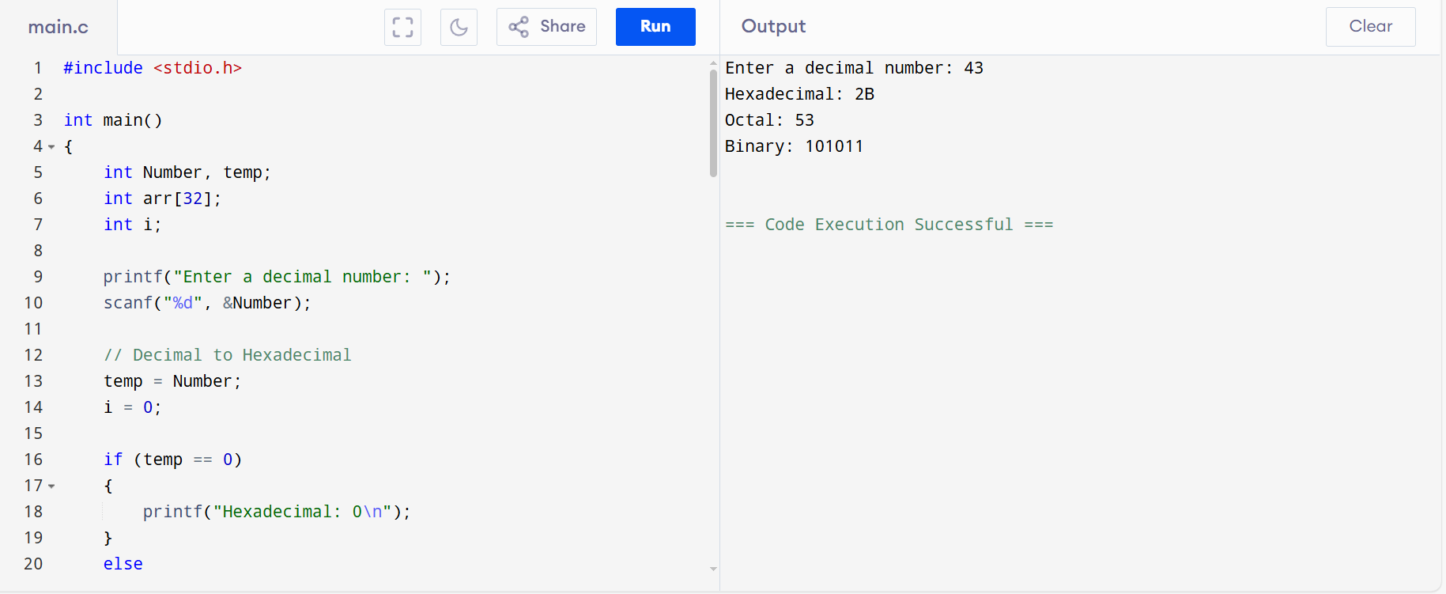

TASK # 03:
Imagine a communication system where a sender sends some message in the form of a data packet to a remote receiver. In order to ensure that the correct packet reaches a remote destination, the sender generates a checksum of the data and appends it with the packet. Upon reception, the receiver also generates the checksum using the same algorithm and matches with the checksum sent by the sender. If both match, it means data is correct.
- Take the number of bytes as input from the user
- Take the byte one by one from the user
- Generate the checksum by computing the XOR of all the bytes. You can take XOR of a and b using a ^ b.

Flow Chart: 25 Minutes Code: 25 Minutes

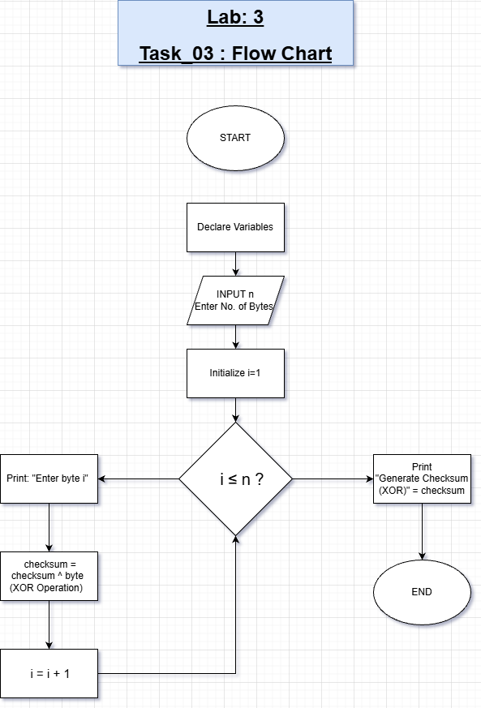
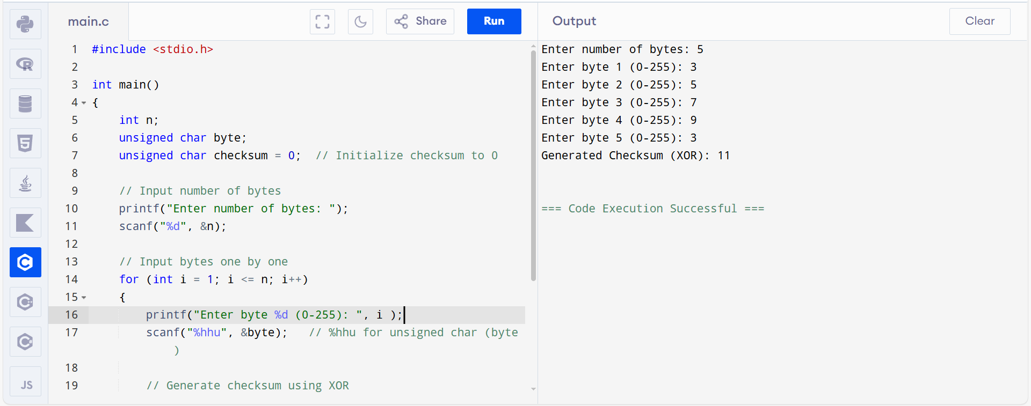

TASK # 04:

Number Guesser
Ask the computer to generate a random number N using the following code snippet

#include <cstdlib>
#include <iostream> using namespace std;

int main()
{ int Limit = 100; int N = rand() % Limit; // Will generate a number between 0 and Limit - 1

return 0;
}
Modify the code to ask the user to keep guessing the number. If the guess is less than the number N, inform the user “The number is less than N” and then ask him to enter the number again. If the guess is greater than the number N, then inform the user “The number is greater than N”. Keep doing it until the number becomes equal to the number N.
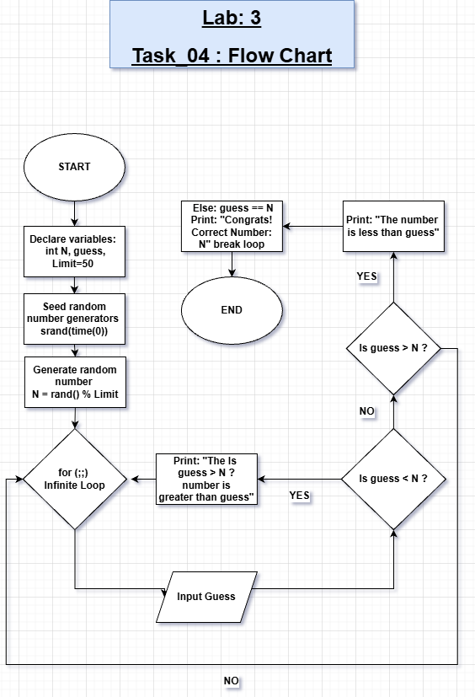
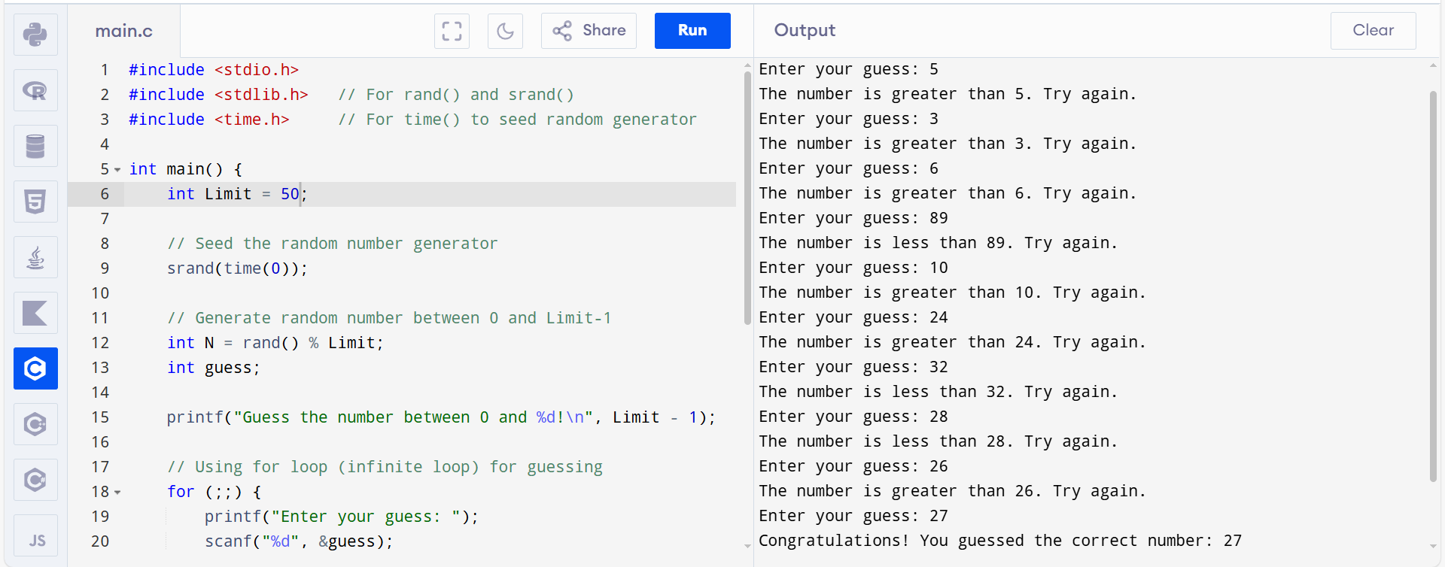

TASK # 05:
Imagine you are playing a grid (4x4) game where the player can move in four directions Up, Down, Right and Left. Take the initial position of the player from the user e.g. (1,2). Now take the direction in which the player will move and keep doing it until it collides with the boundary. Figure out whether it collides with the boundary or not? If it collides, it should simply exit by printing the coordinate of the boundary in the form “The player has reached the boundary at (x,y)” where x,y will be the coordinates of the boundary.
(1,1) | (2,1) | (3,1) | (4,1)
(1,2) | (2,2) | (3,2) | (4,2)
(1,3) | (2,3) | (3,3) | (4,3)
(1,4) | (2,4) | (3,4) | (4,4)

Flow Chart: 15 minutes Coding: 25 minutes

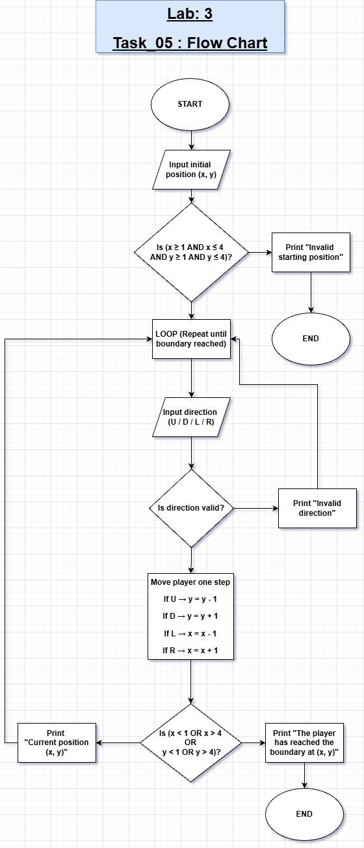

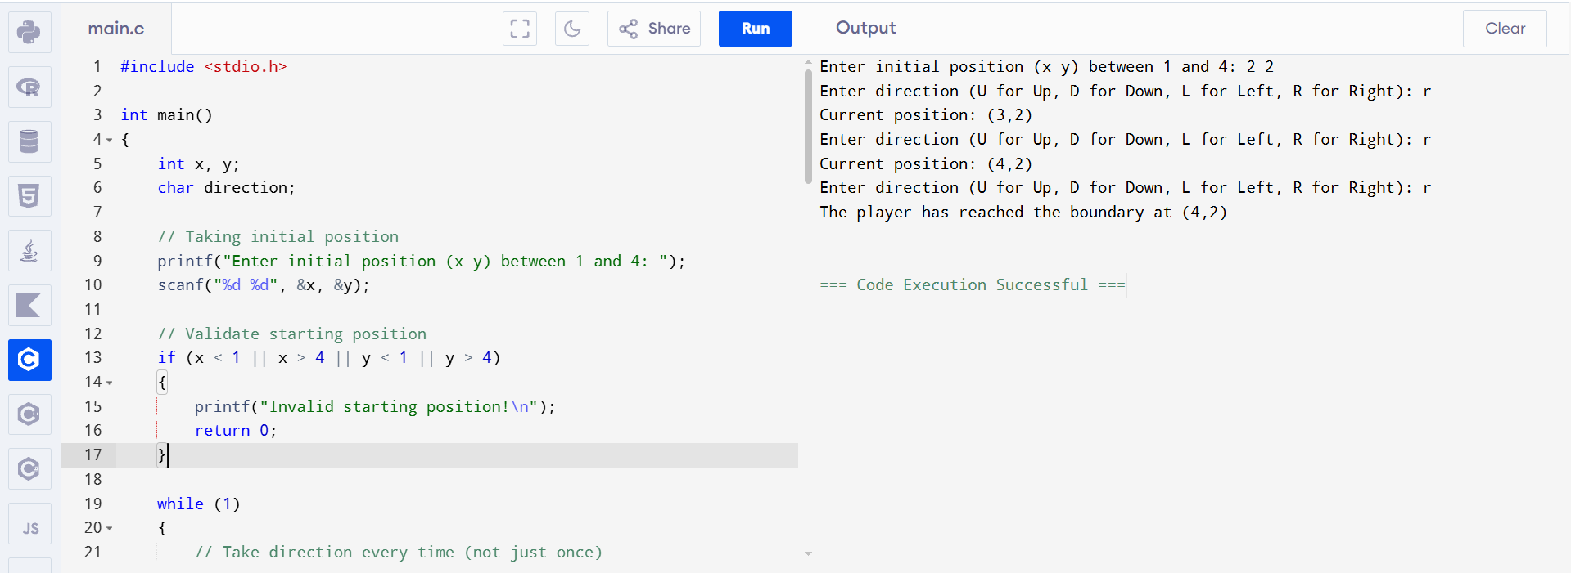
TASK # 06:
Stopwatch Design: Design a stop watch which counts the number of minutes (N). Ask the user to enter the number of minutes.
Note: The watch should display the counter like this. If N = 2, it should count up to 2 minutes.

M : S (M = Minutes, S= Seconds)
00 : 00
00 : 01
00 : 02
00 : 03

|
|
|
- : 59
- : 00
01 : 01
01 : 59
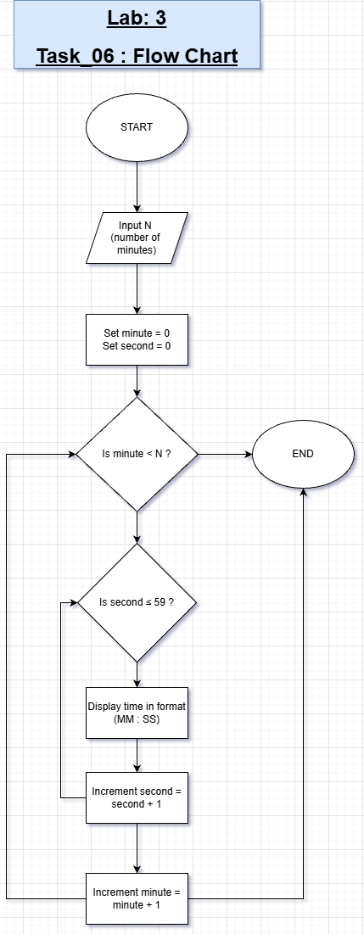
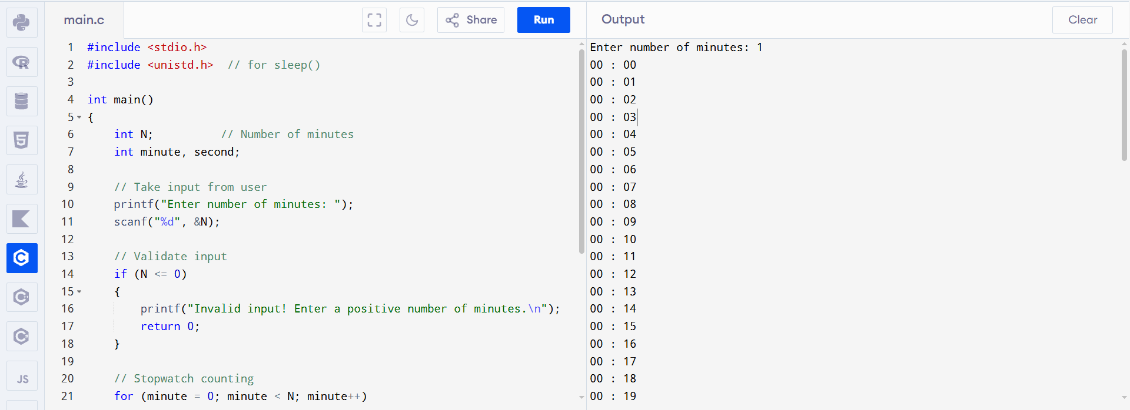
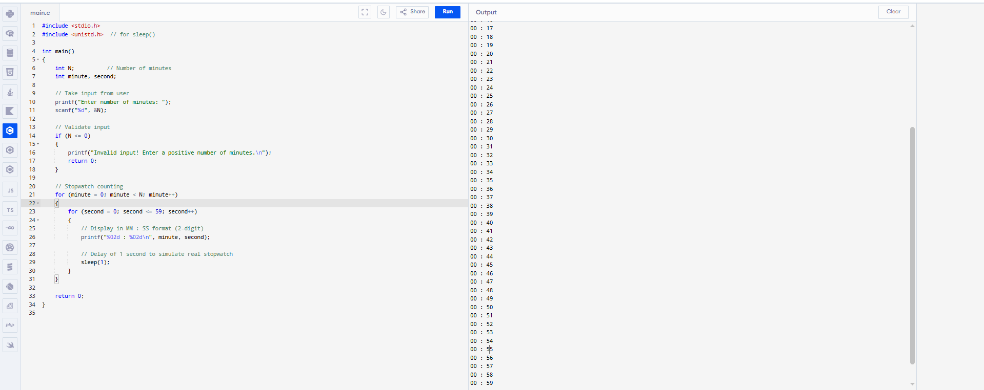
TASK # 07:
Treasure Hunt: Imagine there is a ground which is represented by a 2D grid as shown below. There is a treasure hidden in one of the locations. You have to figure out where exactly the treasure is.
- Your program will not take any input from the user.
- It will generate the location of the hidden treasure (xt,yt) using a random number. You have used random numbers in the previous lab. Choose appropriate values to generate random location within the grid.
- Now search the grid using loops to figure out what is the location of the hidden treasure. Once you found it, print “Hurrah!, I have found the hidden treasure”.

(1,1) |  |  | (4,1)
(1,4) |  |  | (4,4)
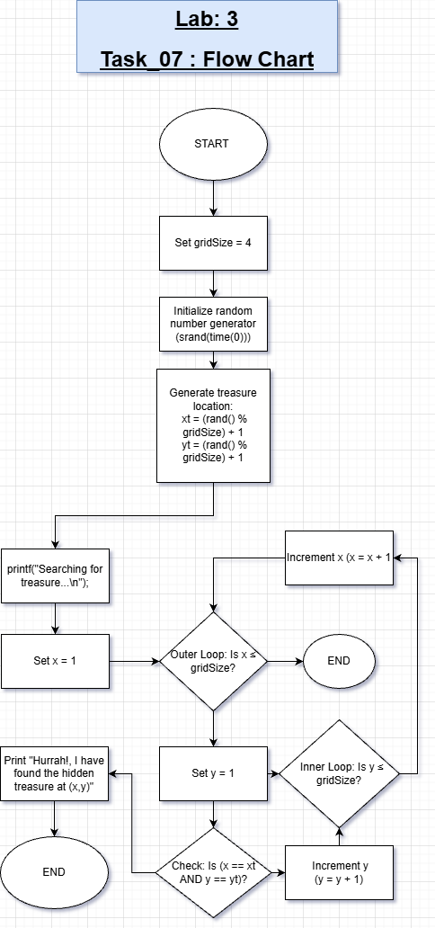
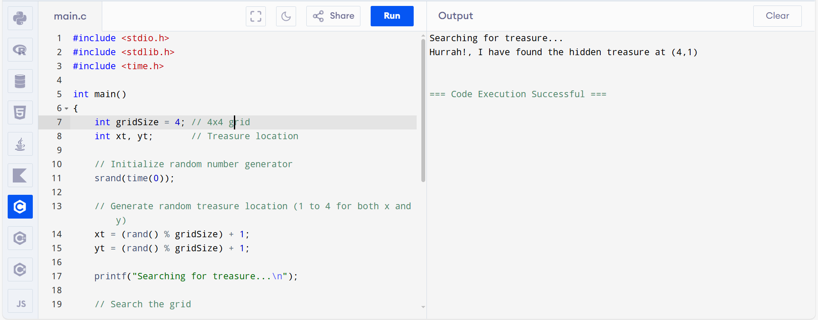

CONCLUSION:

During the lab exercises, I implemented multiple small C programs that allowed me to strengthen my understanding of programming logic. These above tasks includes:
• Decimal Conversion to Binary, Octal, and Hexadecimal
- Learned how to convert decimal numbers into different bases using division and remainder methods.
- Implemented arrays to store remainders and print numbers in reverse.
- Understood why we use an array size of 32 for binary (to handle 32-bit integers).
• Checksum Generator (XOR of Bytes)
- Learned how to take multiple inputs and perform cumulative operations using loops.
- Implemented XOR to generate a simple checksum for data verification.
• Number Guesser Game
- Learned random number generation using rand().
- Understood seed randomization using srand(time(0)) to ensure different numbers every run.
- Applied loops to repeatedly take input until a condition is met.
• Grid Movement Game (4×4)
- Learned nested loops and conditional statements to handle boundary checking.
- Practiced step-by-step updates of coordinates with input in a controlled loop.
- Learned to stop execution when a boundary is reached, and to take repeated user input.

• Stopwatch Design
- Implemented nested loops for minutes and seconds counting.
- Learned real-time simulation using sleep(1) to delay output for one second per iteration.
- Learned how to format output using %02d for two-digit display (MM:SS).
• Treasure Hunt
- Learned random location generation within a 2D grid.
- Applied nested loops to search the grid.
- Learned to use time() for seed generation so that treasure location is randomized each run.

Key Learning Outcomes
- Implementation of nested loops for grids and stopwatch counting.
- Use of random number generation with rand() and seeding with srand(time(0)).
- Use of sleep() function for real-time clock simulation.
- Time-based seeding with time() for generating different random numbers each execution.
- Proper boundary checking in grid-based games.
- Incremental counting for seconds and minutes, formatted printing (%02d).
- Debugging logical errors in loops and conditional statements.
• Why use binary[32] for storing binary digits?
- Because a 32-bit integer can have a maximum of 32 binary digits (bits). This array stores remainders when converting decimal to binary.
• Explain srand(time(0));
- srand() seeds the random number generator.
- time(0) provides the current time in seconds.
- This ensures rand() produces different numbers each run.
• Which library is needed for rand() and time()?
- rand() → #include <stdlib.h>
- time() → #include <time.h>
• Difference between moving straight to the boundary vs taking input repeatedly in grid game
- Moving straight → automatic movement until boundary (no user interaction).
- Repeated input → user decides each step; game checks boundaries after every move.
• How decimal to binary, octal, hexadecimal conversion works
- Divide the decimal number repeatedly by the base (2, 8, 16).
- Store remainder in array.
- Print remainders in reverse order to get the number in the new base.
• Use of sleep() in stopwatch
- Delays the program by one second per iteration, simulating real-time counting.

