
WEEK | Virtual Lab Commissioning and Network Validation
Name | Muhammad Haseeb
Registration No | C11/26/FCDF/17
GUIDED LAB WINDOW | September,2026
SELF-PACED WINDOW | Monday–Friday after the guided session
SUBMISSION DEADLINE | 2-October,2026, 23:59 WAT
LMS ITEMS | Lab 1
Linux Version | 6.18. 12+kali-amd64
Purpose of this laboratory
This laboratory prepares the complete ICDFA virtual environment for all later exercises. You will reconnect the imported virtual machines to the correct VirtualBox networks, generate unique MAC addresses, confirm the preconfigured IPv4 settings and prove that traffic follows the intended Client, OPNsense, DMZ and VRouter path.
Complete this laboratory before attempting any packet analysis or firewall exercise. At the end, create the required baseline snapshots. Those snapshots give you a safe recovery point if a later configuration change causes a problem.
Learning outcomes
- Create and identify NAT Network and Internal Network segments in VirtualBox.
- Generate and record a unique MAC address for every enabled virtual adapter.
- Map each adapter to the correct ICDFA network segment.
- Verify IPv4 addresses, default gateways, routes, forwarding and required services.
- Complete local, inter-network, DNS, web and upstream connectivity tests.
ICDFA virtual lab topology
- The lab contains four virtual machines and four logically separate network segments. Traffic between the LAN, DMZ and upstream network must pass through the intended routing and firewall components.
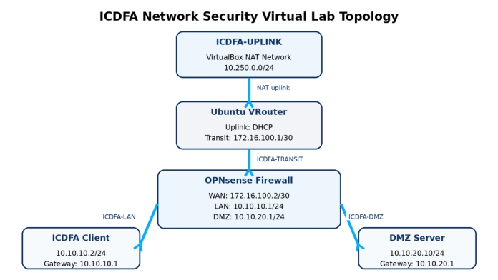
Part 1:Confirm that every VM is powered off
Evidence:
Confirming every VirtualBox Machine is closed.
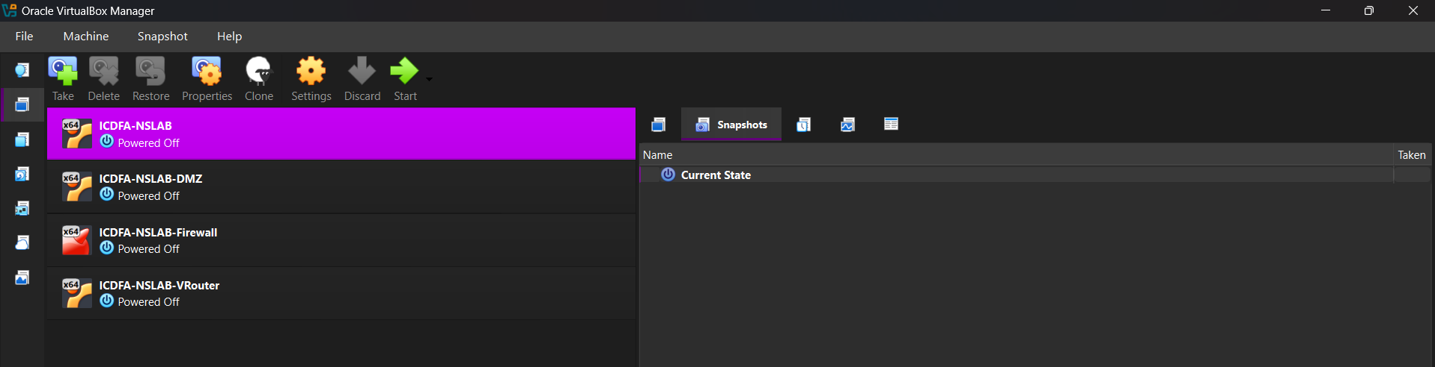
Part 2:Create the ICDFA upstream NAT Network
STEPS:
In VirtualBox Manager, open Tools and then Network. Select the NAT Networks tab. Then Create a new NAT Network. Set its name to ICDFA-UPLINK. Set the IPv4 prefix to 10.250.0.0/24 and enable DHCP.
Apply the settings and confirm that ICDFA-UPLINK appears in the NAT Networks list.
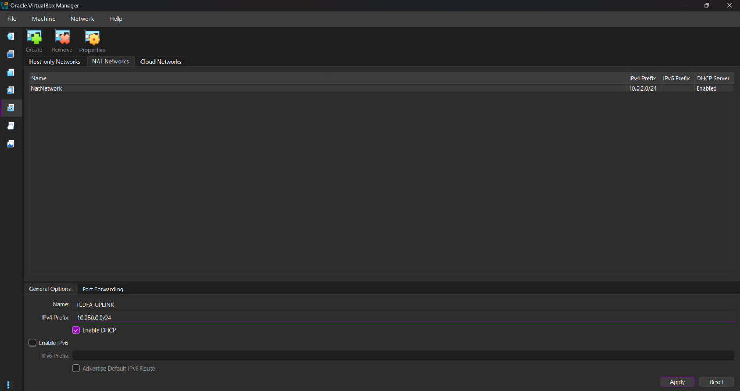
Part 3 Generate unique MAC addresses and attach the networks
Explanation:
The training appliances were distributed without reusable MAC identities. So, we have to generate new MAC addresses after import. A MAC address must be unique within the lab; duplicated addresses can cause unstable ARP entries and misdirected Ethernet frames.
TABLE:
VM | Adapter | Attachment | Network name | New MAC address
Client | 1 | Internal Network | ICDFA-LAN | 08002735D07A
OPNsense | 1 | Internal Network | ICDFA-TRANSIT | 0800270E86E8
OPNsense | 2 | Internal Network | ICDFA-LAN | 080027952A7D
OPNsense | 3 | Internal Network | ICDFA-DMZ | 0800277E35C1
DMZ Server | 1 | Internal Network | ICDFA-DMZ | 08002716FC38
VRouter | 1 | NAT Network | ICDFA-UPLINK | 08002786C518
VRouter | 2 | Internal Network | ICDFA-TRANSIT | 08002759986F
Part 4:Start the machines in the required order
Explanation:
I have imported all the machines inn Ubuntu and all started them al are in running state.
Part 5:Validate the Client
Evidence:
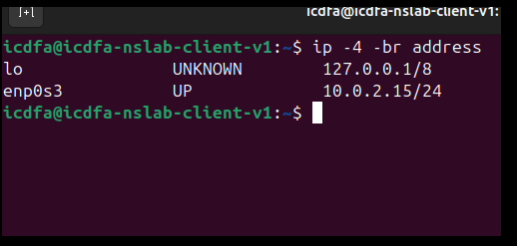
PART 6: Validate the OPNsense interfaces
the OPNsense WAN uses a private training address, open Interfaces, WAN and ensure Block private networks is not selected. Save and apply only if you changed the setting.
In System, Gateways, Configuration, verify that VROUTER_GW uses WAN, IPv4 and gateway address 172.16.100.1. The routing status must contain a default route through 172.16.100.1.
EVIDENCE:
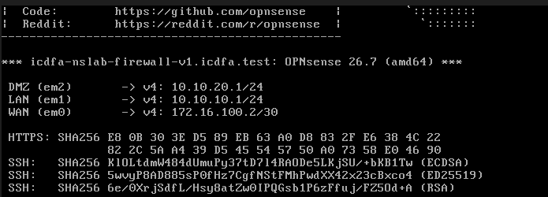
CONNECTIVITY TEST:
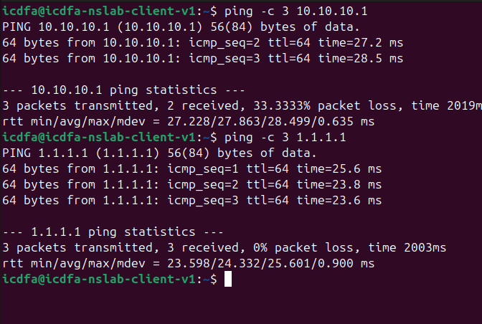
CONCLUSION:
The ICDFA virtual network security lab was successfully deployed, configured, and validated. All four virtual machines (Client, OPNsense Firewall, DMZ Server, and VRouter) were properly mapped to their assigned internal networks (ICDFA-LAN, ICDFA-DMZ, ICDFA-TRANSIT) and NAT uplink (ICDFA-UPLINK) with unique MAC addresses to prevent ARP conflicts. IP addressing, routing tables, and connectivity across all segments were verified. Finally, LAB-BASELINE-VALIDATED snapshots were created across all VMs to serve as a clean recovery point for future network security labs.

