

Proposed Solution Design

Team (AI)

Muhammad Muhid
Ali Bin Mohsin
Hafiz Muhammad Abu Huraira
Muhammad Saad

Assigned By: Sir Ishtiaq Dated: 07/07/2026

AI-Powered Cricket Analytics Chatbot with a Self-Updating Knowledge Base

1. Overview
The project owns a MariaDB database that stores cricket data players, teams, matches, ball-by-ball events, and tournament records. New matches are added to this database every day, continuously growing the dataset. The goal is a chatbot that lets users ask questions in plain English and receive accurate, informative answers, while automatically staying current with newly added data without requiring daily model retraining.

2. Core Design Principle
The solution separates two responsibilities that are often incorrectly combined into one:
- How to talk: handled by a fine-tuned language model, trained once and updated only occasionally (e.g. every few months).
- What is currently true: handled by a continuously updated knowledge base (vector database) and direct database queries.
The language model is never treated as the source of truth for facts. It only explains facts that are retrieved and handed to it at the moment a question is asked. This is what allows the system to stay current daily without any retraining.

3. Proposed Architecture
The system has two independent pipelines that run separately: an Update Pipeline that keeps the knowledge base current, and a Query Pipeline that answers user questions.

3.1 Update Pipeline (runs daily / on schedule)
- Watermark Tracker: a small metadata table records the last processed record ID/timestamp for each database table.
- Delta Extractor: on each run, only rows added after the last watermark are retrieved, never the full database.
- Document Generator: converts each new/changed row into a readable cricket document (player summary, match summary, comparison, etc.), as already defined in the project's data processing design.
- Embedding & Upsert: each document is given a fixed, deterministic ID (for example player_summary: :babar_azam). When a fact changes, the existing entry is overwritten rather than duplicated, keeping the knowledge base accurate and free of stale records.
- Watermark Update: the tracker only advances after a successful update, making the pipeline safe to re-run if it ever fails midway.

3.2 Query Pipeline (runs per user question)
- Intent Routing: each incoming question is classified as either factual/numeric (for example “How many centuries has Babar Azam scored?”) or explanatory/comparative (like “Why is Babar Azam considered great?”).
- Factual Path: the system generates a direct SQL query against MariaDB to fetch the exact number, avoiding any approximation.
- Explanatory Path: the system searches the vector knowledge base for the most relevant documents and retrieves the top matches.
- Response Generation: the fine-tuned model receives the retrieved fact(s) and produces a clear, natural-language answer.

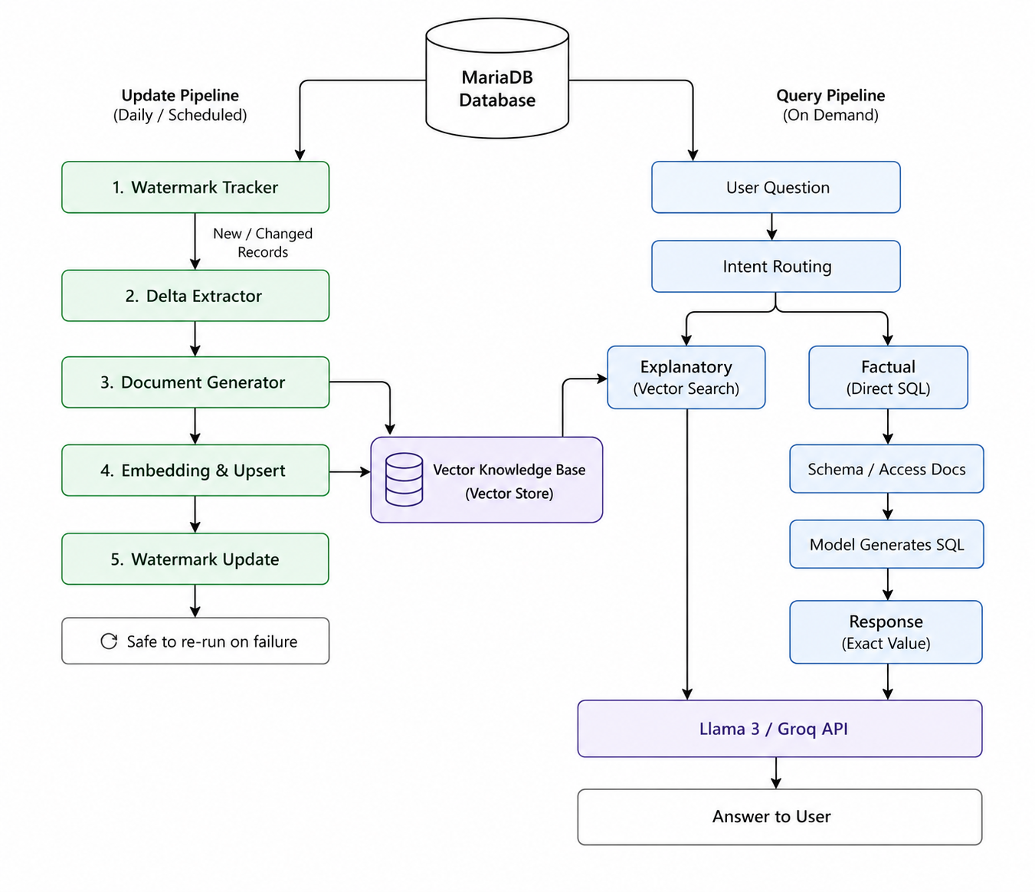

Figure 1: Architectural Design

4. Why This Approach Is Efficient
Efficiency comes from never reprocessing old data. Because the update pipeline only touches rows added since the last run, the daily update cost stays flat whether the database has ten thousand rows or ten million. There is no daily retraining, which removes the recurring GPU cost and downtime that a retrain-every-day approach would require.

5. Why This Approach Is Robust
- Numeric accuracy: factual answers are pulled directly from the database rather than approximated through similarity search, removing a common source of chatbot errors.
- No stale or duplicate facts: deterministic document IDs ensure updated facts overwrite old ones instead of accumulating conflicting versions.
- Fault tolerance: the watermark-based design makes the update pipeline idempotent; a failed run can be safely retried without side effects.
- Stable language quality: because the model is not retrained daily, there is no risk of a bad daily retrain degrading response quality.

Summary Comparison: Traditional vs Proposed Approach
Aspect | Traditional daily retraining | Proposed hybrid design
Daily cost | High - GPU time for full retrain | Low — only new rows processed
Freshness | Delayed by retraining cycle | Immediate after each update run
Numeric accuracy | Depends on model recall | Exact, via direct database query
Scalability | Degrades as data grows | Constant cost regardless of data size

7. Conclusion
This design keeps the language model fixed and lightweight to maintain, while continuously refreshing a separate knowledge base that reflects the latest state of the cricket database. Combined with a factual/explanatory query router, the chatbot remains accurate on statistics, informative on analysis, and self-updating with no manual retraining required as new matches are added.

