NODE JS NOTES

Use to create backend things like api or to run js out of browser

Easier to start, great for prototyping and agile development

Super fast and highly scalable

Used by paypal Netflix uber etc

It uses js

It is not a programming language. It is a run time environment for executing js code

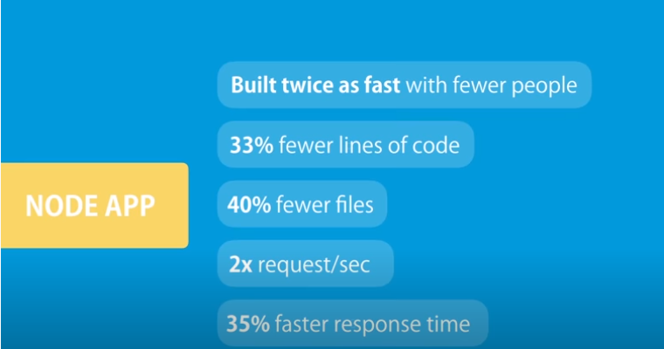

Architecture Of Node:

It is asynchronous non blocking.

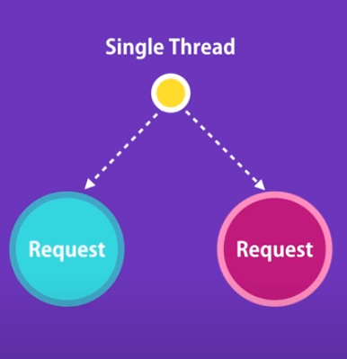

Single thread is sufficient to to handle multiple request. While requesting data from db, until db returns data for particular request, thread till that resolve another request which makes system faster and makes it asynchronous

EVENT QUEUE:

When db prepare result of particular request, it puts msg in event queue. Node monitor this event queue.

Command to execute file:

node filename.js (ex: node app.js)

MODULE:

Define variable functions in modules, not in global file to avoid conflict

That function or variable is able to be used in that particular module, in order to use it outside the module, we have to export it

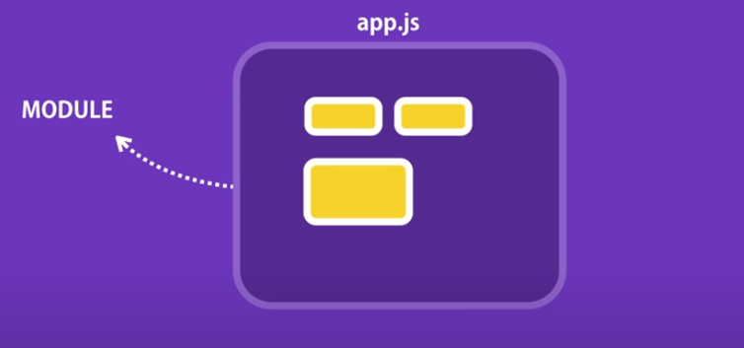

Every node app has one module which is main module, like app.js in my case

To export module:

First method

var url = "http://mylogger.io/log";

function log(message){

    //send an http request

    console.log(message)

}

module.exports.log = log;

Second Method:

module.exports = log;

Importing module in another file:

When using first exporting method

const logger = require('./ModuleLogger');

console.log(logger);

logger.log("muneeb")

When using second exporting method

module.exports = log;

MODULE WRAPPER FUNCTION:

Node wrap all of our code in function, it does not run directly. This function is called Module wrapper function

ASYNC FS MODULE:

const fs = require('fs');

fs.readdir('./', (err, result) => {

    if (err){

        console.log('Error', err);

    }

    else{

     console.log("Result",result);

    }

})

Async method has callback which requires function to handle result or error