What is API?

* An API (or “Application Programming Interface”) is a software intermediary for an application or service that enables other applications or services to send them requests and receive responses to those requests.
* An API (or “Application Programming Interface”) is a software intermediary for an application or service that enables other applications or services to send them requests and receive responses to those requests.
* An API (or “Application Programming Interface”) is a software intermediary for an application or service that enables other applications or services to send them requests and receive responses to those requests.
* An API (or “Application Programming Interface”) is a software intermediary for an application or service that enables other applications or services to send them requests and receive responses to those requests.

It is a link between applications or services. It is a way of communication between application or services. They allow different systems to talk to each other.

Example:

A waiter in a restaurant is an api that takes order from customer (request) and pass it to chef and later chef sends required food to customer (respond). So it connects services or client side and server side

What is Digital Transformation?

Integration of digital technology into all areas of business, changing way of operation

**API is the key to Digital Transformation**

Example:

Payment as a service (make separate payment api)

AI as a service (AI api)

APIs used to access separate systems and provide necessary connectivity

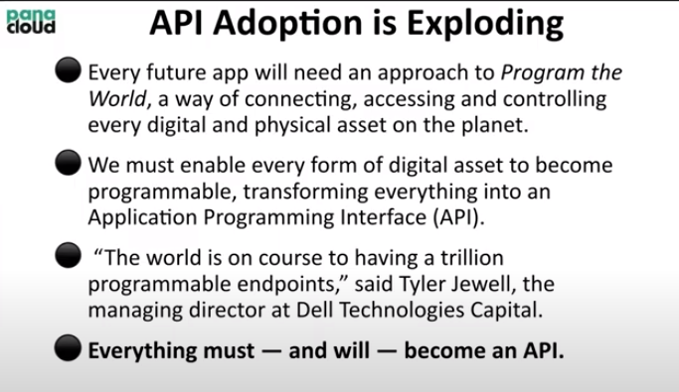

Every physical and digital asset will become API. Every single thing will become API, sofa ,car brakes everything

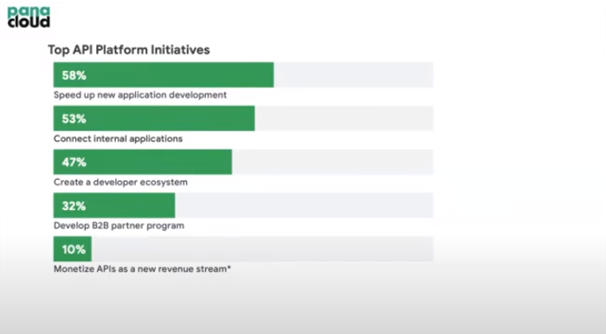

Monetizing apis are our aim

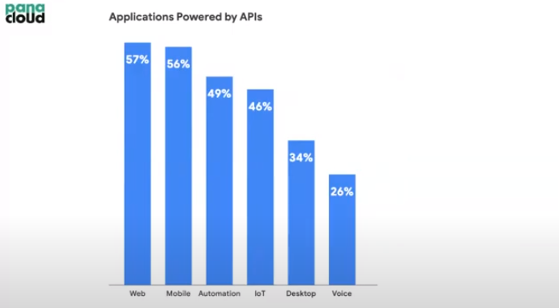

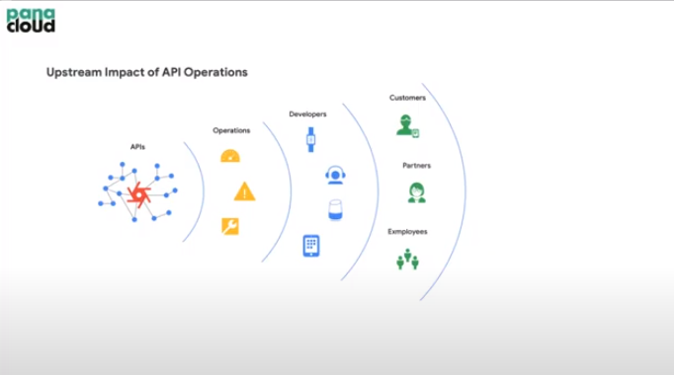

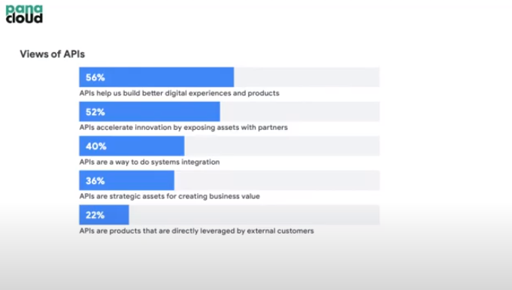

API as a Product:

API is now become a product. It can be sell. One problem associated with it is market to sell API. But API should be bit complex so that companies can buy from you instead of building by themselves which save their time

Example:

Stripe API for payment method

Google map API used by foodpanda, uber, careem and other companies

Interests in API:

Growth of cloud computing which has led to the need for API integration

What is the API Economy?

APIs has lead to SaaS world which results in API Economy. Developers creates API and SaaS can be build by combining different APIs and developers can earn money by monetizing those APIs

The exchange of these APIs and the systems to manage them is, in a nutshell, the API economy

In api economy, developers charge each others for the APIs build by them

The application developers who uses all these APIs bills the end-customers for the service. The exchange of values is what makes an API economy

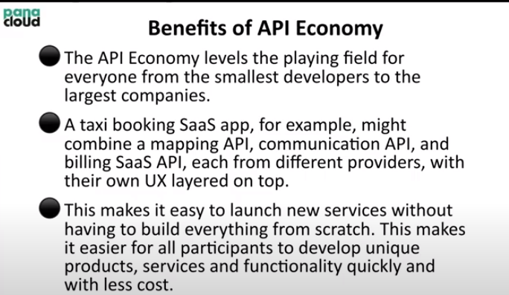

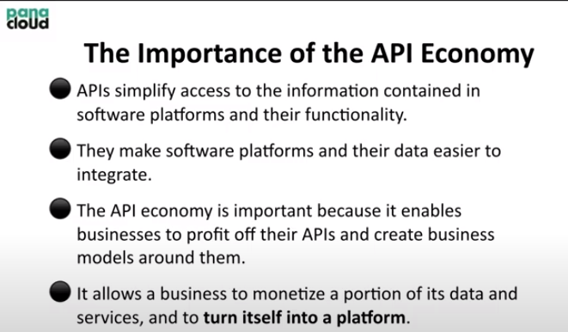

“The API economy is an enabler for turning a business or organization into a platform” – Gartner

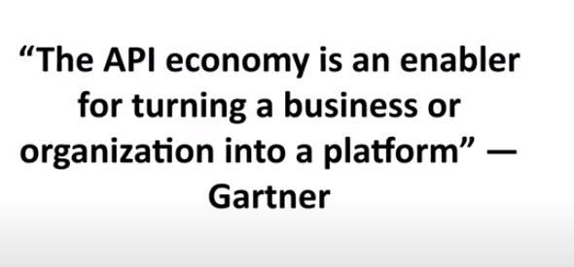

What is Platform?

A platform is a group of technologies, solutions, or offereings that form an iterative basis for developing, implementing or deploying other offerings

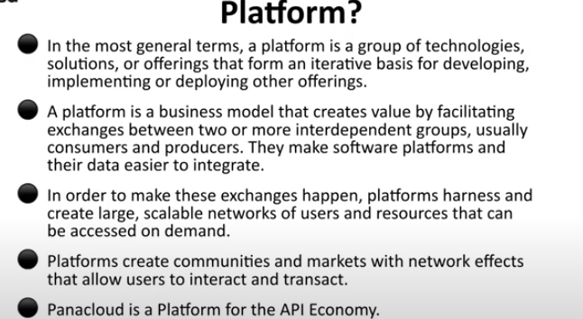

Anything that helps to develop their business in top of you is platform

API value Chain:

API-first company -> Developer -> Customer

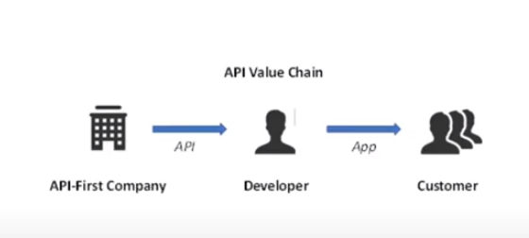

API-First Approach or API-First Company:

The idea is API-as-a-product. It allows oraganizations to build APIS that serve all applications and applications can be developed for all platforms and operating systems.

The same API can be used for mobile, web and chatbox

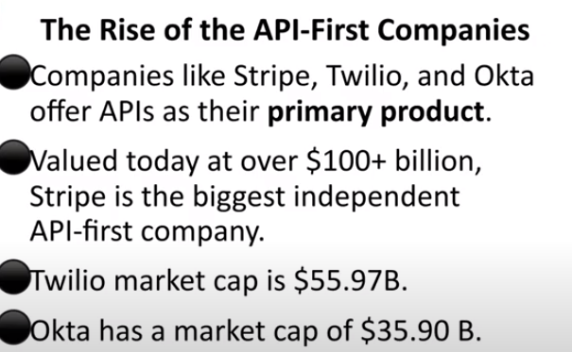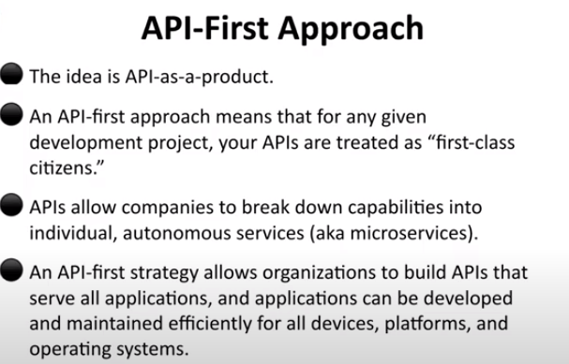

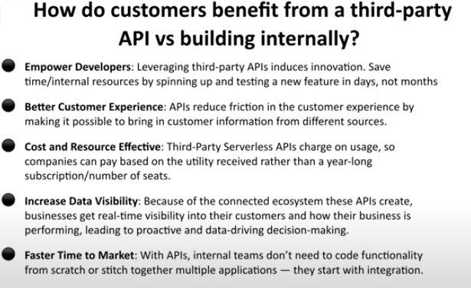

APIs will be serverless and multitenant.

What is multitenant?

When many people are using same resources. In this, one server serves many users

Earlier one for one person

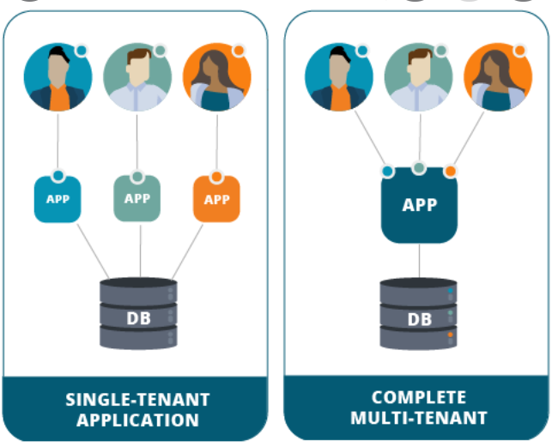

What is serverless (cloud 2.0)?

It does not means no server. It means server is on cloud and charger for only time user using it

Thus APIs should be or will be serverless and multitenant

Link Between APIs and AI:

Internal:

We know that digitization create lots of data and API leverage AI to make use of that data

External:

AI will manage APIs

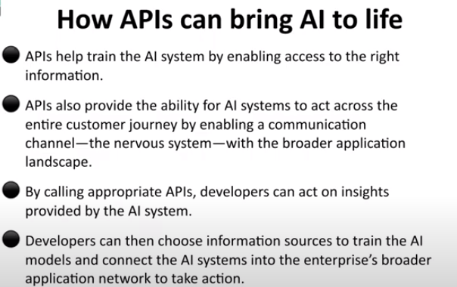

Link Between IoT and API:

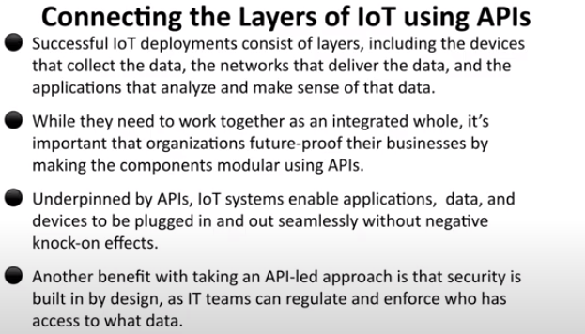

Link Between API and BlockChain:

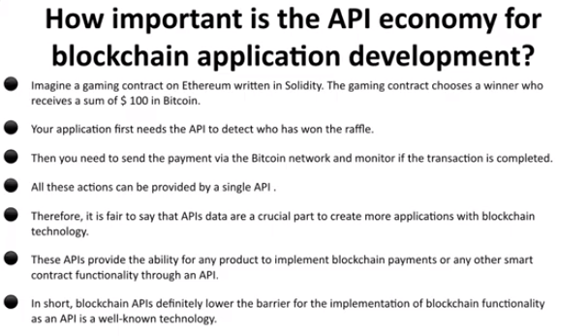

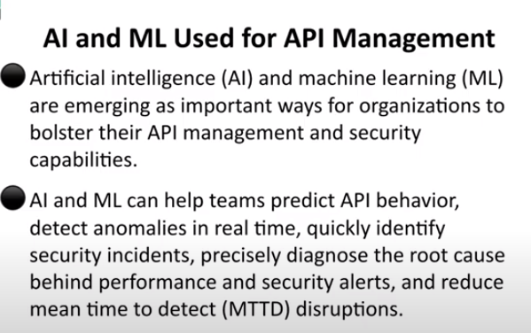

Standards for API Definition:

1. REST based OpenAPI

2. GraphQl

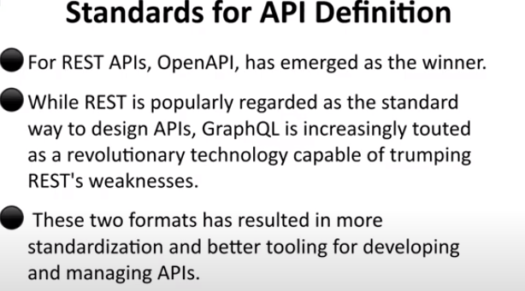

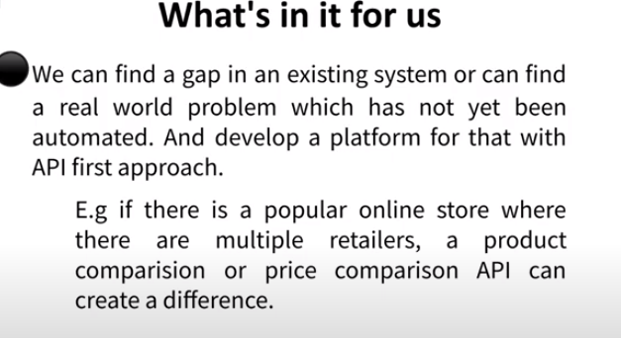

PROGRAMMABLE MONEY FOR API ECONOMY:

Problems to developers

1. Payment method.
2. Investment for startup
3. Payment Method:

Use of stable coin DAI is best for payment. By using cryptocurrency, we don’t need PAypal etc

What is Programmable Money?

It has to be in digital form, like tokens and can be tracked. BlockChain used in it

Sending money using API is not programmable money as bank can easily refuse it. In programmable money, we have full control

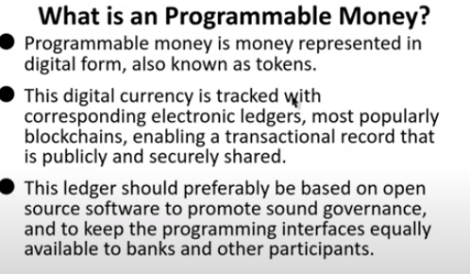

What is BlockChain:

Example:

If I put data in my harddrive consisting of list of people with their names and how much I already paid to them. As it is in my hard drive, it can easily be over ride or it is mutable. On the other hand If I used block chain for security, it can not be mutable (immutable). It is a pear to pear network, which is synchronized with other systems, so if someone wants to override it, everyone knows about it or in a nutshell, changing or overriding data is impossible

**Thus block Chain is a nodes (person1 has a node, person2 has a node…) communicating with each other and all nodes has a copy and synchronized. It addresses lack of trust of issues. Problem is of consensus which can be evacuate through different methods**

**Example:**

**History of world could not be changed so we keep it in blockchain**

What is Consensus?

Example:

Their can be transaction 1, 2 and 3

But there is a problem called consensus. Means how to add another transaction (how everyone will agree?)