Creating Project:

Npx create-react-app linkedin –template redux

Dependencies:

Yarn add @material-ui/core

Yarn add @material-ui/icons

To pass Icon as props or component:

Make Icon (i) capital as we are passing material-ui Icon

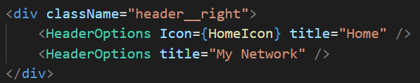

import React from 'react'

import './HeaderOptions.css';

function HeaderOptions({Icon, title}) {

    return (

        <div className="headerOption">

            {Icon && <Icon className="headerOption__icon"/>}

            <h3>{title}</h3>

        </div>

    )

}

export default HeaderOptions

align items work with flexbox, flex direction row or colum

.headerOption{

    display: flex;

    flex-direction: column;

    align-items: center;

    margin-right: 20px;

    color: gray;

    cursor: pointer;

}

Function inside function declare and calling

import { Avatar } from '@material-ui/core'

import React from 'react'

import './Sidebar.css'

function Sidebar() {

    const recentItem = (topic) => (

        <div className="sidebar__recentItem">

            <span className="sidebar__hash">#</span>

            <p>{topic}</p>

        </div>

    )

    return (

        <div className="sidebar">

            <div className="sidebar__bottom">

                <p>Recent</p>

                {recentItem('reactjs')}

                {recentItem('programming')}

                {recentItem('fullstack')}

                {recentItem('design')}

                {recentItem('developer')}

            </div>

        </div>

    )

}

export default Sidebar