**SNS**

**Week # 04:**

*“Frequency response of given RC circuit.”*

* **Values:** R = 10 Ω, C = 1 µf

1. **ACROSS CAPACITOR CIRCUIT:**

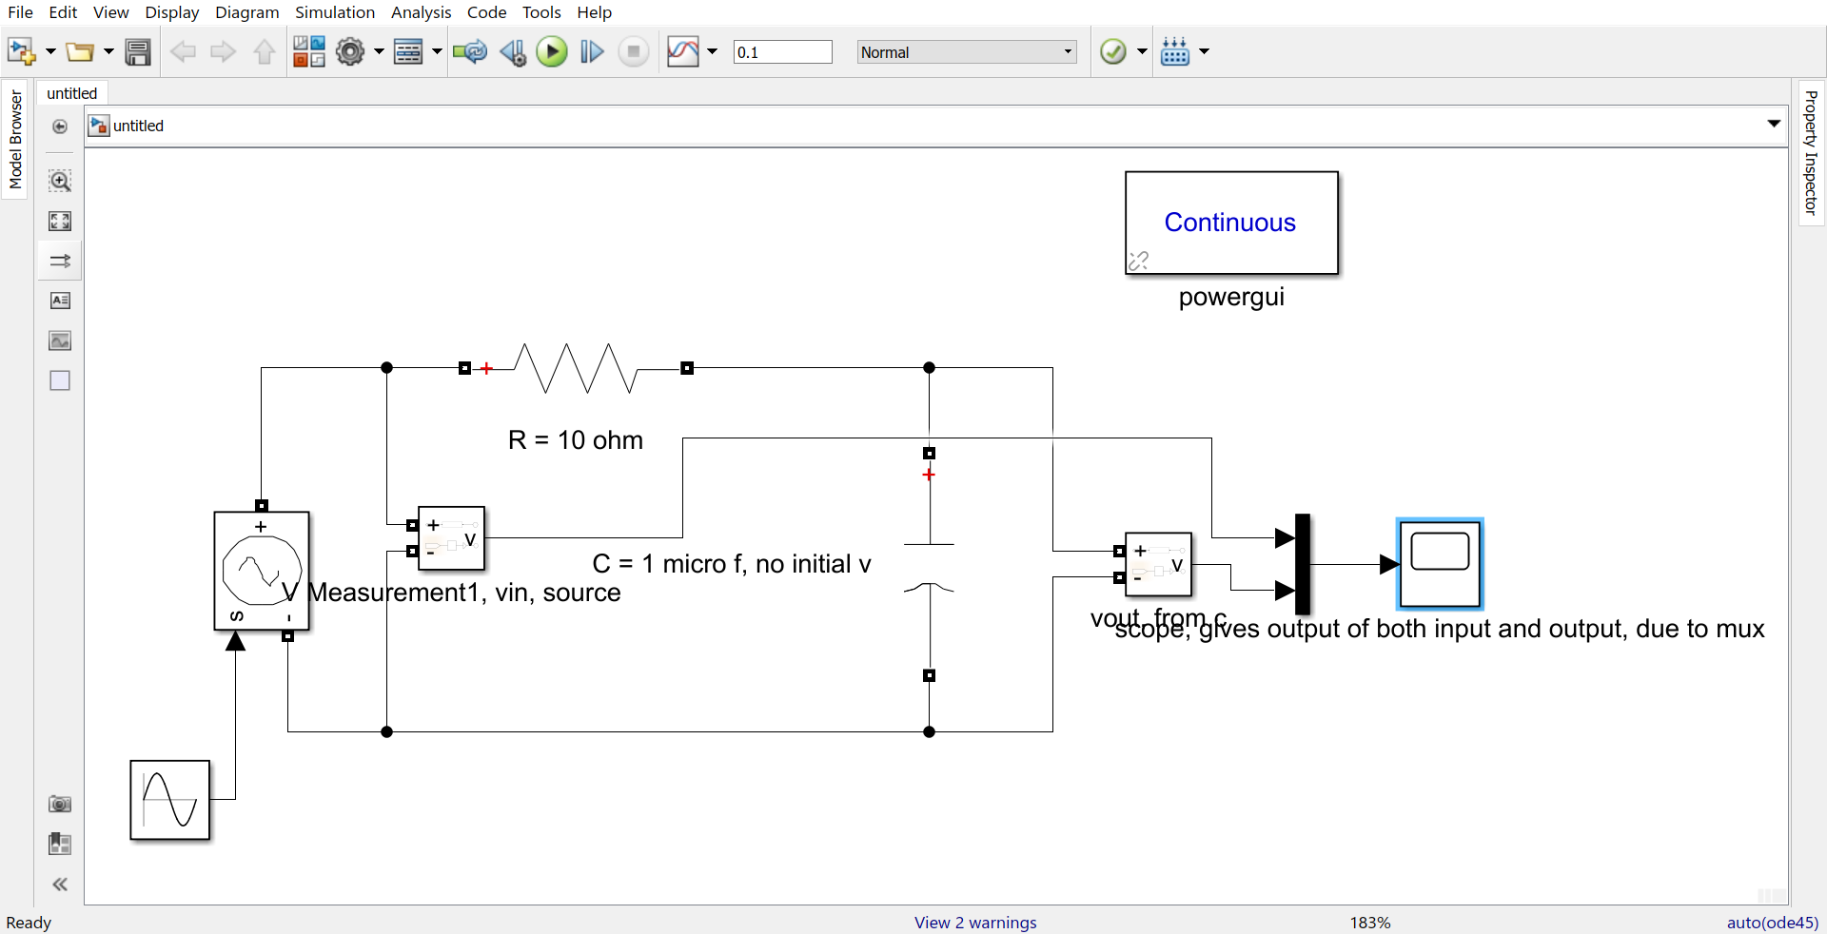

**OBSERVATION TABLE:**

**Frequency is increasing by 250 Hz (low pass):**

|  |  |  |  |
| --- | --- | --- | --- |
| S.No | Frequency  Hz | Gain | Phase shift  Degrees |
| 1 | 500 | 1.000 | 1.814 |
| 2 | 750 | 0.999 | 2.752 |
| 3 | 1000 | 0.998 | 3.638 |
| 4 | 1250 | 0.997 | 4.575 |
| 5 | 1500 | 0.996 | 5.445 |

**Frequency is increasing by the factor of 10:**

|  |  |  |  |
| --- | --- | --- | --- |
| S.No | Frequency  Hz | Gain | Phase Shift  Degrees |
| 1 | 50 | 1.000 | 0.211 |
| 2 | 500 | 1.000 | 1.814 |
| 3 | 5000 | 0.954 | 17.620 |
| 4 | 50000 | 0.302 | 73.872 |

**Cutoff frequency:** 16000 Hz

**GRAPHS:**

**Frequency is increasing by 250 Hz:**

**Gain Plot:**

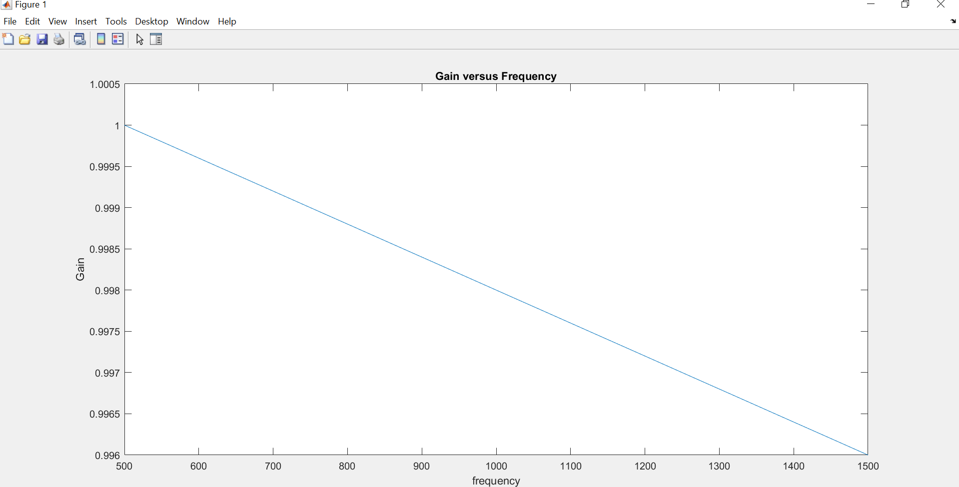

**Phase Shift:**

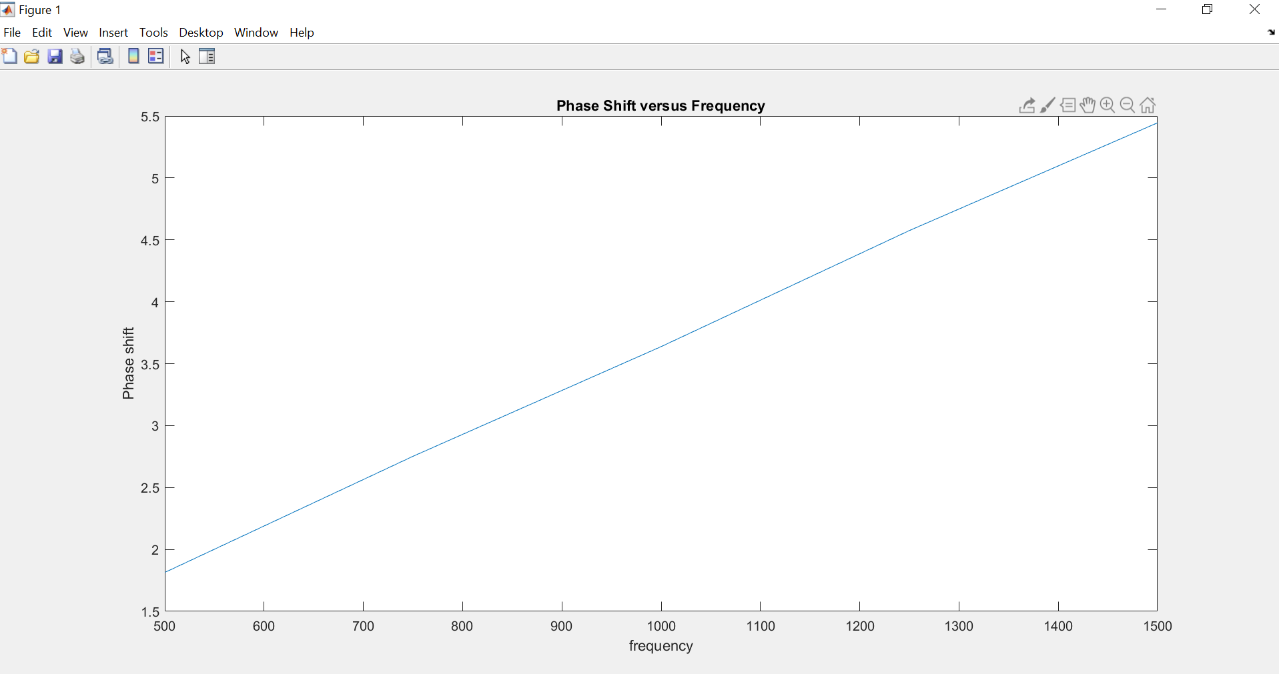

**Frequency is increasing by the factor of 10:**

**Gain:**

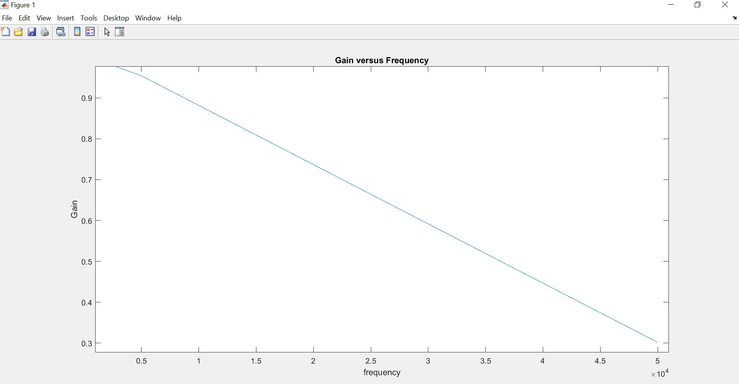

**Phase Shift:**

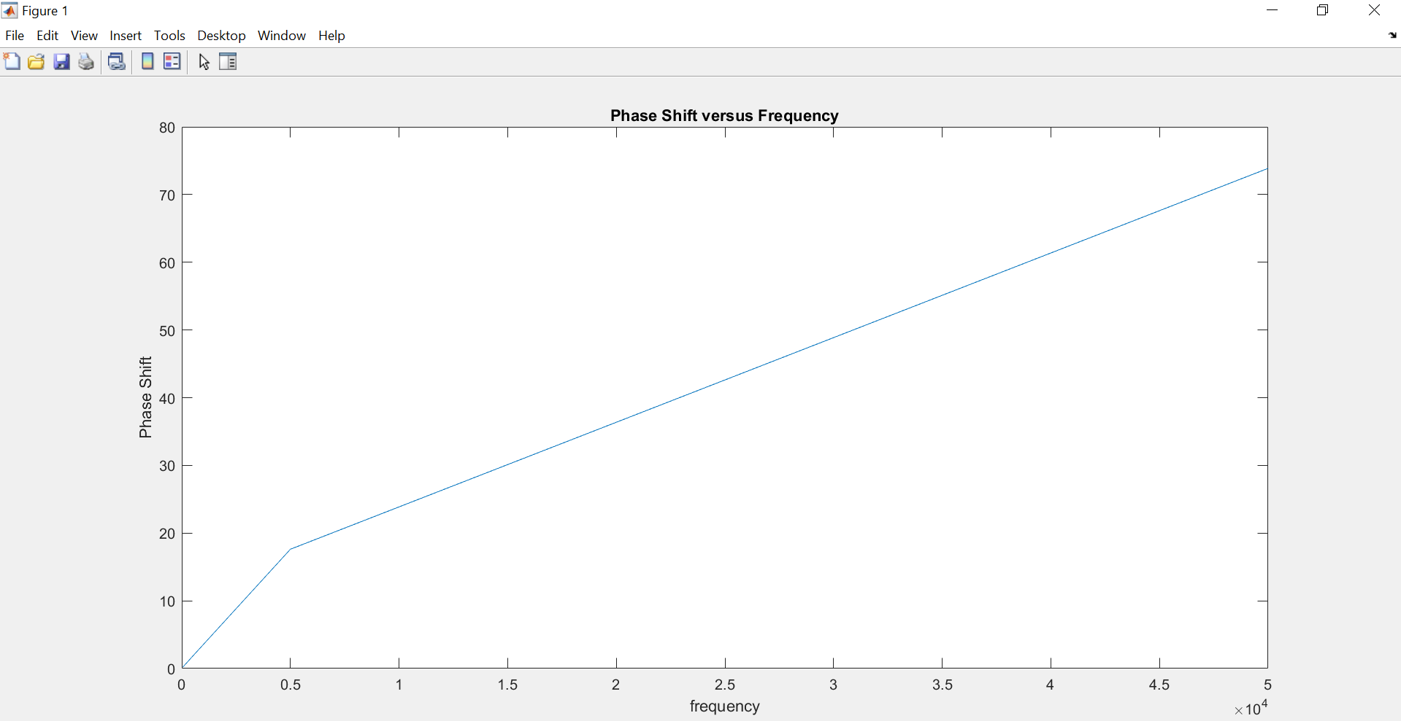

1. **ACROSS RESISTOR CIRCUIT:**

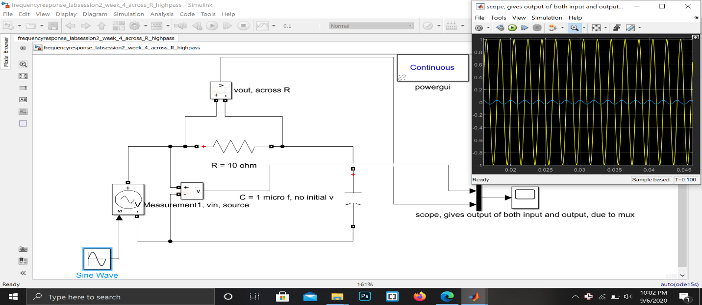

**OBSERVATION TABLE ACROSS R:**

**Frequency with a diff of 2000 Hz (High Pass):**

|  |  |  |  |
| --- | --- | --- | --- |
| S.No | Frequency  Hz | Gain | Phase shift  Degrees |
| 1 | 1000 | 0.063 | 85.547 |
| 2 | 3000 | 0.183 | 80.329 |
| 3 | 5000 | 0.300 | 74.221 |
| 4 | 7000 | 0.403 | 67.135 |
| 5 | 9000 | 0.493 | 61.488 |

**Frequency increasing by the factor of 10:**

|  |  |  |  |
| --- | --- | --- | --- |
| S.No | Frequency  Hz | Gain | Phase Shift  degrees |
| 1 | 50 | 0.0027 | 89.802 |
| 2 | 500 | 0.032 | 88.61 |
| 3 | 5000 | 0.3 | 71.973 |
| 4 | 50000 | 0.953 | 17.871 |

**GRAPHS:**

**Frequency is increasing by 2000 Hz:**

**Gain Plot:**

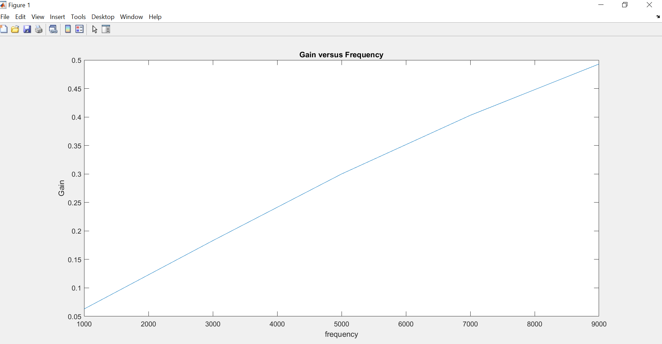

**Phase Shift:**

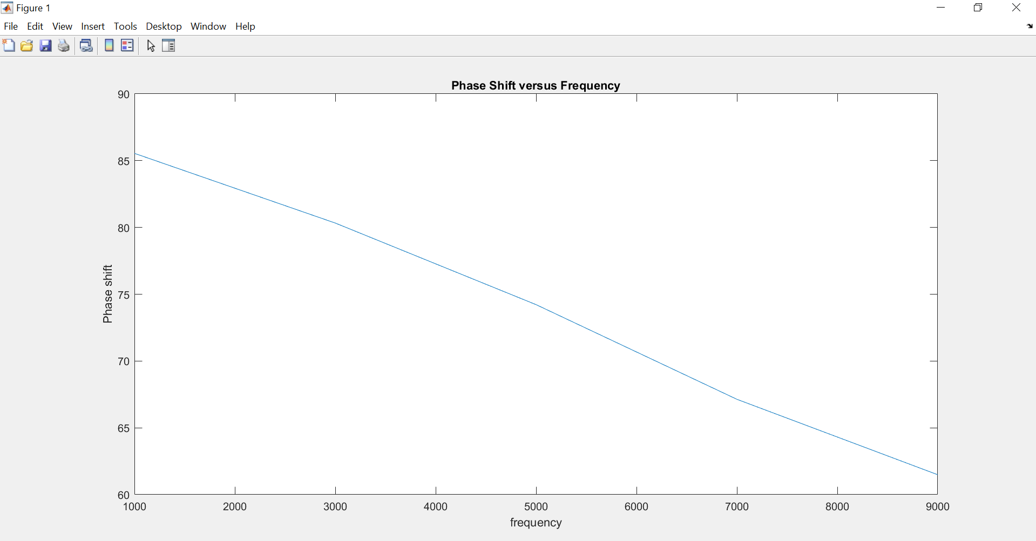

**Frequency is increasing by factor of 10:**

**Gain Plot:**

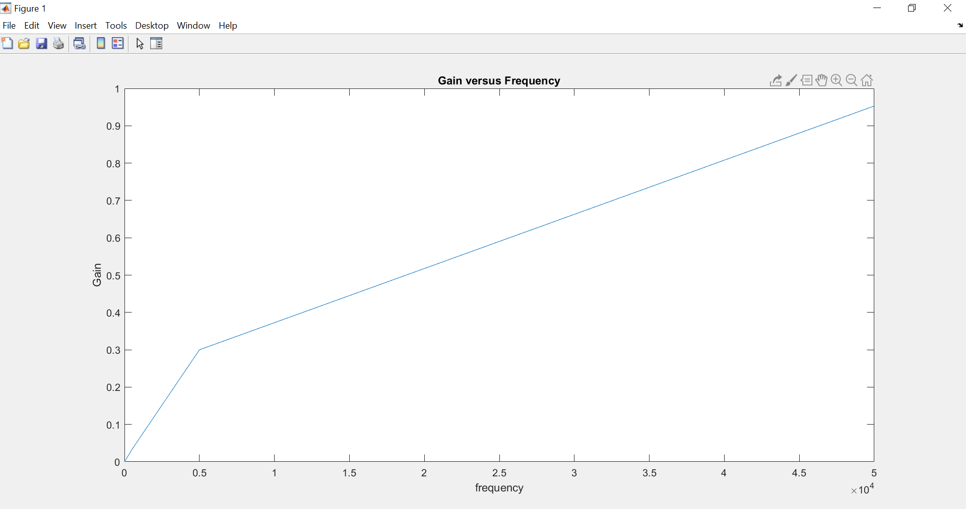

**Phase Shift:**

