**SNS**

**Lab # 04:**

“Frequency response of given RC circuit.”

**CIRCUIT:**

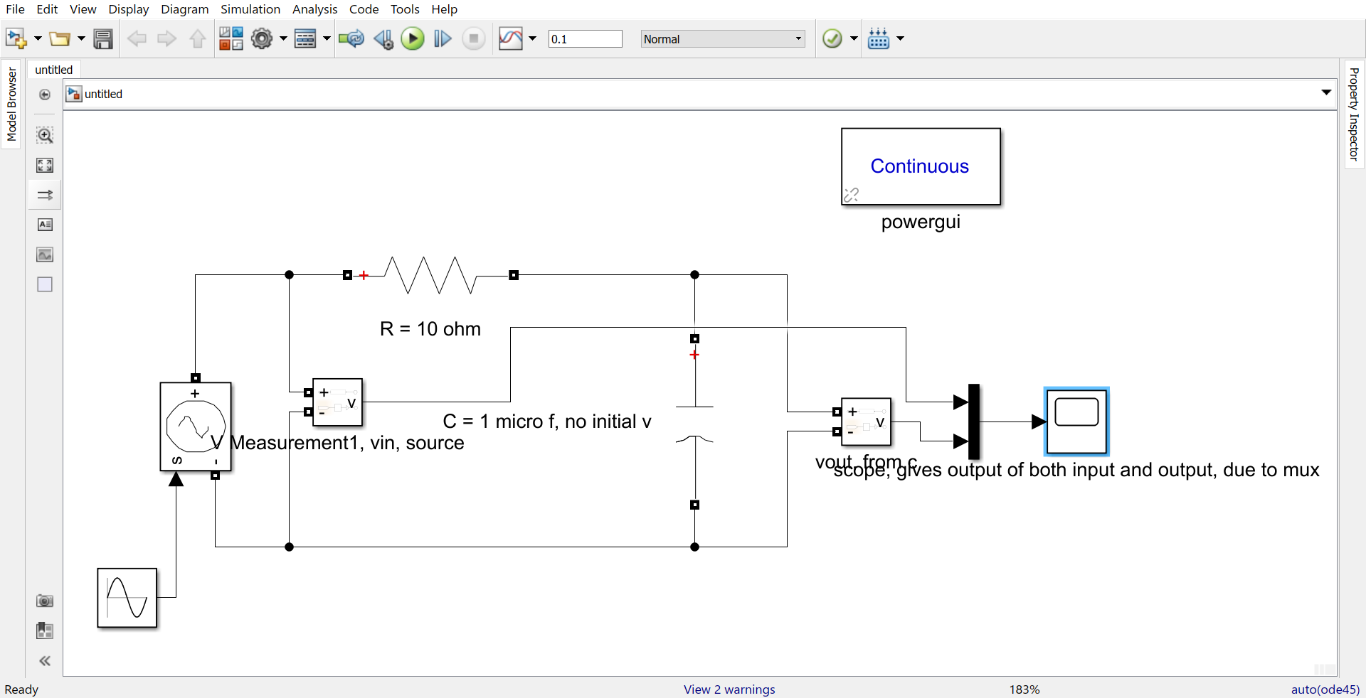

**F = 50 Hz:**

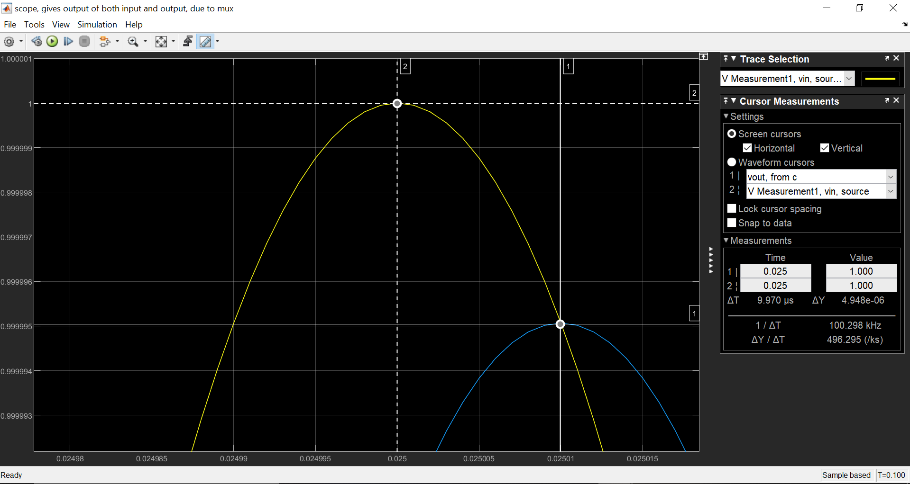

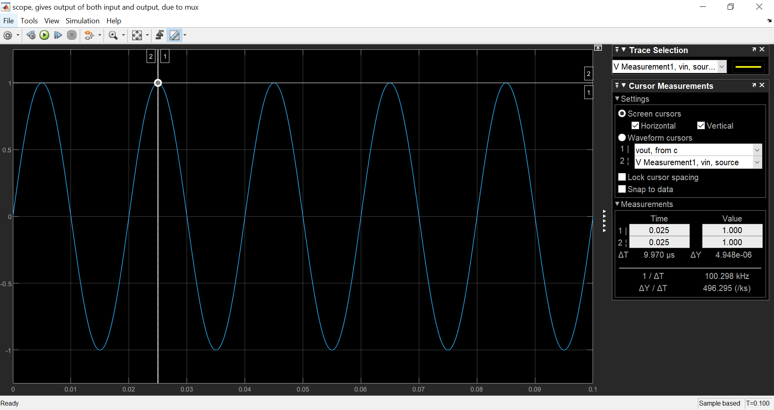

**F = 200 Hz:**

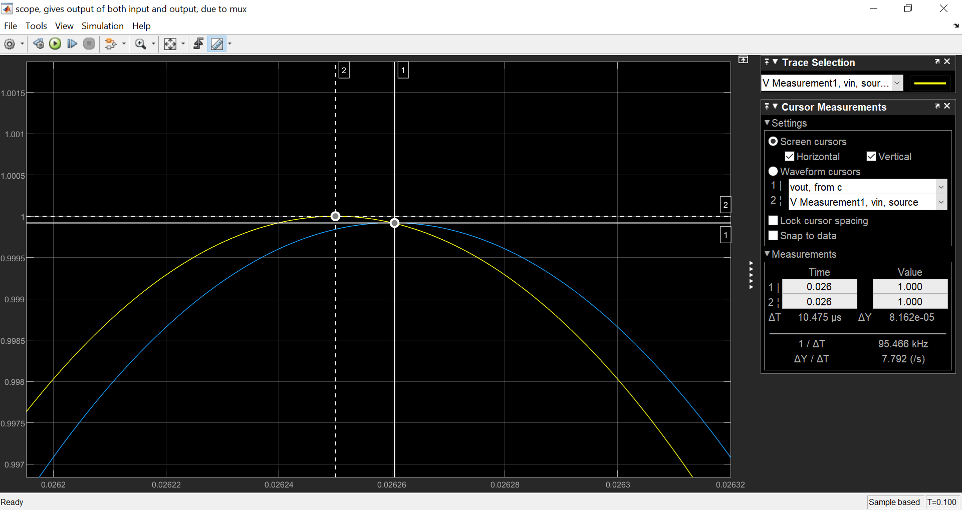

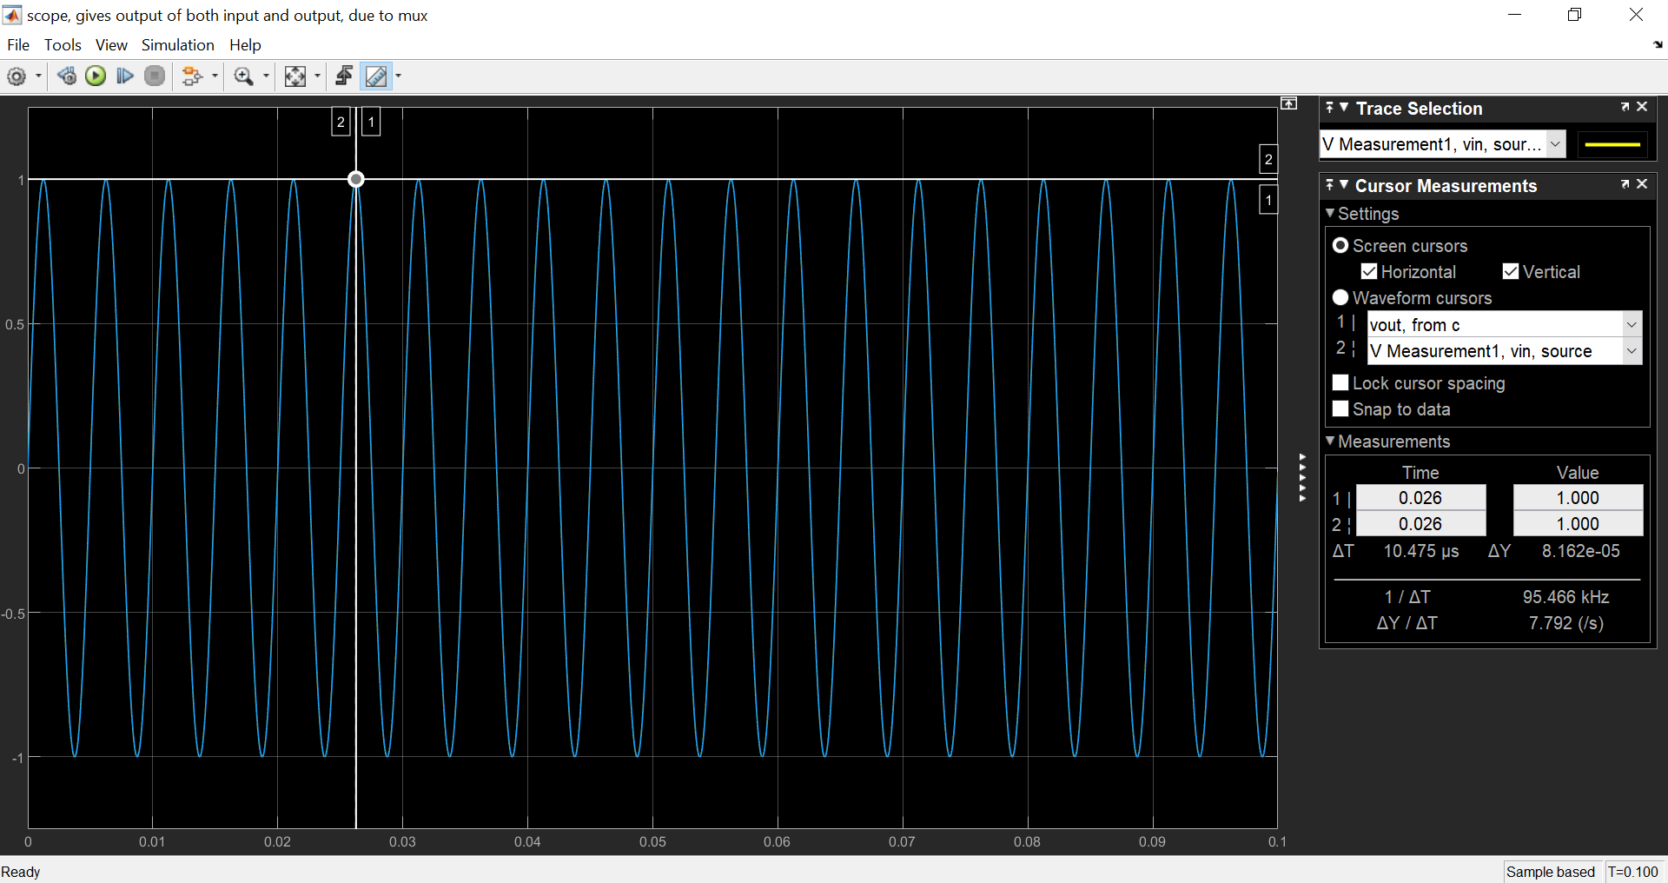

**F = 350 Hz:**

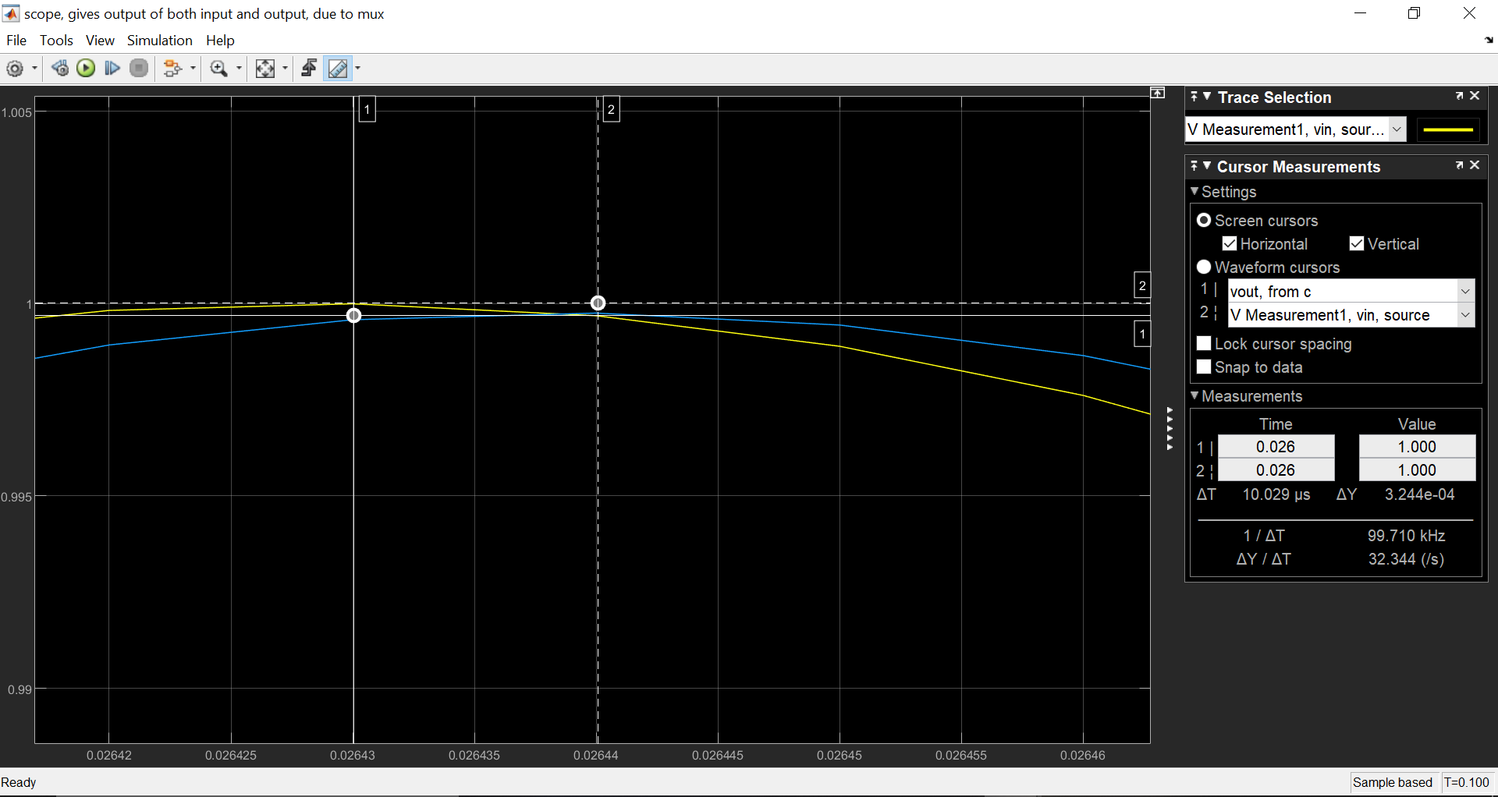

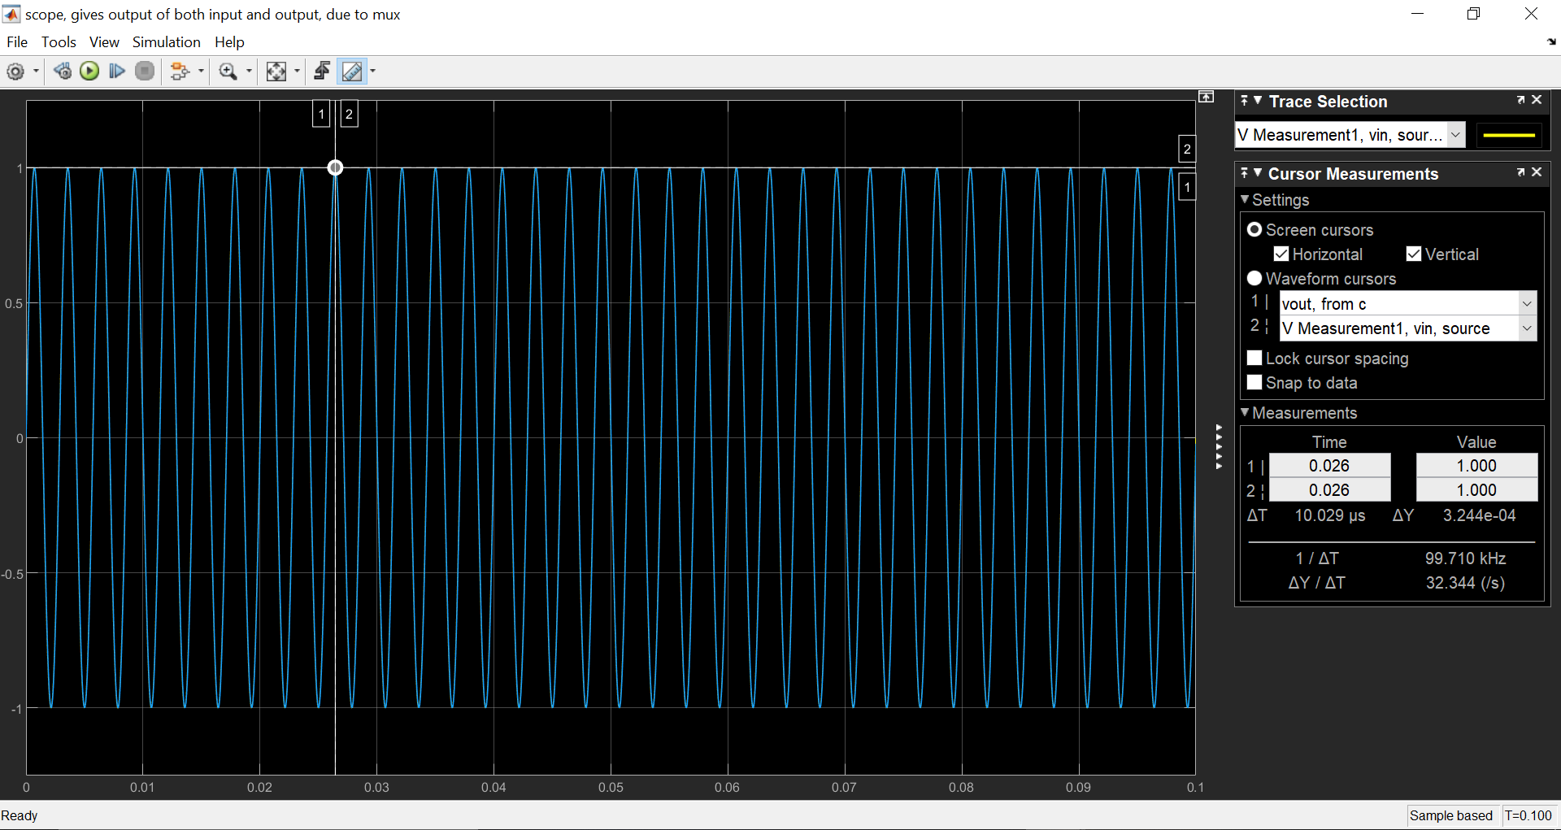

**F = 500 Hz:**

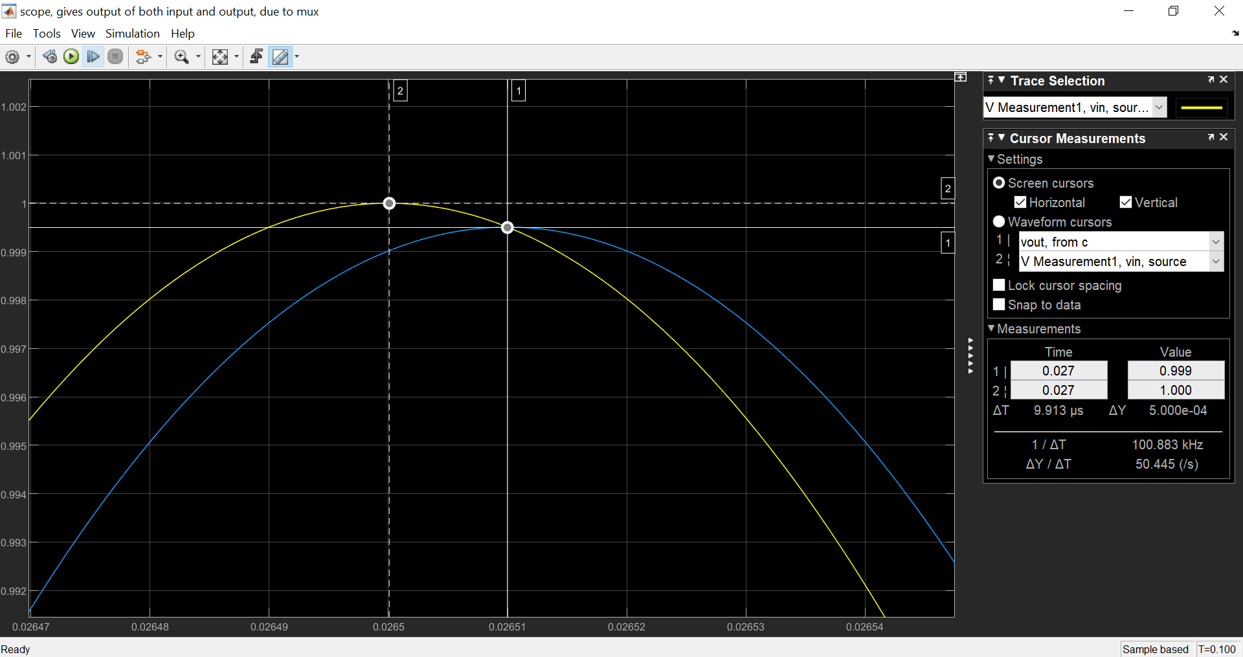

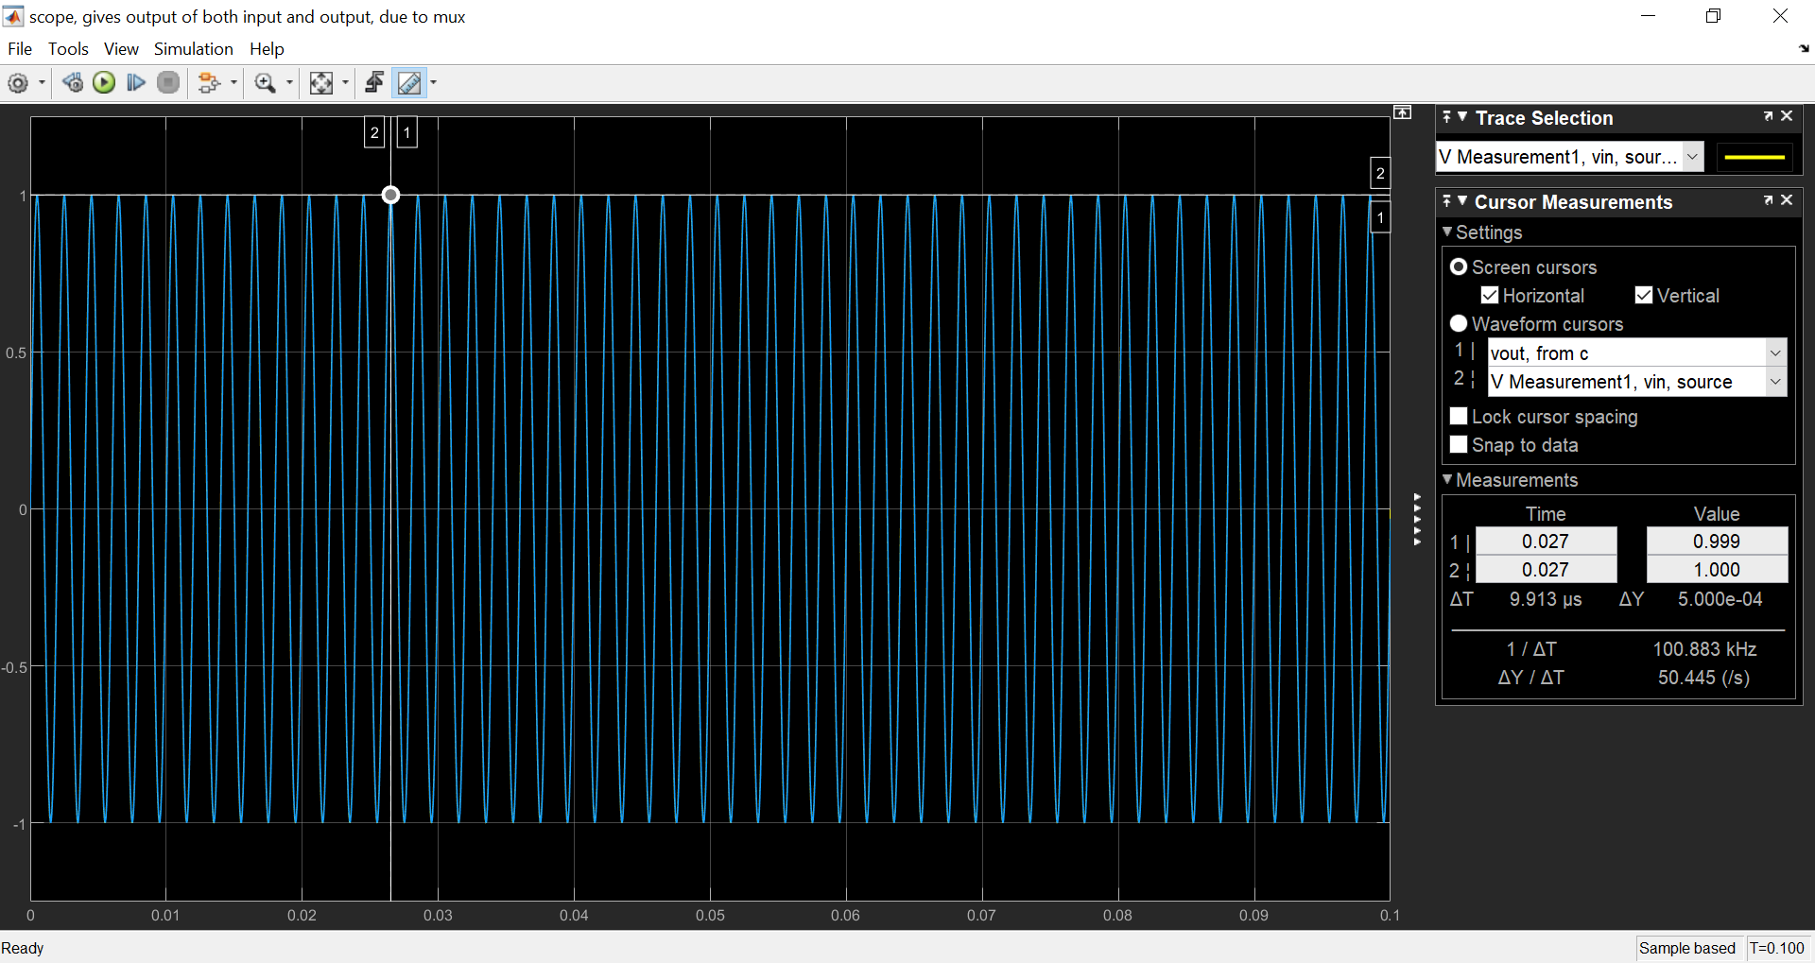

**F = 650 Hz:**

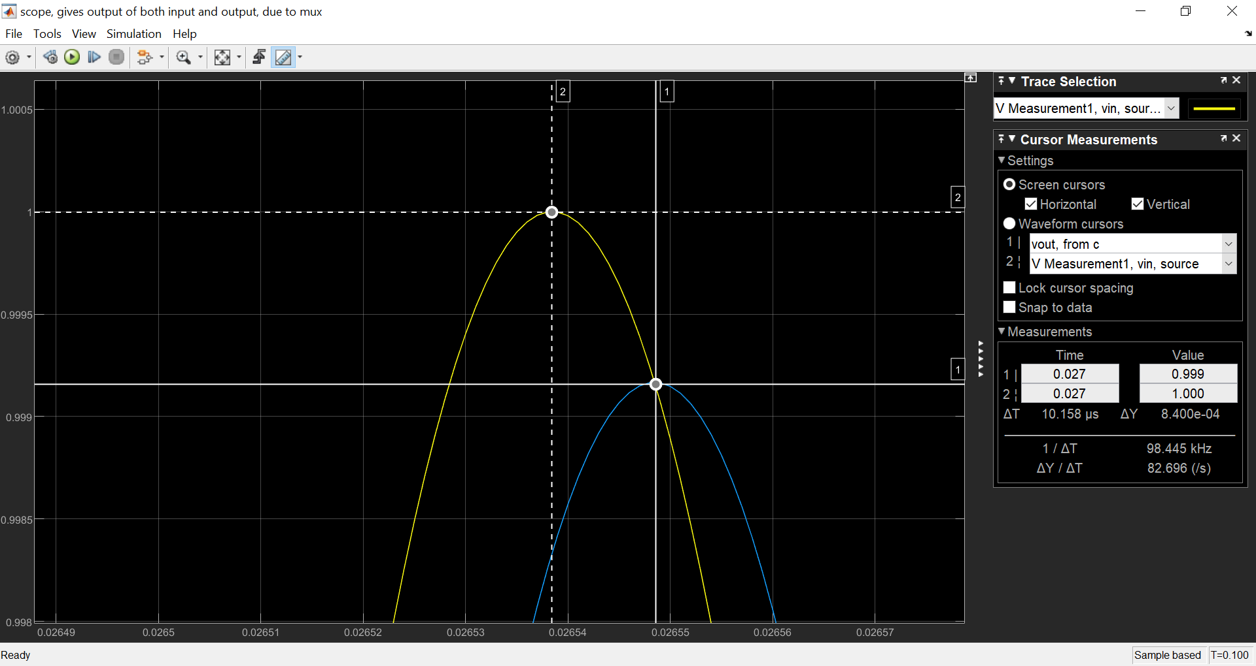

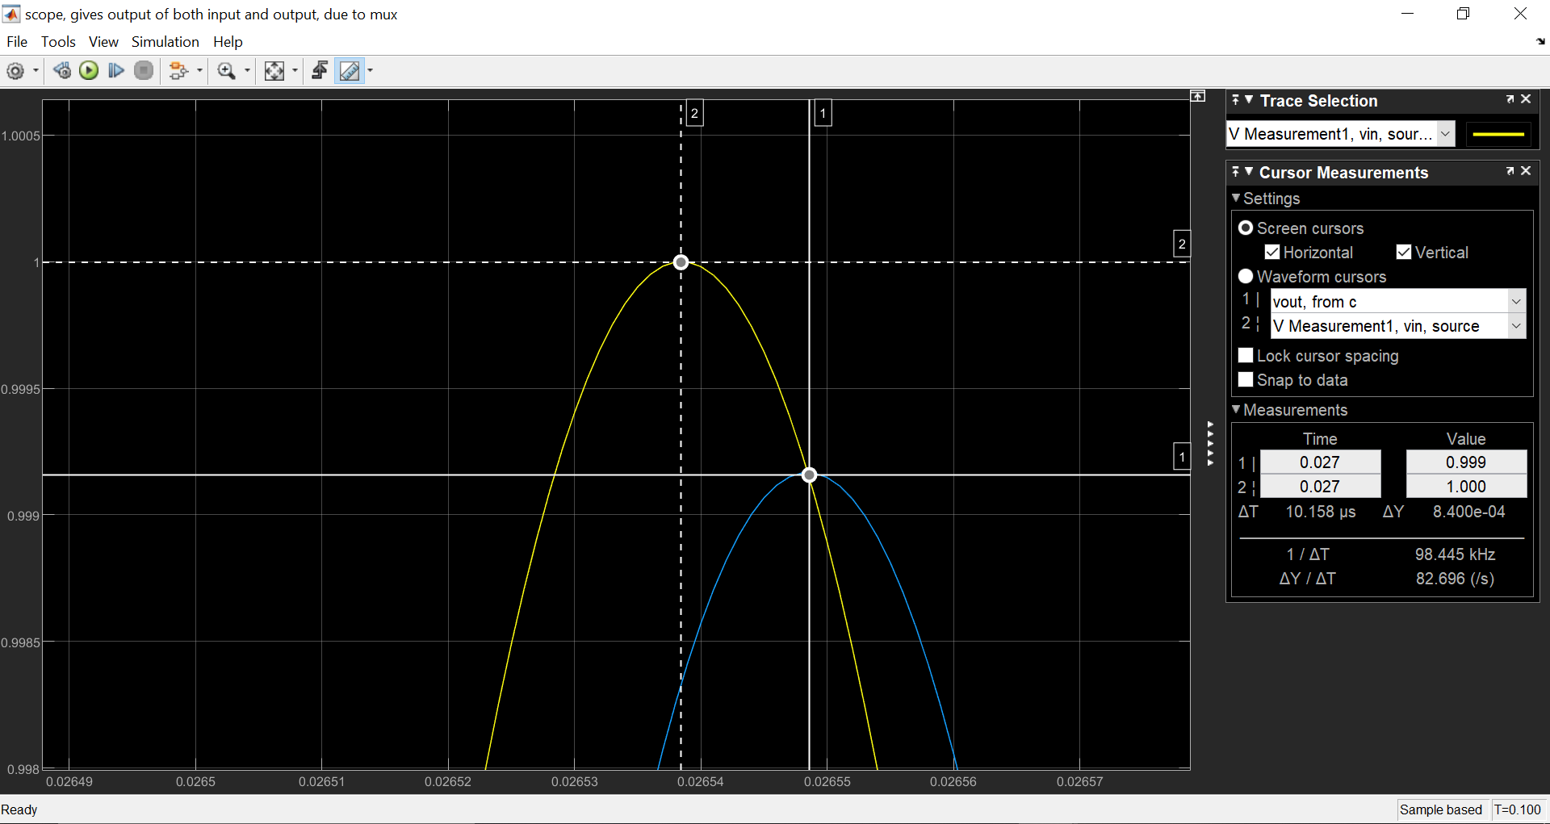

**F= 1000 Hz:**

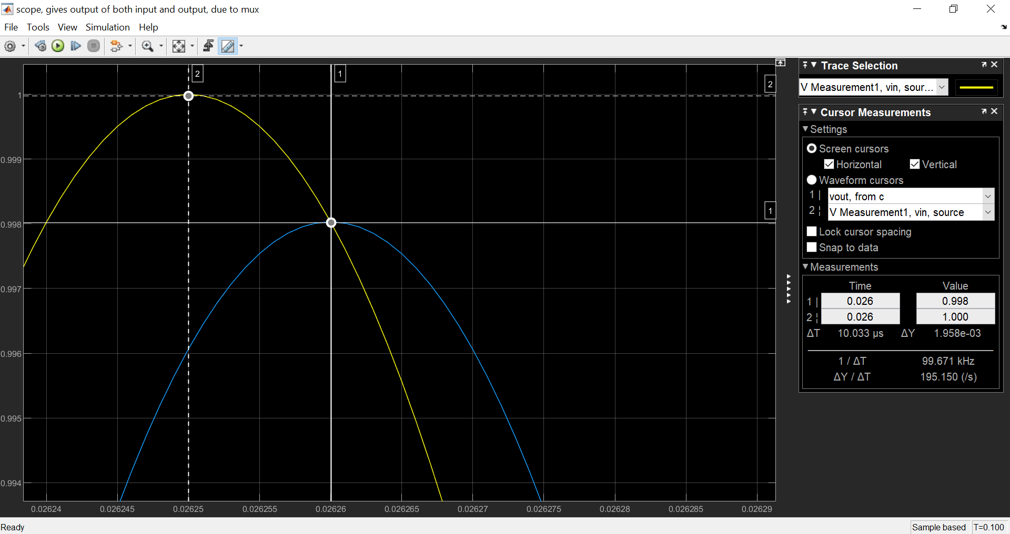

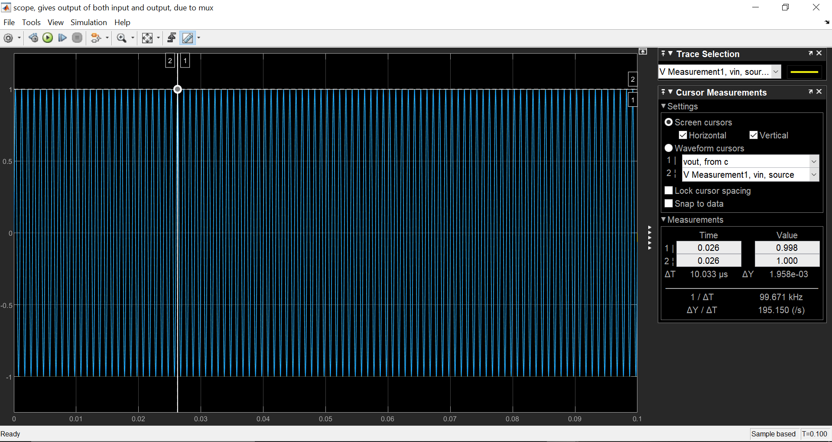

**OBSERVATION TABLE:**

**Frequency is increasing by 250 Hz:**

|  |  |  |  |
| --- | --- | --- | --- |
| S.No | Frequency  Hz | Gain | Phase shift  Degrees |
| 1 | 250 | 1.000 | 1.014 |
| 2 | 500 | 1.000 | 1.814 |
| 3 | 750 | 0.999 | 2.752 |
| 4 | 1000 | 0.998 | 3.638 |

Frequency is increasing by the factor of 10 :

|  |  |  |  |
| --- | --- | --- | --- |
| S.No | Frequency | Gain | Phase Shift  Degrees |
| 1 | 50 | 1.000 | 0.211 |
| 2 | 500 | 1.000 | 1.814 |
| 3 | 5000 | 0.954 | 17.620 |
| 4 | 50000 | 0.302 | 73.872 |

**GRAPH:**

**Frequency is increasing by 250 Hz:**

**Gain:**

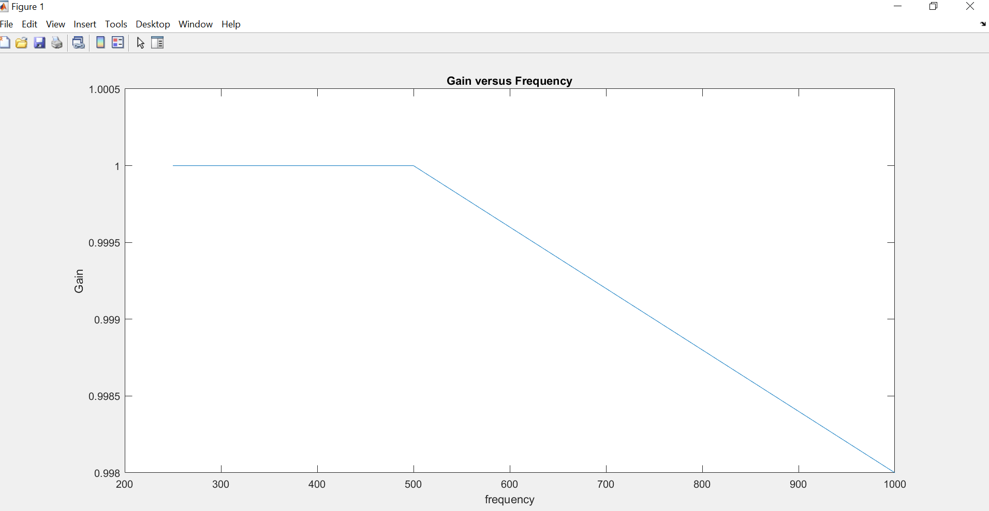

**Phase Shift:**

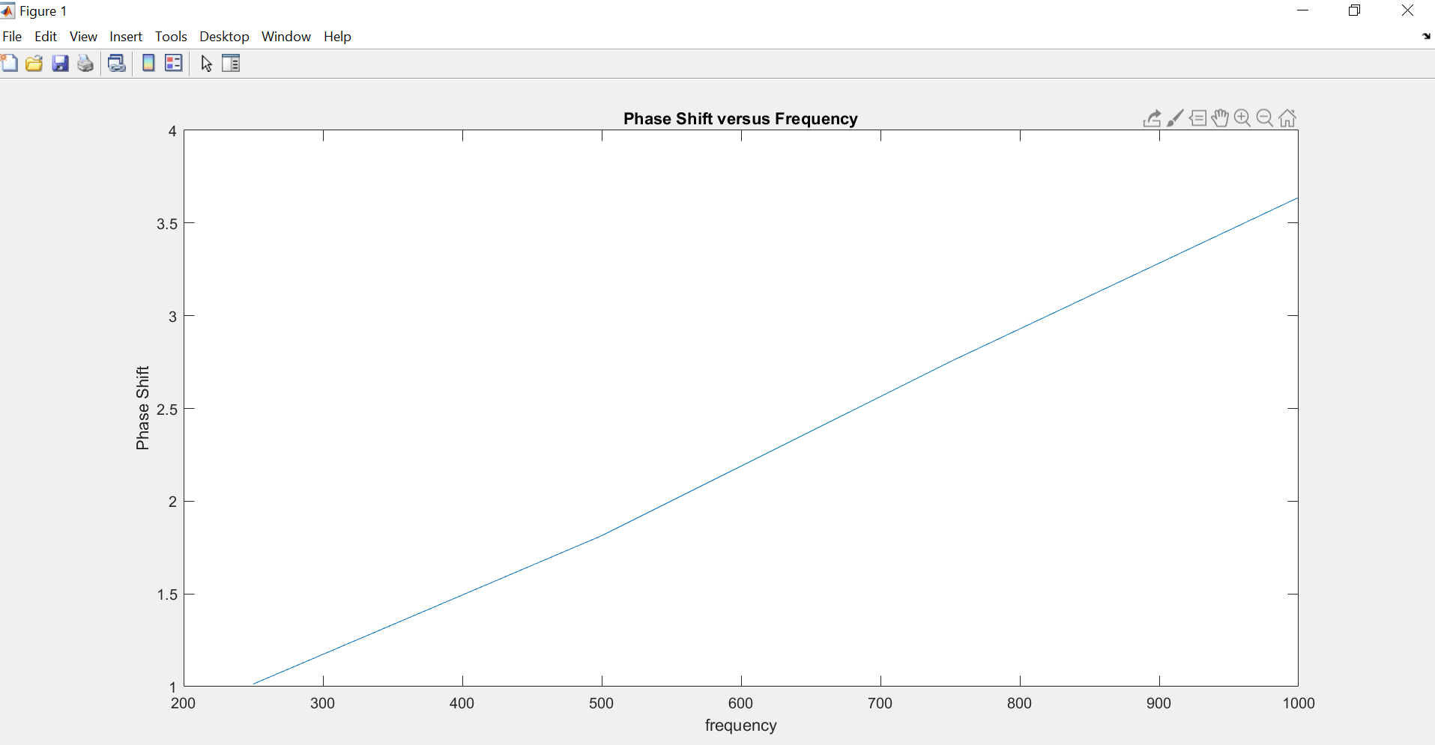

**Frequency is increasing by the factor of 10:**

**Gain:**

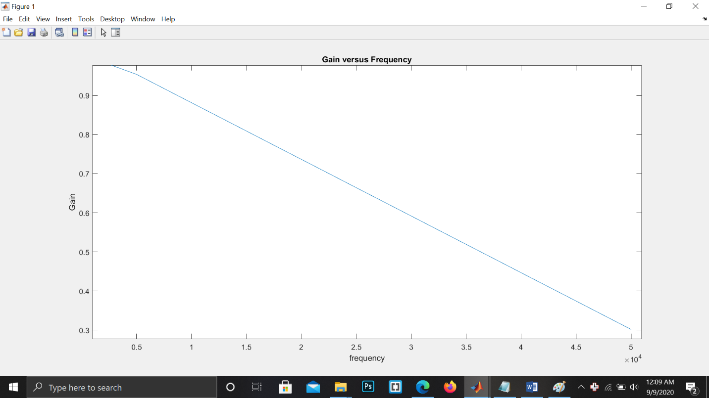

**Phase Shift:**

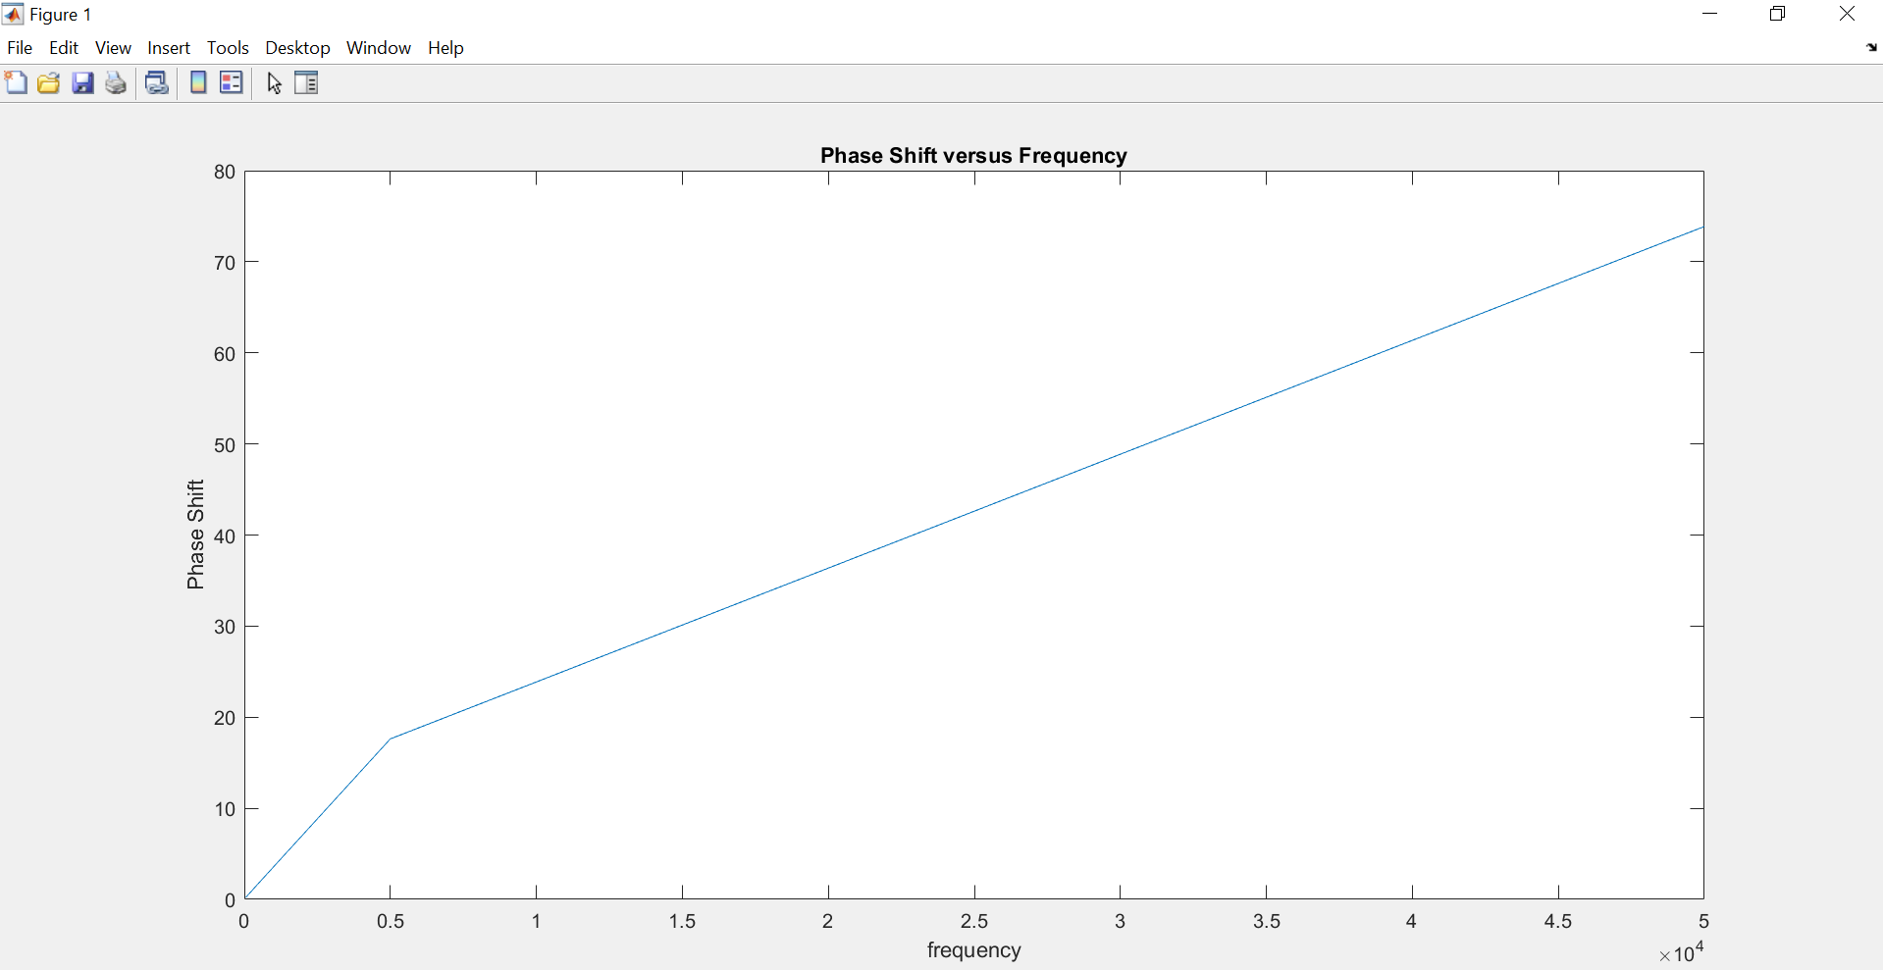

**ACROSS R:**

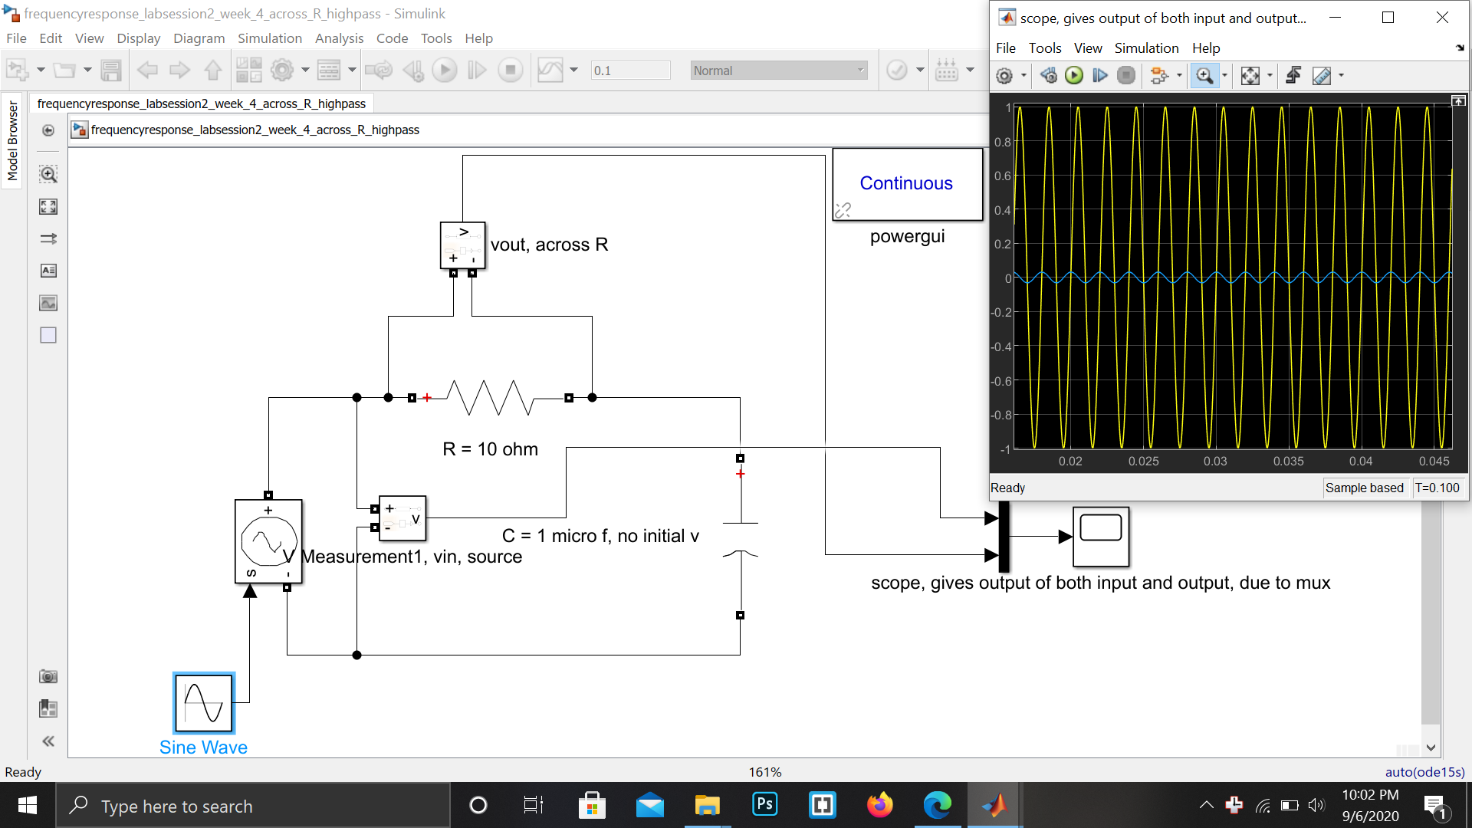

**OBSERVATION TABLE AND GRAPHS ACROSS R:**

Frequency with a diff of 2000 Hz:

|  |  |  |  |
| --- | --- | --- | --- |
| S.No | Frequency  Hz | Gain | Phase shift  Degrees |
| 1 | 1000 | 0.063 | 85.547 |
| 2 | 3000 | 0.183 | 80.329 |
| 3 | 5000 | 0.300 | 74.221 |
| 4 | 7000 | 0.403 | 67.135 |

Frequency increasing by the factor of 10:

|  |  |  |  |
| --- | --- | --- | --- |
| S.No | Frequency  Hz | Gain | Phase Shift  degrees |
| 1 | 50 | 0.0027 | 89.802 |
| 2 | 500 | 0.032 | 88.61 |
| 3 | 5000 | 0.3 | 71.973 |
| 4 | 50000 | 0.953 | 17.871 |

Gain:

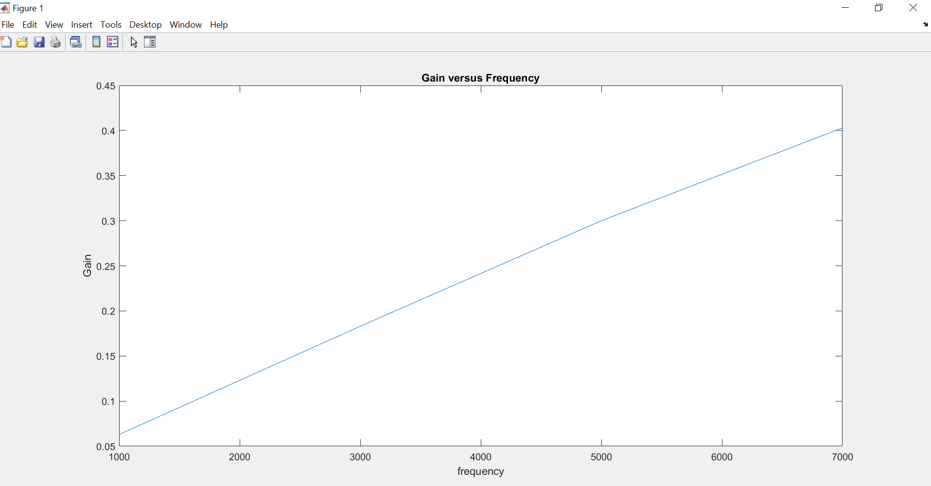

Phase Shift:

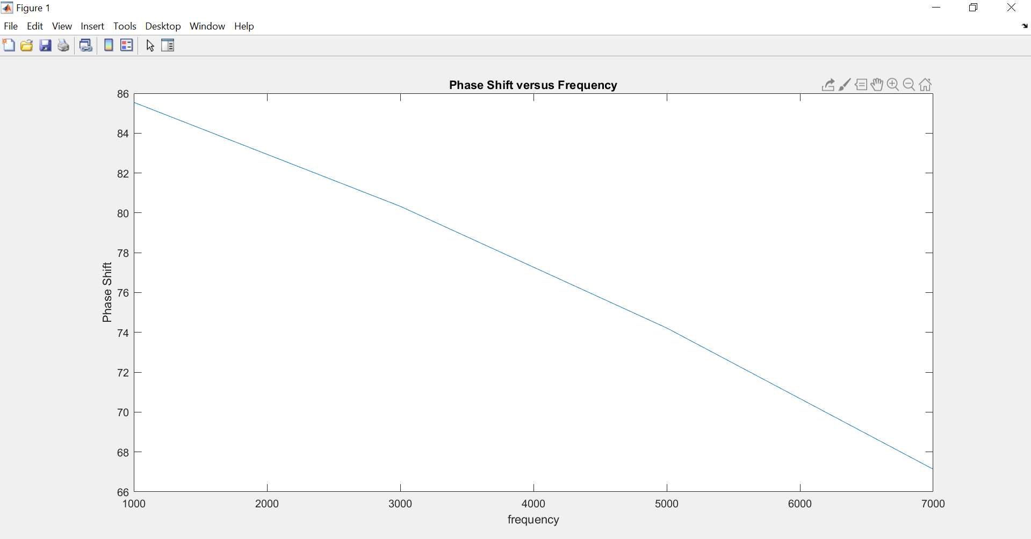

Gain:

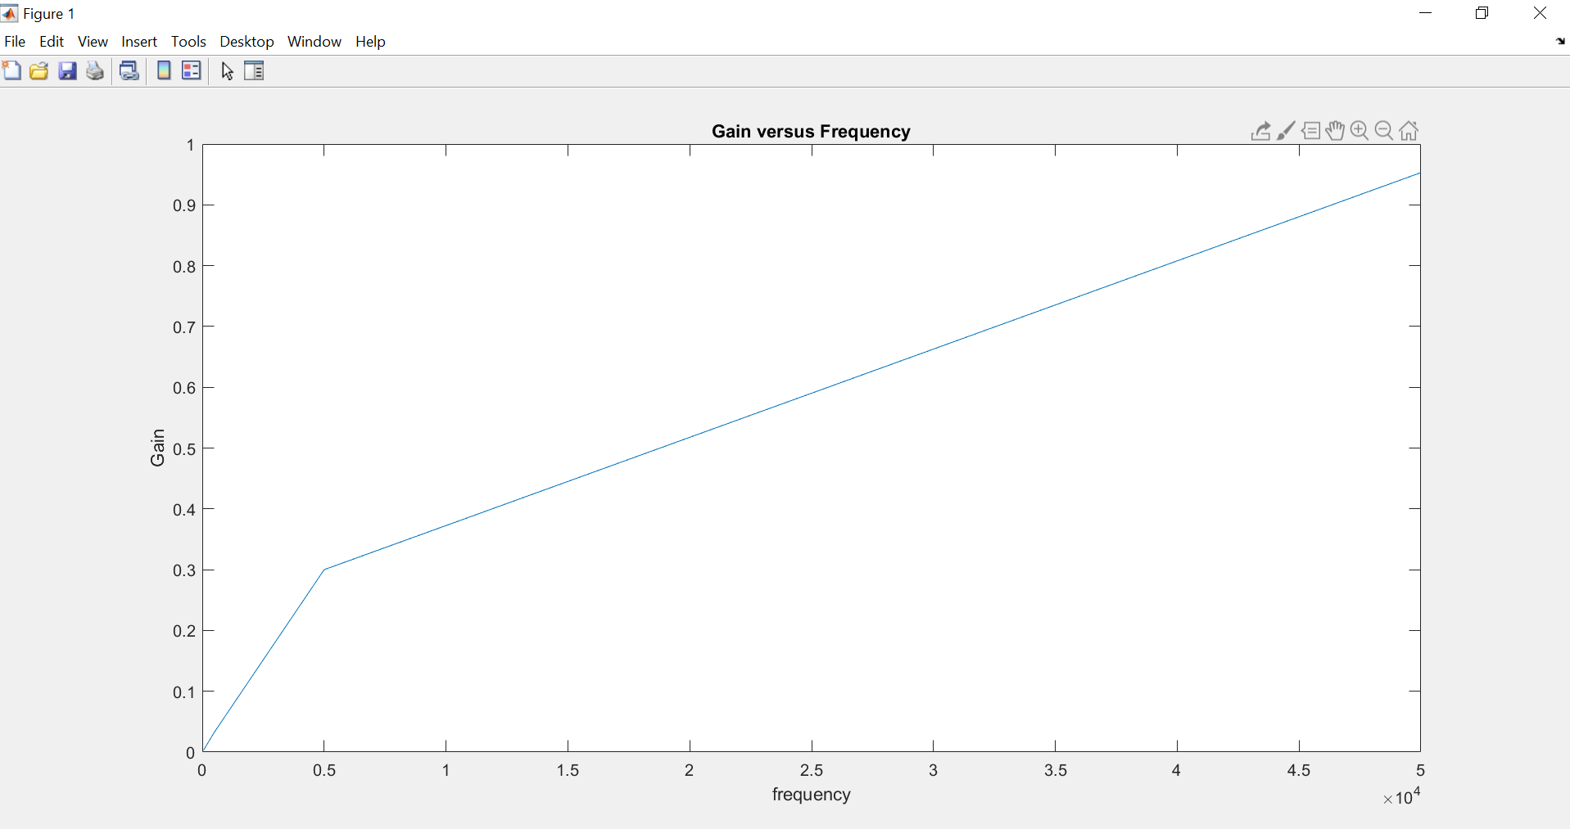Phase Shift:

