1. Install Oclif global CLI

npm install -g oclif

1. To create oclif project named muneeb

oclif multi muneeb

1. To run file

node bin/run <filename> (node bin/run hello)

1. Create files and folder:
2. Create api folder and write all apis there and data to be save in todos.json file
3. Create files to run those apis:

* oclif command add (create add.ts in src and test folder, to add todo)
* oclif command remove (to remove todo)
* oclif command list (to get all todos)
* oclif command interact-inquirer (to interact with cmd and mark done to selected todos)

1. Functionality

Node bin/run add “task” (to add todo)

Node bin/run list (to get todo)

Node bin/run remove <index> or 0 (to remove todo at provided index like at index 0)

Node bin/run interact-inquirer

1. To publish as global package

In Muneeb folder, run;

npm publish --access public (published as muneeb@0.0.0)

1. To Install global package:

npm I muneeb -g

1. To test global package:

First create todos.json file under C:\Users\abc\AppData\Roaming\npm\node_modules\muneeb\lib\api

And pass some data;

[{“done”:true, “todo”: “task 1”}]

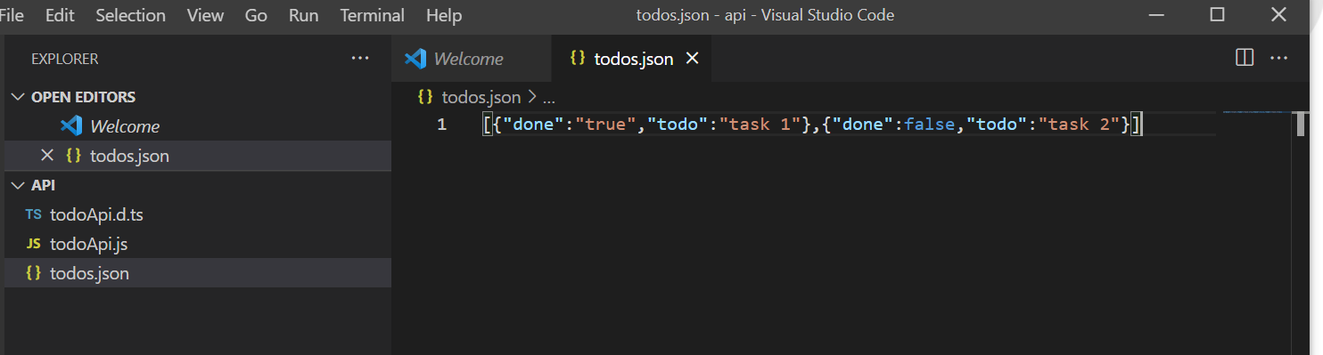

Now;

* muneeb list
* muneeb add “task 2”

And other functionality command with named “Muneeb” instead of node bin/run

