Initial:

Index.css:

Add rule

*{

  margin: 0;

}

To make things center align horizontally and vertically:

.app{

  display: grid;

  place-items: center;

  height: 100vh;

}

Width using flex:

.sidebar{

    display: flex;

    flex-direction: column;

    flex: 0.35; /*sidebar takes 35% of screen*/

}

How to break down layout:

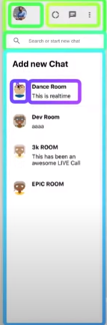

Icon use as button:

 <IconButton>

                    <DonutLarge />

                  </IconButton>

Automatic space between contents:

Use justify content:

.sidebar__header{

    display: flex;

    justify-content: space-between;

    padding: 20px;

}

Code to make search bar thing:

<div className="sidebar__search">

                    <div className="sidebar__searchContainer">

                      <SearchOutlined/>

                      <input type="text" placeholder="Search or start new chat"/>

                    </div>

            </div>

.sidebar__search{

    display: flex;

    align-items: center;

    background-color: #f6f6f6;

    padding: 10px;

    height: 39px;

}

.sidebar__searchContainer{

    display: flex;

    align-items: center;

    width: 100%;

    height: 35px;

    border-radius: 20px;

}

.sidebar__searchContainer > .MuiSvgIcon-root{

    color: grey;

    padding: 10px;

}

.sidebar__searchContainer > input{

    border: none;

    margin-left: 10px;

    outline-width: 0;

}

To take full space:

Use flex: 1

For scroll:

Overflow: scroll

Simple card:



        <div className="sidebarChat">

            <Avatar/>

            <div className="sidebarChat__info">

                <h2>Room name</h2>

                <p>This is the last room</p>

            </div>

        </div>

.sidebarChat{

    display:flex;

    padding: 20px;

    cursor: pointer;

    border-bottom: 1px solid #f6f6f6;

}

.sidebarChat:hover{

    background-color: #ebebeb;

}

.sidebar__chats{

    flex:1;

    background-color: white;

    overflow: scroll;

}

.sidebarChat__info{

    margin-left: 15px;

}

.sidebarChat__info > h2{

    font-size: 16px;

    margin-bottom: 8px;

}

To make content full width as possible:

Use flex 1 (to take all possible vertical width)

Example:

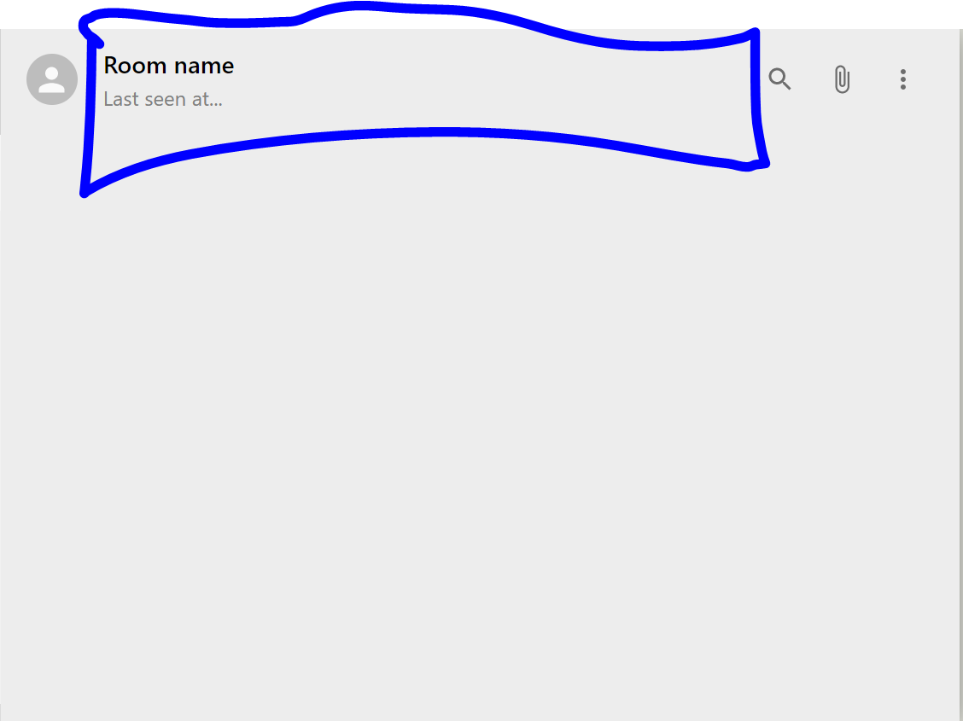

.chat__headerInfo{

    flex: 1;

    padding-left: 20px;

}