IMPLEMENTATION OF LINKEDLIST

PROGRAM

#include <stdio.h>
#include <stdlib.h>

void inputFirst(int);
void inputEnd(int);
void inputParticular(int, int);

void deleteFirst();
void deleteEnd();
void deleteParticular();

void display();

struct node {
int data;
struct node *ptr;
};
struct node *start;

int main() {
int option, value, position;
printf("The linked list operations are : \n");
printf("1) Enter at the first position\n2) Enter at the end position\n3) Enter at a particular position\n4) Delete from the first position\n5) Delete from the end position\n6) Delete from a particular position\n7) Display\n8) Exit\n");
do {
printf("\nSelect your option : ");
scanf("%d", &option);

switch(option) {
case 1:
printf("Enter the data : ");
scanf("%d", &value);
inputFirst(value);
display();
break;
case 2:
printf("Enter the data : ");
scanf("%d", &value);
inputEnd(value);
display();
break;
case 3:
printf("Enter the data : ");
scanf("%d", &value);
printf("Enter the position : ");
scanf("%d", &position);
inputParticular(value, position);
display();
break;
case 4:
deleteFirst();
display();
break;
case 5:
deleteEnd();
display();
break;
case 6:

deleteParticular(position);
display();
break;
case 7:
display();
break;
case 8:
printf("Exited\n");
break;
default:
printf("Invalid option");
}

} while(option!=8);
}

void inputFirst(int value) {
struct node *temp;
temp = (struct node *)malloc(sizeof(struct node *));

if(start == NULL) {
temp->ptr = NULL;
temp->data = value;
start = temp;
} else {
temp->ptr = start;
temp->data = value;
start = temp;
}
}

void inputEnd(int value) {
struct node *temp, *p;
temp = (struct node *)malloc(sizeof(struct node *));

if(start == NULL) {
temp->ptr = NULL;
temp->data = value;
start = temp;
} else {
p = start;
while(p->ptr != NULL) {
p = p->ptr;
}
p->ptr = temp;
temp->ptr = NULL;
temp->data = value;
}
}

void inputParticular(int value, int position){
struct node *temp, *p;
temp = (struct node *)malloc(sizeof(struct node *));

if(start == NULL) {
temp->ptr = NULL;
temp->data = value;
start = temp;
} else if(position <= 1) {
temp->ptr = start;
temp->data = value;
start = temp;
} else {
p = start;
for(int i=1; i<position-1; i++) {
p = p->ptr;
}
temp->ptr = p->ptr;
p->ptr = temp;
temp->data = value;
}
}

void deleteFirst() {
struct node *temp;

if(start == NULL) {
printf("Cannot delete\n");
} else if(start->ptr == NULL) {
temp = start;
start = NULL;
printf("Deleting data = %d\n", temp->data);
free(temp);
} else {
temp = start;
start = start->ptr;
printf("Deleting data = %d\n", temp->data);
free(temp);
}
}

void deleteEnd() {
struct node *temp;

if(start == NULL) {
printf("Cannot delete\n");
} else if(start->ptr == NULL) {
temp = start;
start = NULL;
printf("Deleting data = %d\n", temp->data);
free(temp);
} else {
struct node *p;
temp = start;
p = start->ptr;
while(p->ptr != NULL){
p = p->ptr;
temp = temp->ptr;
}
temp->ptr = NULL;
printf("Deleting data = %d\n", p->data);
free(p);
}
}

void deleteParticular() {
struct node *temp, *t;
int position;
if(start == NULL)
printf("Cannot delete\n");
else if(position==1 && start->ptr==NULL) {
temp = start;
start = NULL;
printf("Deleted data = %d\n", temp->data);
free(temp);
} else if(position == 1) {
temp = start;
start = start->ptr;
printf("Deleted data = %d\n", temp->data);
free(temp);
} else {
printf("Enter the position : ");
scanf("%d", &position);
temp = start;
for(int i=1; i<position-1; i++) {
temp = temp->ptr;
}
t = temp->ptr;
temp->ptr = t->ptr;
printf("Deleted data = %d\n", t->data);
free(t);
}
}

void display(){
struct node *temp;

if(start == NULL){
printf("List is empty\n");
} else {
printf("\nThe linked list : \n");
for(temp=start; temp!=NULL; temp=temp->ptr)
printf("%d ", temp->data);
printf("\n");
}
}

OUTPUT

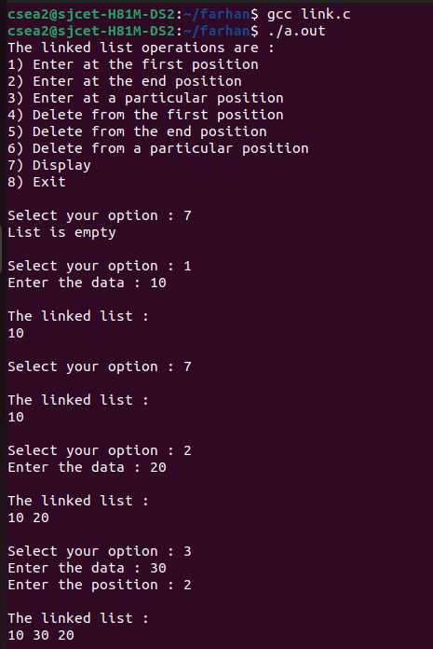

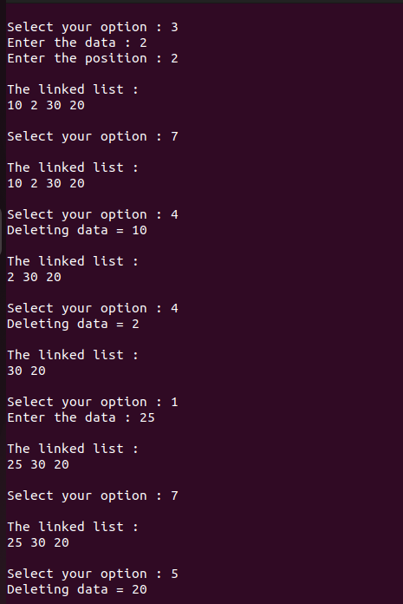

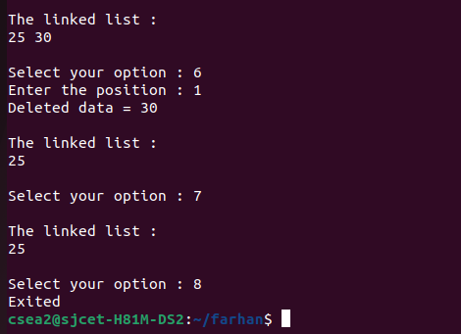
2

