1. What are the various types of operators in dart? Explain with Examples.

There are 3 types of operators:

1. Arithmetic Operators.
2. Equality and Relational Operators.
3. Logical Operators.
4. Arithmetic Operators:

|  |  |
| --- | --- |
| **S.no** | **Operators & Meaning** |
| A | +Add |
| B | −Subtract |
| C | *Multiply |
| D | /Divide |
| E | ~/Divide, returning an integer result |
| F | %Get the remainder of an integer division (modulo) |
| G | ++Increment |
| H | --Decrement |

Examples are:

1. Add +

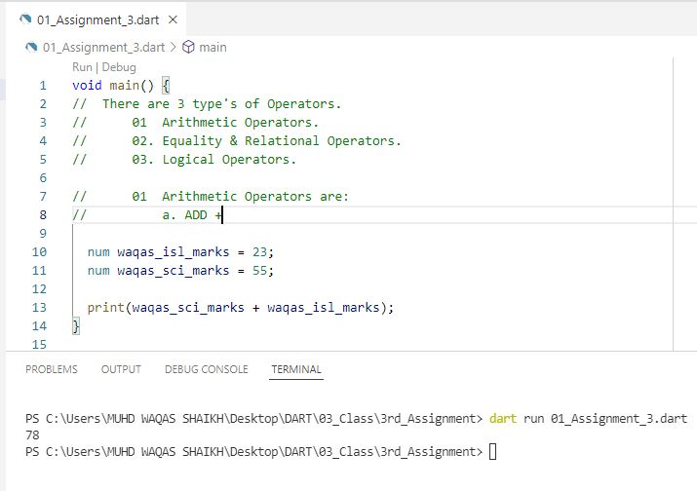

1. Subtract –

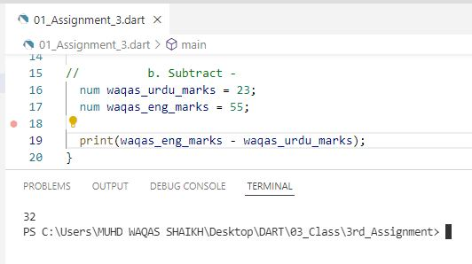

1. Multiply *

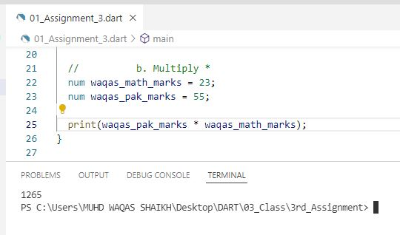

1. Divide /

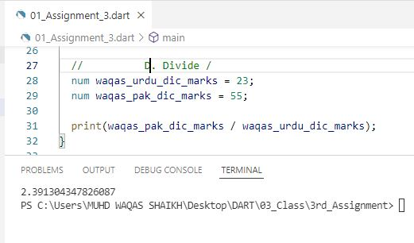

1. Divide ~/, returning an integer result.

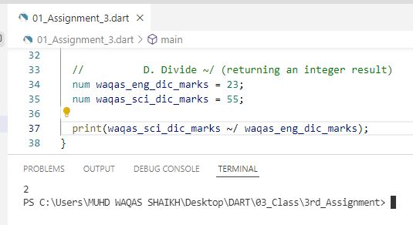

1. %Get the remainder of an integer division (modulo).

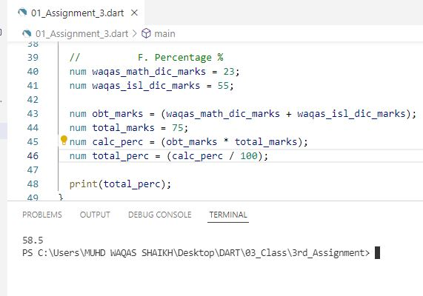

1. Equality and Relational Operators are:

|  |  |  |  |
| --- | --- | --- | --- |
| S.no | Operator | Description | Example |
| A | > | Greater than | (A > B) is False |
| B | < | Lesser than | (A < B) is True |
| C | >= | Greater than or equal to | (A >= B) is False |
| D | <= | Lesser than or equal to | (A <= B) is True |
| E | == | Equality | (A==B) is False |
| F | != | Not equal | (A!=B) is True |

1. Greater than.

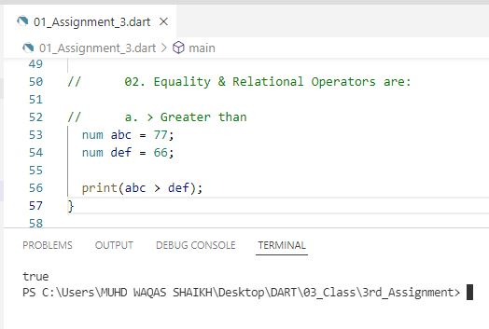

1. Lesser than.

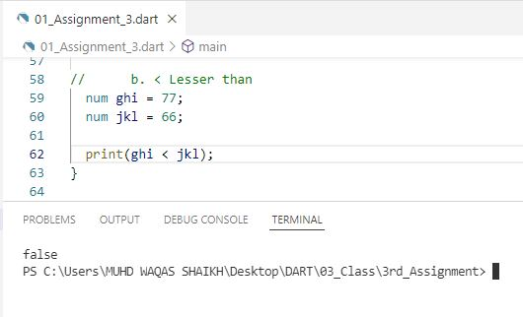

1. Greater than or equal to.

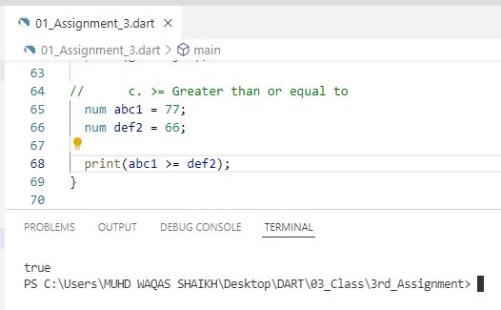

1. Equality.

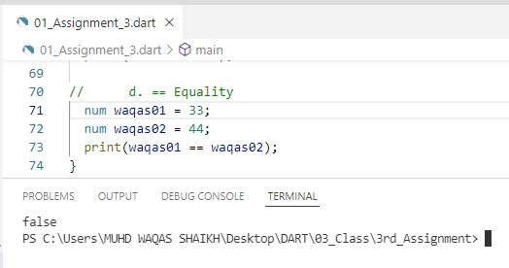

1. Not Equal.

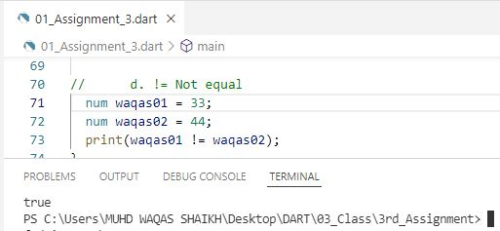

1. Logical Operators are:



1. && - And − The operator returns true only if all the expressions specified return true.

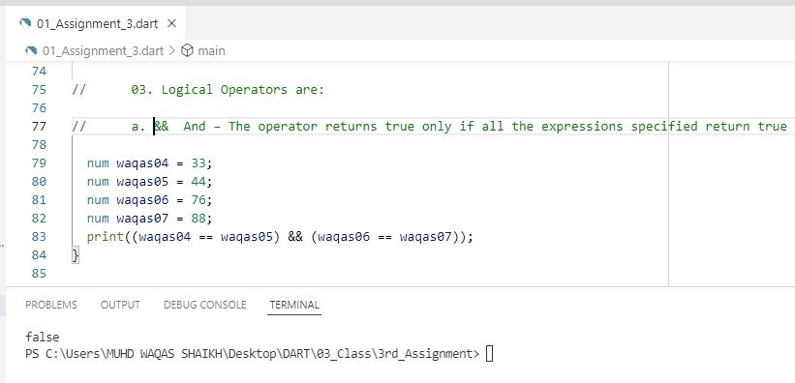

1. || - OR − The operator returns true if at least one of the expressions specified return true.

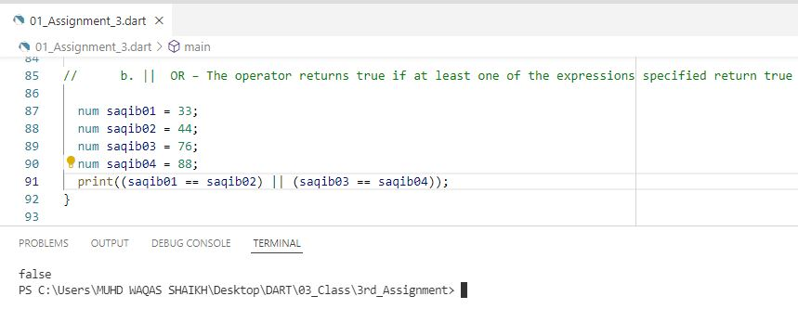

1. ! - NOT − The operator returns the inverse of the expression’s result.

