AUTOMATED SERVERLESS DATA TRACKER
Prepared in the partial fulfilment of the Summer Internship Program on AWS
AT

Under the guidance of
Mrs BETHALA SUMANA, APSSDC
Mr JUTTUKA LOVABABU, APSSDC
Submitted by
MATTAPARTHI MUKESH, 25NU5A4213 , NSRIT, (Batch -1)
IPPILI CHANDRA VARDHAN, 25NU5A4206 , NSRIT, (Batch -1)
THURAGA VAIBHAV , 24NU1A42C6, NSRIT, (Batch -1)
VELAGA POORNA CHANDHU, 24NU1A0562, NSRIT, (Batch -1)

ABSTRACT
This project presents the design, implementation, and monitoring of an automated, event-driven Serverless Data Tracker on Amazon Web Services (AWS). Designed to audit development workflows and enforce repository security, the system actively tracks GitHub repository activity via webhooks. Rather than relying on traditional polling servers, the architecture utilizes Amazon API Gateway to receive real-time JSON payloads from GitHub, which immediately trigger a Node.js AWS Lambda function.
The Lambda function acts as the core processing engine, parsing the incoming data to permanently log commit details into a NoSQL Amazon DynamoDB table. Simultaneously, the system evaluates security policies; if a direct push to the restricted main branch is detected, the function publishes an alert to Amazon SNS, delivering an instant email notification to the administrative team. To provide operational visibility, a custom React frontend dashboard was developed to fetch and visualize the tracked activity data securely via CORS-enabled API Gateway endpoints.

The result is a production-ready, fully serverless tracking pipeline that is secure, scalable, and requires zero ongoing server maintenance. This report documents the architecture, build methodology, technology stack, implementation details, challenges encountered, and the final results of the project.

TABLE OF CONTENTS
1. INTRODUCTION 4
2. METHODOLOGY 5
2.1. Requirements & Planning 5
2.2. Database Layer Setup 5
2.3. Notification Layer Setup 5
2.4. Access Control Setup 5
2.5. Serverless Processing Setup 5
2.6. API & Webhook Setup 5
2.7. Frontend Dashboard Setup 6
3. TECHNOLOGY STACK 7
4. SYSTEM DESIGN / ARCHITECTURE 8
4.1. Ingestion Flow 8
4.2. Processing Layer — AWS Lambda 9
4.3. Storage Layer — Amazon DynamoDB 10
4.4. Alerting Layer — Amazon SNS 10
4.5. Presentation Layer — React Dashboard 11
5. IMPLEMENTATION 14
5.1. DynamoDB Table Configuration 14
5.2. SNS Topic Configuration 14
5.3. IAM Role Configuration 14
5.4. Lambda Logic Configuration (Node.js 24.x) 14
5.5. API Gateway Configuration 14
5.6. GitHub Webhook Integration 15
6. RESULTS 16
6.1. Automated Data Logging 16
6.2. Instant Security Alerts 16
6.3. Real-Time Dashboard Visualization 16
6.4. Serverless Efficiency 16
7. TEAM CONTRIBUTIONS 17
8. CHALLENGES & LEARNINGS 18
9. RESOURCE TEARDOWN 19
10. CONCLUSION 20
REFERENCES 21

1. INTRODUCTION
In modern software development, tracking repository activity and enforcing branch security is critical. However, dedicating a traditional, always-on server merely to listen for continuous integration webhooks introduces unnecessary operational overhead, maintenance, and cost. A cloud-native, event-driven architecture can process this same data in real time, more securely, and at a fraction of the cost of a conventional server.
This project implements exactly that pattern on AWS. Amazon API Gateway acts as the secure public front door, receiving real-time JSON payloads directly from GitHub webhooks. AWS Lambda sits behind the gateway as the core processing engine, instantly parsing the incoming data and logging the commit details into Amazon DynamoDB, a highly durable and fast NoSQL database. Critically, the architecture requires zero server provisioning; the backend logic executes only when a developer pushes code, ensuring efficient, on-demand compute scaling.
A key objective of this project was to go beyond simple data logging and build an active security enforcement mechanism. The Lambda function is programmed to evaluate development policies in real time. If a developer attempts a direct push to the restricted main branch—bypassing the standard Pull Request workflow—the system automatically triggers Amazon SNS to deliver an instant email alert to the administrative team.
A second objective, introduced to enhance operational visibility, was to move beyond reading raw data in the AWS console. The team developed a custom React frontend dashboard that securely interfaces with the API Gateway. This web application fetches the DynamoDB audit logs and visualizes the repository activity in a clean, interactive interface.
Finally, since this project was built to demonstrate modern cloud architecture for portfolio purposes rather than sustained enterprise traffic, cost control and serverless efficiency were treated as first-class design constraints. By relying entirely on on-demand services (API Gateway, Lambda, and DynamoDB) and avoiding provisioned EC2 instances or always-on databases, the system naturally scales to zero during idle periods, staying well within AWS’s free-tier usage limits.
.

2. METHODOLOGY
The project was executed in sequential, checkpointed phases, allowing each layer of the architecture to be verified before the next layer was built.

2.1. Requirements & Planning
The primary goals were defined: a public endpoint to receive GitHub webhooks, a database to log commit history, a policy engine to detect main branch pushes, an email alert system, and a custom web dashboard to display the data.

2.2. Database Layer Setup
An Amazon DynamoDB table was created with EventID as the primary partition key to store the incoming structured tracking data.

2.3. Notification Layer Setup
An Amazon SNS topic was created and configured with an email subscription to handle security alerts.

2.4. Access Control Setup
A dedicated IAM role was created for the Lambda functions, adhering to the principle of least privilege. It was granted specific policies to write/read to DynamoDB, publish to SNS, and log to CloudWatch.

2.5. Serverless Processing Setup
Two Node.js 24.x Lambda functions were deployed: a WebhookProcessor (to write incoming GitHub data and trigger alerts) and an ActivityFetcher (to read data for the dashboard).

2.6. API & Webhook Setup
An HTTP API was created in Amazon API Gateway. A POST /webhook route was created to ingest data and connected to the GitHub repository settings. A GET /activity route was created with strict CORS policies to serve data to the web app.

2.7. Frontend Dashboard Setup
A React application was built to fetch data from the /activity endpoint and display a real-time, color-coded table of repository activity.

3. TECHNOLOGY STACK
The project uses five AWS services alongside GitHub and React to create a full-stack, serverless monitoring tool.
Service | Role in this project
Amazon API Gateway | Provides public HTTP endpoints to receive GitHub webhooks and serve data to the React dashboard.
AWS Lambda (Node.js) | Executes the core business logic: parsing JSON payloads, writing to the database, and triggering security alerts.
Amazon DynamoDB | Fast, NoSQL database used to permanently store the audit log of developer activity.
AWS IAM | Secures the architecture by granting Lambda specific, restricted permissions to interact with DynamoDB and SNS.
Amazon SNS | Delivers a real-time email notification to the team the moment the CloudWatch alarm enters the ALARM state.
GitHub Webhooks | Automatically pushes a JSON payload to the API Gateway every time a developer commits code.

4. SYSTEM DESIGN / ARCHITECTURE
The architecture follows a private-origin, CDN-fronted pattern: nothing reaches S3 directly, every request is served through CloudFront, every deployment is triggered by a GitHub push rather than a manual upload, and every error condition is actively reported rather than passively logged.
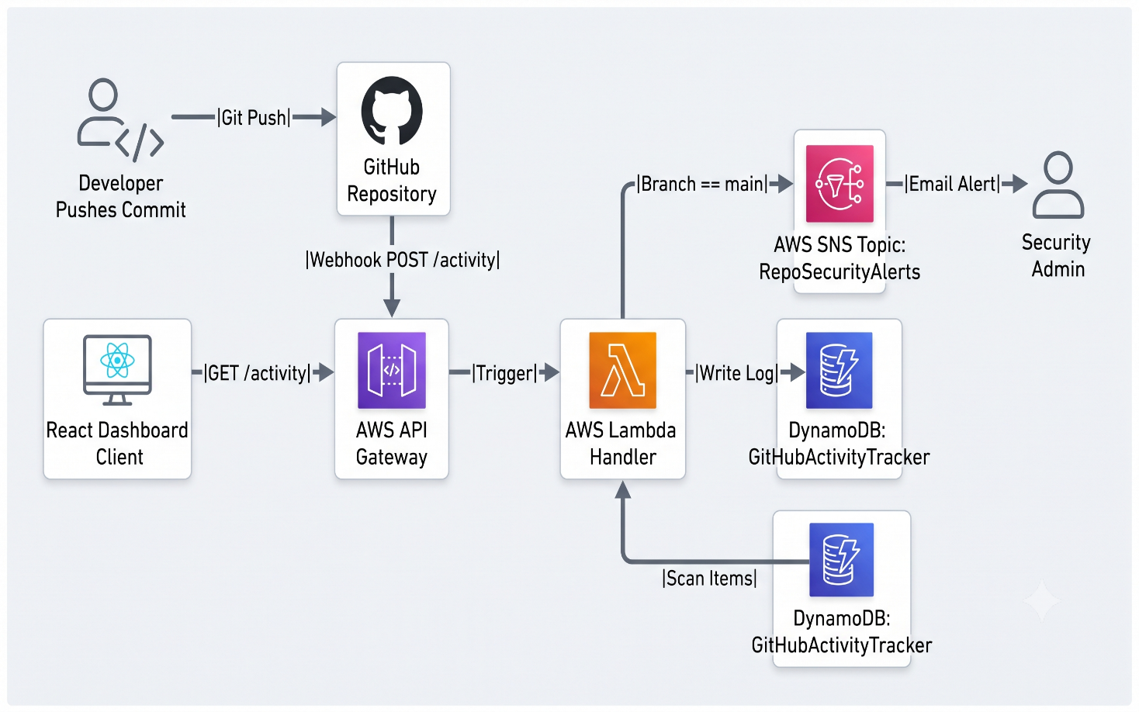
Figure 1. End-to-end architecture

4.1. Deployment Flow

A developer pushes code to GitHub. GitHub triggers a webhook, sending a POST request with a JSON payload to the Amazon API Gateway endpoint.

4.2. Processing Layer — AWS Lambda
API Gateway triggers the WebhookProcessor Lambda function. Using the modern @aws-sdk (v3), the function parses the payload to extract the committer's name, branch, message, and timestamp. It safely handles initial GitHub "ping" test events without crashing.

4.3. Storage Layer — Amazon DynamoDB
The parsed data is immediately pushed to the DynamoDB table, creating a permanent, searchable audit trail.

4.4. Alerting Layer — Amazon SNS
The Lambda script includes a security policy check. If the extracted branch name equals refs/heads/main, it triggers a PublishCommand to SNS, broadcasting a high-priority email alert.

4.5. Presentation Layer — Dashboard
When a user loads the React application, it sends a GET request to the API Gateway. The Gateway triggers the ActivityFetcher Lambda, which scans DynamoDB and returns the audit log to the frontend for visualization.

5. IMPLEMENTATION
This section details how each layer of the design was translated into a working configuration.

5.1. DynamoDB Table Configuration
- Table Name: GitHubActivityTracker
- Partition Key: EventID (String)
- Capacity: On-Demand provisioning for cost efficiency

5.2. SNS Topic Configuration
- Topic: RepoSecurityAlerts (Standard type)
- Subscription: Email protocol with verified administrative email address

5.3. IAM Role Configuration
A custom role (GitHubTrackerRole) was assigned policies: AmazonDynamoDBFullAccess, AmazonSNSFullAccess, and AWSLambdaBasicExecutionRole for CloudWatch logging.

5.4. Lambda Logic Configuration (Node.js 24.x)
The code was written utilizing modern @aws-sdk/client-dynamodb and @aws-sdk/client-sns libraries, ensuring compatibility with the Node.js 24.x runtime environment. Strict error handling was implemented to catch malformed payloads.

5.5. API Gateway Configuration
- POST /webhook: Integrated with the ingestion Lambda
- GET /activity: Integrated with the fetcher Lambda. CORS was explicitly configured (Access-Control-Allow-Origin: *) to permit browser-based fetch requests from the React local development server

5.6. GitHub Webhook Integration
The API Gateway invoke URL (appended with /webhook) was added to the GitHub repository settings. The content type was set to application/json, triggering strictly on push events.

6. RESULTS

6.1. Automated Data Logging
Pushes to secondary branches successfully trigger the pipeline. The data is accurately parsed and visible as structured items within the DynamoDB console.

6.2. Instant Security Alerts
When a direct push is made to the main branch, the system accurately evaluates the policy violation. An email alert containing the developer's name and commit message is delivered to the inbox within seconds.

6.3. Real-Time Dashboard Visualization
The React development server successfully requests data from the AWS backend. The dashboard renders an interactive table, accurately color-coding secure commits vs. direct-to-main policy violations.

6.4. Serverless Efficiency
The architecture handled all webhook traffic instantly without the need to provision, scale, or maintain an EC2 instance or traditional web server.

7. TEAM CONTRIBUTIONS
This project was completed collaboratively by a team of four students from NSRIT (Batch 1), under the guidance of the project mentors at APSSDC.
Name | ID Number | Institution | Focus Area
Mattaparthi Mukesh | 25NU5A4213 | NSRIT | Serverless Logic (Lambda) & API Gateway
Ippili Chandra Vardhan | 25NU5A4206 | NSRIT | DynamoDB Configuration & Data Modeling
Thuraga Vaibhav | 24NU1A42C6 | NSRIT | SNS Alerting & IAM Security Roles
Velaga Poorna Chandu | 24NU1A0562 | NSRIT | Frontend & Documentation

8. CHALLENGES & LEARNINGS
Several practical challenges were encountered during the build, each of which produced a useful learning outcome for the team.

8.1 Initial GitHub "Ping" Payload Crashes
When connecting the webhook, GitHub sends a test "ping" without commit data. The Lambda function initially crashed with a 500 error because it tried to read undefined properties (e.g., body.pusher.name). The team implemented a safe-check in the Node.js code (if (body && body.zen)) to return a 200 OK status for ping events, ensuring smooth initial handshakes.

8.2. AWS SDK Version Conflicts (Node.js 24.x)
The initial code utilized require('aws-sdk'), which resulted in module errors because AWS Lambda runtimes (Node.js 18+) transitioned exclusively to the modular AWS SDK v3. The code was successfully refactored to use the modern @aws-sdk/client-dynamodb and client-sns imports, aligning with current cloud development standards.

8.3. Syntax Errors with AWS ARNs
During SNS integration, a SyntaxError: Unexpected token ':' caused the function initialization to fail. CloudWatch logs revealed that the SNS Topic ARN was pasted into the JavaScript object without quotation marks. The team learned how to utilize CloudWatch Log Streams to pinpoint exact line-number crashes and correctly format ARN strings in code.

8.4. Cross-Origin Resource Sharing (CORS) Blocks
The React dashboard initially displayed a blank screen, with the browser console showing a 403 Forbidden / CORS error when attempting to fetch data. The team learned that browsers block cross-origin requests by default. The issue was resolved by explicitly configuring Access-Control-Allow-Origin headers inside the API Gateway CORS settings and redeploying the API stage.

9. RESOURCE TEARDOWN
To avoid any risk of ongoing charges, resources can be safely deleted in the following order:

- Delete the GitHub Webhook from repository settings.
- Delete the HTTP API from Amazon API Gateway.
- Delete both Node.js Lambda functions.
- Delete the DynamoDB GitHubActivityTracker table.
- Delete the SNS Topic and its associated subscriptions.
- Delete the custom IAM Role.

10. CONCLUSION
This project successfully demonstrates a highly scalable, automated, and cost-conscious approach to tracking developer activity using a serverless architecture on AWS. By combining Amazon API Gateway, AWS Lambda, and Amazon DynamoDB, the architecture avoids the common pitfall of provisioning and maintaining always-on servers for sporadic webhook traffic, while still ensuring real-time data ingestion and processing.
The integration of real-time policy evaluation within the Node.js Lambda function elevates the project beyond a simple data logging tool into an active security enforcer. Instantly scanning incoming commits for restricted branch pushes replicates the automated governance patterns used in enterprise engineering teams, without the operational overhead of third-party auditing software.
The addition of Amazon SNS for immediate security notifications turns a passive audit log into an active alerting system, closing the loop between detecting a policy violation and notifying administrators. Pairing this robust backend with a custom React frontend dashboard ensures that the tracked repository data is not only securely stored but also easily visualized and accessible for team review.
Equally important was the project's discipline around cost: every architectural decision, from utilizing on-demand Lambda executions to leveraging DynamoDB's pay-per-request capacity, was made to keep the build genuinely free while remaining fully representative of a real-world event-driven pipeline. This makes the project a practical, low-risk template for building custom data trackers and serverless APIs.
Future enhancements could include integrating Artificial Intelligence models to analyze commit message sentiment, expanding the webhook ingestion to cover Pull Requests and issue management, or upgrading the SNS email alerts to integrate directly with team ChatOps platforms like Slack or Discord.

REFERENCES
1. Amazon Web Services — AWS Lambda Documentation. https://docs.aws.amazon.com/lambda/
2. Amazon Web Services — Amazon API Gateway Guide. https://docs.aws.amazon.com/apigateway/
3. Amazon Web Services — Amazon DynamoDB Developer Guide. https://docs.aws.amazon.com/dynamodb/
4. Amazon Web Services — Amazon SNS Developer Guide. https://docs.aws.amazon.com/sns/
5. GitHub — Webhooks Documentation. https://docs.github.com/webhooks/

