**DESIGN AND ANALYSIS OF VOLTAGE DIVIDER BIAS**

Experiment No: …………….

Date: ……. /……. /……………

***Questions:***

1. Compare the bandwidth of feedback amplifier.
2. Give the stability of gain with feedback.
3. Which sampling and mixing network is used in Voltage shunt feed back amplifier,
4. Calculate the input impedance for with feed back.
5. What type of feedback is used in amplifier?
6. Does VC increase or decrease if R1 is increased?
7. Does IC increase or decrease if β(hFE) is reduced?
8. What happens to VCE if the transistor is replaced one with larger β (hFE)?
9. What happens to VCE if the transistor EB junction fails by becoming open?
10. If the transistor collector junction becomes open, what will happen to VE?

**Design Example:**

**Given specifications:**

VCC= 15V, IC=1mA, AV= 30, fL= 50Hz, S=3, hFE= 100, hie= 1.1KΏ

Gain formula is,

AV= - hFE RLeff / hie

Assume, VCE= VCC / 2 (transistor in active region)

VCE = 15 /2=7.5V

VE = VCC / 10= 15/10=1.5V

Emitter resistance is given by, re =26mV/ IE

Therefore re =26Ώ

hie= hfe re

hie =2.6KΏ

(i) **To calculate RC:**

Applying KVL to output loop,

VCC= IC RC + VCE + IE RE ----- (1)

Where RE = VE / IE (IC= IE)

RE = 1.5 / 1x10-3= 1.5KΏ

From equation (1),

RC= 6KΏ

(ii) **To calculate RB1&RB2:**

Since IB is small when compared with IC,

IC ~ IE

VB= VBE + VE= 0.7 + 1.5=2.2V

VB= VCC (RB2 / RB1+ RB2) ----- (2)

S=1+ (RB / RE)

RB= 2KΏ

We know that RB= RB1|| RB2

RB= RB1RB2 / RB1+RB2--------- (3)

Solving equation (2) & (3),

Therefore, 

RB1 = 14KΏ

From equation (3), RB2= 2.3KΏ

(iii) **To find input coupling capacitor (Ci):**

XCi = (hie|| RB) / 10

XCi = 113

XCi= 1/ 2пf Ci

Ci = 1 / 2пf XCi

Ci = 1/ 2X3.14X 50 X 113=28µf

(iv)**To find output coupling capacitor (CO):**

XCO= (RC || RL) / 10, (Assume RL= 10KΏ)

XCO= 375

XCO= 1/ 2пf CO

CO = 1/ 2x 3.14x 50 x 375=8µf10 µf

(v) **To find Bypass capacitor (CE):**

**(Without feedback)**

XCE = {(RB+hie / 1+ hfe) || RE}/ 10

XCE = 4.416

CE = 1 / 2пf XCE

CE = 720 µf

**Design with feedback:**

To design with feedback remove the bypass capacitor (CE).

Assume RE = 10KΏ

Procedure:

1. Connect the circuit as per the circuit

2. Set Vi= 50mV and by keeping input voltage constant, vary the frequency and note            down the output voltage.

3. Plot the graph gain (dB) vs. frequency (Hz)

4. Calculate the bandwidth from the graph.

5. Remove the emitter capacitance and calculate for with feedback.

Tabulation: (With feedback) Vi= 50mV

|  |  |  |  |
| --- | --- | --- | --- |
| S.No. | Frequency  (Hz) | Output voltage      (VO) | Gain(dB)= 20 log(VO / Vi) |
|  |  |  |  |

Tabulation: (Without feedback) Vi= 50mV

|  |  |  |  |
| --- | --- | --- | --- |
| S.No. | Frequency  (Hz) | Output voltage      (VO) | Gain(dB)= 20 log(VO / Vi) |
|  |  |  |  |

**VOLTAGE SHUNT FEEDBACK AMPLIFIER**

**AIM:**

To design and test the current shunt feedback amplifier and to calculate the          bandwidth and cutoff frequencies with and without feedback.

**Apparatus required:**

|  |  |  |  |
| --- | --- | --- | --- |
| S.No | Apparatus | Range | Quantity |
| 1. | Power supply | (0-30)V | 1 |
| 2. | CRO | **(**0-20)MHz | 1 |
| 3. | Function generator | (0-1)MHz | 1 |
| 4. | Resistor | 3KΏ,5kΏ  1.1 KΏ | Each one |
| 5. | Capacitor | 66µf,30µf, 58µf | Each one |
| 6. | Bread board | - | 1 |

**DESIGN EXAMPLE:**

**GIVEN SPECIFICATION:**

VCC= 10V, IC=1.2mA, AV= 30, fI = 1 kHz, S=2, hFE= 150, β=0.4

The feedback factor, β= - 1/Rf = +1/0.4=2.5KΏ

(i) **To calculate RC:**

The voltage gain is given by,

AV= -hfe (RC|| RF) / hie

h ie = β re

re = 26mV / IE = 26mV / 1.2mA = 21.6

hie = 150 x 21.6=3.2K

Apply KVL to output loop,   
 VCC= IC RC + VCE + IE RE ----- (1)

Where VE = IE RE (IC= IE)

VE= VCC / 10= 1V

Therefore RE= 1/1.2x10-3=0.8K1KΏ

VCE= VCC/2= 5V

From equation (1), RC= 3 KΏ

(ii) **To calculate R1&R2:**

S=1+ (RB/RE)

RB= (S-1) RE= R1 || R2 =1KΏ

RB= R1 R2 / R1+ R2 ------- (2)

VB= VBE + VE = 0.7+ 1= 1.7V

VB= VCC R2 / R1+ R2 ------- (3)

Solving equation (2) & (3),

R1= 5 KΏ & R2= 1.1KΏ

(iii) **To calculate Resistance:**

Output resistance is given by,

RO= RC || Rf

RO= 1.3KΏ  
 input impedance is given by,

Ri = (RB|| Rf) || hie = 0.6KΏ

Trans-resistance is given by,

Rm = -hfe (RB|| Rf)( RC || Rf ) / (RB|| Rf)+ hie

Rm= 0.06KΏ

**AC parameter with feedback network:**

(i) Input Impedance:

Rif = Ri /D (where D= 1+β Rm)

Therefore D = 25

Rif = 24

Input coupling capacitor is given by,

Xci= Rif / 10= 2.4 (since XCi<< Rif)

Ci = 1/ 2пfXCi =66µf

(ii) Output impedance:

ROF= RO/ D = 52

Output coupling capacitor:

XCO= Rof /10= 5.2

CO = 1/ 2пfXCO= 30µf

(iii) Emitter capacitor:

XCE << R’E = R’E/10

R’E= RE|| {( hie +RB) / (1+hfe)}

XCE= 2.7

Therefore CE= 58µf

**Practical Applications of Self bias**

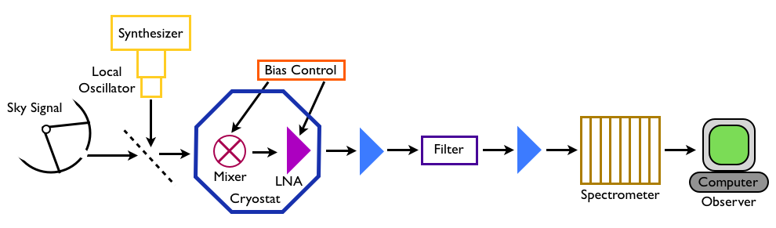

Fig : A block diagram of a heterodyne receiver. The sky signal is mixed with a local oscillator signal generated in the lab. In astronomy, we often use superconducting mixers for their extremely high sensitivity. The intermediate frequency is amplified using a low-noise amplifier (LNA) and then filtered and amplified as needed to match the power desired by the spectrometer

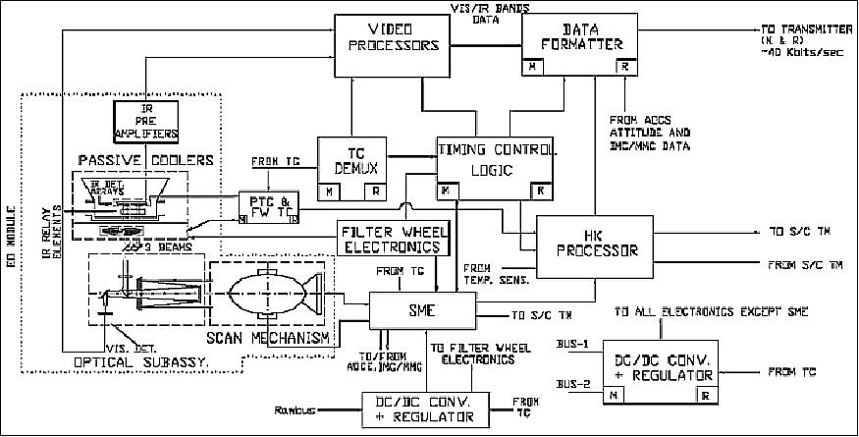

Fig : INSAT 3D

**DESIGN AND ANALYSIS OF RC PHASE SHIFT OSCILLATOR**

Experiment No: …………….

Date: ……. /……. /……………

***Questions:***

1. What are the general oscillation conditions in feedback amplifiers?
2. Drive an expression for the frequency of oscillation in both phase shift and Wein bridge oscillators.
3. Compare between phase shift and Wein Bridge oscillators.
4. What is Oscillator?
5. Discuss the effect of changing RB and RE on fo.
6. Say the Barkhausion Criteria
7. What is the frequency range of RC Oscillators ?
8. Draw the Circuit of Twin T oscillator.
9. List out the Advantages and Disadvantages of RC Oscillators
10. Write down the general applications of oscillators

**Practical Applications of RC phase shift oscillator**

RC phase shift oscillators are used for musical instruments, oscillators, voice synthesis, and GPS units. They work at all audio frequencies.



Fig: Arrangement of Binary Phase Shift Keying (BPSK) Transmitter Using Voice signal interfacing

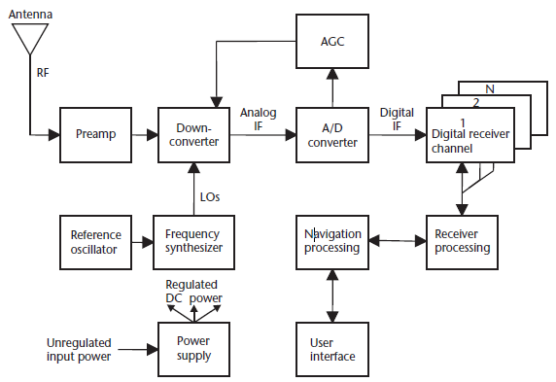

Fig : General digital GPS receiver block diagram.

**DESIGN AND ANALYSIS OF HARTLEY OSCILLATOR *Questions:***

Experiment No: …………….

Date: ……. /……. /……………

1. How does an oscillator differ from an amplifier?
2. What is the approximate value of hfe in a Hartley oscillator using BJT?
3. Mention the expression for frequency of oscillation?
4. Mention the reasons why LC oscillator is preferred over RC oscillator at radio frequency?
5. How the Hartley oscillator satisfy the barkhausen criterion
6. Is Hartley oscillator is better than Colpitts oscillator

**Practical Applications of RC phase shift oscillator**

Sinusoidal oscillators have a wide range of applications including usage in radios, televisions, communication systems, computers, industrial controlled applications, and laboratories. They work as a function or signal generator. Hartley oscillators are mainly used in radio receivers

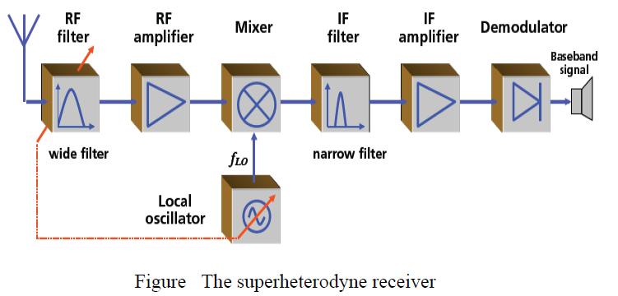



Fig Block diagram of BPSK transmitter