EXPERIMENT 1: Vector and Matrix Operations for Deep Learning

1. Aim
To perform vector and matrix operations used in a neural-network dense layer and visualize the resulting score matrix.

2. Formula(s)
Dot product: a·b = Σ(aᵢbᵢ)
Matrix multiplication: C = AB
Dense layer: y = Wx + b
Cosine similarity: cos(θ) = (a·b)/(‖a‖‖b‖)
Matrix inverse: A⁻¹A = I (only for invertible square A).

3. Overall Flow Diagram
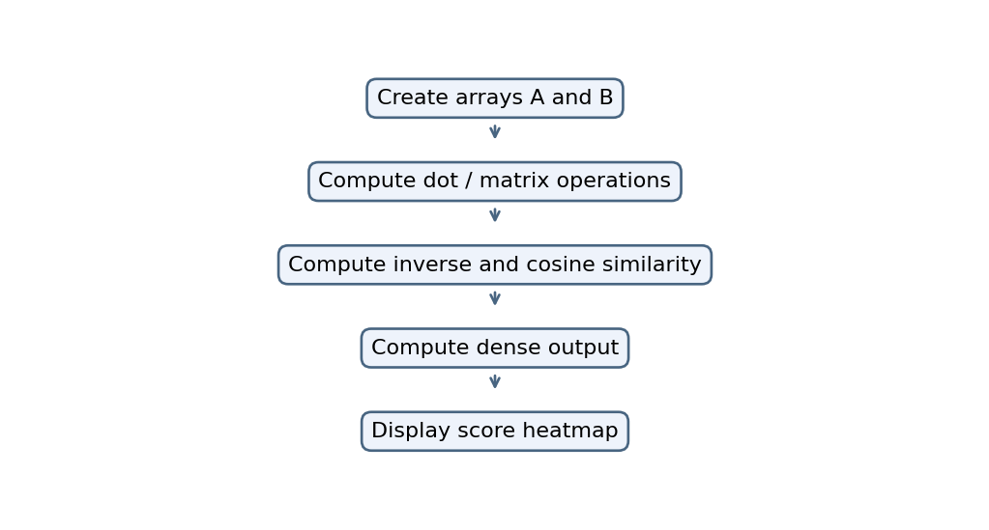

4. Code :
import numpy as np
import matplotlib.pyplot as plt

A = np.array([[1, 2, 3], [4, 5, 6]])
B = np.array([[1, 2], [3, 4], [5, 6]])

print("Dot Product:", np.dot(A[0], A[1]))
print("Matrix Multiplication:\n", A @ B)
print("Transpose:\n", A.T)
print("Element-wise Multiplication:\n", A * A)

C = np.array([[1, 2], [3, 4]])
print("Inverse:\n", np.linalg.inv(C))

# Cosine similarity
X = np.array([[1, 2, 3], [2, 3, 4]])
print("Cosine Similarity:",
np.dot(X[0], X[1]) /
(np.linalg.norm(X[0]) * np.linalg.norm(X[1])))

# Dense layer: y = Wx + b
W = np.array([[1, 2], [3, 4]])
x = np.array([2, 3])
b = np.array([1, 1])
print("Dense Output:", W @ x + b)

plt.imshow(A @ B, cmap="Blues")
plt.colorbar()
plt.title("Score Heatmap")
plt.show()

5. Output
Dot Product: 32
Matrix Multiplication:
[[22 28]
[49 64]]
Transpose:
[[1 4]
[2 5]
[3 6]]
Element-wise Multiplication:
[[ 1 4 9]
[16 25 36]]
Inverse:
[[-2. 1. ]
[ 1.5 -0.5]]
Cosine Similarity: 0.9925833339709303
Dense Output: [ 9 19]

Graph
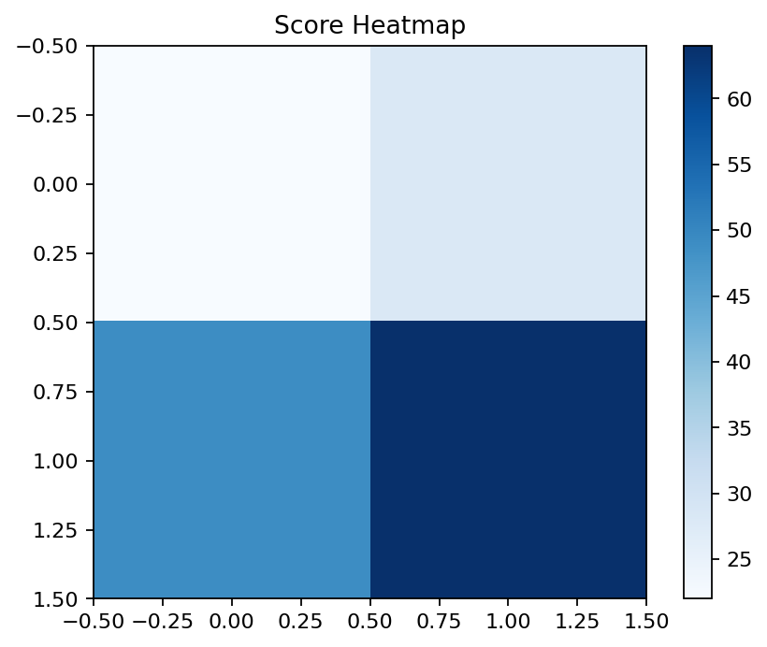

6. Result
Vector and matrix operations, cosine similarity, inverse, dense-layer output and a score heatmap are demonstrated by the supplied code.

