TCS TECHNOLOGY DAY | CSE AIML + CYBER

PermitAI
Project blueprint: datasets, official sources, AWS architecture and a map-first citizen experience
9 September 2026 | Three-hour prototype plan
Core idea
The map establishes where the activity happens. AI understands the citizen and asks for missing facts. A deterministic engine checks reviewed rules. The response explains the result with evidence and the exact rule version.

The problem we are solving
Citizens struggle to determine which municipal permits apply, which requirements they meet and what documents are missing. The supplied problem statement calls for a conversational assistant, structured criteria, synthetic applicant profiles, multiple permit types, a simple UI, rule-integration documentation and a demo video. Its stated assessment-accuracy target is 80%+, alongside user satisfaction. This is a target to measure, not a result already achieved. [P01]

Scope for today
Build in the prototype | Keep outside the three-hour commitment
Karnataka focus; one confirmed local authority; two manageable permit services. | Nationwide validated coverage, every departmental permission, and automatic legal interpretation.
Map selection, source-backed rule checks, missing-information questions, explanation and audit. | Document-authenticity verification, government submission, payment, final approval and autonomous rule publication.
Synthetic applicant/test data; real rule sources only after review. | Real citizen IDs, applicant records, or claims that a synthetic rule is official.

Bengaluru is the preferred demo area only after the correct authority and service sources are confirmed. Hubballi-Dharwad is a possible alternative with published municipal manuals; its rules must never be relabelled as Bengaluru rules. [S03, S04]

How to use this pack
Sections 2-6 define jurisdiction, datasets, sourcing and approval. Sections 7-11 cover the AWS workflow, agent contract, data model and map UI. Sections 12-14 cover implementation, test fixtures and references. The companion Excalidraw file contains five editable frames; diagrams in this document correspond to those frames.

02 Location and authority flow
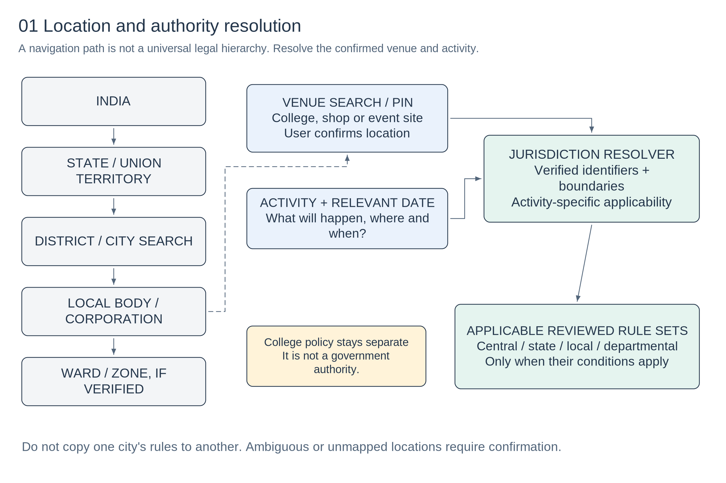
Figure 1. UI navigation and activity-specific authority resolution. The left-hand path is navigation, not a claim that all jurisdictions form one strict tree.

A college is a venue, not an administrative tier
Ask for the college name only to find the site or apply an explicitly supplied institution policy. Confirm the venue pin or address. Keep campus permission rules separate from statutory requirements. A name, postcode or unconfirmed geocoder result is not enough to certify jurisdiction.

Identifiers, geography and legal applicability are different
LGD provides official location identifiers and relationships. Store those identifiers rather than matching only names, and retain boundary versions separately. The selected activity may involve central, state, local or departmental rule sets; apply each only when its reviewed conditions match. [S01]
Use a reviewed location-authority mapping for the pilot. If a point lies near a disputed or low-resolution boundary, or the needed ward data is absent, ask the user to confirm the authority. Unsupported coverage returns a limitation, not an ineligibility decision.

03 What dataset do we need?
This is primarily a rules-and-reference-data product, not a model-training project. Assemble a small verified corpus and a separate synthetic test set. The source register is a collection plan; it is not a downloaded nationwide database.
Dataset / proposed file | Origin and role | Prototype target
locations.json | LGD identifiers, names, aliases and entity relationships. [S01] | National/state selector; verified records for one demo authority.
boundaries/*.geojson | SoI overview boundaries; separately verified municipal/ward geometry. [S02, S04] | Overview plus only the detailed layers actually acquired.
authorities.json | Reviewed mapping from location and service to issuing authority. | One supported authority; unsupported entries remain explicit.
source_register.json | Official URLs, document details, reuse terms, review owner and check date. | A few relevant source documents per selected service.
rules/*.json | Human-reviewed conditions, exceptions, required facts and effective dates. | Two services; roughly 15-25 rules only where justified.
questions.json | Team-authored prompts linked to the required fields in each rule. | Ask only missing, decision-relevant information.
synthetic_profiles.json + expected_results.json | Invented applicant facts and independently checked expected outcomes. | Target 30-50 varied tests; 12 starter fixtures included.
assessments / audit | Created during usage: inputs, rule IDs, outcomes, dates and evidence. | Persist only the minimum needed for the demo.

Collection order
First confirm the two services and issuing authority. Then collect the applicable source documents and their terms. Convert only verified requirements into JSON. Finally add questions, coverage metadata and synthetic cases. Do not begin with a broad crawler or a large vector database.
Data that is not included
The starter bundle contains a source register and clearly marked synthetic rules/tests. It does not contain verified government eligibility rules, official boundary downloads, real applicant records or a measured accuracy report.

Minimum provenance on every production rule
Rule ID; jurisdiction and authority IDs; service; applicability; test; exceptions; source URL plus page/section; document hash; effective-from/to; retrieved-at and reviewed-at; reviewer; version; and publication status. Never fabricate an LGD code or use a null effective date as if it were verified.

04 Official data sources: directories and municipalities
Use the sources below as acquisition starting points. Verify each exact dataset or document before reuse; website access and legal reuse are different questions. Source links were checked on 9 September 2026.

[S01] Local Government Directory (LGD)
https://lgdirectory.gov.in/downloadDirectory.do
Official location identifiers, local bodies, wards and administrative relationships. Use directory downloads; complete any CAPTCHA manually.
Reuse and limits: Published LGD policy permits accurate, attributed reproduction, excluding third-party content. Policy was inspected on an official LGD demo mirror; reconfirm the production policy before bulk collection. Directory identifiers are not permit criteria or a guaranteed parcel-level boundary dataset.
Published policy / guidance

[S02] Survey of India (SoI)
https://surveyofindia.gov.in/pages/administrative-boundary-data-base-abdb-
State, district and subdistrict boundaries; use verified local sources for municipal and ward detail. Acquire the relevant download/product and inspect its metadata and access conditions.
Reuse and limits: Check product-specific terms. Follow SoI standards for India political-boundary depiction; public availability alone is not a blanket reuse licence. Do not use coarse national geometry to claim precise ward or property-level jurisdiction.
Published policy / guidance

[S03] Hubballi-Dharwad City Corporation
https://www.hdmc.mrc.gov.in/en/user_manuals
Manual listings for trade licence, signage and other municipal applications. Read and download relevant manuals, then verify the operative requirements and amendments.
Reuse and limits: The published policy allows accurate, attributed reproduction without specific permission, excluding identified third-party content. The manuals page is dated 19 October 2023. It is a source lead, not proof that every rule is current.
Published policy / guidance

[S04] Bengaluru North City Corporation
https://bengalurunorth.karnataka.gov.in/home
Municipal service links, notifications, and a ward/corporation location facility. Follow official service and notification links; verify the authority for the actual venue.
Reuse and limits: Published site policy permits accurate, attributed reproduction, with third-party exclusions. Separate linked sites and map layers need their own rights check. An interactive boundary viewer is not, by itself, permission to extract its underlying dataset.
Published policy / guidance
Practical choice: import only a small location subset and the source material needed for the pilot. Do not copy a whole state website, bypass CAPTCHAs or follow a public link into private applicant records.

05 Official data sources: laws, changes and discovery

[S05] Open Government Data Platform India
https://www.data.gov.in/
Optional supporting open datasets and statistics, selected at resource level. Permit statistics are not eligibility rules. No nationwide permit-rule dataset is assumed. GODL-covered resources allow reuse with attribution and stated exclusions; verify the resource licence.

[S06] India Code
https://indiacode.gov.in/
Central and state legislation and subordinate material such as rules and notifications. A law must be interpreted with applicability, commencement and amendments; do not treat a search result as a complete rule set. Check source-specific reuse terms before corpus copying or automation.

[S07] Karnataka e-Rajyapatra
https://erajyapatra.karnataka.gov.in/
Karnataka gazette notifications, including departmental publications and changes. Pages may require browser interaction. Publication date and legal effective date can differ. Check source-specific reuse terms before corpus copying or automation.

[S08] Gazette of India
https://egazette.gov.in/
Central gazette publications and notifications. Only include central requirements that are relevant to the selected activity. The portal describes free access and also copyright; do not assume unrestricted republication.

[S09] FSSAI FoSCoS
https://foscos.fssai.gov.in/document-required/SL
Food-business licence document requirements, including category-specific conditions. Food licensing is not the same as a municipal trade licence. Do not invent turnover, attendance or certificate thresholds. Check source-specific reuse terms before corpus copying or automation.

[S10] National Single Window System (NSWS)
https://www.nsws.gov.in/portal/investor-decision
Discovery of potentially relevant central and state business approvals. NSWS explicitly describes this output as indicative guidance, not a final legal determination. Check source-specific reuse terms before corpus copying or automation.

[S11] Karnataka Vyapar trade-licence portal
https://www.mrc.gov.in/TradeLicense/loadCreateApplicationForCitizen
Published application fields and document categories, including district, urban local body and ward. A field or upload option on a form does not prove it is mandatory for every applicant. Check source-specific reuse terms before corpus copying or automation.
Reuse review is source-specific, not legal clearance for the whole product. Attribute the issuing authority and original URL, retain policy links, do not use official logos to imply endorsement, and exclude personal or third-party material outside the stated permission. [S03-S05, S08]

06 From an official document to a live rule
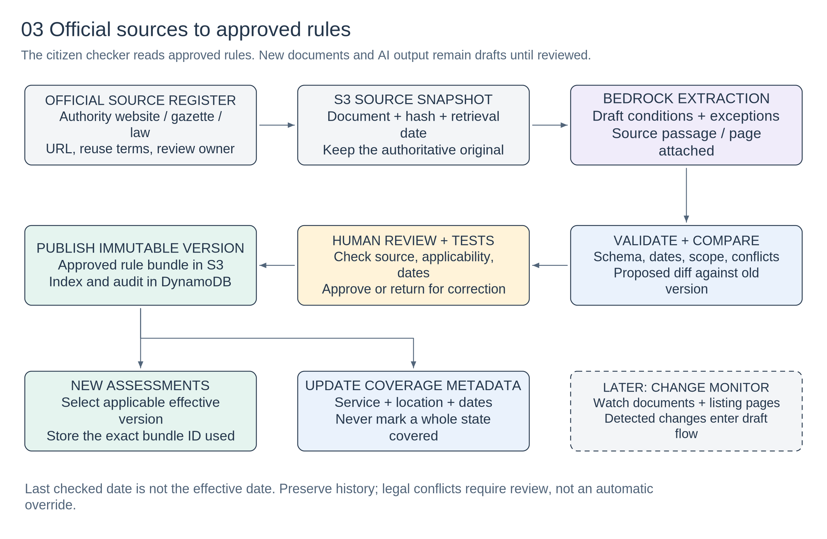
Figure 2. Reviewed publication workflow. The change monitor is a later extension; manual document upload is enough for the hackathon.

Publication gate
Before approval, a reviewer checks the source passage, issuing authority, applicable service, conditions, alternatives, exceptions, units and legal effective dates. The AI only proposes structured data. Schema validation and independent test cases must pass before a version becomes available to the citizen checker.

Rule changes and old assessments
Create a new immutable rule-bundle version; do not overwrite the meaning of past decisions. Record publication, effective, retrieval and review dates separately. Choose the applicable version using the reviewed temporal rule; do not simply select the newest file. Preserve the exact rule and boundary versions used by each assessment.
S3 Versioning can preserve document/object history, but application metadata must still determine legal validity and approval status. Overlapping effective periods, contradictory notifications and uncertain transitions go to review rather than an automatic local-over-state override. [T06]

A safe update demonstration
Use a clearly labelled synthetic amendment: show an old demo rule, the proposed change, human approval and a new assessment using the new version. Historical assessments continue to display the previous version. Do not fabricate a government circular.

07 AWS architecture: citizen runtime
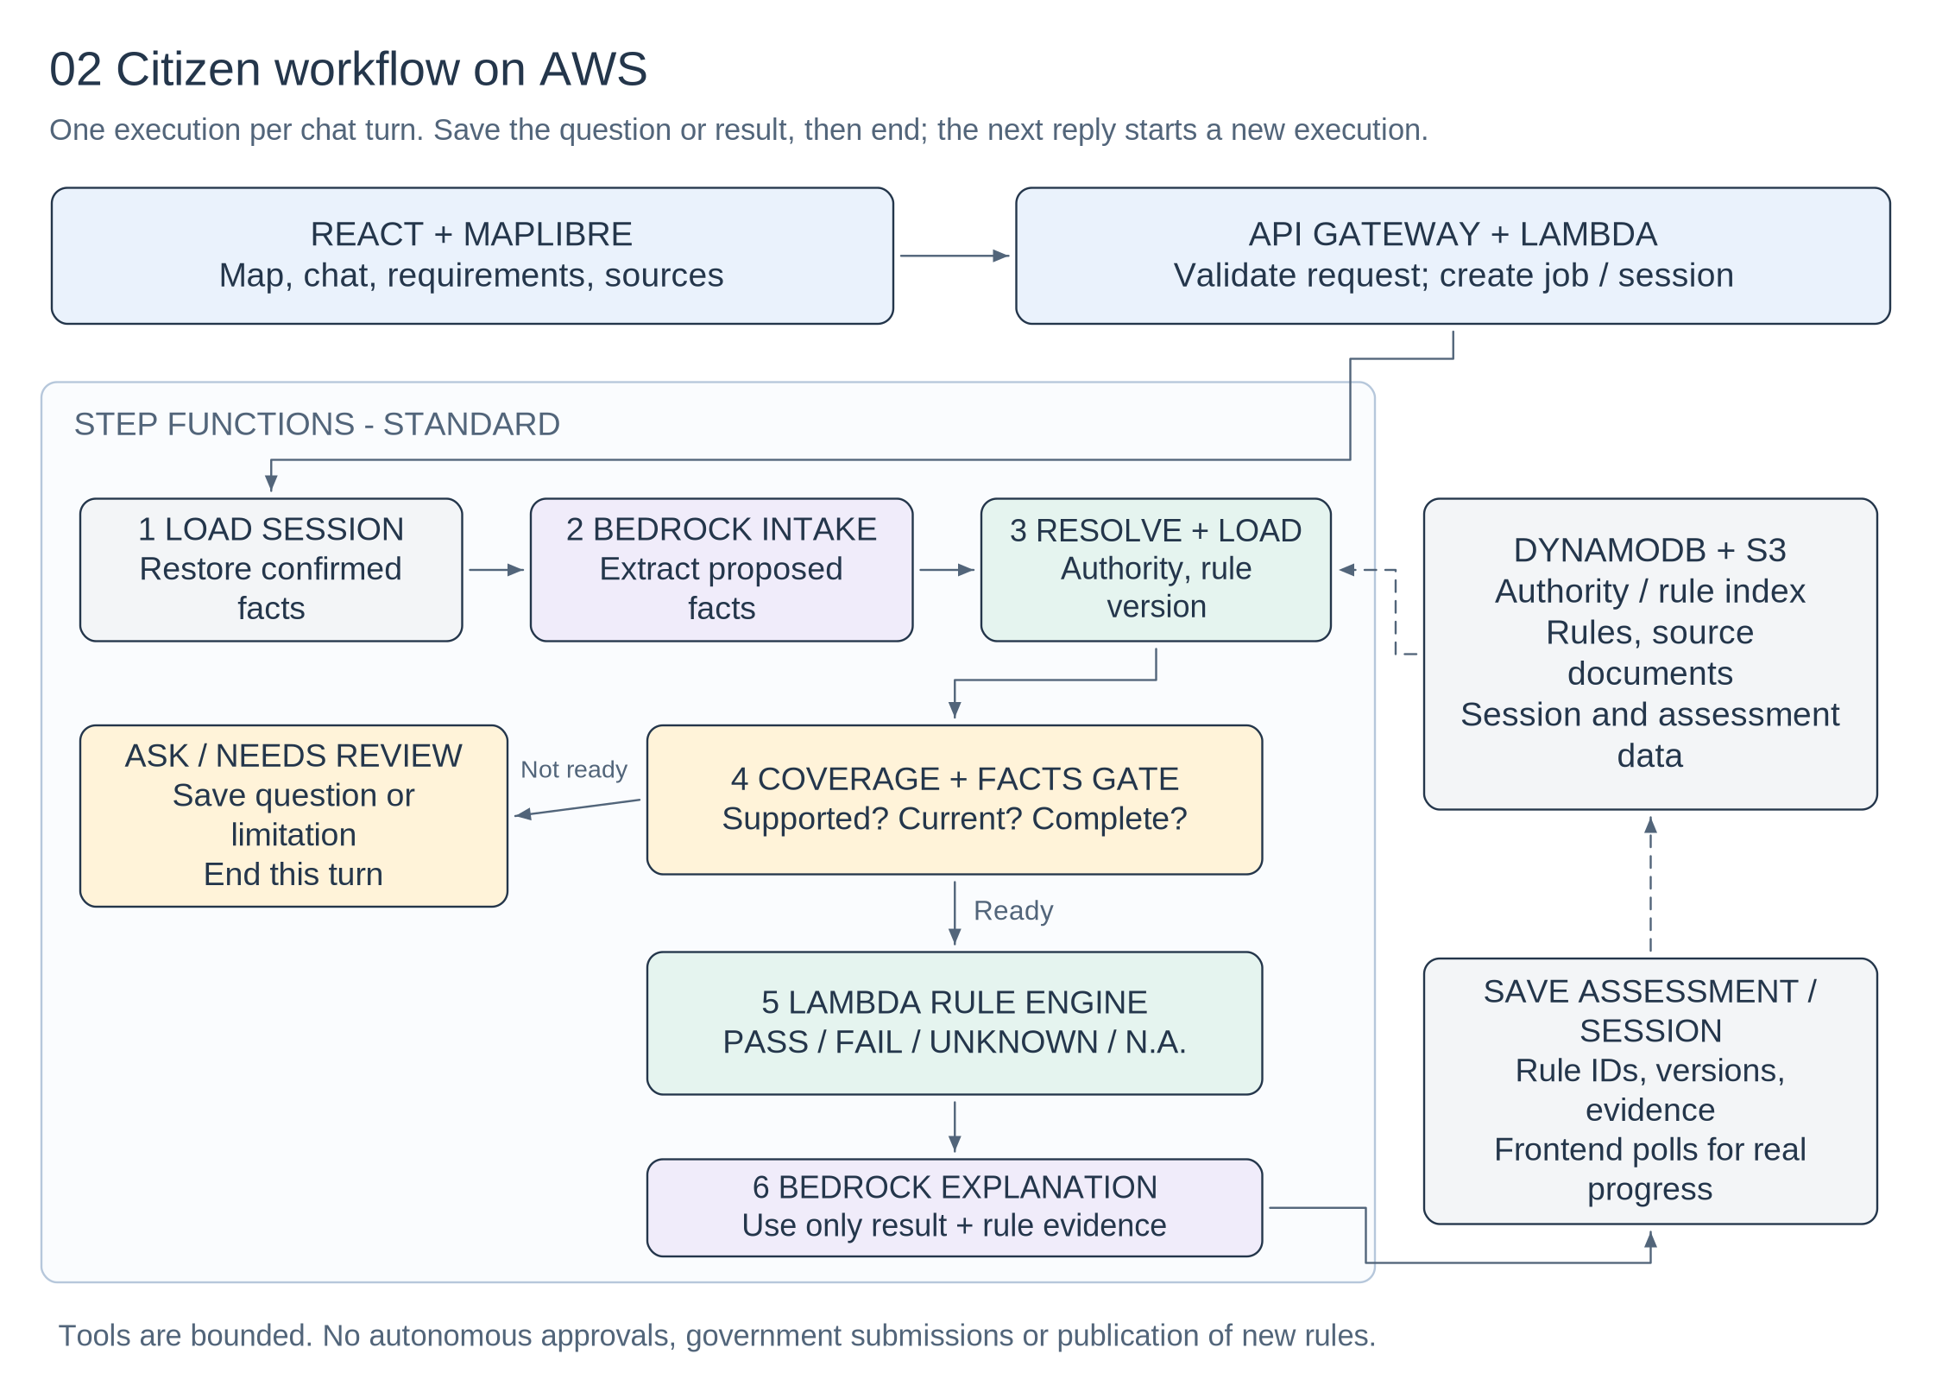
Figure 3. Proposed orchestration. Bedrock handles language and bounded tool use; Lambda owns validation and rule evaluation. [T01, T02]

08 Agent, API and decision contracts

One bounded agent, not a collection of renamed prompts
The citizen-assistance agent can request a supported-service lookup, required-question lookup, deterministic assessment, or evidence retrieval. With Bedrock tool use, application code executes the requested tool and returns its result. The backend enforces prerequisites and the tool allowlist; the model cannot publish rules or approve permits. [T01]
Tool / endpoint | Contract
find_supported_services | Inputs: confirmed location, activity, date. Output: candidate supported services, authority IDs and coverage limitations.
get_required_questions | Inputs: rule bundle and known facts. Output: only unknown or conflicting fields that can change the assessment.
evaluate_rules | Inputs: validated, confirmed profile and approved applicable bundle. Output: per-rule checks, rule IDs, evidence and overall status.
get_rule_evidence | Returns the exact stored source passage and metadata; does not invent citations.
POST /sessions/{id}/messages | Validate session ownership and request_id; start one workflow execution; return job_id immediately.
GET /jobs/{job_id} | Return real stage, question/result or error. Authorize against the session; prevent cross-user reads.

Evaluation semantics
At rule level, use PASS, FAIL, UNKNOWN and NOT_APPLICABLE; use REVIEW for unresolved source or applicability problems. Treat null or unmentioned facts as unknown. Conditional applicability must be evaluated before a requirement; an unknown condition is not automatically false. Use an allowlisted expression interpreter, never eval() on AI-generated code.
Overall result | When to display it
Meets assessed requirements | Complete supported scope; all applicable checks pass.
Requirements not met | One or more known failures; still show any unanswered questions.
More information needed | No established failure, but decision-relevant facts remain unknown.
Needs verification / unsupported | Missing authority coverage, uncertain rule version, source conflict or unreliable jurisdiction.

Keep statutory eligibility and application readiness separate. A missing document may block submission without proving permanent ineligibility. Self-reported possession is not document authentication. Counts of completed checks are not approval probabilities.

09 Logical data model
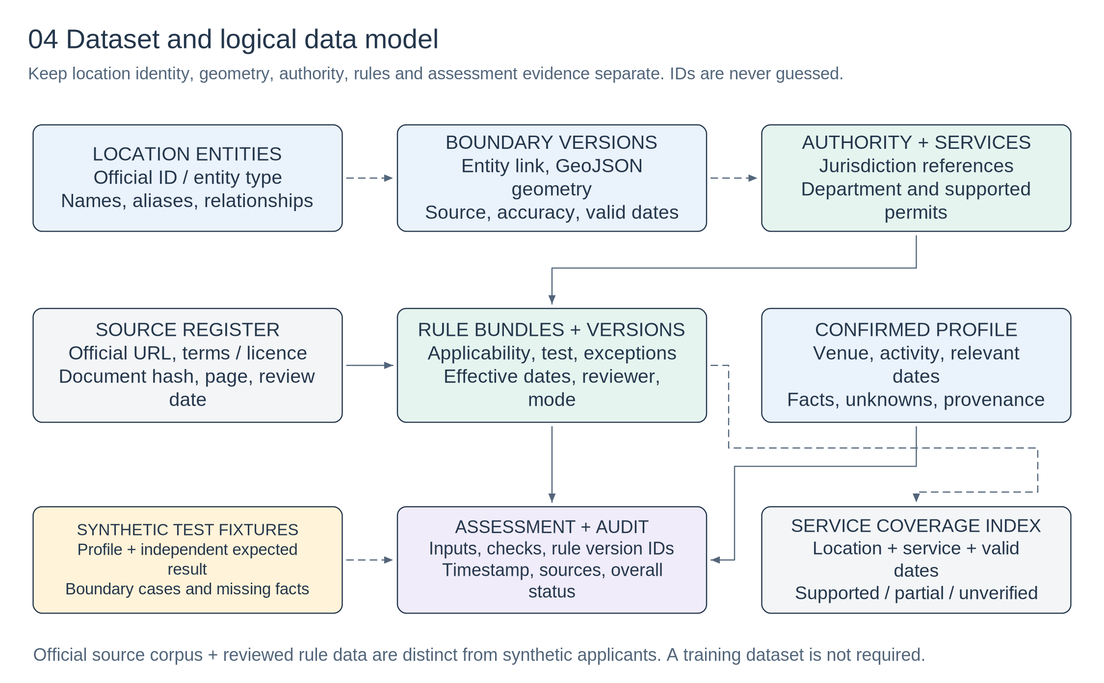
Figure 4. Logical entities, not a prescription for nine databases. Dashed connections show supporting/reference relationships.
Physical pilot design: S3 for source snapshots, boundary files and versioned JSON rule bundles; DynamoDB for indexes, sessions, assessments and review metadata. Keep boundary geometry separate from directory identifiers and keep synthetic mode separate from official-rule mode.

10 Map-first citizen UI
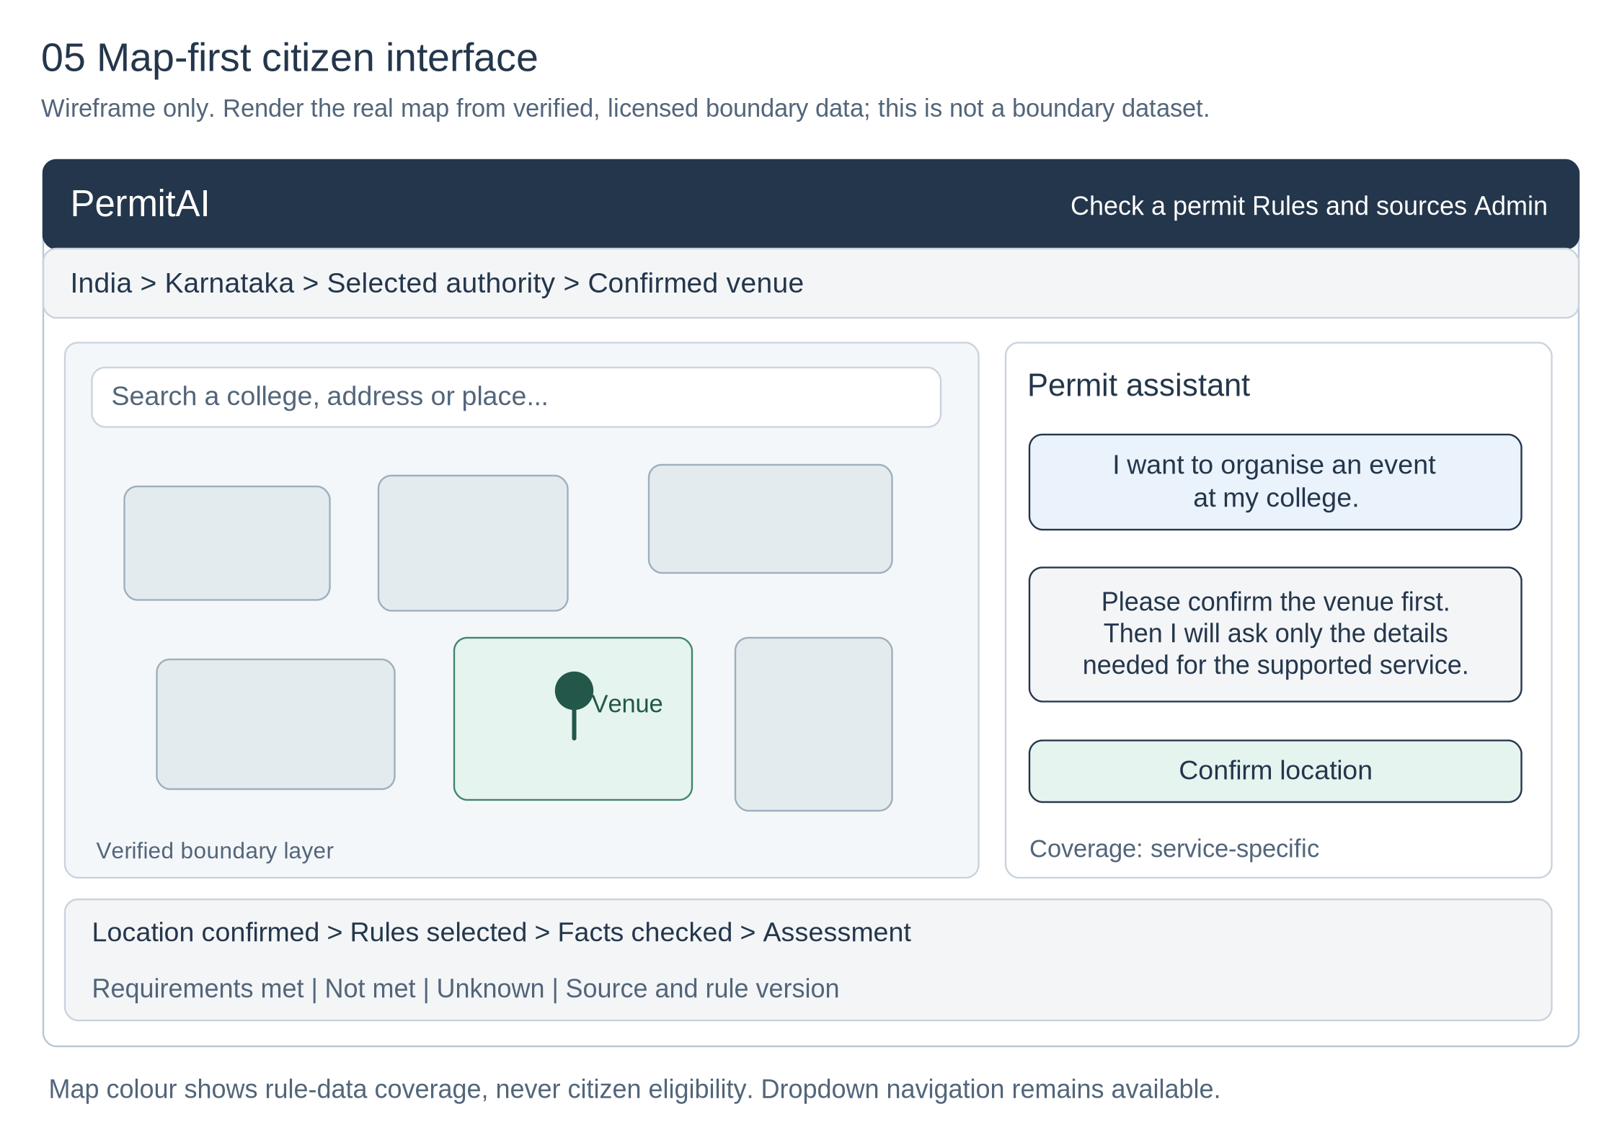
Figure 5. Editable interface wireframe, not an implemented app or an official map. The coloured areas illustrate layer selection only.

11 Map behaviour, data quality and security

A useful map rather than a decorative globe
Use React, a restrained component layout and MapLibre. Start with an India overview, state selection and a prominent place search. MapLibre supports GeoJSON polygon layers; Amazon Location Places can supply candidate college/address locations. The user confirms the venue before assessment. [T03, T05]
Action | Required behaviour
Select state / local authority | Zoom or focus the selected layer. Show coverage for the selected service and date; a state highlight never means all permits are supported.
Search college / place | Show candidates and require confirmation. Keep institution policy distinct from government requirements.
Move the venue pin | Invalidate the old jurisdiction-dependent result, rerun the resolver and ask for confirmation when needed.
Inspect an authority | Show name, official identifier, supported services, boundary source/version and last rule review date.
No ward geometry / uncertain boundary | Use manual authority selection or needs-verification status. Never fabricate a polygon or infer a ward from a similar name.

Boundary and rendering controls
Acquire the official overview boundary files, inspect their licence and coordinate reference system, and convert a copy to web-compatible GeoJSON. Keep full-resolution source geometry for resolution and a simplified display copy for speed. Validate topology, coordinate order and entity joins. Coarse national geometry is unsuitable for exact venue-level decisions. [S01, S02]
Use SoI-standard political boundaries for India. Validate any background map before enabling its boundary labels. A quiet boundary-only national view is a viable fallback. A public municipal viewer may help verify an area, but extraction rights and precise layer metadata still need checking. [S02, S04]

Privacy and operational safety
Use synthetic profiles during the demo. Avoid Aadhaar numbers, personal uploads and real applicant records. Protect the admin publication route with authentication and role checks. Keep AWS account credentials server-side, authorize session reads, validate inputs and escape generated text before rendering.
Restrict any browser map key to the intended actions, resources and domains. Avoid arbitrary URL-fetch tools; allowlist official sources to reduce malicious redirects and server-side request forgery. Treat retrieved documents as untrusted data, not instructions. [T04]
Meaning of map colours
Supported, partial, unverified and boundary-needs-confirmation describe the application's data coverage. They never describe the legal eligibility of every citizen in an area. Always provide a searchable dropdown alternative to the map.

12 Three-hour delivery and validation plan
Treat the following as a time-boxed target, not a promise that cloud setup and source verification will always finish in three hours. Confirm AWS access, model availability and local development tooling first.
Minutes | Deliverable and exit condition
0-15 | Confirm one authority, two services and demo mode. Test one Bedrock request and one Lambda invocation. Freeze the smallest working scope.
15-45 | Review source material or load clearly labelled synthetic fixtures. Implement the deterministic evaluator and independent expected cases.
45-85 | Wire intake, confirmation, required questions and explanations. Persist sessions; make missing/unsupported outcomes work.
85-125 | Build the map-first screen, location confirmation, editable facts and source/result panel. Use manual authority fallback if geometry is unavailable.
125-150 | Connect the Step Functions workflow and real progress polling. Keep the UI local if hosting would risk completion.
150-165 | Demonstrate one reviewed rule change, fix source/version handling and test error paths.
165-180 | Run the evaluation set, rehearse the story, record the short demo and finish documentation.

Evaluation plan tied to the problem statement
Target at least 30-50 synthetic cases spanning both services. Have a person label expected results directly from the reviewed rules, independently of the implementation. Include input paraphrases, unknowns, negatives, threshold equality, conditional documents, wrong jurisdictions, version changes and source conflicts. [P01]
Report the actual correct/total case count and accuracy separately for deterministic evaluation and end-to-end conversational assessment. Report false eligibility, appropriate abstention, coverage and extraction errors as separate measures. Do not hide unsupported cases or count all abstentions as correct. No accuracy has been measured by creating this blueprint.

Four demo moments
1. Confirm a venue and complete an assessment with source links. 2. Leave out a fact and show a targeted follow-up question. 3. Select an unsupported authority and show an honest limitation. 4. Approve a synthetic rule update and show a new assessment while preserving the old version.

What to cut first
Cut nationwide ingestion, vector search, multiple autonomous agents, 3D maps and automated submissions. Keep the rule engine, confirmation step, version/source evidence and working demo. If a cloud feature is mocked, label it; do not animate a pretend successful workflow.

Operational safeguards
Set model/tool-call and token limits, request timeouts, bounded retries and idempotent writes. Handle Bedrock failure with a deterministic checklist/form. An incomplete or failed workflow must never display a successful assessment.

13 Rule example and starter dataset
Synthetic fixture only
The following rule is invented to exercise the evaluator. It is not an official Indian, Karnataka, Bengaluru or municipal requirement. The supplied JSON uses a DEMO authority and no fabricated government identifiers.

{
"rule_id": "DEMO-EVENT-SOUND-01",
"mode": "synthetic_demo",
"authority_id": "DEMO_AUTHORITY_01",
"permit_id": "demo_event",
"kind": "application_readiness",
"applies_when": {
"field": "amplified_sound",
"op": "eq",
"value": true
},
"test": {
"field": "documents.demo_sound_clearance",
"op": "eq",
"value": true
},
"effective_from": "2026-01-01",
"source": {
"type": "synthetic_fixture",
"url": null
},
"version": "demo-v1"
}

Required handling
Input | Rule-level result
amplified_sound = false | NOT_APPLICABLE; do not demand the demo document.
amplified_sound = true; clearance = true | PASS for this rule only.
amplified_sound = true; clearance = false | FAIL: known missing readiness requirement.
amplified_sound or clearance not provided | UNKNOWN as applicable; ask the relevant question.

Files in the companion starter folder
source_register.json contains the collection endpoints and reuse caveats. demo_rules.json contains two synthetic permit fixtures. demo_test_cases.json contains 12 independent expected examples. These fixtures test behaviour; they do not establish legal compliance or production accuracy.
For official-rule mode, require an approved source passage, valid authority identifier, effective-date review and human approval. Do not let the application silently promote a synthetic fixture into the live rule catalogue.

14 Technical references and handoff
Government sources [S01-S11] are linked in sections 4 and 5. The source register also preserves policy URLs and source-specific restrictions. Technical references below support the proposed implementation, not a claim that the prototype is deployed.

[T01] Amazon Bedrock: client-side tool use
https://docs.aws.amazon.com/bedrock/latest/userguide/tool-use-client-side.html
Supports model-requested tools executed by application code. The application controls permissions and validation.

[T02] AWS Step Functions: execution details
https://docs.aws.amazon.com/step-functions/latest/dg/concepts-view-execution-details.html
Documents graph/table views and execution history. Use actual workflow status for the demo.

[T03] Amazon Location: Places APIs
https://docs.aws.amazon.com/location/latest/developerguide/places-choose-api.html
Place search, geocoding and related location APIs; not a substitute for reviewed jurisdiction mappings.

[T04] Amazon Location: API-key restrictions
https://docs.aws.amazon.com/location/latest/developerguide/using-apikeys.html
Restrict keys by permitted actions/resources and client domains; use a short-lived, least-privilege configuration.

[T05] MapLibre GL JS: GeoJSON polygons
https://maplibre.org/maplibre-gl-js/docs/examples/add-a-geojson-polygon/
Supports polygon fill layers for the map. The renderer licence and the geographical dataset licence are separate.

[T06] Amazon S3: object versioning
https://docs.aws.amazon.com/AmazonS3/latest/userguide/Versioning.html
Retains object versions. Legal effective dates and approval status remain application metadata.

[T07] Excalidraw: scene utilities
https://docs.excalidraw.com/docs/@excalidraw/excalidraw/api/utils
Documents JSON scene serialization and import/export utilities for editable diagrams.

[P01] Supplied problem statement
TCS Technology Day - Public Services: Automated Permit Eligibility Checker. Source: the one-page photograph supplied in this conversation. The 80%+ target, synthetic-data guidance, multiple permit types, UI, documentation and demo-video expectations are taken from that sheet.

Editable architecture file
Open PermitAI_Architecture.excalidraw in Excalidraw using its file-open action. It contains five named frames: location resolution; citizen AWS workflow; source-to-rule publication; logical data model; and map-first UI. Shapes, connectors and text are editable, not flattened into a screenshot.
Suggested judge introduction: "We built a location-aware permit assistant. AI collects and explains information, while reviewed, versioned rules drive auditable requirement checks. The map makes jurisdiction and data coverage visible, including where the system cannot yet assess a case."

