SasyaAI

Hyperlocal Intelligent Agricultural Advisory System
"Every Indian farmer deserves a personal agricultural scientist in their pocket — one that knows their land, their history, their constraints, and their aspirations."

1. PROBLEM STATEMENT UNDERSTANDING
India's agricultural sector sustains over 600 million livelihoods, yet smallholder farmers — who operate 86% of all landholdings — continue to make consequential decisions in an information vacuum. AgriStack, Soil Health Card records, IMD weather feeds, and eNAM market data exist as disconnected silos; no system today fuses them into verified, personalised guidance calibrated to an individual farmer's land, season, and financial circumstances.

Challenge | Real-World Impact
Fragmented data silos | AgriStack, SHC records, weather feeds, and scheme portals operate independently, with no unifying intelligence layer
Generic, one-size-fits-all advisory | KCC helplines and bulk SMS advisories disregard individual soil type, water access, and credit standing
Delayed pest and disease detection | Infestations are typically identified 7–10 days after onset, by which time 20–40% of yield is already lost
Low scheme uptake | Fewer than 35% of eligible farmers access PM-KISAN, owing to complex applications and limited awareness
Climate exposure | Erratic monsoons and heat events inflict an estimated ₹1.5 lakh crore in annual crop losses nationwide

SasyaAI addresses this gap by building a Dynamic Digital Twin for every farmer — a continuously refreshed model of their land, crops, finances, and surrounding environment — and orchestrating a multi-agent AI pipeline that converts this twin into verified, explainable, hyper-local recommendations delivered in the farmer's own language.
2. PROJECT REPORT
2.1 Technical Approach & Methodology
SasyaAI is architected as a modular multi-agent system built around a per-farmer Dynamic Digital Twin that unifies AgriStack identity, soil health, crop history, live weather, and financial context. The pipeline operates across four coordinated stages:

- Data Ingestion & Twin Synchronisation: Apache Kafka streams weather (IMD), market prices (eNAM), and satellite imagery (ISRO Bhuvan) into a PostgreSQL/PostGIS digital twin keyed to each farmer's AgriStack ID, refreshed at a maximum 15-minute latency.
- Multi-Agent Orchestration: An LLM-powered Orchestrator decomposes farmer queries and routes them to four specialised sub-agents — Planning (crop optimisation, scheme matching), Vision (pest and disease diagnosis), Geospatial (NDVI analysis, water stress mapping), and Monitoring (constraint verification, alerting) — each deployed as an independent FastAPI microservice.
- Constraint Verification: Every agent output is passed through a hard constraint engine (Google OR-Tools) prior to delivery, validating scheme eligibility, water budgets, and risk thresholds. No recommendation reaches a farmer without clearing this gate, eliminating hallucinated or infeasible advice.
- Explainable Delivery: Structured reasoning graphs translate agent logic into plain-language, causal explanations — for instance, 'because soil phosphorus is low and the sowing window closes in 8 days, apply DAP at 100 kg/ha within 3 days' — rendered in 10+ Indian languages via Whisper ASR and Coqui TTS.

2.2 AI Innovation — Differentiation from Existing Solutions
AI Innovation | Description & Differentiator
Personalised Digital Twin | A per-farmer state model fusing AgriStack identity, five-year crop history, and real-time soil, weather, and market data — a living profile refreshed every 15 minutes, not a static farm record
Constraint-Aware Planning Agent | LLM-guided Google OR-Tools integer programming generates a Pareto-optimal frontier across yield, profit, water budget, and scheme eligibility simultaneously, rather than a static rule-based lookup
NPSS Vision Agent (On-Device) | YOLOv8 fine-tuned on the ~50K-image NPSS dataset with few-shot learning for rare species, quantised for offline mobile inference — a first-of-kind pest classifier tuned to the Indian agro-climatic context
Continuous Verification Loop | The Monitoring Agent validates 100% of AI outputs against hard constraints before delivery, escalating low-confidence cases to human agri-expert KAMs as a critical safety layer
Structured Reasoning Graphs | Each recommendation produces an auditable decision DAG — farmers hear a causal 'why', while policymakers view aggregate reasoning patterns through the policy dashboard
What-If Simulator | Farmers interactively explore scenarios such as switching from rice to millets, with projected yield, income, water savings, and carbon impact computed live from the digital twin
2.3 Resources
Category | Components & Specification
AI / ML | Gemini 1.5 Pro / GPT-4o (Orchestrator LLM); Llama 3.2 GGUF quantised (offline edge); YOLOv8 + EfficientNet-B4 (Vision Agent); LSTM + Temporal Fusion Transformer (yield forecasting); XGBoost / LightGBM (tabular); Whisper + Coqui TTS (multilingual voice); SHAP + reasoning DAG engine (explainability)
Backend | Python 3.11, FastAPI microservices, Celery + Redis (task queue), Apache Kafka (event streaming), Kong API Gateway, Google OR-Tools (constraint planning), Elasticsearch
Databases | PostgreSQL 15 + PostGIS 3.3 (digital twin store); MongoDB Atlas (advisory logs); Redis 7.2 (session cache); pgvector (RAG embeddings); AWS S3 / Azure Blob (satellite data lake)
Frontend | React Native + Expo (offline-first iOS/Android); React.js + Tailwind CSS (web dashboard); Next.js PWA (low-bandwidth fallback); MapLibre GL JS + Deck.gl (GIS maps); Twilio Voice + VXML (IVR)
Infrastructure | Docker 24 + Kubernetes 1.29 (EKS/AKS); GitHub Actions + ArgoCD (CI/CD); Prometheus + Grafana + Loki (observability); HashiCorp Vault (secrets); Terraform + Helm (IaC)
Hardware (Prototype) | Sensor simulator for soil moisture, temperature, and humidity; ESP32-based field probe prototype (three-sensor array) for live IoT demonstration at Stage 3
2.4 Datasets & Derived Features
Integration of MoAFW-provided datasets is central to SasyaAI's advisory engine. All mandatory datasets are consumed via the AgriStack Sandbox and supplemented by open government sources:

Dataset | Source (MoAFW mandatory *) | Derived Features
AgriStack Farmer Registry * | MeitY / AgriStack Sandbox API | Farmer identity, land area, crop linkage, scheme eligibility pre-screen
Soil Health Card Database * | DACFW / eKhedut | Composite Fertility Index, Nutrient Deficiency Flags (N/P/K), Water Holding Capacity
AgriStack Sandbox Geospatial * | Telangana shapefiles, soil moisture series, pincode GeoJSON | Parcel boundaries, NDVI baseline, sub-district microclimatic risk zones
NPSS Pest Image Dataset | DPPQ&S (~50,000 labelled images) | YOLOv8 pest classification, severity grade 0–5, treatment protocol mapping
IMD Weather Data | IMD Open Data Portal / MOSDAC | Growing Degree Days, Drought Stress Index, Frost Risk Score, dry-spell duration
eNAM Market Prices | eNAM API (1,000+ mandis, daily) | Price Volatility Score, Input-Output Price Ratio, mandi-level supply index
ISRO Satellite Imagery | Bhuvan GeoServer / Sentinel-2 | NDVI / NDWI / EVI time-series for bi-weekly canopy health monitoring

2.5 Architecture Diagram
The system is organised into five layers: a Presentation layer (mobile, web, and IVR access), an API Gateway for authentication and rate-limiting, an LLM-powered Orchestrator that routes to four specialised agents, a Data layer for the digital twin store and event streaming, and an External Sources layer connecting AgriStack, IMD, eNAM, and ISRO Bhuvan.

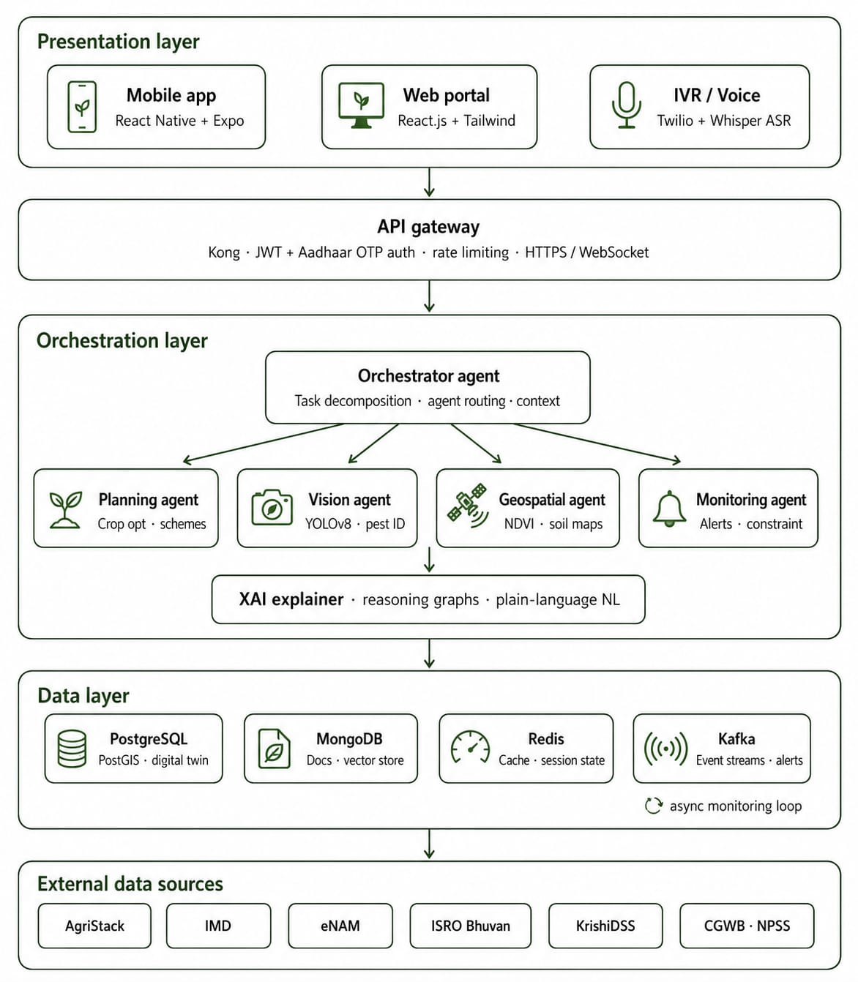
2.6 User Interface — Mockups & Wireframes
The mobile-first interface is designed for low-literacy, rural users around three principles: voice-first interaction (Whisper ASR and TTS in regional languages), explain-by-default recommendations (every output carries a 'Why?' reasoning chain), and offline capability (on-device pest detection and cached advisories that function without connectivity).

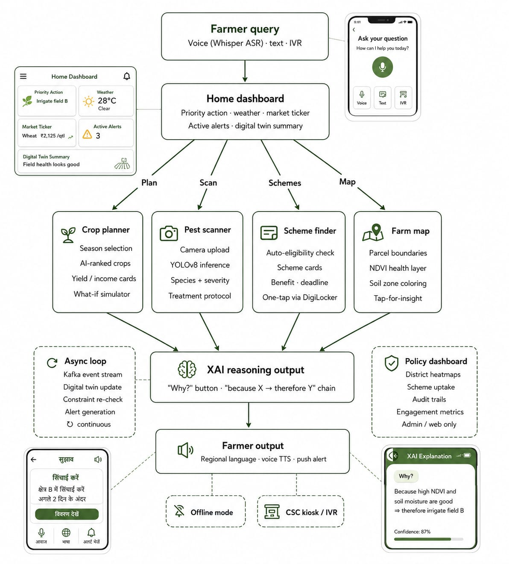
3. IMPACT & SCALABILITY
3.1 Target Beneficiaries
Beneficiary Group | Scale | Primary Benefit
Smallholder farmers (< 2 ha) | ~100M households | Personalised crop plans, timely pest alerts, direct scheme access
Marginal farmers (feature phone only) | ~65M households | IVR voice advisory and scheme eligibility via USSD, no smartphone required
FPO member farmers | ~20M farmers | Collective advisory, coordinated input sourcing, aggregate market intelligence
Agricultural Extension Officers | ~100,000 officers | AI-augmented advisory reach, district-level analytics, decision audit trails
Policymakers (State / Central) | State & Central Depts. | Evidence-based scheme design, real-time crop situation awareness
3.2 Projected Benefits (Year 1 PoC — 50,000 Farmers)
Metric | Target | Basis
Crop yield improvement | +15–20% | Optimised variety selection and precision input timing from the Planning Agent
Input cost reduction | −10–15% | Precision recommendations eliminate over-application of fertiliser and pesticide
Pest damage reduction | −25–30% | Vision Agent enables detection roughly 7 days earlier than unaided observation
Scheme adoption uplift | +30% uptake | Automated eligibility matching and one-tap DigiLocker application reduce friction
Water use efficiency | −20% | Irrigation scheduling from soil moisture and GDD data replaces blanket application
Farmer income gain | +₹8,000–15,000/yr | Combined effect of yield, cost reduction, and scheme access per household
3.3 Scalability
- Crop & geography: Supports all 200+ notified crops across agro-climatic zones; stateless microservices with per-farmer state partitioning enable multi-state rollout, each with a regionally fine-tuned advisory model.
- Infrastructure: Kubernetes HPA and KEDA auto-scale services through peak sowing and harvesting seasons, at an estimated USD 0.05–0.07 per active farmer per month at 50,000+ scale.
- Language: The Whisper ASR and LLM translation layer extends to new regional languages with minimal retraining; current coverage spans Hindi, Tamil, Telugu, Marathi, Bengali, Kannada, Odia, Gujarati, Malayalam, and Punjabi.
- Ecosystem: A B2B API layer enables integration with banks, crop insurers, input companies, and agri-marketplaces, unlocking sustainable revenue beyond the government PoC.

3.4 Key Challenges & Mitigation Strategies
Challenge | Mitigation Strategy
Low smartphone penetration in deep-rural areas | IVR voice interface for feature phones; CSC kiosk mode enables core advisory access without a smartphone
AI hallucination risk on crop advice | 100% output verification via the hard constraint engine; low-confidence outputs are escalated to human agri-expert KAMs
Data quality gaps in AgriStack records | Validation pipelines flag anomalies, with crowdsourced correction via extension officers and fallback to district-level estimates
DPDP Act & data privacy compliance | Privacy-by-design architecture, Aadhaar OTP consent management, and data localisation on Indian cloud infrastructure
4. TEAM
Name & Role | Expertise | Hackathon Responsibility
Mukul Prasad  Team Lead & AI Architect | ML/LLM systems, multi-agent design, 1 yrs agri-tech | Orchestrator design, Planning Agent, system integration
Sunidhi Shree  Computer Vision Engineer | YOLOv8, PyTorch, CNN fine-tuning, image datasets | Vision Agent, NPSS dataset processing, on-device optimisation
Ananaya Mehrotra  Backend & Data Engineer | FastAPI, Apache Kafka, PostgreSQL/PostGIS, GIS systems | Data pipelines, Geospatial Agent, Digital Twin engine
Varshith Reddy  Full-Stack / UX Developer | React Native, React.js, UI/UX for low-literacy users | Mobile app, voice interface, offline-first architecture
Charithra G  Agricultural Domain Expert and Data scientist | Agricultural science, scheme knowledge, KVK field experience | Domain validation, dataset curation, impact assessment

The team combines hands-on expertise across ML/LLM engineering, geospatial systems, agricultural science, and product design for Bharat-scale deployment, with prior exposure to AgriStack APIs, ICAR datasets, and MoAFW advisory frameworks ensuring domain-grounded technical execution.

Compliance Note: All required institutional NOCs have been secured. The team commits fully to the 6-month PoC deployment and maintenance phase following the hackathon, and will adhere to all MoAFW terms, India AI Governance Guidelines, and DPDP Act 2023 requirements. MoAFW datasets will be used exclusively for authorised purposes per the Terms & Conditions.

