LLM Model (google/flan-t5-base)

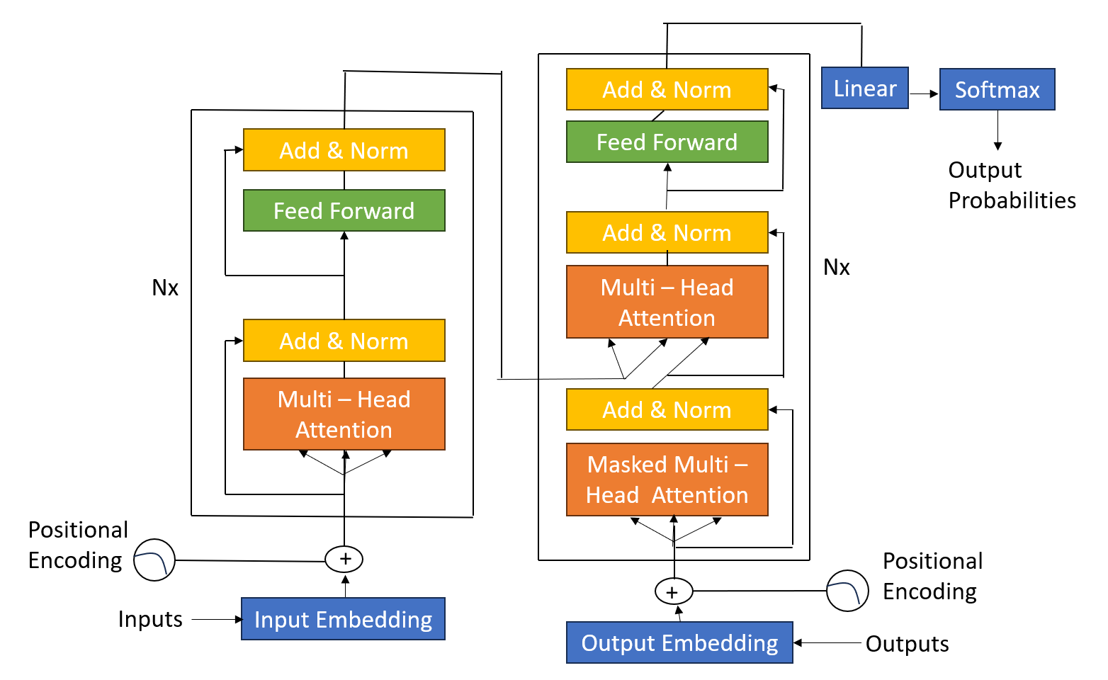

Example task: translate English : German
Input text: "The cat sat"
Target output (example): "Die Katze saß"

Step 0: Given data with Embedding table (d=2)

Token | Embedding (row-vector)
The | ([1,0])
cat | ([0,1])
sat | ([1,1])
<s> | ([0,0])
Die | ([1,-1])
Katze | ([0.5,0.5])

- Input Sequence: [The, cat] matrix X$∈$ R^{2x2} X = $\left|\begin{matrix}1 & 0 \\ 0 & 1\end{matrix}\right|$
- Positional Encoding (given): PE(0) = [0.1,0.1] PE(1) = [0.2,0.2]
- Decoder(so far): [<s>, Die] (generally PE not used.) Y = $\left|\begin{matrix}0 & 0 \\ 1 & -1\end{matrix}\right|$
- As Dimension d=2 Therefore Scaling factor for attention $√2$ = 1.4142

Step 1: Token embedding + Positional encoding(encoder)
Formula: x1_{i} = x_{i} + PE(i)
Add row-wise:
The: [1,0] + [0.1,0.1] = [1.1,0.1]
Cat: [0,1] + [0.2,0.2] = [0.2,1.2]

Encoder input matrix is : x1 = $\left|\begin{matrix}1.1 & 0.1 \\ 0.2 & 1.2\end{matrix}\right|$

Step 2: Encoder: Self-Attention
Formula: Q = x1W_{Q} K= x1W_{K} V= x1W_{V}
Attention (Q,K,V) = softmax (QK^{T} / $√d$) V
We set W_{Q} = W_{K} = W_{V} = I Q = K = V= x1
QK^{T} = x1x1^{T} = $\left|\begin{matrix}1.22 & 0.34 \\ 0.34 & 1.48\end{matrix}\right|$ QK^{T} / $√2$ = $\left|\begin{matrix}0.8626 & 0.2404 \\ 0.2404 & 1.0465\end{matrix}\right|$
Apply Softmax to each row
Softmax(z)_{I} = e^{zi} / ∑e^{zi}
Attention matrix is $\left|\begin{matrix}0.6507 & 0.3492 \\ 0.3087 & 0.6912\end{matrix}\right|$

Multi – Head Attention: H = Ax1 = $\left|\begin{matrix}0.7856 & 0.4814 \\ 0.4778 & 0.8604\end{matrix}\right|$

Step 3: Encoder: Add & Norm (1)
res1 = x1 + H
LayerNorm(u) = u-µ / √α² + £
Where µ = 1/d u and α² = 1/d(u - µ)

res1 = $\left|\begin{matrix}1.8856 & 0.5841 \\ 0.6778 & 2.0604\end{matrix}\right|$

After applying the layer-norm:
Out1 = $\left|\begin{matrix}0.999988 & -0.999988 \\ -0.999989 & 0.999989\end{matrix}\right|$

Step 4: Encoder: Feed-Fordward(FNN) and Add&Norm(2)
FNN(x) = (ReLU(W1x + b1)) + b2, ReLU(x) = max(0,x)
We consider W1=W2 and b1=b2=0, Therefore FNN = ReLU

FNN(1) = $\left|\begin{matrix}0.999988 & 0 \\ 0 & 0.999989\end{matrix}\right|$
Then residual:
Res2 = ou1 + FNN(out1) = $\left|\begin{matrix}1.999976 & -0.999988 \\ -0.999989 & 1.999979\end{matrix}\right|$
Then add LayerNorm:
Encoder output (H)= $\left|\begin{matrix}0.999978 & -0.999978 \\ -0.999978 & 0.999978\end{matrix}\right|$

Step 5: Decoder: Input embedding + (optional PE)
In this example we are not considering the PE.
Y = $\left|\begin{matrix}0 & 0 \\ 1 & -1\end{matrix}\right|$

Step 6: Decoder: Self Attention (casual)
QK^{T} =YY^{T} = $\left|\begin{matrix}0 & 0 \\ 0 & 2\end{matrix}\right|$ Scale YY^{T} / $√d$ = $\left|\begin{matrix}0 & 0 \\ 0 & 1.4142\end{matrix}\right|$
After applying softmax:
A = $\left|\begin{matrix}1 & 0 \\ 0.1955 & 0.8044\end{matrix}\right|$

Masked Multi Head Attention: M = AV = AY
M = $\left|\begin{matrix}0 & 0 \\ 0.8044 & 0.8044\end{matrix}\right|$

Step 7: Decoder : Add&Norm
Res_d1 = Y+M, d_out = LayerNorm(Res_d1)
Res_d1 = $\left|\begin{matrix}0 & 0 \\ 1.8044 & -1.8044\end{matrix}\right|$

LayerNorm row-wise:
d_out1 = $\left|\begin{matrix}0 & 0 \\ 0.9999 & -0.9999\end{matrix}\right|$ No we will use token “Die” as decoder output of Self Attention and Add&Norm.

Step 8: Decoder: Encoder Cross Attention
Cross-Attention uses decoder side Q=d_out1 and encoder side output H. We only need the query vector for current prediction ”Die” call it q , second row of d_out1.
qK^{T} = [q.H(row0), q.H(row1)]
qK^{T} = [1.999956,-1.999956]
Scale by $√d$ : qK^{T}/$√2$ = [1.414208,-1.414208]
Softmax of pair: [0.9817, 0.0183]

Attention output = weighted sum of encoder V rows.
Cross_out = 0.9817(H_{row0}) + 0.0183(H_{row1}) = [0.995,-0.995]

Step 9: Decoder: Add & Norm
Res_d2 = d_out1 + cross_out , d_out2 = LayerNorm(res_d2)
The answer will be near[0.9999,-0.9999]

Step 10: Decoder: FNN + Add & Norm
Apply FNN(ReLU) to d_out2 and add the residual and LayerNorm again,
The answer will be near[0.9999,-0.9999]

Step 11: Decoder: Linear (logit score)
Formula: Logit z = W.H
W = token embeddings and H = result after FNN +Add &Norm.
Therefore Logit vector are: [0/999778,-0.99978,0,0,1.9956]
Step 12: Softmax
After applying the softmax we get the highest probability for the word “Katze” ie 76%, Therefore the next word is selected as “Katze”.

