Project Report

On

# Enhancing Email Security A biologically inspired optimized approach algorithm for spam detection in machine learning

Thesis submitted in partial fulfillment of the requirements for the award of degree of

**Bachelor of Engineering**

In

**Computer Science and Engineering**

By

|  |  |
| --- | --- |
| **Mullapudi Venkata Krishna Sai** | **1608-20-733-307** |
|  |  |
|  |  |

Under the guidance of

**Mrs. P. Uma Maheshwari**

**Assistant Professor**



# Department of Computer Science and Engineering Matrusri Engineering College

**Accredited by NBA & NAAC**

(Affiliated to Osmania University, Approved by AICTE)

Saidabad, Hyderabad-500059

2023-2024

# Department of Computer Science and Engineering Matrusri Engineering College

**Accredited by NBA & NAAC**

(Affiliated to Osmania University, Approved by AICTE)

Saidabad, Hyderabad-500059

2023-2024



## CERTIFICATE

This is to Certify that a Project report entitled **“Enhancing Email Security A biologically inspired optimized approach algorithm for spam detection in machine learning**” is being submitted by Mullapudi Venkata Krishna Sai **(**1608-20-733-307**)** in partial fulfillment of the requirement of the award for the degree of Bachelor of Engineering in “Computer Science and Engineering” O.U., Hyderabad during the year 2023-2024 is a record of bonafide work carried out by him/her under my guidance. The results presented in this thesis have been verified and are found to be satisfactory.

|  |  |
| --- | --- |
| **Project Guide** | **H.O.D.** |
| **Mrs. P. Uma Maheshwari** | **Dr. P. Vijayapal Reddy** |
| **Assistant Professor,** | **Professor & Head,** |
| **Dept of C.S.E.** | **Dept. of CSE** |

**External Examiner(s)**

# Department of Computer Science and Engineering Matrusri Engineering College

**Accredited by NBA & NAAC**

(Affiliated to Osmania University, Approved by AICTE)

Saidabad, Hyderabad-500059

(2022-2023)



**DECLARATION**

I, Mullapudi Venkata Krishna Sai **(**1608-20-733-307**)** hereby certify that the project report entitled “**Enhancing Email Security A biologically inspired optimized approach algorithm for spam detection in machine learning**” is submitted in the partial fulfillment of the requirement for the award of the degree of Bachelor of Engineering in Computer Science and Engineering.

This is a record of the bonafide work carried out by us under the guidance of Mrs. P. Uma Maheshwari, Associative Professor, Matrusri Engineering College, Saidabad, Hyderabad. The Results embodied in this report have not been reproduced/copied from any source. The results embodied in this report have not been submitted to any other University or Institute for the award of any other degree or diploma.

**Mullapudi Venkata Krishna Sai (1608-20-733-307)**

**Dept. of CSE, MECS**

## ACKNOWLEDGEMENT

This project consumed huge amount of work, research and dedication. Still implementation would not have been possible if we did not have support of my Project Guide, Project Coordinator, Head of the Department and Principal. Therefore, I like to extend our sincere gratitude to all of them.

I am grateful to our project guide **Mrs. P. Uma Maheshwari**, Assistant Professor, for provision of expertise, technical support and guidance in the implementation.

I wish to express my gratitude to project coordinators for their indefatigable inspiration, constructive criticisms and encouragement throughout this dissertation work.

I would like to express my sincere thanks to the Professor and Head of the Department,

**Dr. P. Vijaya Pal Reddy**, for permitting us to do this project.

I would like to express our gratitude to **Dr. D. Hanumantha Rao**, principal of Matrusri Engineering College who permitted to carry out this project as per the academics.

I would like to thank CSE Department for providing me this opportunity to share and contribute our part of work to accomplish the project in time and all the teaching and support staff for their steadfast support and encouragement.

Nevertheless, I express my gratitude towards my families and colleagues for their kind cooperation and encouragement which helped me in completion of this project.

**Mullapudi Venkata Krishna Sai (1608-20-733-307)**

## ABSTRACT

This project aims to enhance email spam detection through the integration of Genetic Algorithm (GA) and Harris Hawk Optimization (HHO) algorithm. The proposed approach leverages GA's evolutionary principles to optimize feature selection and model parameters, enhancing the efficiency of spam classification. Additionally, HHO, inspired by the hunting behavior of Harris's Hawks, contributes to further optimization of the algorithm. The combination of these evolutionary techniques aims to improve accuracy and reduce false positives in email spam detection, offering a robust solution to combat evolving spam tactics.

The synergy between these two evolutionary algorithms enhances the overall robustness and adaptability of the spam detection system, providing a novel approach to address the evolving nature of email spam. The project's methodology, experimental results, and comparative analysis contribute to advancing the field of email security and cyber threat detection. The study also presents a testing process and test cases for evaluating the performance of the system. The testing process includes functional testing, performance testing, and usability testing, and aims to ensure that the system is accurate, efficient, scalable, robust, and user friendly.

Overall, the results of the study demonstrate the effectiveness of using bio-inspired algorithms for spam mail detection, and highlight the importance of testing in ensuring the performance and usability of the system.

**TABLE OF CONTENTS**

## ACKNOWLEDGMENT…………………………………iv ABSTARCT………………………………………………v

## LIST OF FIGURES………………………………………viii

## LIST OF TABLES……………………………………….ix

## 1. INTRODUCTION………………………………………1-3

### 1.1 EXISTING SYSTEMS…………………………..1

**1.1.1 Problems of Existing Systems…………………..2**

**1.2 PROPOSED SYSTEM…………………………..3**

## 2. LITERATURE SURVEY………………………………4-8

## 3. ANALYSIS………………………………………..……9-13

**3.1 GENETIC ALGORITHM………………………9**

**3.2 HARRIS HAWK ALGORITHM………………10**

**3.3 NAÏVE BAYES THEOREM…………………...11**

**3.4 PROCESS LOGIC……………………………...12**

## 4. DESIGN………………………………………………..14-18

**4.1 USECASE DIAGRAM…………………………15**

**4.2 CLASS DIAGRAM…………………………….16**

**4.3 ACTIVITY DIAGRAM………………………..16**

**4.4 SEQUENCE DIAGRAM………………………17**

**4.5 COMPONENT DIAGRAM……………………17**

**4.6 ARCHITECTURE DIAGRAM………………..18**

## 5. IMPLEMENTATION………………………………….5-25

### 5.1 FRONTEND……………………………………19

### 5.2 BACKEND……………………………………..19

**5.2.1 HARRIS HAWK ALGORITHM……19**

**5.2.2 MULTINOMIAL NAIVE BAYES…..22**

**5.2.3 GENETIC ALGORITHM…………...23**

**5.3 DATABASE……………………………………25**

## 6. TESTING………………………………………………26-28

### 6.1 TESTING FRONTEND AND BACKEND….26

**6.1.1 UNIT TESTING………………………26**

**6.1.2 INTEGRATION TESTING…………27**

**6.1.3 SYSTEM TESTING………………..27**

**6.1.4 VALIDATION TESTING…………27**

**6.2 TEST CASES……………………………….27**

**6.3 OBJECTIVES OF TESTING……………...28**

## 7. RESULT SCREENS…………………………………29-32

**7.1 LOGIN PAGE………………………………29**

**7.2 ABSTRACT PAGE…………………………29**

**7.3 PERFORMANCE ANALYSIS……………..30**

**7.4 PREDICTION PAGE……………………….30**

**7.5 EMAILS UPLOAD PAGE………………….31**

**7.6 SPAM MAIL PREDICTION PAGE………31**

**7.7 NON-SPAM MAIL PREDICTION PAGE..32**

## 8. CONCLUSION & FUTURE SCOPE……………...33-35

**8.1 CONCLUSION……………………………..33**

**8.2 FUTURE SCOPE…………………………..34**

**9. REFERENCES……………………………………..36**

## LIST OF FIGURES

|  |  |  |  |
| --- | --- | --- | --- |
| **S.No** | **Figure No** | **Name of the Figure** | **Page No** |
| 1 | 4.1 | Use case Diagram | 15 |
| 2 | 4.2 | Class Diagram | 16 |
| 3 | 4.3 | Activity Diagram | 16 |
| 4 | 4.4 | Sequence Diagram | 17 |
| 5 | 4.5 | Deployment Diagram | 17 |
| 6 | 4.6 | Architecture Diagram | 18 |
| 7 | 6.1 | Levels of Testing | 26 |
| 8 | 7.1 | Login Page | 29 |
| 9 | 7.2 | Abstract Page | 29 |
| 10 | 7.3 | Performance Analysis | 30 |
| 11 | 7.4 | Prediction Page | 30 |
| 12 | 7.5 | Emails Upload Page | 31 |
| 13 | 7.6 | Spam Mail Prediction Page | 31 |
| 14 | 7.7 | Non-Spam Mail Prediction Page | 32 |

**LIST OF TABLES**

|  |  |  |  |
| --- | --- | --- | --- |
| **S.No** | **Table No.** | **Name of the Table** | **Page No** |
| 1 | 6.2 | Test Cases | 27 |

## 1. INTRODUCTION

Spam mail, also known as junk mail or unsolicited email, is a pervasive problem that affects email users around the world. According to a report by Statista , spam emails accounted for approximately 53.5% of global email traffic in 2020. The high volume of spam mail not only wastes users' time and resources, but also poses security risks, as many spam emails contain malware or phishing scams.

Bio-inspired algorithms are computational methods that are inspired by natural processes, such as genetic evolution or neural networks in the brain. These algorithms are often used in machine learning and optimization problems, and have been shown to be effective in solving complex problems that are difficult to solve using traditional techniques.

In the context of spam mail detection, bio-inspired algorithms can be used to optimize the feature selection process, which involves selecting a subset of features or attributes that are most relevant for identifying spam emails. By using a genetic algorithm to optimize the feature selection process, the system can automatically identify the most important features, without the need for manual intervention or expert knowledge. Once the features has selected, Harris Hawk Optimization (HHO) algorithm provides ability to outperformed established algorithms in terms of accuracy, efficiency and adaptibility to evolving spam patterns. The use of bio-inspired algorithms for spam mail detection has several advantages are they can handle large and complex datasets and they can achieve a high level of accuracy in categorizing emails, while minimizing the number of false positives and false negatives.

Spam mail is a major problem that affects email users worldwide, leading to wasted time and resources, and potentially exposing users to security risks. Traditional spam detection techniques rely on rule-based systems, which can be easily bypassed by spammers using new techniques. In recent years, bio-inspired algorithms, such as genetic algorithms and artificial neural networks, have been used to improve the accuracy and efficiency of spam mail detection.

### 1.1 EXISTING SYSTEMS

Several existing systems and approaches exist for spam mail detection, each utilizing various techniques and technologies. Here are some of the prominent ones:

1. **Rule-Based Filters:** These systems use predefined rules and patterns to identify spam emails. Rules may include keywords commonly found in spam emails, suspicious sender addresses, or specific formatting patterns. While simple and efficient, rule-based filters may struggle to adapt to evolving spamming techniques.
2. **Bayesian Filters:** Bayesian spam filters use probabilistic algorithms, such as the Naive Bayes classifier, to classify emails as spam or non-spam. These filters calculate the probability that an email belongs to each class based on the presence of certain words or features. Bayesian filters are effective and can adapt to new spam patterns over time.
3. **Machine Learning Models:** Machine learning-based spam detection systems utilize various algorithms and techniques to learn patterns and characteristics of spam emails from labeled training data. Popular machine learning algorithms include Support Vector Machines (SVM), Random Forests, and Neural Networks. These models can achieve high accuracy and can adapt to new spamming techniques with proper training and updates.
4. **Heuristic Analysis:** Heuristic analysis involves analyzing the content and structure of emails for suspicious or malicious characteristics. Heuristics may include examining email headers, checking for phishing links or attachments, and detecting obfuscated content. Heuristic analysis is effective but may generate false positives if overly aggressive.
5. **Collaborative Filtering:** Collaborative filtering systems leverage feedback from users to identify spam emails. Users mark emails as spam or non-spam, and the system aggregates this feedback to improve classification accuracy over time. Collaborative filtering systems rely on a large user base to provide meaningful feedback.
6. **Hybrid Approaches:** Many modern spam detection systems employ hybrid approaches that combine multiple techniques and technologies to achieve better performance. For example, a system might combine rule-based filtering with machine learning models or heuristic analysis with collaborative filtering to improve accuracy and reduce false positives.
7. **Cloud-Based Solutions:** Cloud-based spam detection services offer scalable and efficient solutions for organizations to filter spam emails. These services typically leverage large datasets, advanced machine learning models, and real-time threat intelligence to identify and block spam emails before they reach users' inboxes.

#### 1.1.2 PROBLEMS WITH THE EXISTING SYSTEM

Many tools and techniques are offered by companies in order to detect spam emails in a network. Organizations have set up filtering mechanisms to detect unsolicited emails by setting up rules and configuring the firewall settings. There are different areas for deploying the spam filters such as on the gateway (router), on the cloud hosted applications or on the user’s computer. In order to overcome the detection problem of spam emails, methods such as content-based filtering, rule-based filtering or Bayesian filtering have been applied.

Unlike the ‘knowledge engineering’ where spam detection rules are set up and are in constant need of manual updating thus consuming time and resources, Machine learning makes it easier because it learns to recognize the unsolicited emails (spam) and legitimate emails (ham) automatically and then applies those learned instructions to unknown incoming emails.

* need of manual updating
* consuming time and resources.

### 1.2 PROPOSED SYSTEM

The proposed spam detection to resolve the issue of the spam classification problem can be further experimented by feature selection or automated parameter selection for the models.

This research conducts experiments involving machine learning model with Genetic Algorithm (GA) and Harris Hawk Algorithm(HHO).

This research will experiment Bio-inspired algorithms along with Machine learning models. This will be conducted on different spam email corpora that are publicly available.

Here we aim to achieve the following objectives:

1. To explore machine learning algorithms for the spam detection problem.

1. To investigate the workings of the algorithms with the acquired datasets.

1. To implement the bio-inspired algorithms.

1. To test and compare the accuracy of base models with bio-inspired implementation.

## 2. LITERATURE SURVEY

**Simran Gibson, Biju Issac et al.** stated that electronic mail has eased communication methods for many organisations as well as individuals. This method is exploited for fraudulent gain by spammers through sending unsolicited emails. This article aims to present a method for detection of spam emails with machine learning algorithms that are optimized with bioinspired methods. A literature review is carried to explore the efficient methods applied on different datasets to achieve good results. An extensive research was done to implement machine learning models using Naïve Bayes, Support Vector Machine, Random Forest, Decision Tree and Multi-Layer Perceptron on seven different email datasets, along with feature extraction and pre-processing. The bio-inspired algorithms like Particle Swarm Optimization and Genetic Algorithm were implemented to optimize the performance of classifiers. Multinomial Naïve Bayes with Genetic Algorithm performed the best overall. The comparison of our results with other machine learning and bio-inspired models to show the best suitable model is also discussed.

**A. I. Taloba and S. S. I. Ismail** stated that the upsurge in the volume of unwanted emails called spam has created an intense requirement for the development of more dependable and robust anti-spam channels. Machine learning methods of ongoing are being used to successfully distinguish and channel spam emails. The present a systematic audit of some of the popular machine learning based email spam filtering approaches. The audit covers review of the important concepts, attempts, effectiveness, and the research pattern in spam filtering. The preliminary discussion in the investigation background examines the applications of machine learning methods to the email spam filtering cycle of the leading internet specialist organizations (ISPs) like Gmail, Yahoo and Outlook emails spam channels. Discussion on general email spam filtering measure, and the various efforts by different researchers in combating spam through the use machine learning procedures was done. Our survey compares the qualities and drawbacks of existing machine learning approaches and the open research problems in spam filtering. We recommended profound leaning and profound adversarial learning as the future methods that can adequately handle the menace of spam emails.

**J. K. Agarwal and T. Kumar et al.** stated that communication through email has become one of the cheapest and easy ways for the official and business users because of easy availability of internet access. Most individuals like to use email to share important information and to maintain their official records. Be that as it may, just like the two sides of coin, many individuals misuse this easy way of communication by sending unwanted and useless mass emails to others. These unwanted emails are spam emails that affect the normal user to face the problems like exorbitant usage of their mailbox memory and filtration of useful email from unwanted useless emails. Thus, there is the need of some autonomous approach that channels the extreme data of emails in the form of spam emails. In this paper, an integrated approach of machine learning based Naive Bayes (NB) algorithm and computational intelligence based Particle Swarm Optimization (PSO) is used for the email spam detection. Here, Naive Bayes algorithm is used for the learning and classification of email content as spam and non-spam. PSO has the stochastic distribution and swarm behavior property and considered for the global optimization of the parameters of NB approach. For experimentation, dataset of Ling spam dataset is considered and evaluated the performance in terms of precision, recall, f-measure and accuracy. Based on the evaluated results, PSO outperforms in comparison with individual NB approach.

**W. Feng, J. Sun, L. Zhang et al.** proposed that Electronic mail has eased communication methods for many organizations as well as individuals. This method is exploited for fraudulent gain by spammers through sending unsolicited emails. This article aims to introduce a method for detection of spam emails with machine learning algorithms that are optimized with bio- inspired methods. A literature survey is carried to investigate the proficient methods applied on different datasets to achieve great results. A broad research was done to implement machine learning models using Naïve Bayes, Support Vector Machine, Random Forest, Decision Tree and Multi-Layer Perceptron on seven different email datasets, along with feature extraction and pre-processing. The bio-inspired algorithms like Particle Swarm Optimization and Genetic Algorithm were implemented to optimize the performance of classifiers. Multinomial Naïve Bayes with Genetic Algorithm performed the best overall. The comparison of our results with other machine learning and bio-inspired models to show the best suitable model is also discussed.

**A.Wijaya and A. Bisri** proposed that the Email spam is an increasing problem because it disrupting and time consuming for user, since the easy and cheap of sending email. Email Spam filtering can be done with a binary classification with machine learning as classifier.

To date, email spam detection actually challenging since the email spam actually happens a great deal and the detection actually need improvement. Decision Tree (DT) is one of famous classifier since DT able to handle nominal and numerical attributes and increasing the effectiveness of computing. However, DT has a weakness in over-sensitivity to the training set and the noise data or instance that can degrade the performance. In this investigation, they propose half breed combination Logistic Regression (LR) and DT for email spam detection. LR is used for decrease noisy data or instance before data feed to DT induction. Noisy data reducing is done by LR by filtering right prediction with certain false negative edge. In this investigation, Spam base dataset is used to evaluate the proposed method. From the experiment, the outcome shows that proposed method yield impressive and promising outcome with the accuracy is 91.67%. It can be concluded that LR able to improve DT performance by reducing noisy data.

**Abduelbaset M. Goweder, Tarik Rashed et al.** Stated that email is broadly becoming one of the fastest and most economical forms of communication .Thus, the email is prone to be misused. One such misuse is the posting of unsolicited, unwanted messages known as spam or garbage messages. This paper presents and discusses an implementation of an Anti-spam filtering system, which uses a Multi-Layer Perceptron (MLP) as a classifier and a Genetic Algorithm (GA) as a training algorithm. Standard hereditary operators and advanced strategies of GA algorithm are used to train the MLP. The implemented filtering system has achieved an accuracy of about 94% to recognize spam messages, and 89% to identify legitimate messages.

**R. Kishore Kumar et al** proposed the survey of email spam filter over data mining techniques. In their work, ―Comparative Study on Email Spam Classifier using Data Mining Techniques‖ is proposed. TANAGRA data mining tool is used to analyze the spam data .It explore the efficient classifier for email spam classification. Firstly, feature creation and feature selection is done to draw out the relevant features. Then numerous grouping algorithms are applied on this dataset and cross validation is done for each of these classifiers. In conclusion, best classifier for email spam is acknowledged on the basis of error rate, precision and recall.

**Nosseir, Khaled Nagati and Islam Taj-Eddin** performed a work,‖ Intelligent Word-

Based Spam Filter Detection Using Multi-Neural Networks‖. They proposed a character- based technique. A multi-neural networks classifier is used by this approach. A normalized weight values derived from the ASCII value of the word characters are used to train the neural network. Results obtained from experiment show high false positive and low true negative percentages.

**Asmeeta Mali** performed a work, ―Spam Detection using Bayesian with Pattern

Discovery‖. In her paper she proposed an operative procedure to recover the efficiency of using and apprising revealed patterns for conclusion appropriate information using Bayesian filtering algorithm and effective pattern. Discovery technique we can detect the spam mails from the email dataset with good correctness of term.

**Wijaya and Bisri** proposes a hybrid-based algorithm, which is integrating Decision Tree with Logistic Regression along with False Negative threshold. They were successful in increasing the performance of DT. The results were compared with the prior research. The experiment was conducted on the Spam Base dataset. The proposed method presented a 91.67% accuracy.

**E. G. Dada, J. S. Bassi, H. Chiroma, S. M. Abdulhamid, A. O. Adetunmbi, and O.**

**E. Ajibuwa:** The upsurge in the volume of unwanted emails called spam has created an intense need for the development of more dependable and robust antispam filters. Machine learning methods of recent are being used to successfully detect and filter spam emails. We present a systematic review of some of the popular machine learning based email spam filtering approaches. Our review covers survey of the important concepts, attempts, efficiency, and the research trend in spam filtering. The preliminary discussion in the study background examines the applications of machine learning techniques to the email spam filtering process of the leading internet service providers (ISPs) like Gmail, Yahoo and Outlook emails spam filters. Discussion on general email spam filtering process, and the various efforts by different researchers in combating spam through the use machine learning techniques was done. Our review compares the strengths and drawbacks of existing machine learning approaches and the open research problems in spam filtering. We recommended deep leaning and deep adversarial learning as the future techniques that can effectively handle the menace of spam emails.

**Karthika and Visalakshi** reviews the ML algorithm – SVM along with the optimization technique – Ant Colony Optimization (ACO). The proposed algorithm was performed on the Spam Base dataset with supervised learning method. The paper briefly defines the existing work based on pheromone updating and fitness function. The paper provides an overview of the ML algorithm such as NB, SVM and KNN classifiers. The proposed algorithm was conducted by integrating the ACO algorithm into the SVM ML algorithm. ACO is based on the behaviour of the ants observed while creating a shortest path towards the food source. The paper states that the proposed ACO based feature selection algorithm deducts the memory requirement along with the computational time. The experiment uses the N-fold cross validation technique to evaluate the datasets with different measures. The feature selection methods were used with the ACO. The result of the proposed algorithm ACO-SVM was higher than the rest of the ML algorithms itself. The paper concluded that the accuracy of ACO-SVM was 4% higher than the SVM itself alone. The paper evaluated that the optimization algorithm resolves the activities of the problem simultaneously to classify the emails into ham and spam. Additional research looked at algorithms for optimization such as Firefly and Cuckoo search.

**Chen et al.** proposed a spam email detection method based on a hybrid approach combining genetic algorithm and support vector machine (SVM). The method used the genetic algorithm to optimize the SVM hyper parameters and achieved high accuracy in detecting spam emails.

**Feng et al.** describes a hybrid system between two machine learning algorithms i.e., SVM-NB. Their proposed method is to apply the SVM algorithm and generate the hyper plane between the given dimensions and reduce the training set by eliminating data points. This set will then be implemented with NB algorithm to predict the probability of the outcome. This experiment was conducted on Chinese text corpus. They successfully implemented their proposed algorithm and there was an increase in accuracy when compared to NB and SVM on their own

**Wijaya and Bisri** proposes a hybrid-based algorithm, which is integrating Decision Tree with Logistic Regression along with False Negative threshold. They were successful in increasing the performance of DT. The results were compared with the prior research. The Spam Base dataset was used to conduct the experiment. The proposed method presented a 91.67% accuracy.

## 3. ANALYSIS

Biologically inspired algorithms, also known as nature-inspired algorithms or bio-inspired algorithms, are computational methods that mimic natural processes or phenomena to solve complex optimization and decision-making problems. These algorithms draw inspiration from various biological systems, such as evolution, swarm intelligence, and the behavior of organisms in ecosystems. Bio-inspired algorithms offer powerful tools for solving complex optimization problems, drawing inspiration from the rich diversity of biological systems in nature. They continue to be an active area of research and development in the field of computational intelligence.

This method is exploited for fraudulent gain by spammers through sending unsolicited emails. This article aims to present a method for detection of spam emails with machine learning algorithms that are optimized with bio-inspired methods. A literature review is carried to explore the efficient methods applied on different datasets to achieve good results. An extensive research was done to implement machine learning models using Naive Bayes with Genetic Selection, on dataset, along with pre-processing. The bio-inspired Genetic Algorithm was implemented to optimize the performance of classifiers.

### 3.1 GENETIC ALGORITHM

Genetic algorithms can be used for feature selection in spam mail detection. In this application, the genetic algorithm would search for the most effective combination of features to use in a machine learning classifier for identifying spam emails. Here's a general overview of how this process might work:

* **Data preprocessing:** The first step in any machine learning task is to preprocess the data. In the case of spam mail detection, this might involve cleaning the data, removing stop words, and converting the text into numerical feature vectors.
* **Feature selection:** Next, the genetic algorithm is used to select the most effective combination of features to use in the spam mail detection classifier. The features that are selected might include things like the frequency of certain words, the presence of certain characters or patterns, or other characteristics that are known to be associated with spam mail.
* **Fitness function:** The effectiveness of each combination of features is evaluated using a fitness function. The fitness function might be based on metrics like accuracy, precision, and recall, which measure how well the classifier is able to distinguish between spam and non-spam emails.
* **Selection, crossover, and mutation:** The genetic algorithm uses selection, crossover, and mutation operators to generate new combinations of features that are likely to be more effective than the previous generation. This involves selecting the most fit individuals (i.e., combinations of features), combining them through crossover to create offspring, and then introducing random mutations to explore new areas of the feature space.
* **Evaluation and convergence:** The new combinations of features are evaluated using the fitness function, and the process continues for a fixed number of generations or until a satisfactory solution is found. At each iteration, the algorithm converges on the combination of features that provides the best performance on the given dataset.
* **Testing:** Finally, the selected combination of features is used to train a machine learning classifier, which can then be used to identify spam emails in new data. Overall, the genetic algorithm provides a way to automatically search for the most effective combination of features for spam mail detection, and has the potential to outperform manually selected feature sets.

### 3.2 HARRIS HAWK OPTIMIZATION ALGORITHM

Harris Hawk Optimization (HHO) is a relatively recent metaheuristic optimization algorithm inspired by the hunting behavior of Harris's Hawks, a species of bird of prey found in the Americas. The HHO algorithm was proposed to address optimization problems across various domains, including engineering, economics, and logistics. Harris's Hawks are known for their cooperative hunting strategy, where they work together in a team to capture prey more effectively than when hunting individually. The HHO algorithm simulates this behavior by incorporating mechanisms inspired by the hunting strategies of Harris's Hawks.

* HHO starts with an initial population of candidate solutions (hawk positions) randomly generated within the solution space.
* During each iteration, the algorithm evaluates the fitness of each candidate solution based on a predefined objective function.
* The positions of candidate solutions are then updated iteratively using a set of predefined rules inspired by the hunting behavior of Harris's Hawks.
* The process continues until a termination criterion is met (e.g., a maximum number of iterations or a satisfactory solution is found).

### 3.3 NAIVE BAYES THEOREM

Naive Bayes is a probabilistic machine learning algorithm that is commonly used for classification tasks. It is based on Bayes' theorem, which describes the probability of an event occurring given certain prior knowledge or evidence. In the context of machine learning, Naive Bayes works by calculating the probability of each class label given a set of features. It does this by assuming that each feature is independent of the others, which is known as the "naive" assumption. This assumption simplifies the 25 calculation of probabilities and makes the algorithm very efficient, but it may not always be accurate in practice. There are several types of Naive Bayes algorithms, including:

* Gaussian Naive Bayes: This algorithm assumes that the features follow a Gaussian (normal) distribution.
* Multinomial Naive Bayes: This algorithm is used for discrete data, such as text classification, where the features represent the frequency of words in a document.
* Bernoulli Naive Bayes: This algorithm is similar to Multinomial Naive Bayes, but is used for binary data where the features can take on values of 0 or 1.

To train a Naive Bayes classifier, the algorithm needs to be provided with a labelled dataset where each example is associated with a class label. The algorithm then estimates the probability distributions for each feature in each class, and uses these probabilities to calculate the posterior probability of each class given the input features. The class with the highest posterior probability is then selected as the predicted class label for the input. One advantage of Naive Bayes is that it is very fast and requires relatively little training data compared to other machine learning algorithms. It also works well with high-dimensional data, such as text classification. However, it may not always be the best choice for datasets where the "naive" assumption is not valid, or where the features are highly correlated.

### 3.4 PROCESS LOGIC

The Python program will load all the necessary Python libraries that will assist the ML modules to classify the emails and detect the spam emails.

* Adding Corpus: This section will load all the email datasets within the program and distribute into training and testing data. This process will be accepting the datasets in

’*.txt’ format for individual email (Ham and Spam). This is to help understand the real world issues and how can they be tackled.

* Tokenization: Tokenization is the method where the sentences within an email are broken into individual words (tokens). These tokens are saved into an array and used towards the testing data to identify the occurrence of every word in an email. This will help the algorithms in predicting whether the email should be considered as spam or ham.
* Feature extraction: This was used to remove the unnecessary words and characters within each email, and creates a bag of words for the algorithms to compare against.
* Model training and test phase: As discussed through the research, supervised learning methods were used and the model was trained with known data and tested with unknown data to predict the accuracy and other performance measures.
* Performance measures: There are different performance metrics that were used in this work as follows.

CONFUSION MATRIX : The detection of spam emails can be evaluated by different performance measures. Confusion Matrix is being used to visualise the detection of the emails for models. Confusion matrix can be defined as below:

* + 1. TN = True Negative – Ham email predicted as ham
    2. TP = True Positive – Spam email predicted as spam
    3. FP = False Positive – Spam email predicted as ham
    4. FN = False Negative – Ham email predicted as spam
  + ACCURACY: The research was aimed at finding the highest accuracy for detecting the emails correctly as ham and spam. The module from the Scikit-learn library called ‘Accuracy’ helped analyse the correct number of emails classified as ‘Spam’ and ‘Ham’. This can be measured by equation below: Accuracy = (TN

+ TP)/(TP + FN + FP + TN) where the denominator of the equation is the total number of emails within the testing data.

* + RECALL: The recall measurement provides the calculation of how many emails were correctly predicted as spam from the total number of spam emails that were provided. This is defined by equation where ‘TP + FN’ are the total number of spam emails within the testing data Recall = TP TP + FN
  + PRECISION: The precision measurement is to calculate the correctly identified values, meaning how many correctly identified spam emails have been classified from the given set of positive emails. This means to calculate the total number of emails which were 30 correctly predicted as positive from amongst the total number of emails predicted positive .This is defined by equation: Precision = TP TP + FP
  + F1-SCORE: The F-measure or the value of Fβ is calculated with the help of precision and recall scores, where β is identified as 1, Fβ or F1 provides the F1- score. F1-score is the ‘Harmonic mean’ of the precision and recall values. This can be defined by equation: Fβ = (1 + β 2 )(precision × recall) / (β 2 × (precision + recall))

## 4. DESIGN

The Unified Modeling Language (UML) is a standard language for writing software blueprints. The UML is a language for Visualizing, Specifying, Constructing, the artifacts of a software intensive system.

The UML is a language which provides vocabulary and the rules for combining words in that vocabulary for the purpose of communication. A modeling language is a language whose vocabulary and the rules focus on the conceptual and physical representation of a system. Modeling yields an understanding of a system.

There are two broad categories of diagrams, and they are again divided into structural diagrams and behavioral diagrams. The structural diagrams represent the static aspect of the system. The four structural diagrams are class diagram, object diagram, component diagram, deployment diagram. Behavioral diagrams basically capture the dynamic aspect of a system. Types of behavioral diagrams are use case diagram, sequence diagram, collaboration diagram, state chart diagram, activity diagram. Some of the frequently used use case diagrams in software development are:

* **Use Case diagram:** Use case is a description of set of sequence of actions that a system performs that yields an observable result of value to actor. Actors are the entities that interact with a system. Although in most cases, actors used to represent the users of system, actors can be anything that needs to exchange information with the system. So, an actor may be people, computer hardware, other systems, etc.
* **Activity diagram**: An activity diagram is a special case of state diagram. An activity diagram is like a flow Machine showing the flow a control from one activity to another. An activity diagram is used to model dynamic aspects of the system. Activities are nothing but the functions of a system. Numbers of activity diagrams are prepared to capture the entire flow in a system.
* **Class diagram:** In software engineering, a class diagram in the Unified Modeling Language (UML) is a type of static structure diagram. It describes the structure of a system by showing the system's classes, their attributes, operations (or methods), and the relationships among objects.
* **Sequence diagram:** A sequence diagram simply depicts interaction between objects in a sequential order i.e., the order in which these interactions take place. Sequence diagram used lifeline which is a named element which depicts an individual participant in a sequence diagram. Communications happens as the messages appear in a sequential order on the lifeline.
* **Component diagram:** A component diagram in UML illustrates the structure and relationships of software components within a system. Components are depicted as rectangles, and relationships are represented using connectors. It focuses on component organization and dependencies, showcasing how components interact and communicate.
* **Deployment diagram:** A deployment diagram in UML illustrates the physical architecture of a system by showing how software components and hardware resources are distributed and interconnected. It uses nodes to represent hardware devices or execution environments and artifacts to represent software components. Communication paths indicate the channels through which nodes interact.

### 4.1 USE CASE DIAGRAM

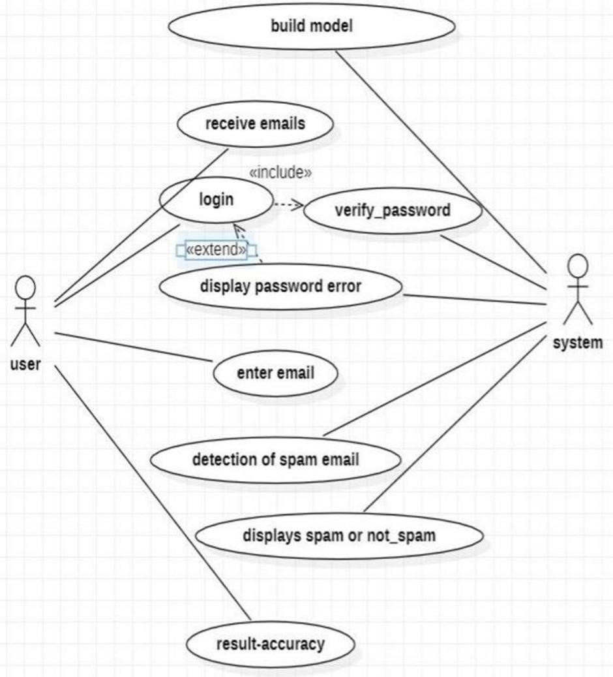

4.1 Usecase Diagram

### 4.2 CLASS DIAGRAM

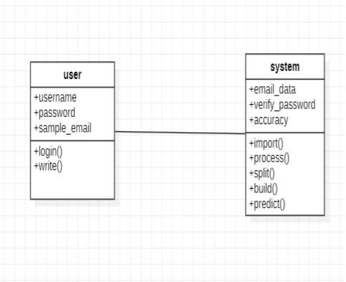

4.2 Class Diagram

### 4.3 ACTIVITY DIAGRAM

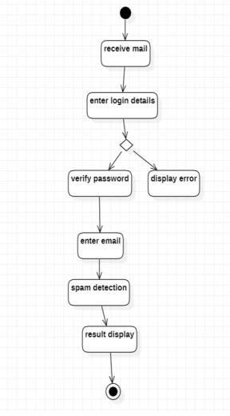

4.3 Activity Diagram

### 4.4 SEQUENCE DIAGRAM

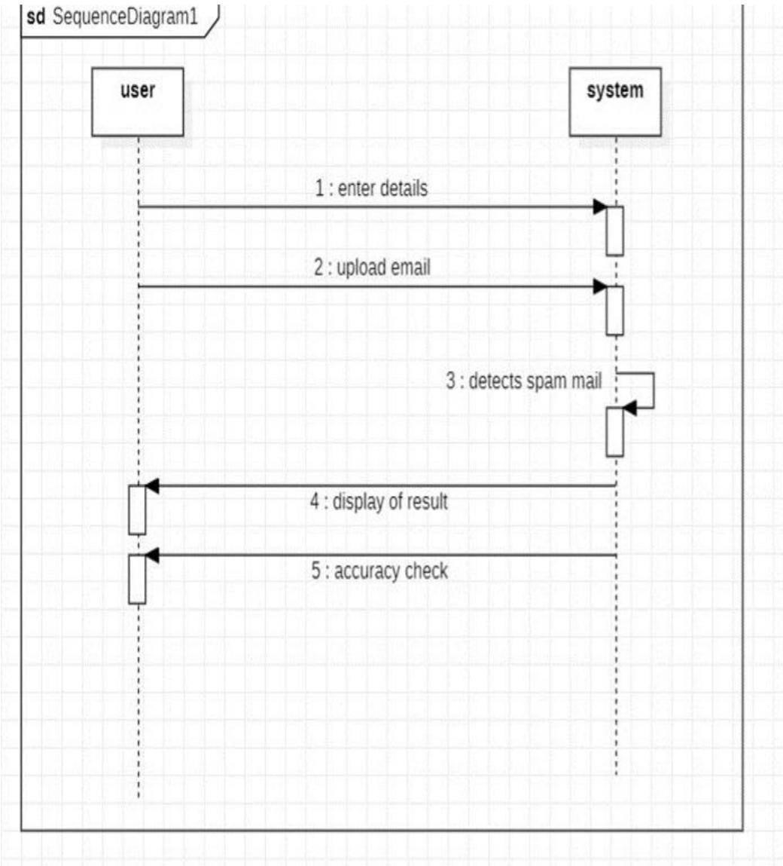

4.4 sequence diagram

### 4.5 DEPLOYMENT DIAGRAM

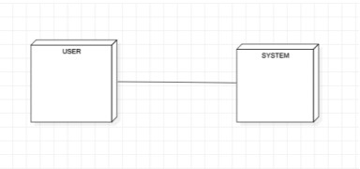

4.5 Deployment Diagram

### 4.6 ARCHITECTURE DIAGRAM

The diagram represents the high-level view of the system's architecture, illustrating the interactions, dependencies, and communication channels between different components.

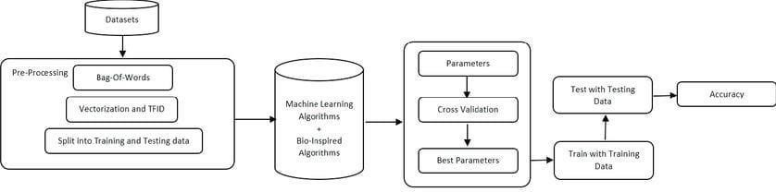

4.6 Architecture Diagram

## 5. IMPLEMENTATION

There are mainly 4 modules in the project:

1. Frontend
2. Backend
3. Database

### 5.1 Frontend

In the frontend development, a suite of technologies is employed to create a user friendly and responsive interface. This includes HTML, CSS, JavaScript and Bootstrap. HTML provides the structural foundation, CSS enhances the visual presentation, JavaScript adds interactivity, and Bootstrap streamlines the design process with its robust set of pre-built components and responsive grid system.

To enable seamless data exchange between the frontend and backend components, REST APIs (Representational State Transfer Application Programming Interfaces) are integrated. These APIs serve as the communication bridge, allowing the frontend to transmit requests and receive data from the backend effortlessly. RESTful architecture ensures flexibility, scalability, and interoperability, making it an ideal choice for modern web application.

In frontend mainly there are mainly two modules are there

1. **Admin:** Admin can manage the data to make sure they work well the email system and keep an eye on how they are doing to fix any problems. Administrators hold the responsibility of maintaining system integrity and ensuring smooth operation.
2. **Users:** Users can login with their credentials and check whether if a mail is spam or not.

### 5.2 Backend

It has mainly two modules that are

#### 5.2.1 HARRIS HAWK ALGORITHM

The Harris Hawks Optimization (HHO) algorithm is a nature-inspired optimization algorithm based on the hunting behavior of Harris's Hawks. It was proposed by Heidari et al. in 2019. The algorithm is designed to solve optimization problems by simulating the social behavior and hunting strategies of Harris's Hawks, a species of raptors found in the southwestern United States and parts of Mexico and Central America.

The key features of the HHO algorithm include:

1. **Hawk Representation:** In the algorithm, potential solutions to the optimization problem are represented as hawks within a search space.
2. **Exploration and Exploitation:** The algorithm balances exploration and exploitation by incorporating two key phases inspired by the hunting behavior of Harris's Hawks:
   * Evasion Phase: Hawks emulate the evasion strategy used by prey to escape attacks. This phase encourages exploration by allowing hawks to explore new areas of the search space.
   * Attack Phase: Hawks mimic the attacking strategy used by predators to capture prey. This phase emphasizes exploitation by enabling hawks to exploit promising areas of the search space.
3. **Collaboration:** Hawks collaborate during the hunting process, sharing information about the location of prey and coordinating their movements. In the algorithm, this collaboration is reflected in the way hawks exchange information about the quality of different solutions.
4. **Dynamic Grouping:** HHO dynamically organizes hawks into different groups, each performing different roles such as exploration, exploitation, and information sharing. This dynamic grouping enhances the diversity of search and facilitates effective exploitation of promising solutions.
5. **Convergence Mechanism:** HHO includes mechanisms to ensure convergence towards high-quality solutions over time. These mechanisms include adaptive adjustments to exploration and exploitation rates, as well as strategies to maintain diversity within the population of hawks.

|  |  |  |
| --- | --- | --- |
|  | def hho_algorithm(objective_function, num_variables, num_hawks, max_iter, lb, ub):  pass  # Initialization |  |

|  |  |  |
| --- | --- | --- |
|  | positions = np.random.uniform(lb, ub, (num_hawks, num_variables)) convergence_curve = []  for iter in range(max_iter): # Calculate fitness values fitness_values = np.apply_along_axis(objective_function, 1,  positions)    # Sort positions based on fitness values sorted_indices = np.argsort(fitness_values) sorted_positions = positions[sorted_indices]    # Update the top positions (based on the exploration and  exploitation phase) for i in range(num_hawks):  for j in range(num_variables):  r1 = np.random.random() # Random number for evasion r2 = np.random.random() # Random number for attack    # Evasion phase if r1 < 0.5:  positions[i, j] = sorted_positions[0, j] +  np.random.uniform(-1, 1) * (sorted_positions[0, j] - sorted_positions[i, j])    # Attack phase else:  positions[i, j] = sorted_positions[0, j] - r2 * (sorted_positions[0, j] - sorted_positions[i, j])    # Boundary handling  positions[i, j] = np.clip(positions[i, j], lb[j], ub[j])    # Update convergence curve  convergence_curve.append(np.min(fitness_values))  return sorted_positions[0], convergence_curve |  |
|  |

#### 5.2.2 MULTINOMIAL NAIVE BAYES

Flask, a lightweight Python web framework, serves as a versatile tool for deploying machine learning models such as the Multinomial Naive Bayes classifier in real-world applications. Leveraging Flask, developers can create interactive web interfaces that allow users to input text data, classify it using the pre-trained model, and receive immediate results.

In this context, Flask facilitates the integration of the Multinomial Naive Bayes model seamlessly into a web application. Upon receiving user input through HTML forms, Flask routes direct the data to the appropriate Python functions. These functions preprocess the input, transform it using techniques such as TF-IDF (Term Frequency-Inverse Document Frequency) vectorization, and then apply the model to make predictions. The prediction results are then relayed back to the user via the web interface.

Moreover, Flask’s modularity enables easy scalability and extension of the application. Developers can integrate additional features such as user authentication, data visualization, or database interaction to enhance the functionality of the web application. Flask's flexibility also allows for the incorporation of other machine learning models or algorithms, enabling developers to experiment with different approaches and compare their performance.

|  |  |  |
| --- | --- | --- |
|  | rom flask import Flask,render_template,url_for,request import pandas as pd import pickle from sklearn.feature_extraction.text import TfidfVectorizer from sklearn.naive_bayes import MultinomialNB  from sklearn.metrics import accuracy_score, f1_score, recall_score, precision_score  from sklearn.model_selection import train_test_split import numpy as np  app = Flask( name ) pickle_in = open('model.pickle','rb') pac = pickle.load(pickle_in) tfid = open('tranform.pickle','rb') tfidf_vectorizer = pickle.load(tfid)  train = pd.read_csv('Email spam.csv') train=train.dropna() train['spam'].unique() train[train['spam']=='its termination would not have such a phenomenal impact on the power situation . however '].shape |  |

|  |  |  |
| --- | --- | --- |
|  | df_x=train['text'] df_y=train['spam']  x_train, x_test, y_train, y_test =  train_test_split(df_x,df_y,test_size=0.3, random_state=9)  tfidf_vectorizer= TfidfVectorizer(min_df=1,stop_words='english') tfidf_train = tfidf_vectorizer.fit_transform(x_train)  clf=MultinomialNB() clf.fit(tfidf_train,y_train) acc = clf.score(tfidf_train,y_train) tfidf_test = tfidf_vectorizer.transform(x_test) y_pred = clf.predict(tfidf_test) |  |
|  |

#### 5.2.3 GENETIC ALGORITHM

A genetic algorithm for detecting spam mails involves mimicking natural selection to evolve a set of rules that classify emails as spam or not. Here's a simplified explanation:

1. **Initialization:** Generate a population of potential solutions (rules) randomly or using heuristics.
2. **Evaluation:** Assess each solution's performance by applying it to a training set of emails and calculating its fitness (accuracy, precision, recall, etc.).
3. **Selection:** Choose the best-performing solutions (based on fitness) to serve as parents for the next generation.
4. **Crossover:** Combine attributes/rules from the selected parents to create new solutions, simulating genetic crossover.
5. **Mutation:** Introduce random changes to some solutions to maintain diversity and explore new possibilities.
6. **Replacement:** Replace the old generation with the new one.

1. **Termination:** Repeat steps 2-6 for a fixed number of generations or until convergence (e.g., no significant improvement in fitness).
2. **Final Evaluation**: Assess the final generation's performance on a separate validation set to ensure generalization.

|  |  |  |
| --- | --- | --- |
|  | import random # Define constants  POPULATION_SIZE = 50  MUTATION_RATE = 0.1  NUM_GENERATIONS = 20    # Main genetic algorithm function def genetic_algorithm():  # Generate initial population  population = [generate_filter() for _ in range(POPULATION_SIZE)]    for generation in range(NUM_GENERATIONS): # Calculate fitness for each filter fitness_scores = [calculate_fitness(filter) for filter in  population]    # Select top filters for reproduction top_filters_indices = sorted(range(len(fitness_scores)),  key=lambda i: fitness_scores[i], reverse=True)[:10] top_filters = [population[i] for i in top_filters_indices]  # Create next generation through crossover and mutation new_population = top_filters[:] while len(new_population) < POPULATION_SIZE: parent1, parent2 = random.choices(top_filters, k=2) child = crossover(parent1, parent2) child = mutate(child) new_population.append(child)  population = new_population  # Display best filter in each generation best_filter_index = top_filters_indices[0] best_filter = population[best_filter_index] print(f"Generation {generation+1}, Best Fitness:  {fitness_scores[best_filter_index]}")    return best_filter |  |
|  |

### 5.3 DATABASE

A database plays a crucial role in several aspects:

1. **Data Storage:** A database is used to store the email data that will be used for training and testing the machine learning models. This data typically includes a large collection of emails labeled as either spam or non-spam (ham). The database should efficiently store and retrieve this data to support model training and evaluation.
2. **Data Preprocessing:** Before training the machine learning models, the email data stored in the database may require preprocessing steps such as text cleaning, tokenization, and feature extraction. These preprocessing steps transform the raw email data into a format suitable for training the spam detection models.
3. **Model Training and Evaluation:** The database is used to feed the training data to the machine learning algorithms for model training. During training, the algorithms learn patterns and characteristics of spam and non-spam emails. After training, the database is also used to store the trained models and relevant evaluation metrics such as accuracy, precision, recall, and F1-score.
4. **Real-time Classification:** In a production environment, the trained machine learning models are deployed to classify incoming emails in real-time. The database may store metadata about incoming emails, such as sender, subject, and timestamp. When a new email arrives, the deployed model retrieves relevant features from the database and predicts whether the email is spam or non-spam.
5. **Feedback Loop:** As users interact with the email system (e.g., marking emails as spam or moving them to the inbox), feedback is collected and stored in the database. This feedback can be used to retrain the machine learning models periodically, improving their accuracy and effectiveness over time.
6. **Security and Access Control:** Given the sensitivity of email data, the database must enforce security measures such as authentication, authorization, encryption, and auditing. Access control mechanisms ensure that only authorized users and applications can access and modify the email data stored in the database.

## 6. TESTING

Errors are to be found and eliminated via the testing process. The process of testing is searching for flaws or vulnerabilities in a work product in as many different ways as possible. It offers a technique to test the functioning of final products, subassemblies, assemblies, and/or individual components. It is the process of putting stress on software with the goal of ensuring that the software system in question lives up to its requirements as well as the expectations of its users and that it does not fail in an undesirable way. There are many different kinds of examinations. Each sort of test is designed to satisfy a different testing need.

### 6.1 TESTING THE FRONTEND AND BACKEND

Testing frontend and backend of an application involved various types of testing methodologies to ensure that both components function correctly and interact seamlessly.

The whole testing of frontend and backend was done manually and no automated tools were used.

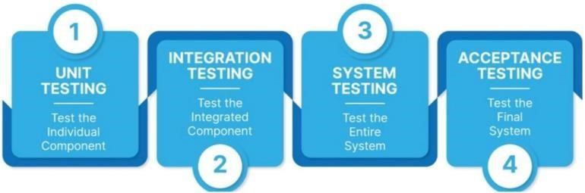

***Fig 6.1 Levels of Testing***

**6.1.1 Unit Testing:**

**Frontend**: Unit testing for the frontend involved testing individual components, such as UI elements, functions, and modules, in isolation.

**Backend**: Unit testing for the backend focused on testing individual functions, classes, and APIs without dependencies on external systems or databases.

**6.1.2 Integration Testing:**

**Frontend**: Integration testing for the frontend involved testing the interaction between different components, modules, or pages to ensure they work together as expected. This included testing UI navigation, data flow, and component communication.

**Backend**: Integration testing for the backend involved testing the interaction between various backend components, such as APIs, databases, and external services. This ensures that the backend system behaves correctly as a whole. Postman was used to test APIs

**6.1.3 System Testing:**

**Frontend**: System testing for the frontend involved testing the entire application from the user's perspective. This includes testing UI functionalities, user interactions, accessibility, and responsiveness across different browsers and devices.

**Backend**: System testing for the backend involved testing the complete application stack, including frontend-backend interactions, data flow, security, performance, and scalability.

**6.1.4 Validation Testing:**

**Frontend**: Validation testing for the frontend involves verifying that the application meets the specified requirements and expectations.

**Backend**: Validation testing for the backend involved confirming that the backend system meets the functional and non-functional requirements outlined during the development process. This included testing data integrity, security controls, compliance with industry standards, and performance benchmarks.

### 6.2 TEST CASES

|  |  |  |
| --- | --- | --- |
| **S.NO** | **TEST CASES** | **RESULTS** |
| 1. | User Login(valid) | Login success |
| 2. | User Login(Invalid) | Invalid Credentials |
| 3. | Input Prediction | Spam or ham |

Table 6.2 Test Cases

### 6.3 OBJECTIVES OF TESTING

The main objective of testing in spam mail detection is to ensure that the system accurately categorizes emails as spam or non-spam, based on predefined criteria. The testing process should aim to identify and eliminate errors or defects in the system, and ensure that the system is reliable, efficient, and effective. Here are some specific testing objectives for spam mail detection:

**Accuracy:** The system should accurately identify spam emails and distinguish them from legitimate emails. Testing should ensure that the system has a high level of accuracy in categorizing emails, and that false positives and false negatives are minimized

**Scalability:** The system should be able to handle a large volume of emails, and be scalable to meet changing demand. Testing should measure the system's ability to handle a large volume of emails, and ensure that it scales up or down as required.

**Usability**: The system should be easy to use and understand.

1. **RESULT SCREENS**

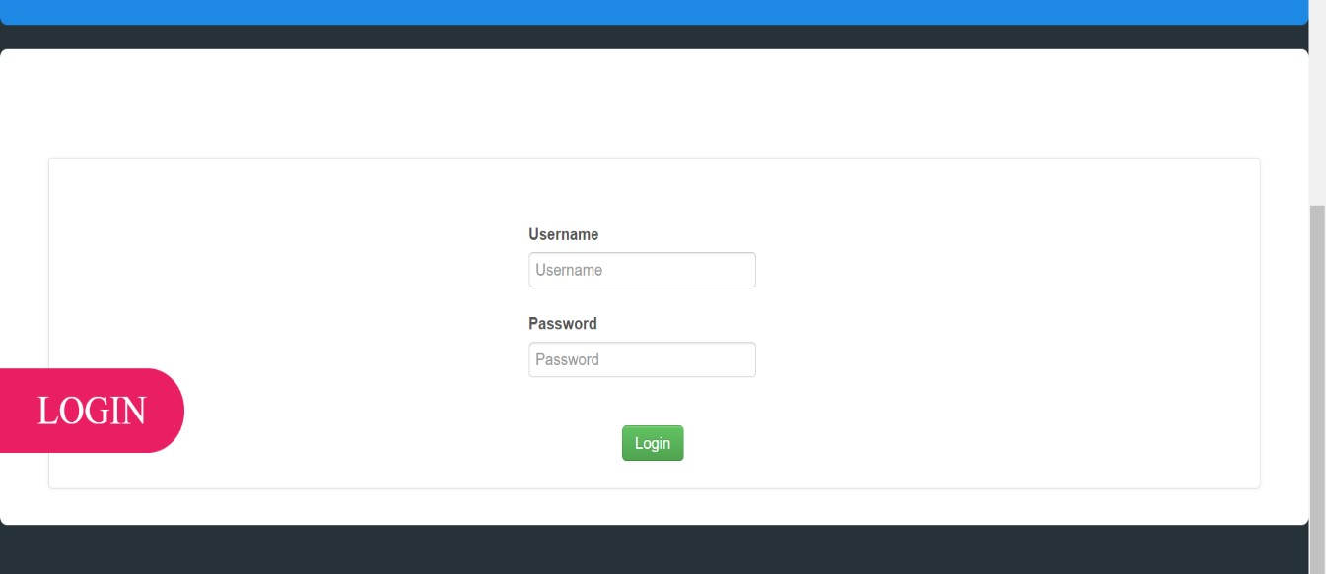

* 1. Login Page

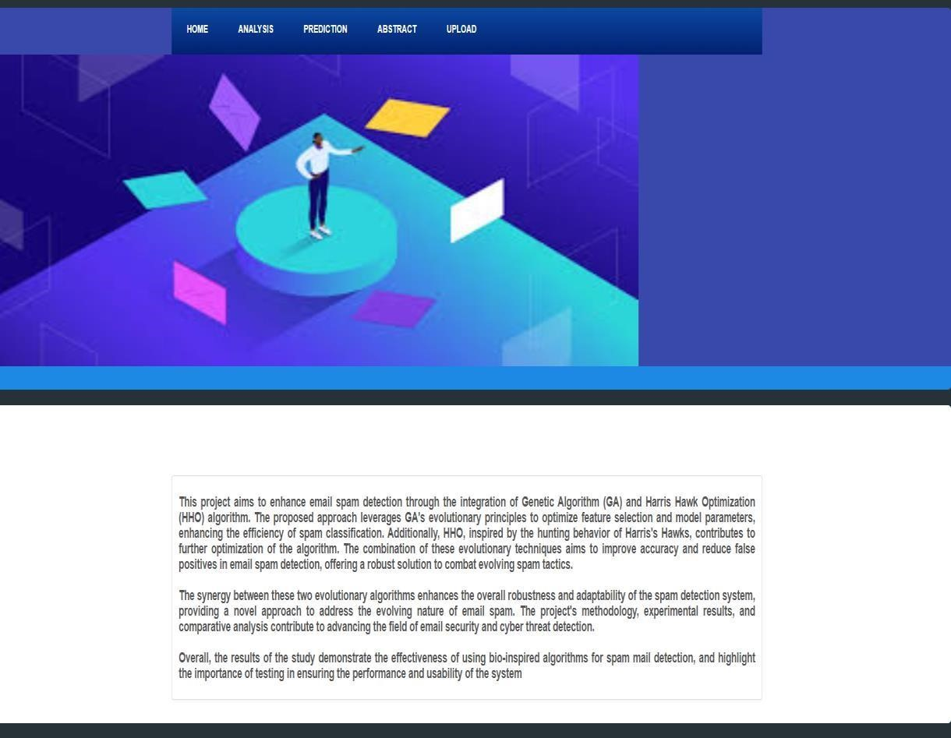

* 1. Abstract Page

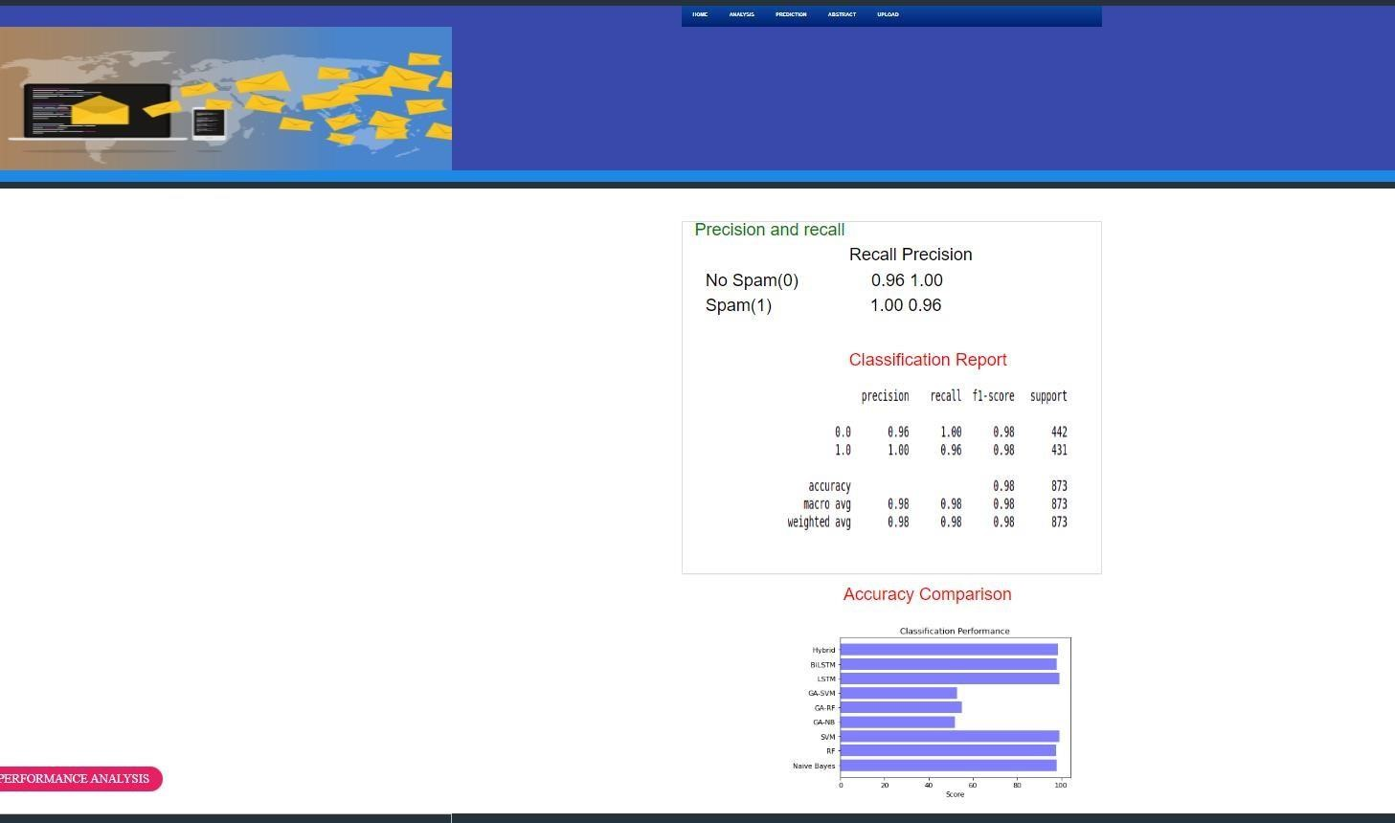

* 1. Performance Analysis

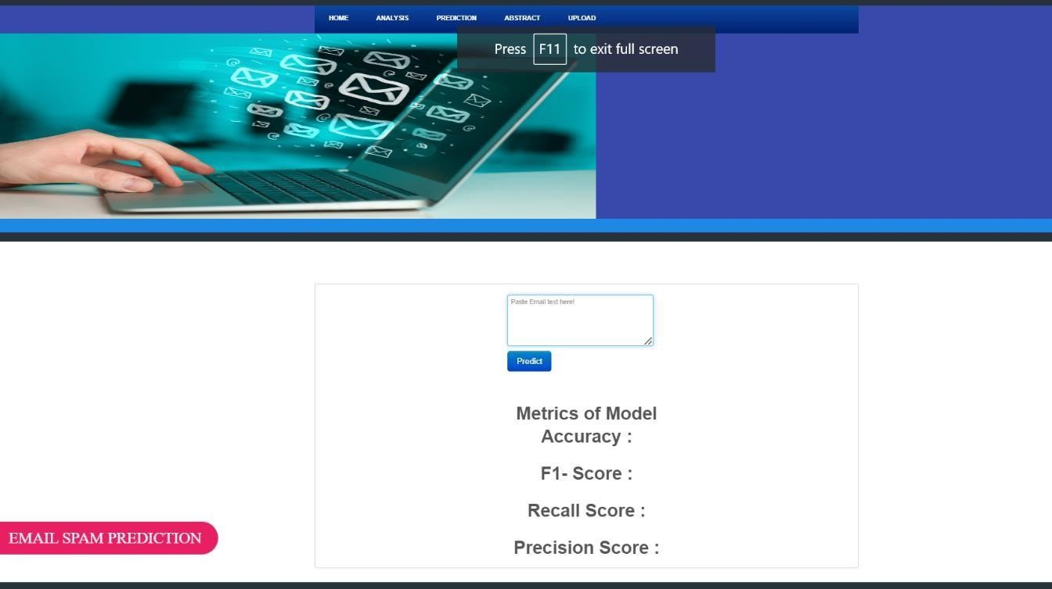

* 1. Prediction Page

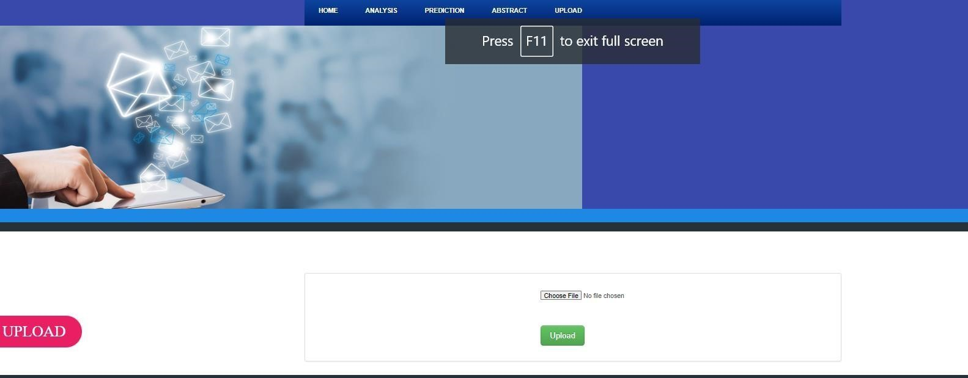

* 1. Emails Upload Page

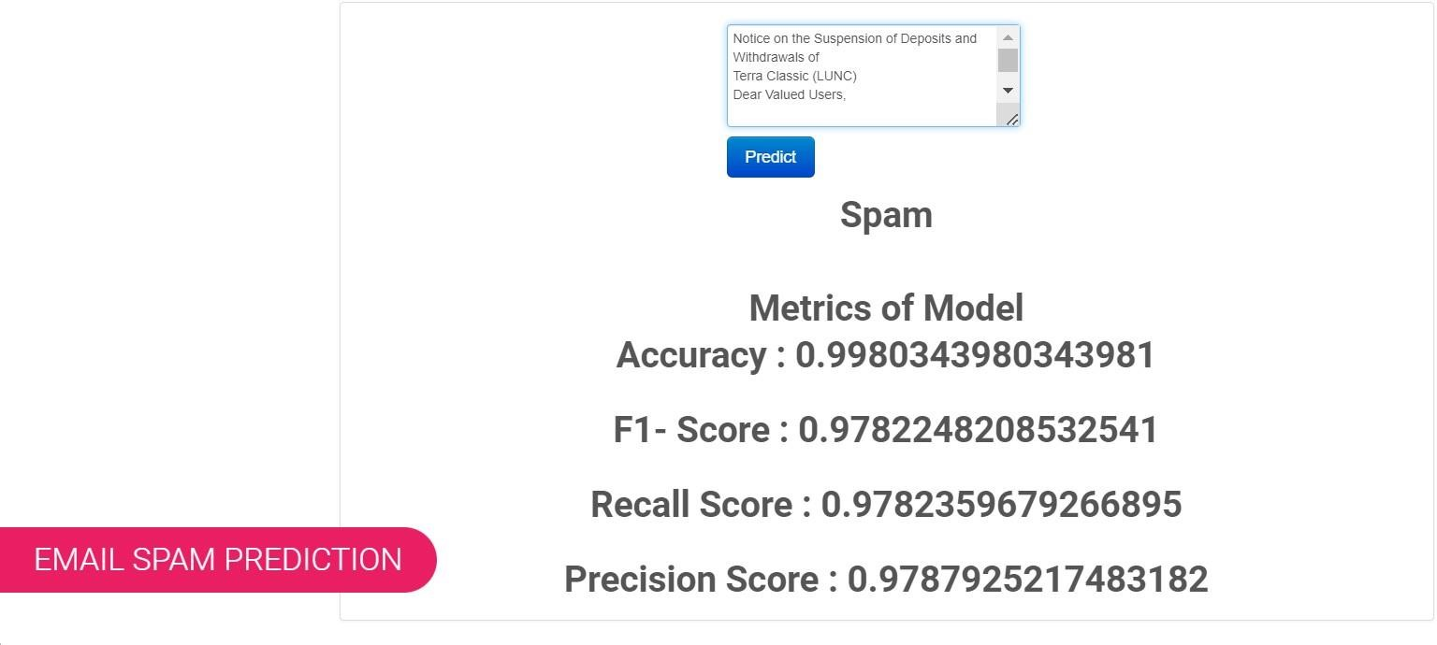

* 1. Spam Mail Prediction

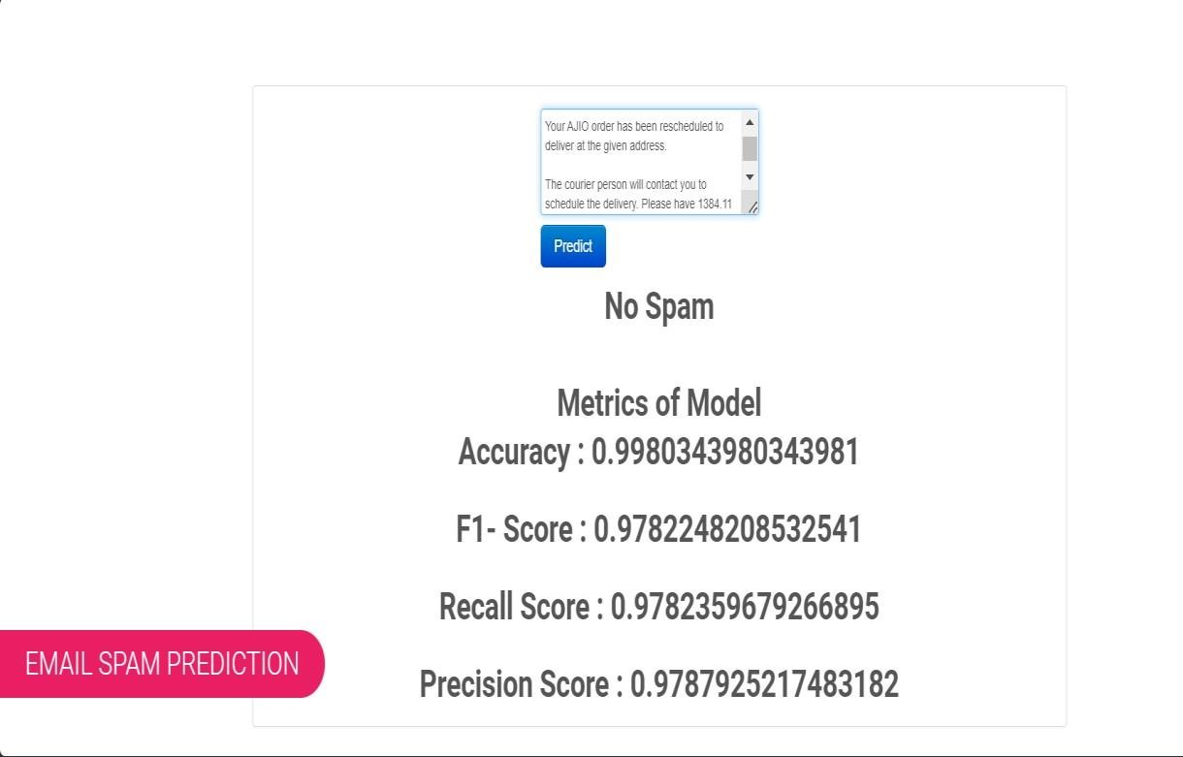

* 1. Non-Spam Mail Prediction

## 8. CONCLUSION & FUTURE SCOPE

### 8.1 CONCLUSION

Email is one the most predominant techniques for communication due of its inexpensive cost of sending messages, availability, ability to send and receive messages very fast. A good number of existing email spam filters cannot efficiently prevent spams from entering the user’s inbox. This is due to the fact that spammers continue to devise more complicated methods for that can easily dodge spam filters.

In conclusion, the use of bio-inspired algorithms for the detection of spam mails has shown promising results. These algorithms use techniques inspired by biological systems, such as genetic algorithms and artificial neural networks, to identify and classify spam mails based on their content and characteristics.

The detection of spam mails using bio-inspired algorithms involves several stages, including pre-processing, feature extraction, training, and classification. The pre-processing stage involves cleaning and transforming the input data, while the feature extraction stage involves identifying the relevant features in the input data. The training stage involves using the input data to train the algorithm, while the classification stage involves using the trained algorithm to classify new mails as spam or non-spam.

The testing process and test cases are critical for ensuring the accuracy and reliability of the spam mail detection system using bio-inspired algorithms. Input validation, feature extraction, training, classification, and performance test cases can be used to validate the system and identify any issues or defects.

Overall, the use of bio-inspired algorithms for the detection of spam mails offers a promising approach to address the challenges posed by spam mails. With further research and development, these algorithms have the potential to significantly improve the accuracy and effectiveness of spam mail detection systems.

### 8.2 FUTURE SCOPE

1. **Integration of Multiple Bio-Inspired Algorithms:** Rather than relying on a single bio- inspired optimization algorithm, future research can explore the combination of multiple algorithms, such as Ant Colony Optimization (ACO), Genetic Algorithms (GA), Particle Swarm Optimization (PSO), and others. Ensemble approaches can harness the strengths of each algorithm to improve spam detection accuracy and robustness.
2. **Dynamic Adaptation to Evolving Threats:** Develop techniques that allow the spam detection system to dynamically adapt and evolve in response to emerging spamming techniques and evolving email threats. Bio-inspired algorithms are well-suited for this task due to their ability to mimic adaptive behaviors observed in nature.
3. **Deep Learning Integration**: Explore the integration of biologically inspired optimization techniques with deep learning architectures for spam detection. Hybrid approaches combining bio-inspired optimization for feature selection and hyperparameter tuning with deep learning models could lead to more effective and efficient spam detection systems.
4. **Real-Time Detection and Response:** Develop real-time spam detection systems capable of analyzing incoming emails in real-time and providing immediate responses. Bio-inspired optimization algorithms can facilitate the rapid processing and classification of emails, enabling timely action to mitigate potential security threats.
5. **Enhanced Feature Engineering:** Investigate advanced feature engineering techniques inspired by biological systems, such as mimicry of sensory systems or social behaviors observed in animals, to extract more informative features for spam detection. This could involve incorporating natural language processing (NLP) techniques, semantic analysis, and contextual information to improve classification accuracy.
6. **Behavioral Analysis and Anomaly Detection:** Explore the application of bio-inspired optimization algorithms for behavioral analysis and anomaly detection in email communications. By modeling normal communication patterns and identifying deviations indicative of spam or malicious activity, these approaches can enhance the detection of sophisticated email-based threats.
7. **Privacy-Preserving Techniques:** Develop privacy-preserving techniques that maintain the confidentiality of email content while still allowing effective spam detection. Bio- inspired optimization algorithms can be leveraged to optimize encryption and anonymization methods that protect sensitive information while enabling accurate spam classification.
8. **Scalability and Efficiency:** Address scalability and efficiency challenges associated with processing large volumes of emails in real-time. Bio-inspired optimization techniques can help optimize computational resources, improve algorithm efficiency, and enable the deployment of spam detection systems in resource-constrained environments.

## 9. REFERENCES

1. KritiAgarwal, Tarun Kumar. “Spam Detection using integrated approach of naïve bayes particle swarm optimization.” In Proceeding of the second International Conference on Intelligent Computing and Control System (ICICC 2018) IEEE Xplore 2018.
2. Harisinghaney, Anirudh, Aman Dixit, Saurabh Gupta, and Anuja Arora. "Text and image based mostly spam email classification using KNN, Naïve Bayes and Reverse DBSCAN algorithmic rule." In improvement, Reliabilty, 2014 International Conference on, pp. 153- 155.
3. Mohamad, Masurah, and Ali Selamat. "An evaluation on the efficiency of hybrid feature selection in spam email classification." In Computer, Communications, and Control Technology (I4CT), 2015 International Conference on, pp. 227-231. IEEE, 2015.
4. Renuka, Karthika D., and P. Visalakshi. "Latent semantic Indexing primarily based SVM Model for Email Spam Classification." (2014).
5. Feng, Weimiao, Jianguo Sun, Liguo Zhang, Cuiling Cao, and Qing Yang. "A support vector machine primarily based naive Bayes algorithmic program for spam filtering." In Performance Computing and Communications Conference (IPCCC), 2016 IEEE thirty fifth International, pp. 1-8. IEEE, 2016.
6. Kumaresan, T., and C. Palanisamy. "E-mail spam classification using S-cuckoo search and support vector machine." International Journal of Bio-Inspired Computation 9, no. 3 (2017): 142- 156
7. W. Awad and S. ELseuofi, ‘‘Machine learning methods for spam E-Mail classification,’’ Int. J. Comput. Sci. Inf. Technol., vol-3.
8. S. Mohammed, O. Mohammed, and J. Fiaidhi, ‘‘Classifying unsolicited bulk email (UBE) using Python machine learning techniques’’.
9. K. Agarwal and T. Kumar, ‘‘Email spam detection using integrated approach of Naïve

Bayes and particle swarm optimization,’’ in Proc. 2nd Int. Conf. Intell. Comput. Control

Syst. (ICICCS)