**ASSIGNMENT 1: Basic Commands in Unix Operating System**

**Objective of this Assignment:** To study the basic commands such as who, whoami, date, cal, pwd, man, mkdir, cd, rmdir, cat, mv, cp, rm, wc, sort, head, tail, cmp, diff, ls, chmod, grep, echo for accessing files and directories.

Q1. Write the commands to create the following directory hierarchy:

🡪 DOS_Regdno 🡪 DOSass1 🡪 dir1

**Commands:**

mkdir DOS_2241013379

cd DOS_2241013379/

mkdir DOSass1

cd DOSass1/

mkdir dir1

cd dir1/

**Output:**

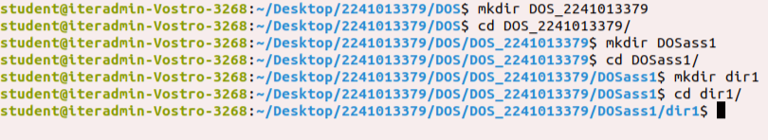

Q2. Write the commands to create another directory with name dir2 in directory DOSass1 and make dir2 as the current working directory.

**Commands:**

mkdir dir2

ls -a

cd ..

cd DOSass1/dir2

**Output:**

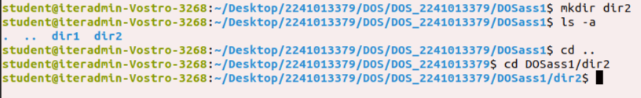

Q3. Write the command to delete the directory dir2, when DOS_Regdno will be the current working directory.

**Commands:**

cd ../..

rmdir dir2

**Output:**

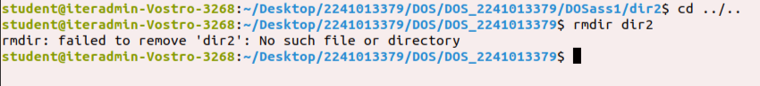

Q4. Write the command to create a file named as file1 using cat command inside dir1. Write your name, regdno, branch, semester and section in file1. Then display the content of the file.

**Commands:**

cd DOSass1/

cd dir1/

cat > file1

Name: SWASTIK MULLICK

Regd. No.: 2241013379

Branch: CSE (Core)

Semester: 5th

Section: 2241011

cat file1

**Output:**

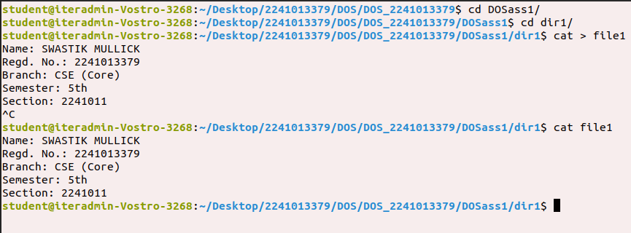

Q5. Write the command to create a file named as file2 using cat command inside dir1. Write your semester wise SGPA in file2.

**Commands:**

cat > file2

Semester: SGPA

1st: 8.45

2nd: 8.66

3rd: 8.71

4th: 8.97

cat file2

**Output:**

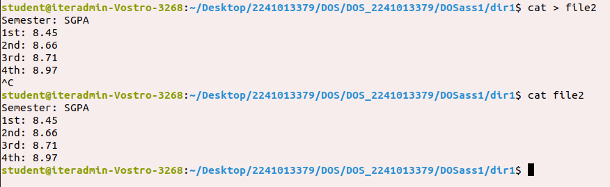

Q6. Create a file named as file3 storing content of file1 merged with content of file2.

**Commands:**

cat file1 >> file3

cat file2 >> file3

cat file3

**Output:**

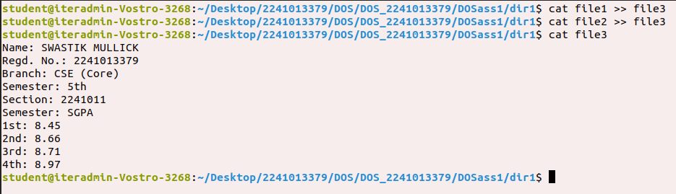

Q7. Write the command to rename file2 as markinfo.

**Commands:**

mv file2 markinfo

ls -a

cat markinfo

**Output:**

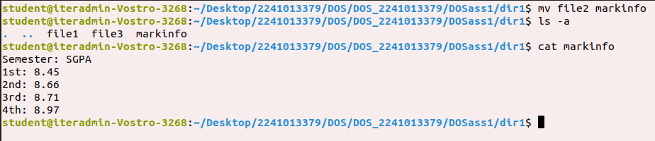

Q8. Write the command to copy the content of file1 to reginfo.

**Commands:**

cp file1 reginfo

cat reginfo

**Output:**

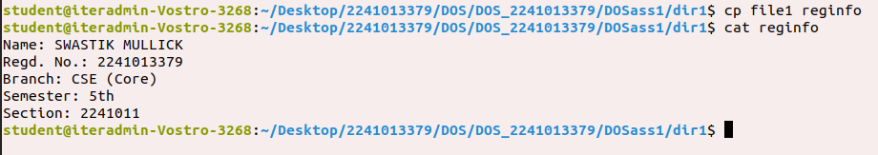

Q9. Write the command to display the inode values of file1, markinfo, reginfo.

**Commands:**

ls -i file1

ls -i markinfo

ls -i reginfo

**Output:**

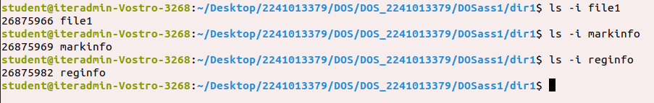

Q10. Write the command to delete file1.

**Commands:**

ls -a

rm -v file1

ls -a

**Output:**

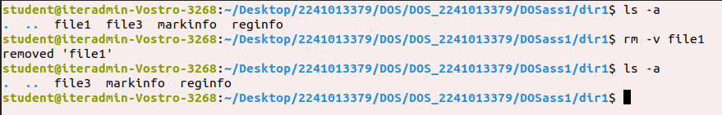

Q11. Write the command to count the number of lines, words, characters in markinfo.

**Commands:**

wc -l markinfo

wc -w markinfo

wc -c markinfo

**Output:**

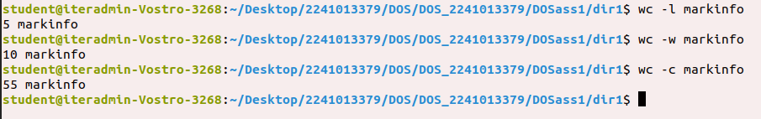

Q12. Write the command to create a file named as Personalinfo inside dir1. Write your name, regdno, address in the file.

**Commands:**

cat > Personalinfo

Name: SWASTIK MULLICK

Regd. No.: 2241013379

Address: Kolkata, West Bengal

cat Personalinfo

**Output:**

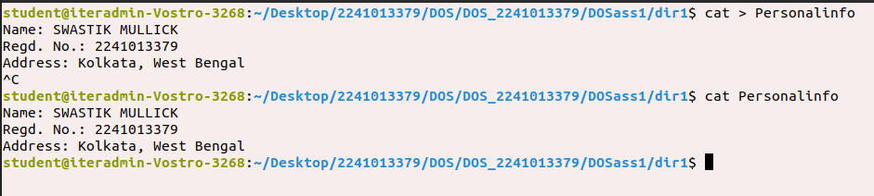

Q13. Write the command to display the content of markinfo in reverse order.

**Commands:**

sort -r markinfo

**Output:**

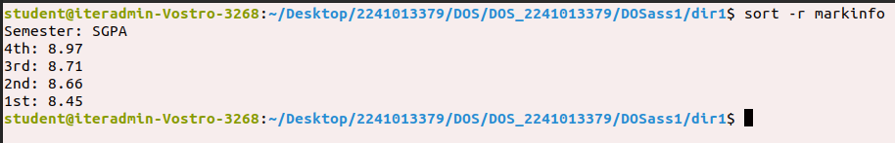

Q14. Check the output of the following command:

cmp reginfo personalinfo

diff reginfo personalinfo

**Commands:**

cmp reginfo personalinfo

diff reginfo personalinfo

**Output:**

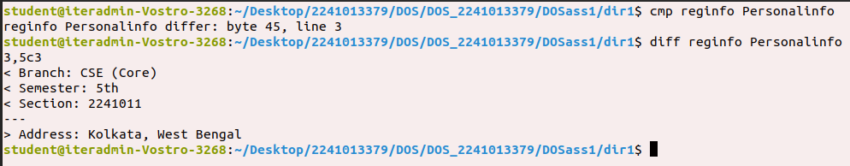

Q15. Write a command to count the number of files in the current working directory and display that number.

**Commands:**

ls

ls | wc -w

**Output:**

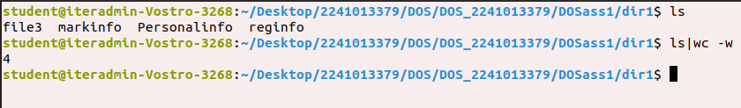

Q16. Write a command to include all the file names present in a current working directory in a file named as filelist without causing filelist to be included in the names.

**Commands:**

ls > filelist

ls

cat filelist

ls | grep –vx filelist filelist

**Output:**

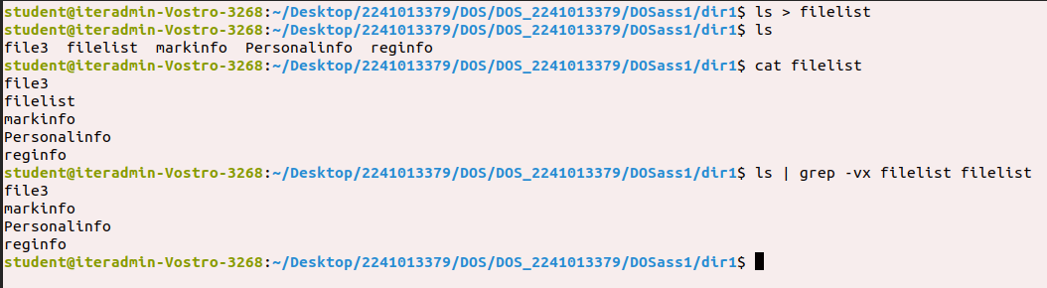

Q17. Write a command to give write permission to all the users of file reginfo.

**Commands:**

ls -l

chmod a+w reginfo

ls -l

**Output:**

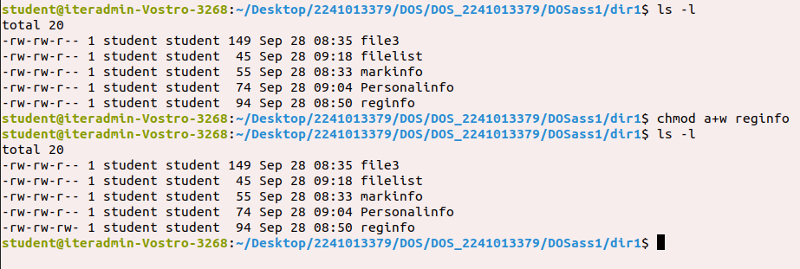

Q18. Write a command to discard write permission from group users of file reginfo.

**Commands:**

chmod g-w reginfo

ls -l reginfo

**Output:**

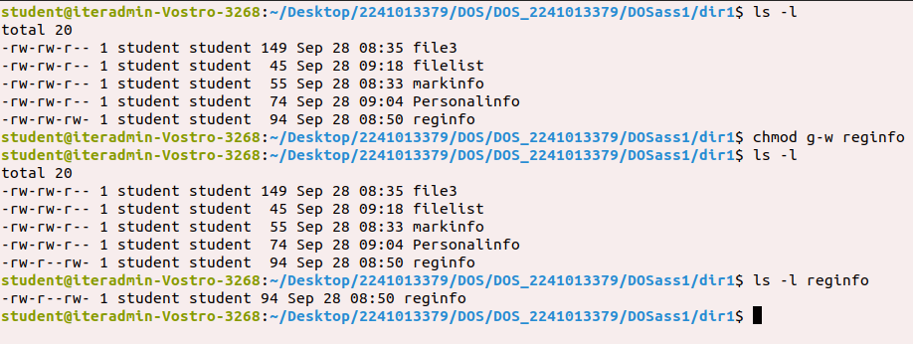

Q19. Write the command to set rwx permissions for all the users of file reginfo.

**Commands:**

chmod a+rwx reginfo

ls -l reginfo

**Output:**

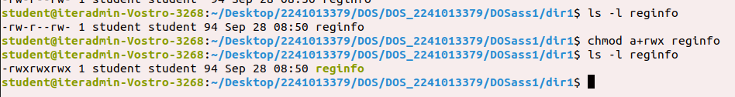

Q20. Differentiate between following commands:

date; pwd

date; pwd | wc -l

(date; pwd) | wc -l

**Commands:**

date; pwd

date; pwd | wc -l

(date; pwd) | wc -l

**Output:**

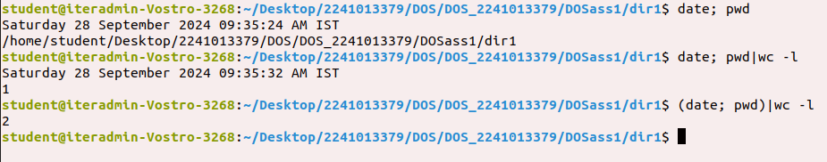

Q21. Interpret the output of the following commands:

echo *

echo ***

echo ‘***’

echo \***

echo \*\*\*

echo */*

echo Don't do this

echo “Don't do this” (Quotes of one kind protect quotes of other kind)

echo Hello # world

echo “Hello # world”

echo ‘Hello # world’

echo date

echo ‘date’

echo “date”

echo `date`

**Commands:**

echo *

echo ***

echo '***'

echo \***

echo \*\*\*

echo */*

echo Don't do this

echo “Don't do this”

echo Hello # world

echo “ Hello # world”

echo ' Hello # world'

echo date

echo 'date'

echo “date”

echo `date`

**Output:**

