**ASSIGNMENT 2: Familiarization with basic Commands in Unix Operating System and Shell Programming**

**Objective of this Assignment:**

* To learn basic concepts of shell programming
* To learn concept of command line argument in shell script

Q1. Write a shell script named as **prog** for merge for merge the content of files a.txt, b.txt and c.txt sort them and save the result in a file called **result** and display the sorted output on the screen.

(Note: a.txt, b.txt and c.txt file contain some numerical value. Mark the script an executable file and run it as a command using its name only.)

**Commands:**

cat > a.txt

SWASTIK MULLICK

2241013379

CSE (Core)

2241011

cat > b.txt

8.45

8.66

8.71

8.97

cat > c.txt

SWASTIK MULLICK

Kolkata, West Bengal

700112

gedit prog

cat a.txt b.txt c.txt >> d.txt

sort d.txt >> result

cat result

./prog

ls -l prog

chmod a+x prog

ls -l prog

./prog

**Output:**

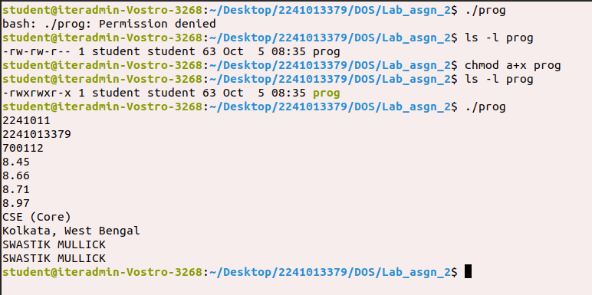

Q2. Write a shell script named as **systeminfo** that will display the information about the login name of the user, name of the Unix system used by the user, type of the SHELL, Path of current working directory of the user and list of file contain in current working directory.

(Make the script an executable file and run it as a command using its name only.)

**Commands:**

gedit systeminfo

whoami

uname

echo $SHELL

pwd

ls

ls -l systeminfo

chmod a+x systeminfo

ls -l systeminfo

./systeminfo

**Output:**

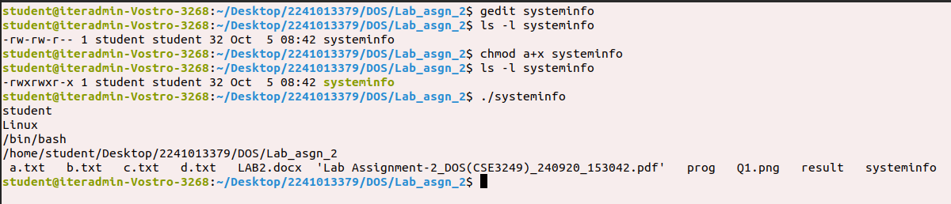

Q3. Write a shell script named as **dtcal** for displaying both the system and calendar for specific month, say march 2022, in the given format:-

Date : specific date

Calendar : current calendar

(Make the script an executable file and run it as a command using its name only.)

**Commands:**

gedit dtcal

echo “Date : ” `date`

echo “Calendar : ” `cal`

ls -l dtcal

chmod a+x dtcal

ls -l dtcal

./dtcal

**Output:**

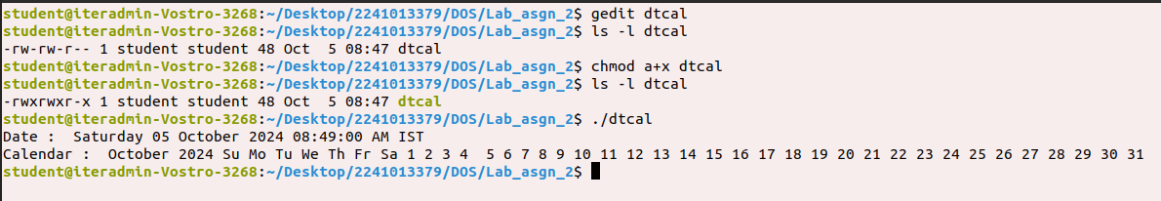

Q4. Write a shell script named as **nvwc** which will display the filename and linecount, wordcount and char count of the file dtcal in the following format:

Filename: dtcal

Line count: -

Word count: -

Char count: -

(Make the script an executable file and run it as a command using its name only.)

**Commands:**

gedit nvwc &

echo “Filename : ” `dtcal`

echo “Linecount : ” `wc -l < dtcal`

echo “Wordcount : ” `wc -w < dtcal`

echo “Charcount : ” `wc -c < dtcal`

chmod a+x nvwc

./nvwc

**Output:**

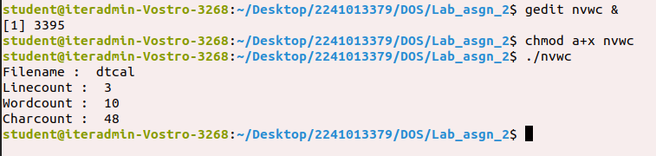

Q5. Write a shell script named as **nvwc2** which will display the filename and linecount, word count and char count of **any file** given as argument to nvwc2 in the following format:

filename linecount wordcount charcount

file 1 **- - -**

(Make the script an executable file and run it as a command using its name only.)

**Commands:**

gedit nvwc2 &

echo “filename linecount wordcount charcount”

echo “$1 ” `wc -l < $1` “ ” `wc -w < $1` “ ” `wc -c < $1`

chmod a+x nvwc2

./nvwc2 dtcal

**Output:**

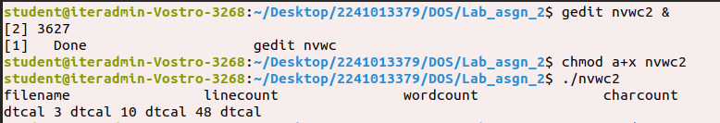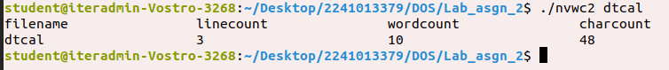

Q6. Write a shell script named as **darg** to display the total number of command line arguments along with the first two arguments.

**-**Modify the script to display all the arguments.

(Make the script an executable file and run it as a command using its name only.)

**Commands:**

gedit darg &

echo “Number of command line argument(s) provided: $#”

echo “Complete list of argument(s): $@”

chmod a+x darg

./darg dtcal systeminfo

**Output:**

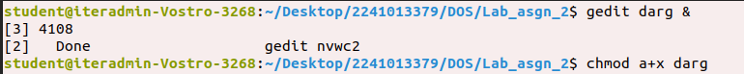

Q7. Write a shell script named as **ndisp** that will take three command line arguments specifying the value of n, m, and a filename and display the first n numbers of lines and last m number of lines of the file given as argument.

(Make the script an executable file and run it as a command using its name only.)

**Commands:**

cat > year

January

February

March

April

May

June

July

August

September

October

November

December

gedit ndisp

echo "The first $1 lines of the file $3"

head -$1 $3

echo "The last $2 lines of the file $3"

tail -$2 $3

chmod a+x ndisp

./ndisp 9 6 year

**Output:**

