

We Build People,

Then they Build Software for the World!

Panacloud is a new kind of company, unlike any other company in the world. We build people, who love building web and mobile apps, games, and software for Internet of things for the world. We are about bringing social change in societies through technology training, adoption and implementation. We are about transforming under developed countries and economies into prosper and stable nations.

We, at Panacloud believe that software developers are the most valuable resource in the world in this digital age - even more valuable than oil wells, gold mines or all other natural resources. Given this belief we mine for software developers. We select them, we train them, and then they provide solutions for world businesses and consumers.

This document not only tells you about us, our people, products, and services but also provides you the tools and services to build people and helps them work in teams using latest state of the art technologies.

Panacloud provides people, products, and services in the global marketplace with a focus on state-of-the-art technologies. We deliver people, products, and services in the following market segments of the software industry:

1. Single Page Web Apps (SPAs) using the MEAN (MongoDB, Express, AngularJS, and Node.js) Stack
2. Real-time Web and Mobile Apps using Firebase
3. Multi-Device Hybrid Mobile Apps (Android, iOS, and Windows Phone) using Ionic/Angular and Famo.us
4. Native Android Apps using Java
5. Native iOS Apps using Swift
6. Windows 10 Apps using HTML5/JavaScript
7. Mobile, Web, Console, Desktop and Virtual Reality (VR) Game Development using Unity 5 and Oculus
8. Internet of Things (IoT) Software Development

We think that App creation process starts with developer’s selection and training, not when we start working on a particular application. Given these beliefs, we have developed a unique business model that focuses on selecting top students and professionals and then training them completely free of charge to be world-class developers in selected cutting-edge technologies. As a result, we are able to train and retain a large number of developers every year in the latest state-of-the-art technologies specifically needed to deliver products and services to the above-mentioned target market segments.

From admitting trainees into the program to their eventual placement onto professional software projects, it is a sophisticated multi-stage process that is carried out under direct supervision of our qualified trainers and senior project managers.

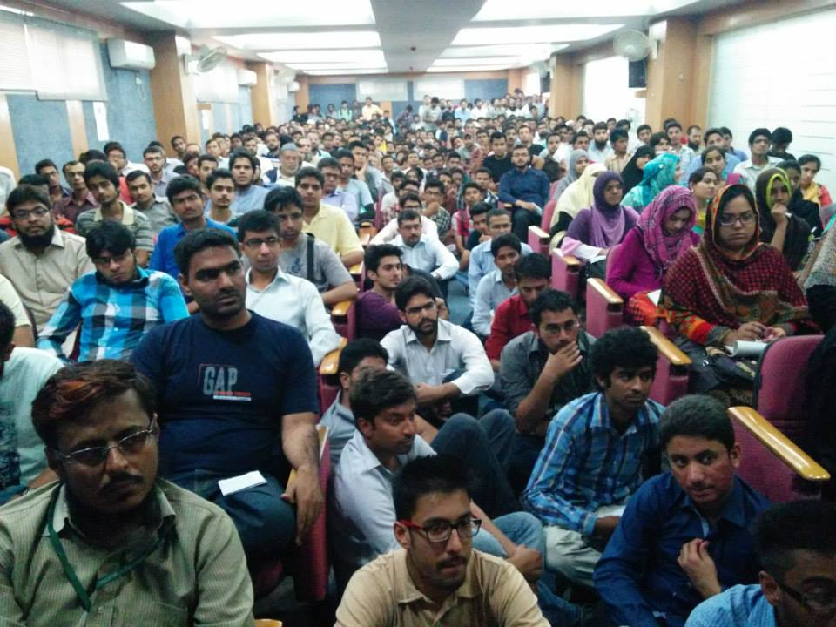The first stage in the process is to create awareness about the technologies mentioned above by giving presentations and seminars in different colleges, universities and software houses nationwide. To date, numerous such events have been organized by us to create widespread interest.

The next stage in the process is to filter out those who are interested in learning these technologies and select for training only the ones who we believe have the capability to learn application design and/or development. During the fiscal year ended in June 2014, over 5,000 candidates from the region’s top universities and professionals participated in our admission tests.

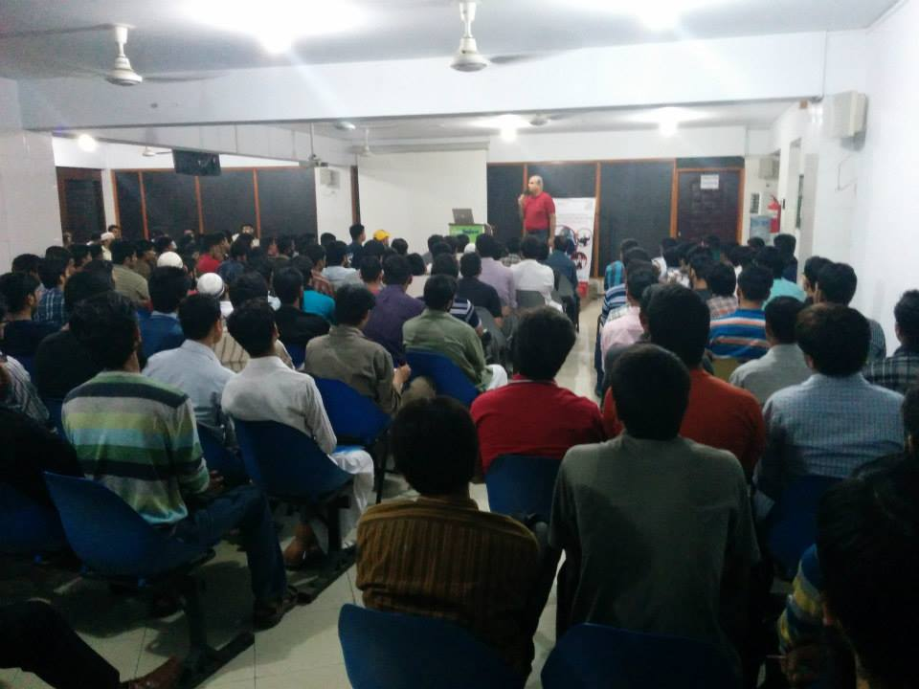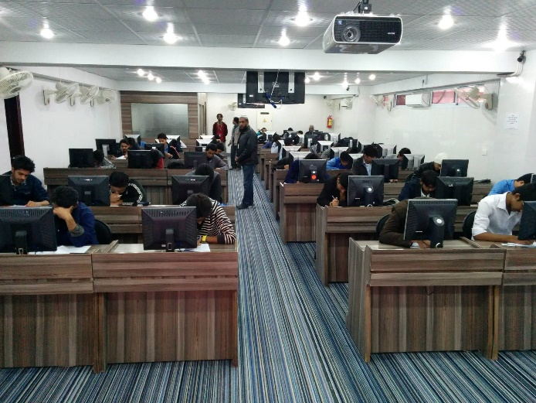The third step in the process is to provide completely free one year training to those candidates who have cleared our admission tests. During the last fiscal year we selected about 1,000 candidates for our one year free training program. The trainees go through a cycle of Theory Classes, Practice in Labs and Examinations to validate the progress at each learning stage. Those candidates who fail in two consecutive exams are removed from the program.

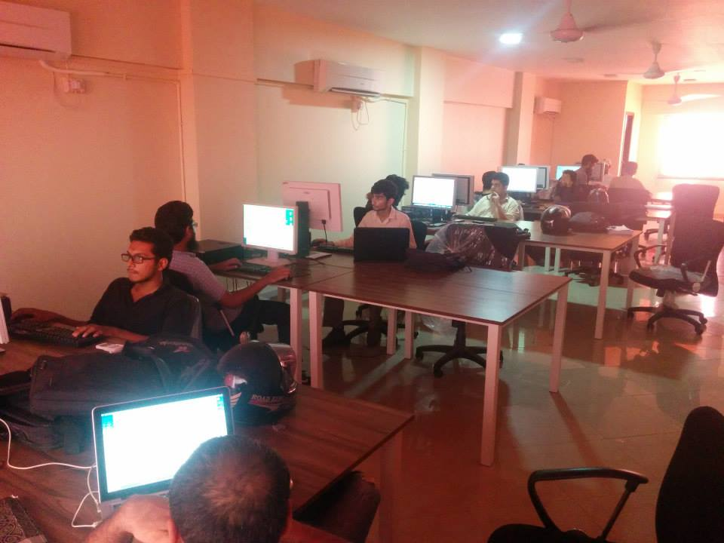The fourth stage in the process involves selecting the top performers from the training program and offering them six to nine months internship in Panacloud. The interns work on mock projects and are constantly monitored and coached in this period. During the last fiscal year, we selected the top 50 students as interns from the pool of 1,000 trainees.

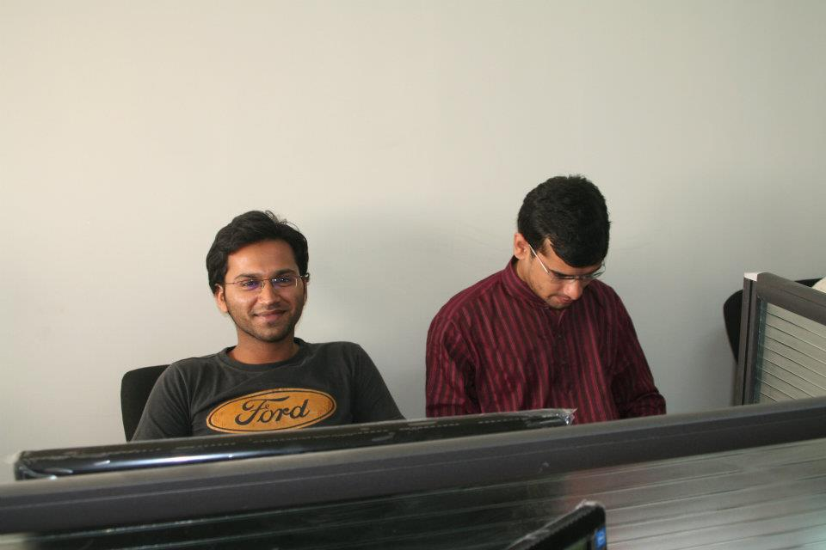It is in the fifth stage of this process that the interns who have successfully completed a number of mock projects are hired as fulltime junior developers. In this role, they are assigned to work with seasoned developers in a pair programming setup.

And finally, after successfully completing at least one customer project in the pair-programming environment is the developer deemed ready to take on customer projects independently. However, the training process for developers continues and does not end when he/she starts working independently for our clients/customers. Every 30 days the developer is required to pass at least one internal exam, failing which he/she is suspended till the exam is passed. Exception to this policy is only given if the suspension is not in the best interest of the customer or the project the developer may be working on. The exams requirements continue to accumulate every 30 days even during the exception period and the developer has to comply as soon as he or she becomes available.

We just celebrated the second birthday of Panacloud. During our third year we plan to reach out to over 15,000 potential candidates in five cities of the country and eventually admit 3,000 of them to our training program. Thus by the end of fiscal year 2015 we hope to become the sole company in the world with a large pool of quality software developers trained in the selected state-of-the-art technologies.

We are also building a web and mobile-based tool to allow any company to duplicate our business model. This tool will be integrated in our website, and will be freely available to everyone.

We have completed numerous projects, but to give you a feel of the quality of our work we will mention only few of our recent projects for our clients.

**Presentation Next, a Windows 8 App**

****In this project we have pushed the boundaries of what is possible with Html5/JavaScript.

You can install the Html5/JavaScript Windows 8 App from:

<http://apps.microsoft.com/windows/en-us/app/presentation-next/57c55802-1bdd-48c9-bf8b-e9e3c24cf051>

The app has been ranked Number One in the productivity app category, within one month of its release. Microsoft has also showcased it in the spotlight as well. It is currently being downloaded at the rate of thousands of installs per day.

For independent articles on the app please check out:

<http://www.html5report.com/topics/html5/articles/349400-presentation-next-html5-presentation-builder-now-available-windows.htm>

<http://slidehunter.com/create-movie-like-html5-presentations-windows-8-presentation-next/>

<http://blogs.msdn.com/b/mvpawardprogram/archive/2013/08/07/mvp-featured-app-presentation-next-a-cinematic-html5-presentation-builder.aspx>

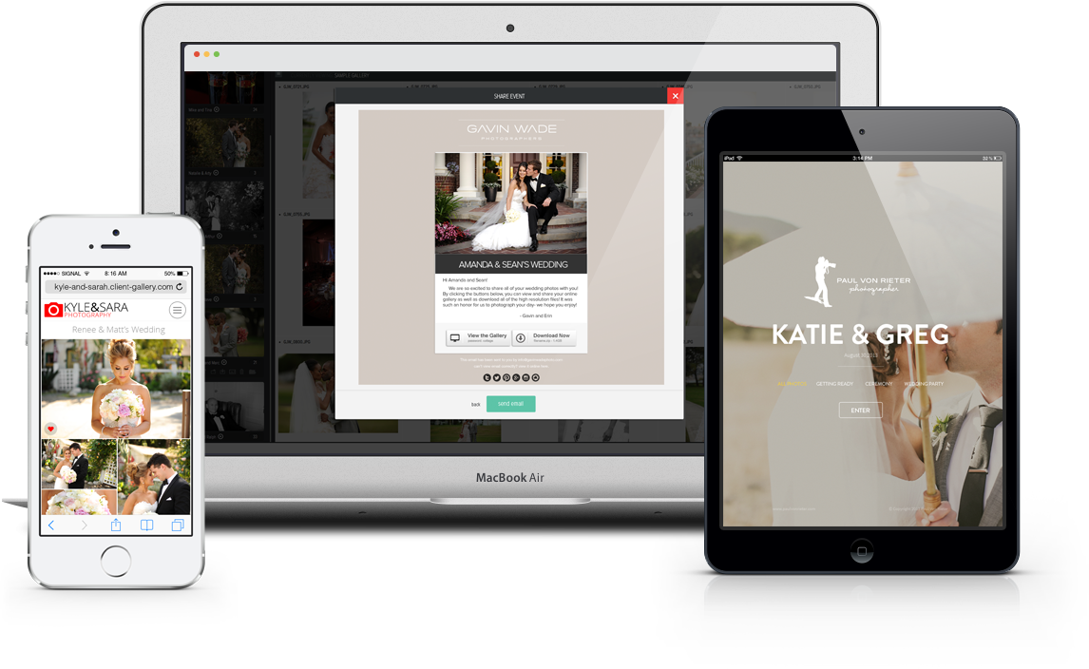**Web Based Responsive Image Gallery:**

Responsive image gallery is built with Angular, Bootstrap, Node.js and MongoDB technologies and is getting excellent reviews from the photographers: <http://www.onecloudpro.com/>

Here is a link to the main video, with links to the other tutorials in the description:

<https://vimeo.com/92950733>

Also, here is an intro video about the product that was created for a conference:

<https://vimeo.com/89644358>

**Web Based Educational Platform including an HTML5 Editor:**

We currently are working on an Educational Platform and HTML5 editor with AngularJS, Bootstrap, etc.:

<http://www.openpd.com>

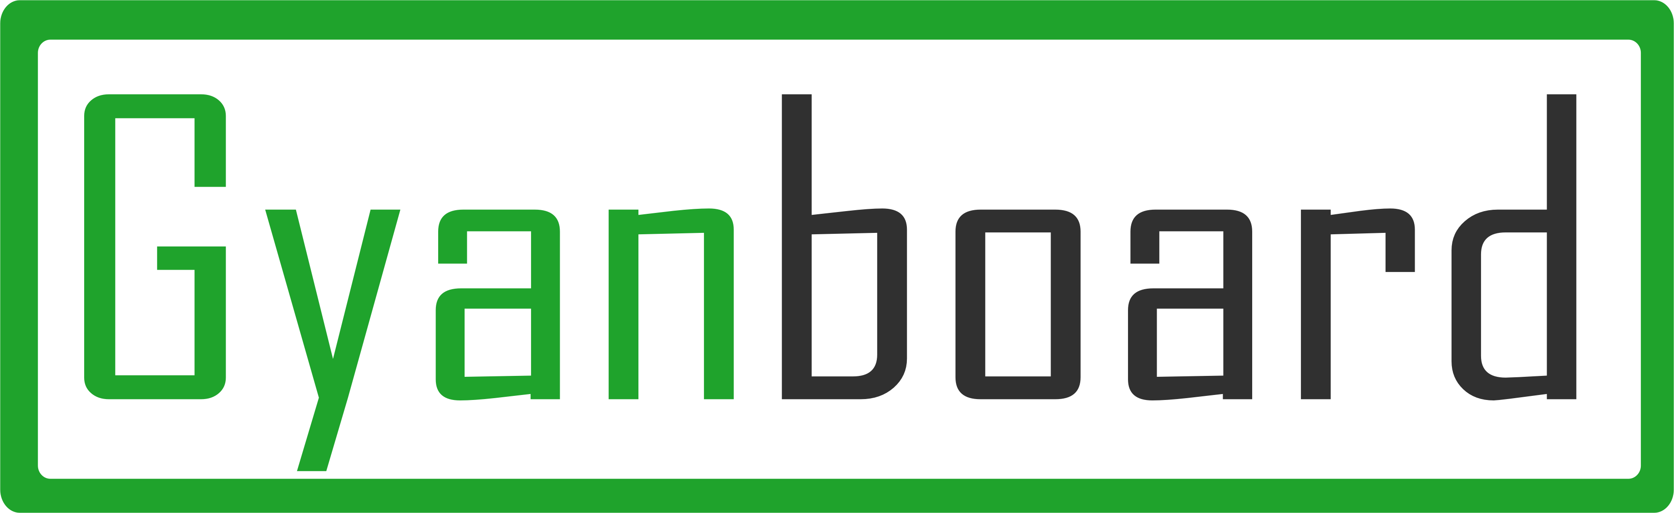**GyanBoard: Mobile Educational Portal**

https://www.elance.com/j/native-android-app/57484030/

GyanBoard is a mobile based education portal where user can create and join channels, post image, video and text in channel, view post from others, mark post as favorite. User can also create event and notify all others that event will also be stored in google calendar.

**Nativelie: Mobile English Learning App**



https://www.elance.com/j/mobile-app-using-phonegap-parse/51614858/

Nativelie is mobile based English learning app which help user to learn how to speak Consonant, Vowel, Word and Sentence. App provide audio and video tour for each category to help user. User can then practice what he/she learns and app will provide feedback about the accuracy and comparison relative to native speaker. App maintains the history of user to see how much user’s skill level improves by time.

**The Founder and Technical Lead:**

Mr. Zia Khan (<http://mvp.microsoft.com/en-us/MVP/Zia%20Khan-38505>) is the CEO and founder of Panacloud. He has a passion for cloud and mobile computing technologies. He has behind him more than fifteen years of experience in software architecture, design, development, implementation, and integration. Taught computer science to over 10,000 students and professionals worldwide. Triple Masters degrees in engineering (MSE), business (MBA), and accounting (MAC.) from the Arizona State University (ASU). Master of Arts (MA) in Economics from KU. Professional qualifications include Certified Public Accountant (CPA) and Certified Management Accountant (CMA). For the last 8 years Microsoft has consecutively presented him the Most Valuable Professional (MVP) award.