BAGBAG Luxury Catalog
Carry Your World In Style
This catalog supports the BAGBAG website download section. It presents selected categories using only supplied BAGBAG product and lifestyle assets.

Men's Bags
For work, travel, and smart casual routines
Sharp silhouettes, secure compartments, and minimal hardware designed for everyday confidence.
Product Image | Lifestyle Image
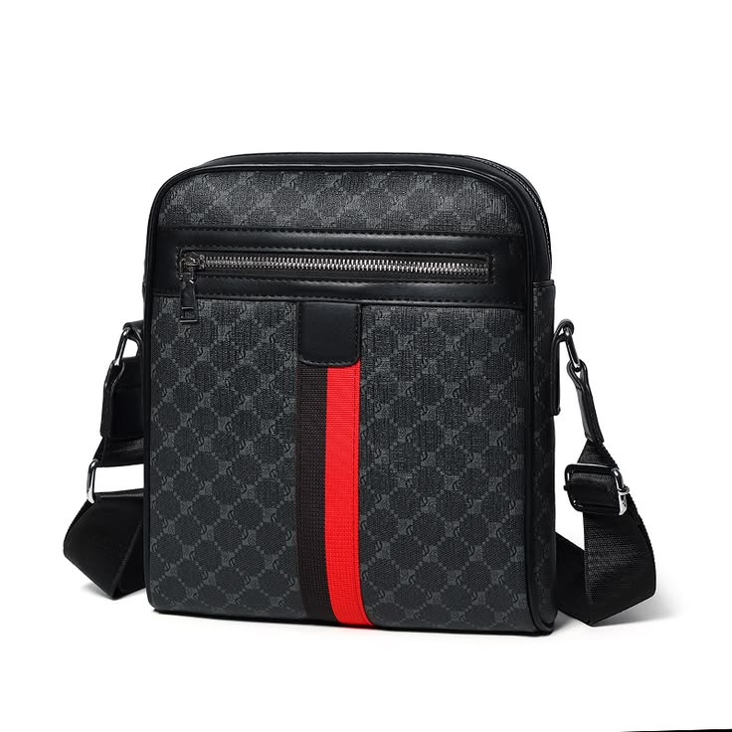 | 

Women's Bags
Clean lines for office and evening styling
Polished handbags with refined finishes, statement hardware, and a balanced luxury feel.
Product Image | Lifestyle Image
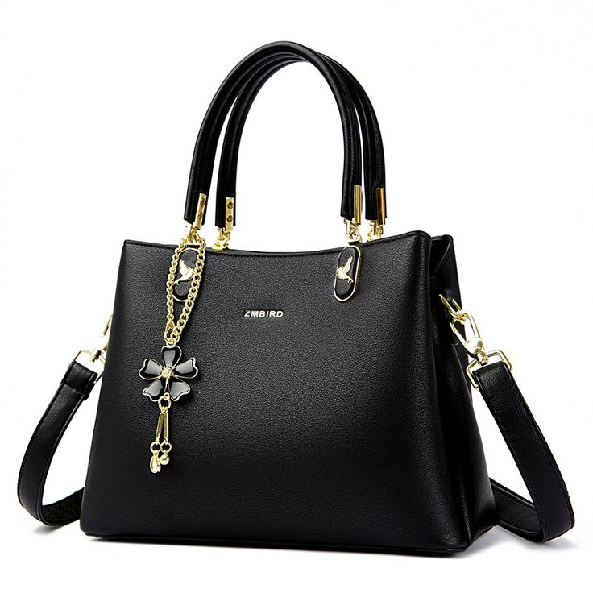 | 

Kids Bags
Soft colors, smart storage, school-ready comfort
Friendly kids backpacks with padded support, accessible pockets, and playful details.
Product Image | Lifestyle Image
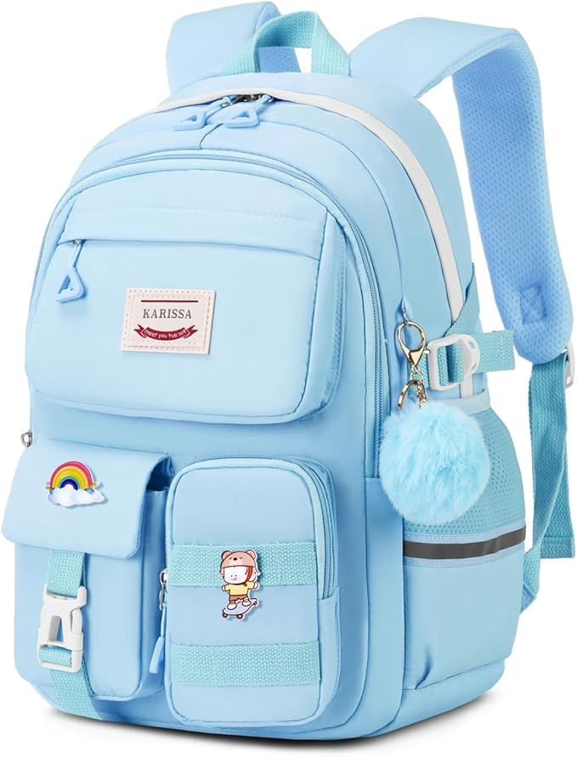 | 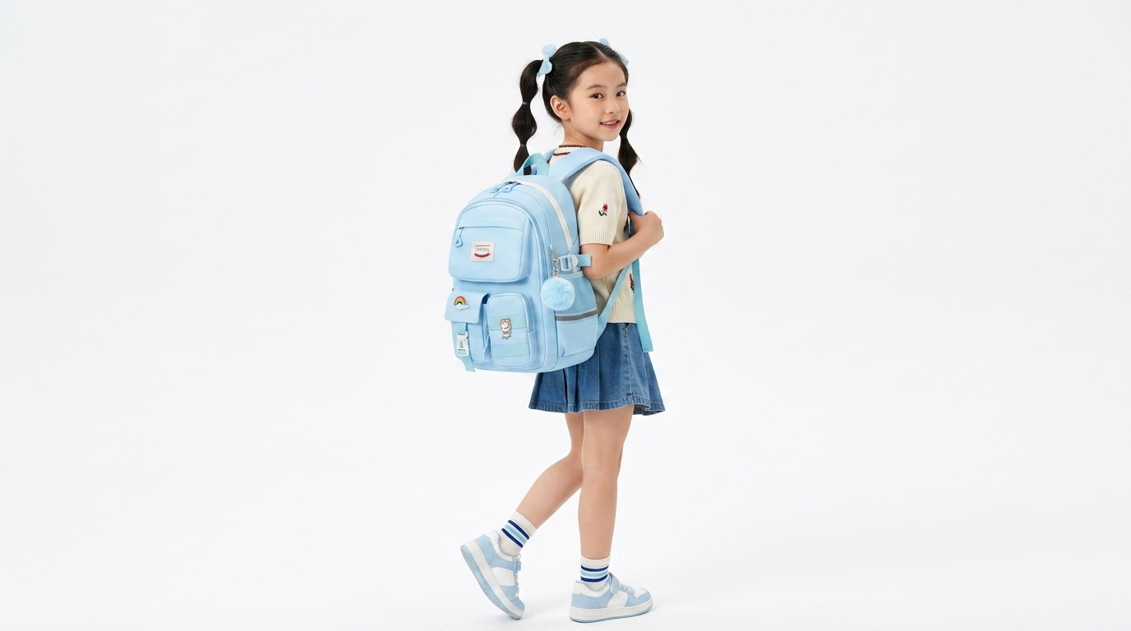

Hand Bags
A refined piece for polished outfits
Statement handbags made for visual impact, organized interiors, and everyday versatility.
Product Image | Lifestyle Image
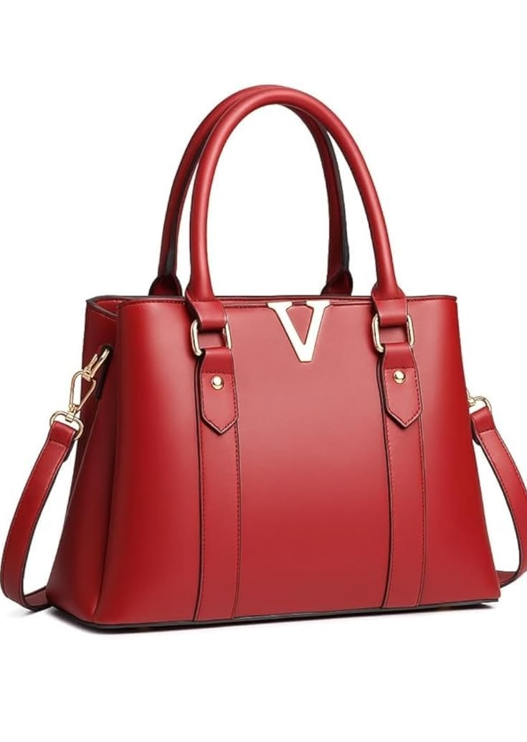 | 

Sling Bags
Hands-free movement with premium detail
Compact sling profiles for essentials, finished with premium texture and elegant zipper lines.
Product Image | Lifestyle Image
women-burgundy-sling-product.jpg | 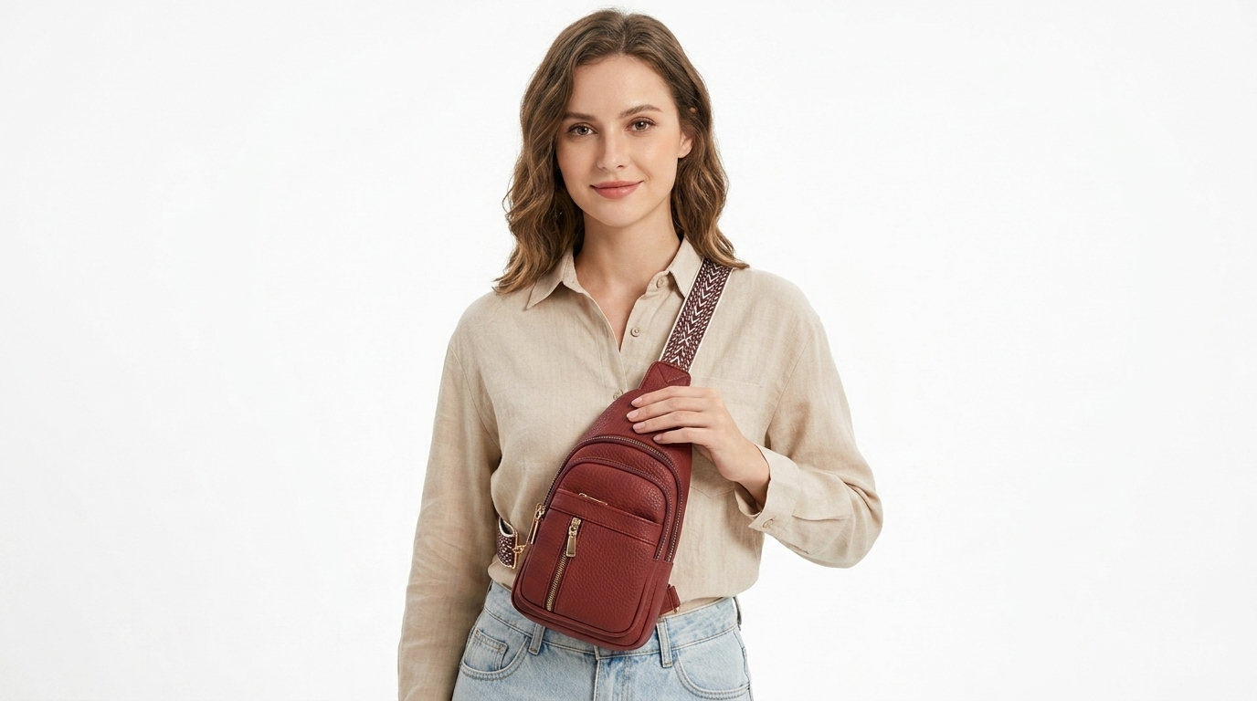

Backpacks
Soft structure for daily commute and light travel
Balanced silhouettes, secure closures, and spacious compartments for practical carry.
Product Image | Lifestyle Image
men-olive-backpack-product.jpg | 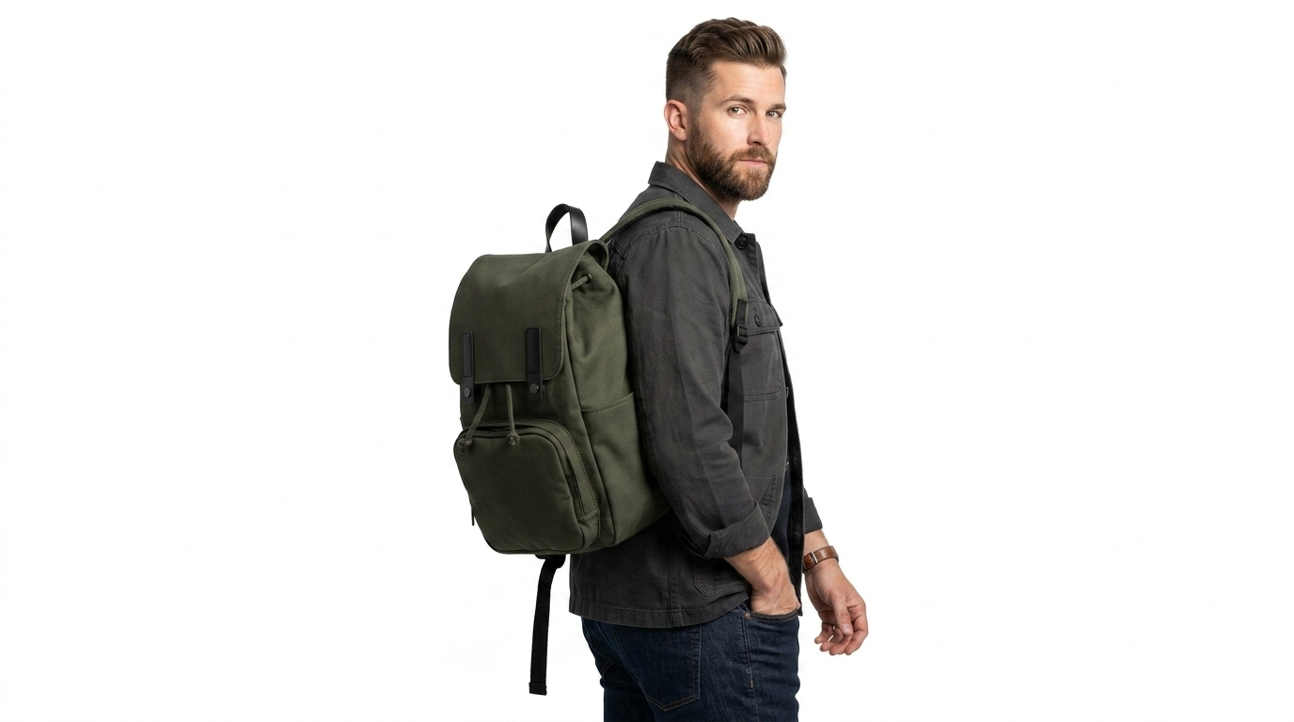

Travel Bags
Built for short trips and organized packing
Soft travel-ready storage with easy-access pockets and reliable carry comfort.
Product Image | Lifestyle Image
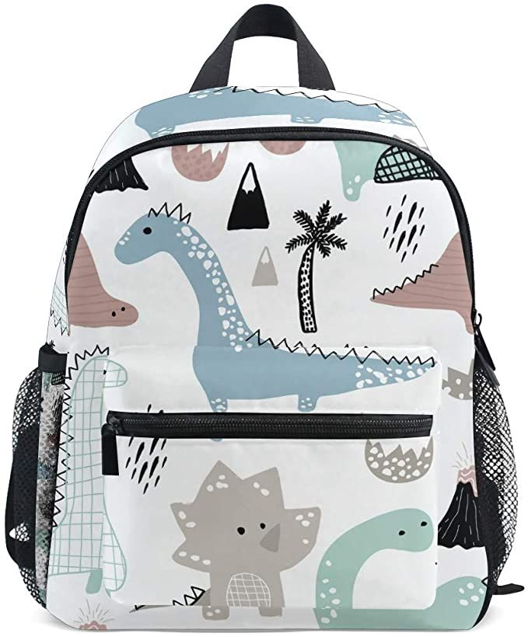 | 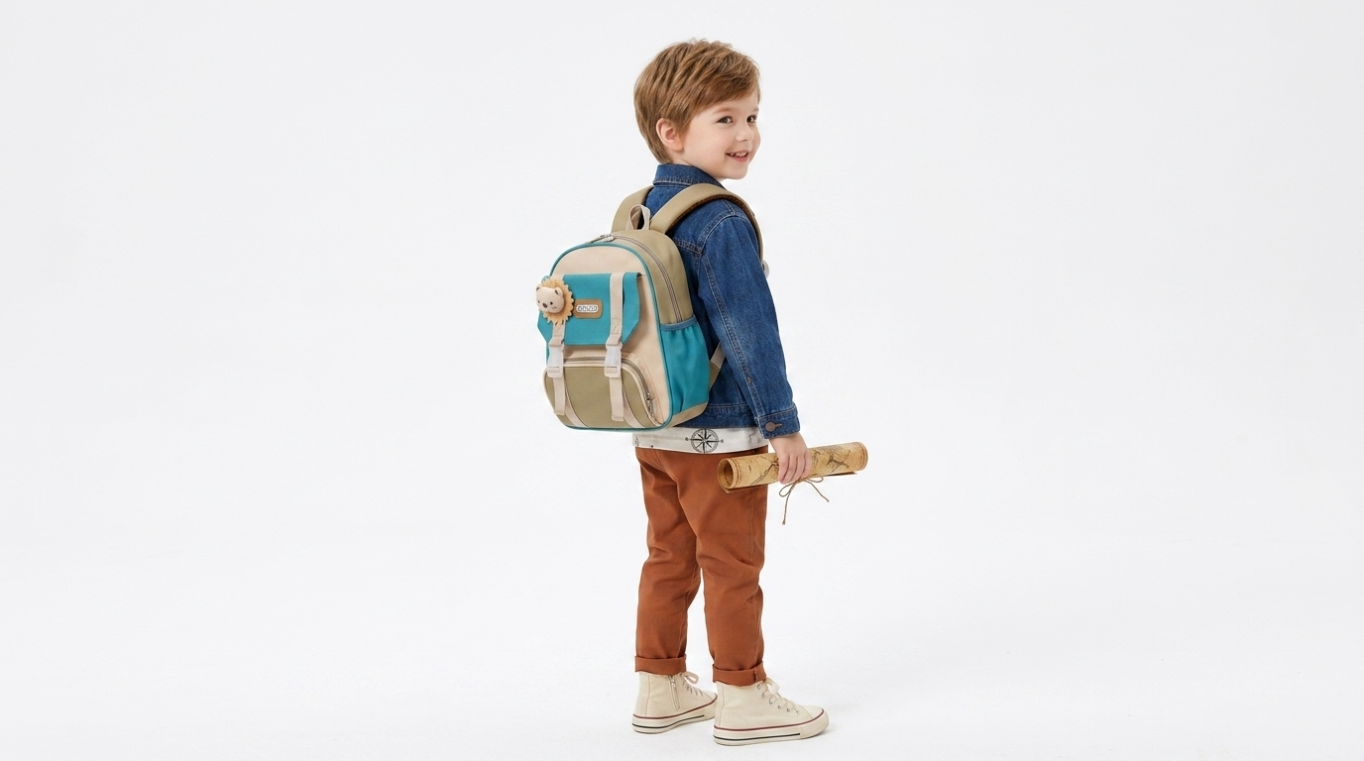

Office Bags
For meetings, errands, and everyday essentials
Slim, confident, and secure designs that pair easily with workwear and smart casual outfits.
Product Image | Lifestyle Image
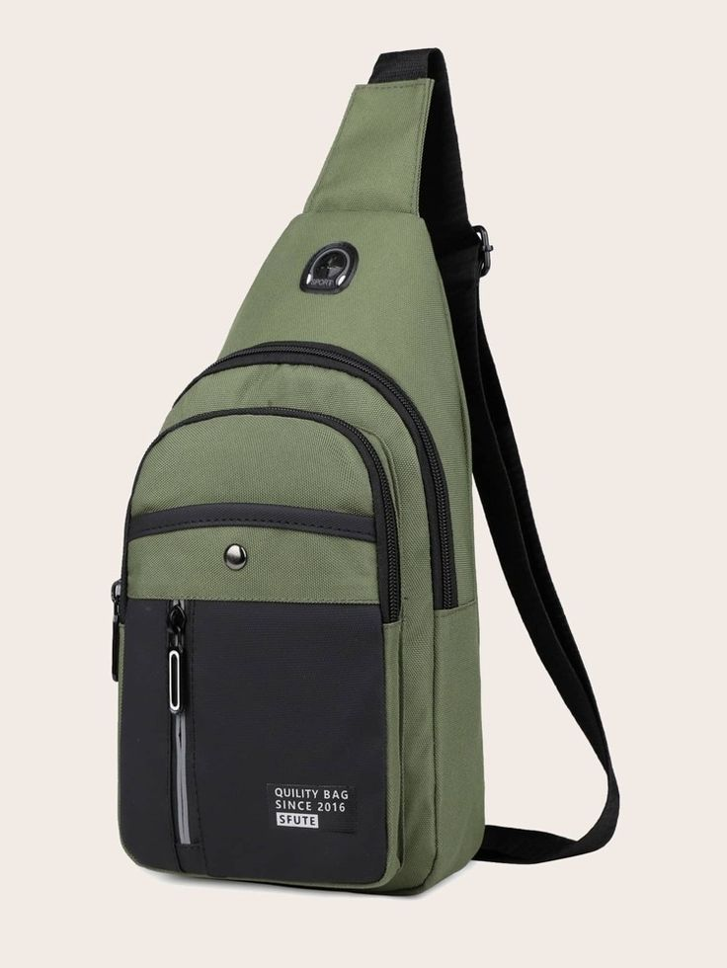 | 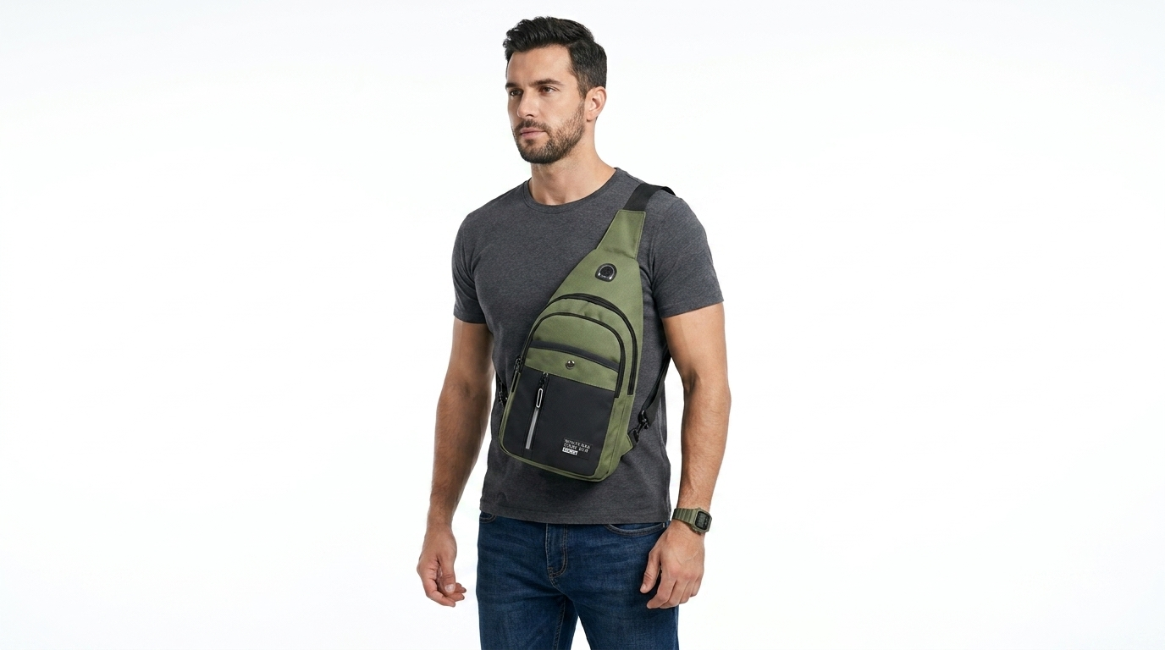

Laptop Bags
Structured space for devices and documents
A refined work carry story built around calm organization and easy everyday access.
Product Image | Lifestyle Image
men-olive-backpack-product.jpg

Contact
BAGBAG Flagship Studio, Karachi, Pakistan
Phone: +92 300 0000000
Email: hello@bagbag.store
Working Hours: Monday to Saturday, 10:00 AM - 8:00 PM

