NOTE: Please ignore the points at the start and the end as the beginning and end points of audio were also classified as spliced points due to large change in pitch at the beginning and end of the audio.
HAD 00001
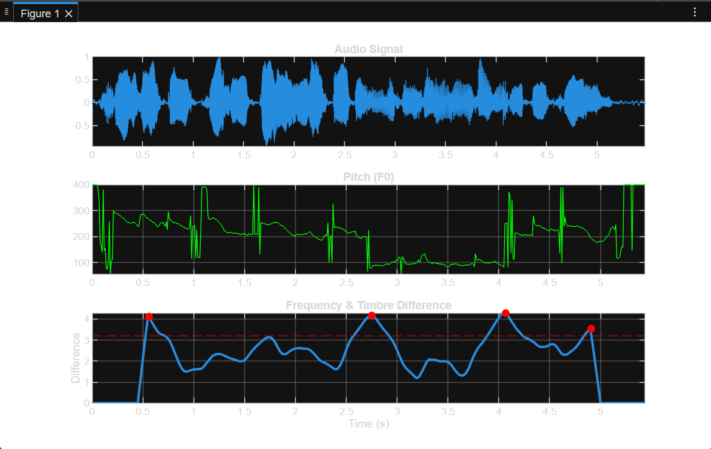
HAD 00002
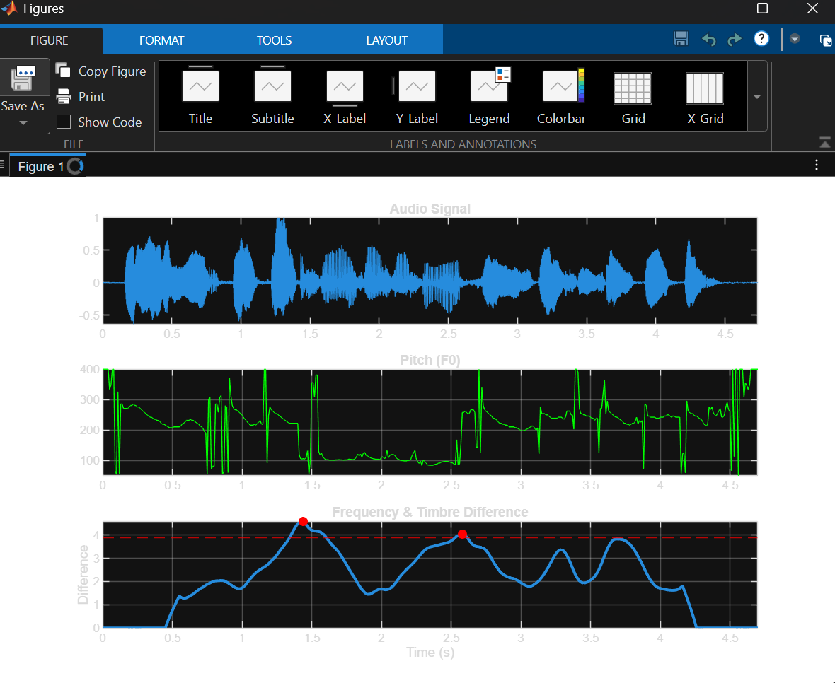
HAD 00003
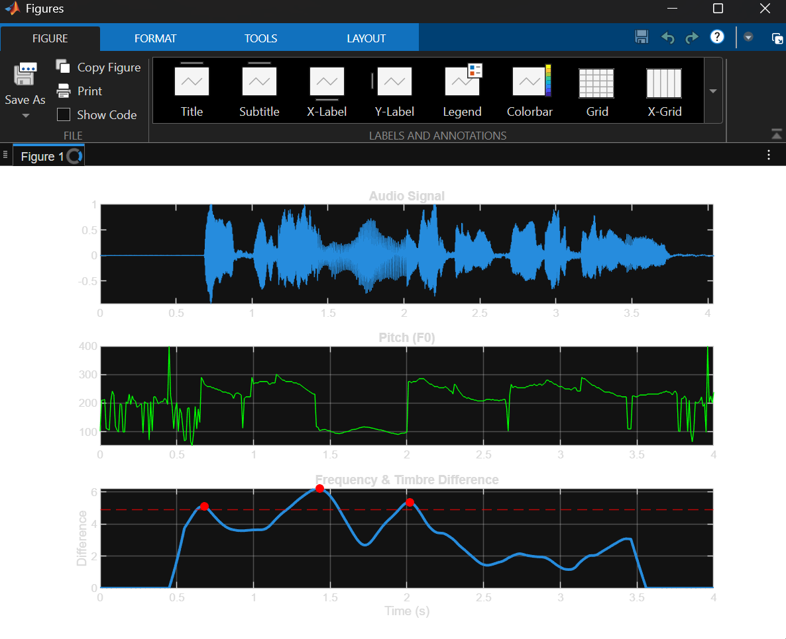
HAD 00005
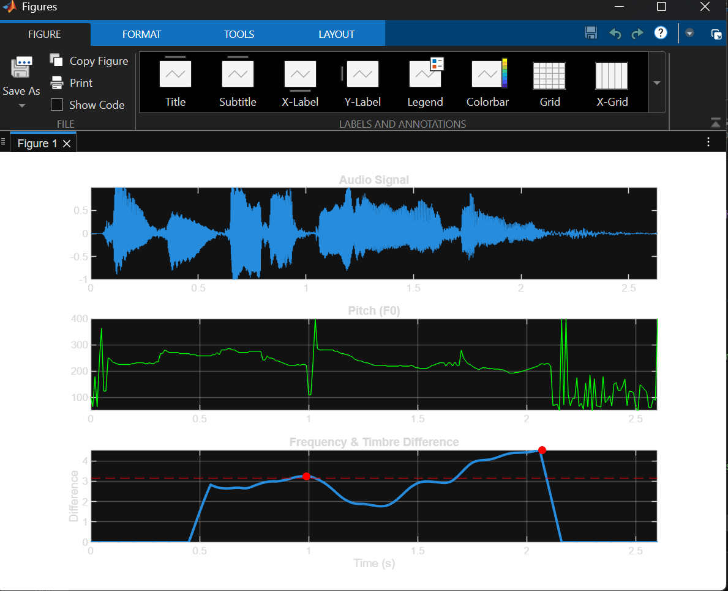
Had 00007
