DevOps Practicum with Jenkins, Docker, Kubernetes, and Ansible (NEXT JS)
Arkinov-Zhanbolat IT2-2211
https://github.com/MUNICIPALIST/RK2-todo-app REPO
Part 1: Docker
- Create a simple Spring Boot application (for ex ToDo or Online library) with a REST controller /tasks or /books
I’m creating Next js application
- Dockerfile of my application Create a Dockerfile to containerize the application:
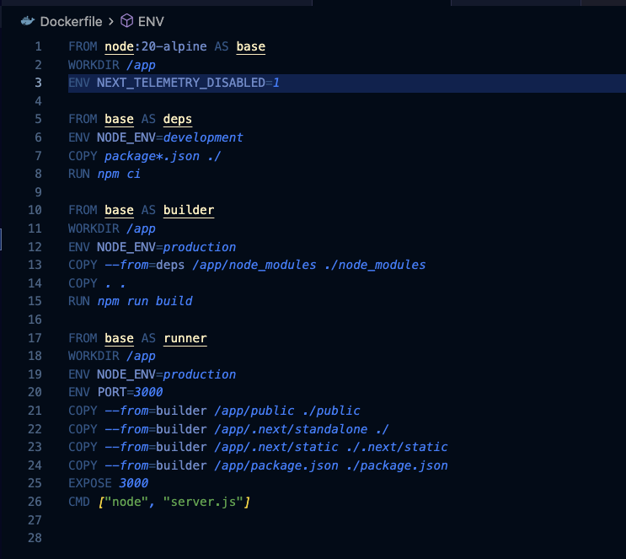
My web application
docker build -t web-app
Docker run -p 4000:4000 web-app
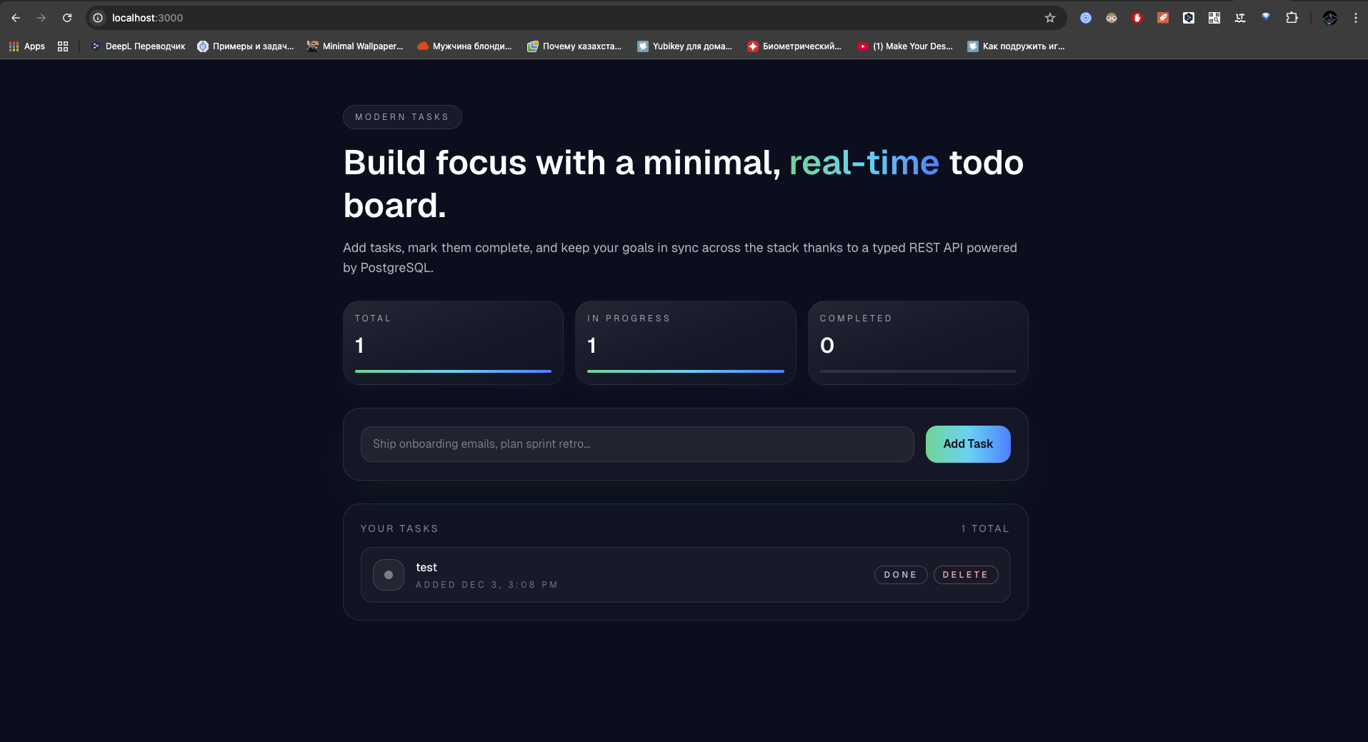

- Create a Docker Compose file
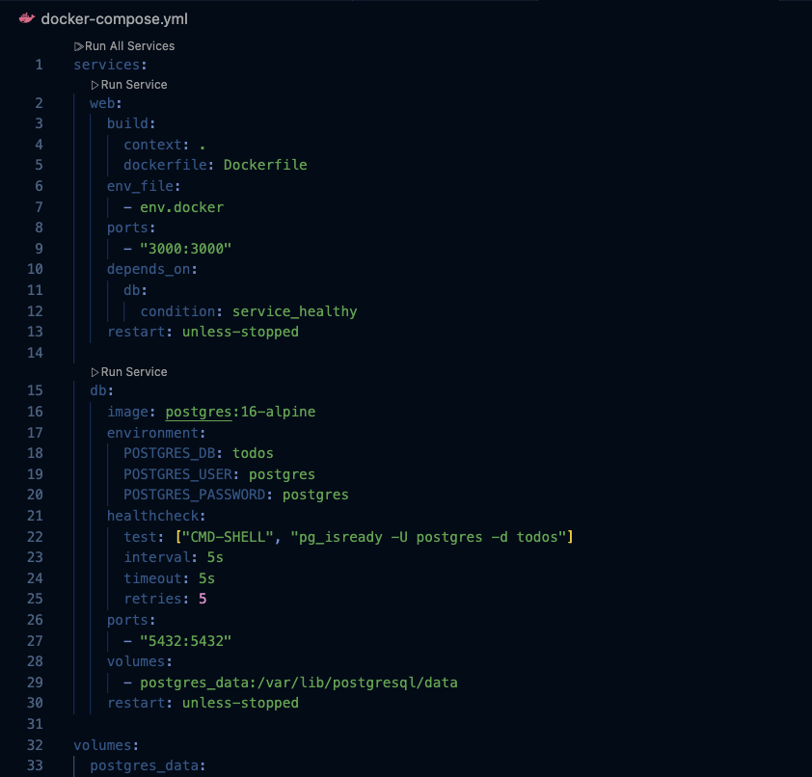

Docker images
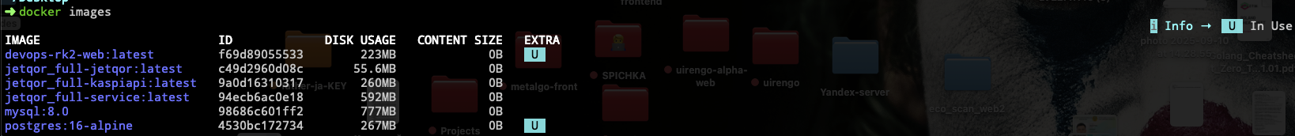

Part 2: Jenkins – CI/CD
- Install Jenkins.
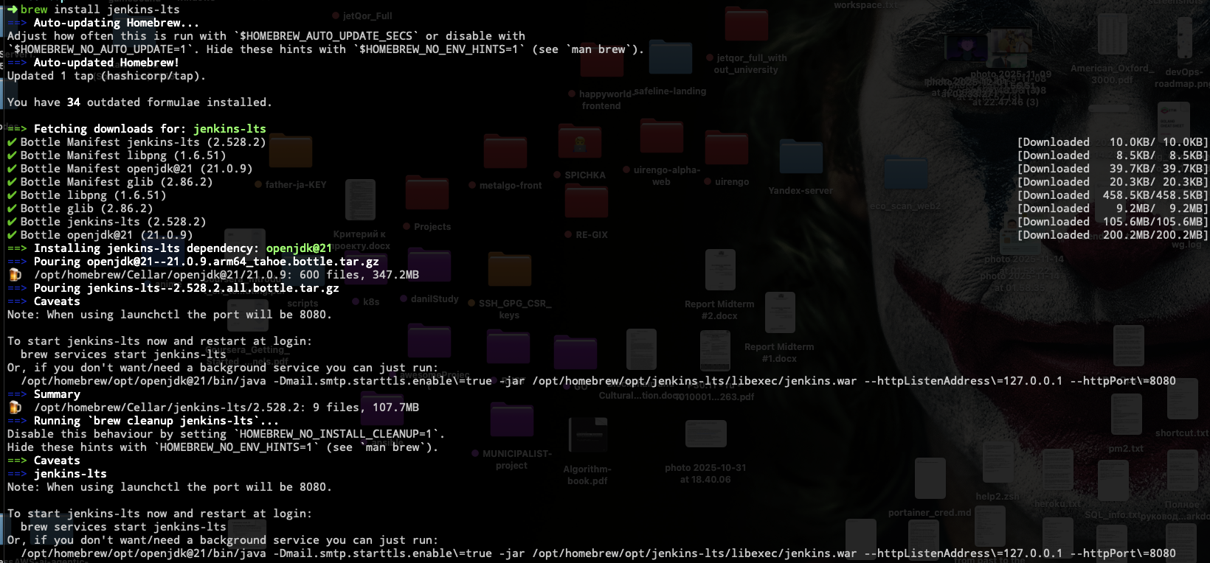

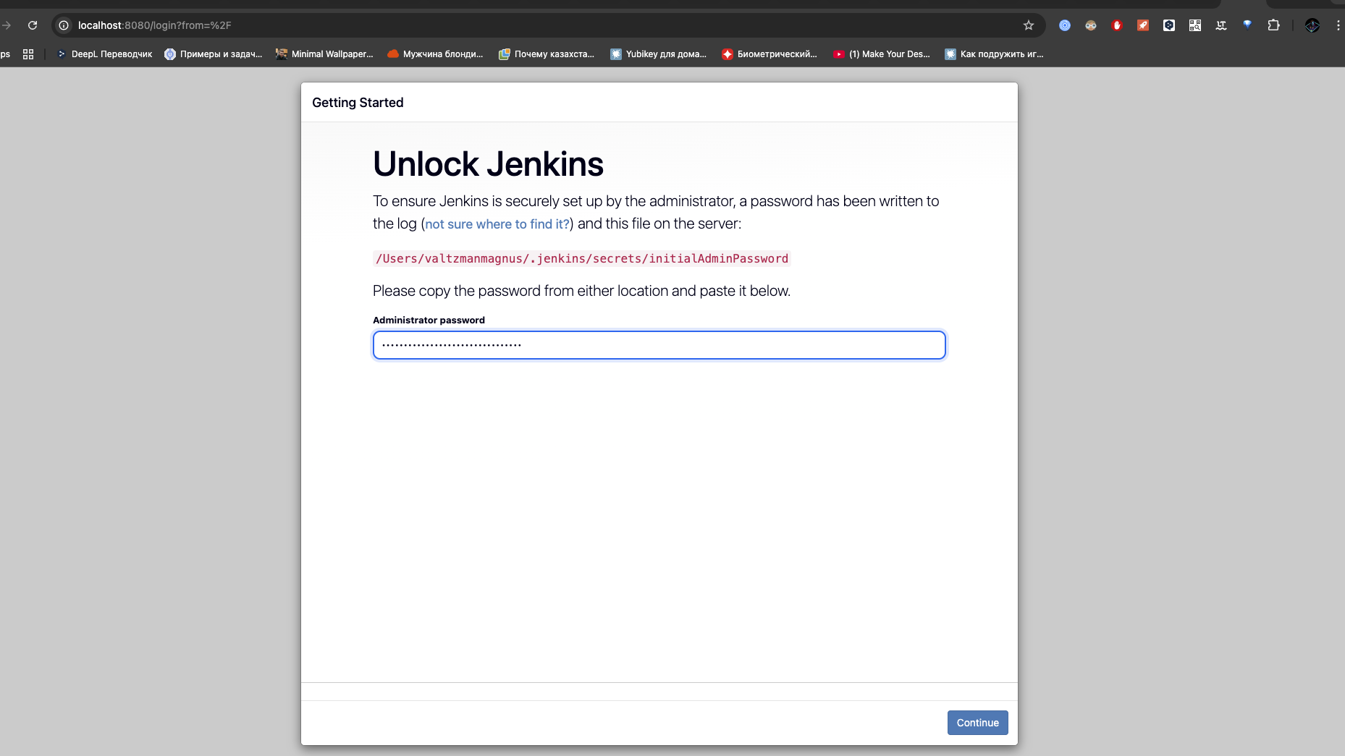
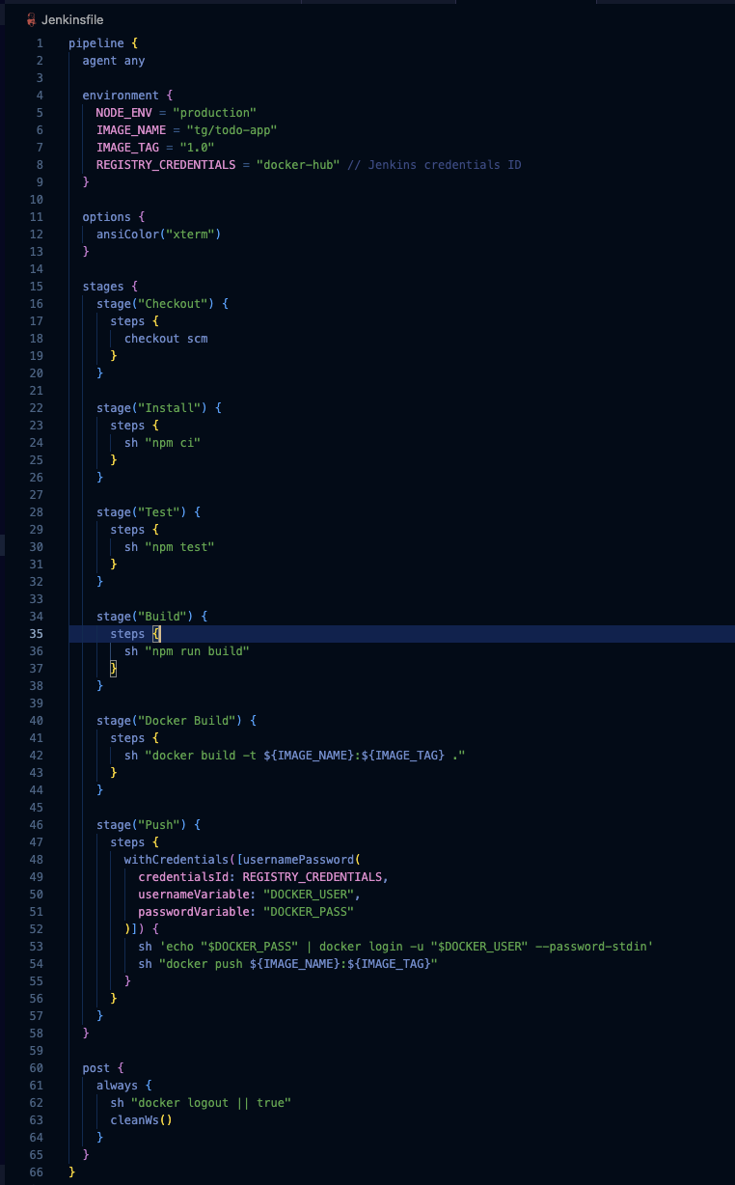
Build – build Spring Boot application:
mvn clean package
Docker Build – build Docker image:
docker build -t tg/todo-app:1.0 .
Test – run unit tests:
mvn test
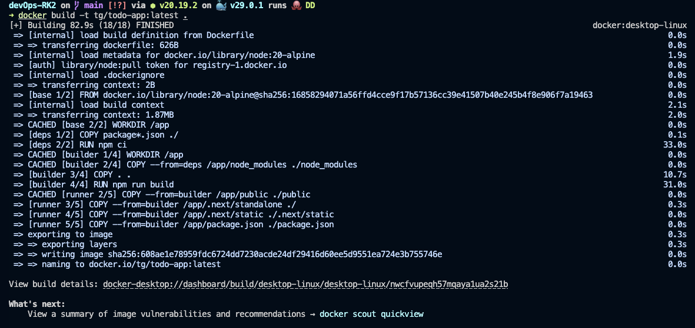
Push – push Docker image to registry:µ
docker tag tg/todo-app:1.0 tg/todo-app:1.0
docker push tg/todo-app:1.0
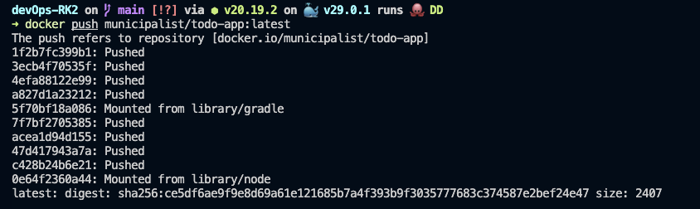
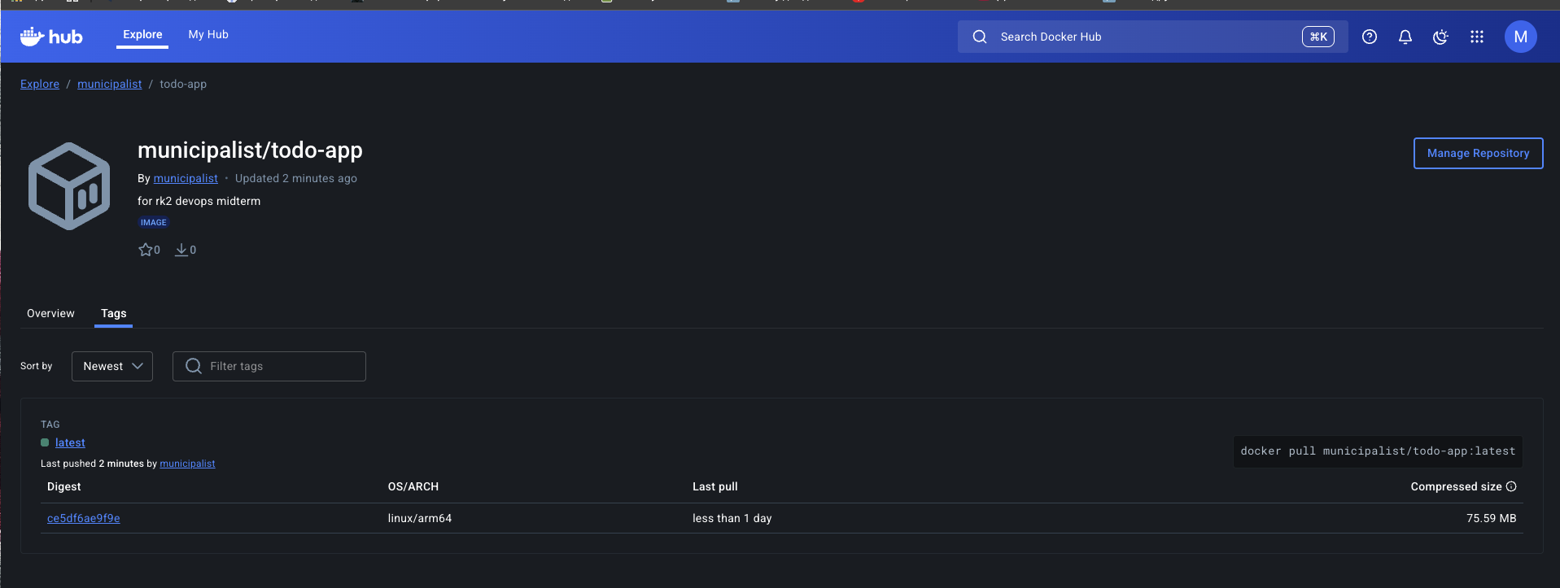

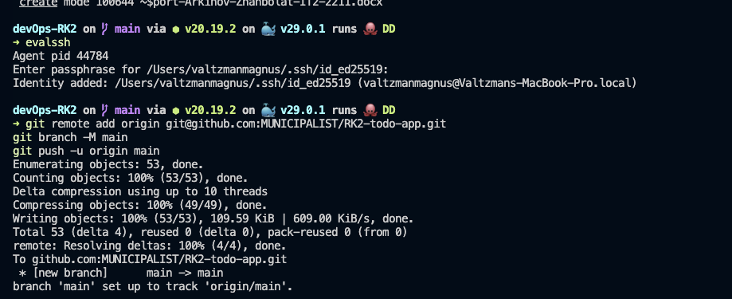

Part 3: Kubernetes
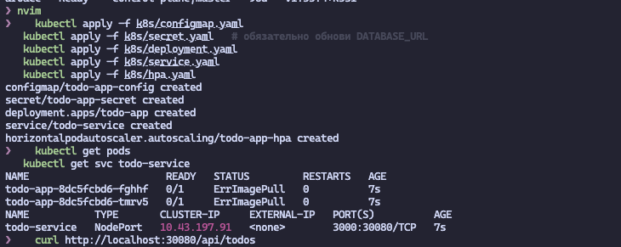

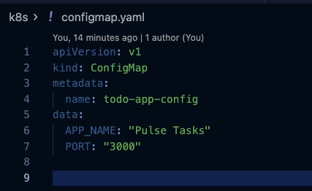
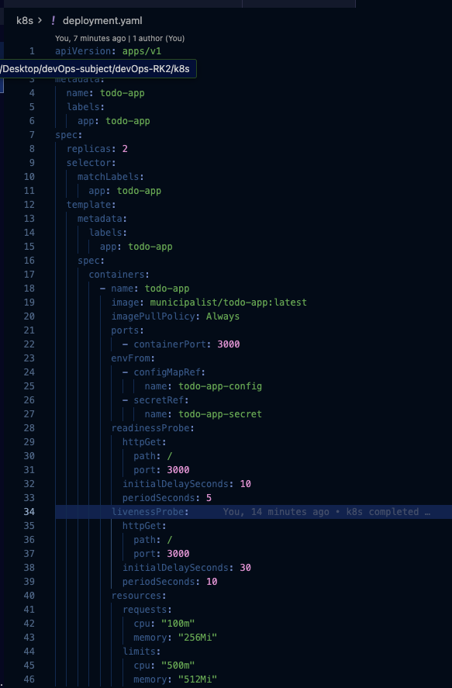
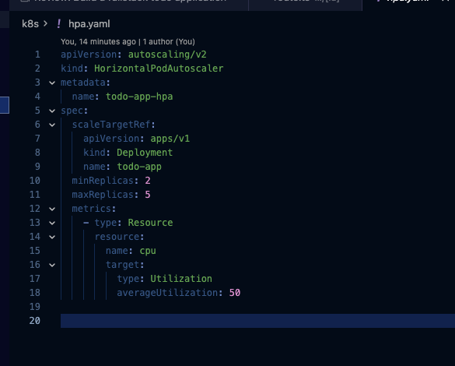
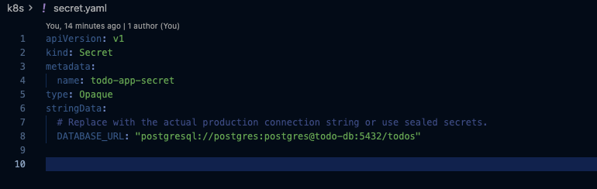
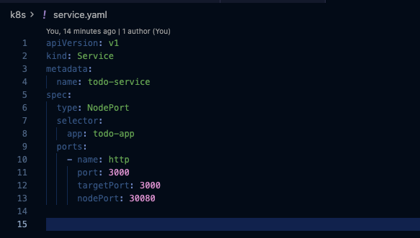
kubectl get pods
kubectl get svc
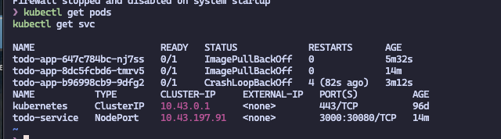
- Horizontal Pod Autoscaling (HPA)
Configure automatic scaling of the Deployment based on CPU usage:

Part 4: Ansible
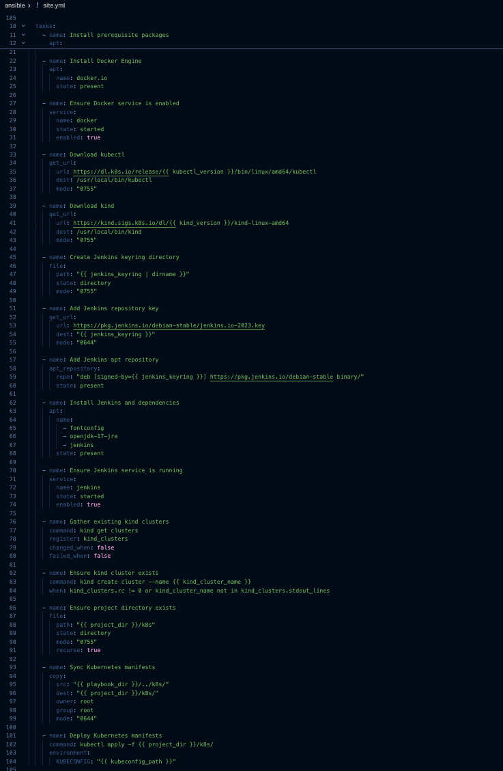
Conclussion
- Application: Built “Pulse Tasks,” a modern Next.js + PostgreSQL todo board with a rich Tailwind UI, typed REST endpoints, and server-side validation. It supports full CRUD over /api/todos, auto-provisions the todos table, and ships in production mode via Next’s standalone output.
- Docker: Added Dockerfile_Arkinov_Zhanbolat and docker-compose_Arkinov_Zhanbolat.yml, so the app and PostgreSQL spin up together. The Docker image (municipalist/todo-app:latest) is ready for pushes/pulls and used consistently across the stack.
- Jenkins: Jenkinsfile_Arkinov_Zhanbolat defines the CI pipeline: checkout → npm ci → npm test → npm run build → Docker build → Docker Hub push with stored credentials. Running this job produces the deployable image automatically.
- Kubernetes: Under k8s/ live ConfigMap/Secret/Deployment/Service/HPA manifests (all suffixed with Arkinov_Zhanbolat). They deploy two replicas of the Docker image, expose it via NodePort 30080, and autoscale between 2–5 pods at 50 % CPU.
• • Ansible: ansible/playbook_Arkinov_Zhanbolat.yml provisions a fresh Ubuntu host—installs Docker, kubectl, kind, Jenkins, creates a kind cluster, syncs the Kubernetes manifests, and applies them. The playbook is idempotent and tied to ansible/inventory.ini.

