**EX.NO:** 1  **CALENDAR OF A GIVEN**

**DATE:**13.10.2020 **MONTH AND YEAR**

**AIM:**

To write a Python program to print the calendar for given month and year

**PROGRAM:**

import calendar

Year = int(input())

Month = int(input())

if ( Year >= 1000 and Year <= 9999 ) and ( Month >= 1 and Month <=12 ) :

print(calendar.month(Year,Month))

else:

print("Invalid Input")

**LINK:** [http://103.53.53.18/mod/vpl/forms/edit.php?id=229&userid=1789#](http://103.53.53.18/mod/vpl/forms/edit.php?id=229&userid=1789)

**OUTPUT:**

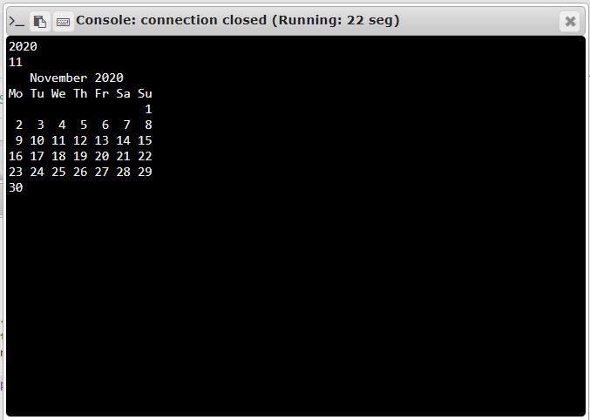

**RESULT:**

The Calendar of the given month and year is printed successfully.