**EX.NO:** 10 **NUMBER OF**

**DATE:**21.11.2020 **UPPER CASE AND LOWER CASE**

**AIM:**

To write a Python program to count the number of uppercase and lowercase in string

**PROGRAM:**

def string_test(s):

d={"UPPER_CASE":0,"LOWER_CASE":0}

uc,lc=0,0

for i in s:

if i.isupper() :

uc+=1

elif i.islower() :

lc+=1

d["UPPER_CASE"]=uc

d["LOWER_CASE"]=lc

print("No. of Upper case characters : ",d["UPPER_CASE"])

print("No. of Lower case characters : ",d["LOWER_CASE"])

s=input()

n=string_test(s)

**LINK:** <http://103.53.53.18/mod/vpl/forms/edit.php?id=325&userid=1789#>

**OUTPUT:**

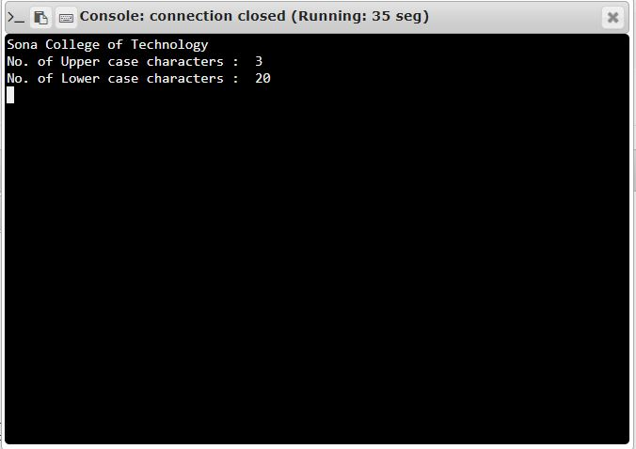

**RESULT:**

The Number of Uppercase and Lowercase of a string is printed successfully.