**EX.NO:** 11  **THE GREATEST COMMON DIVISOR**

**DATE :** 21.11.2020 **OF TWO INTEGERS**

**AIM:**

To write a Python program to print the GCD(Greatest Common Divisor) of two integers

**PROGRAM:**

def gcd(a,b):

while b!=0 :

s=a%b

a=b

b=s

return a

a=int(input("Enter first number:"))

b=int(input("Enter second number:"))

GCD=gcd(a,b)

print("GCD is: ")

print(GCD)

**LINK:** <http://103.53.53.18/mod/vpl/forms/edit.php?id=326&userid=1789#>

**OUTPUT:**

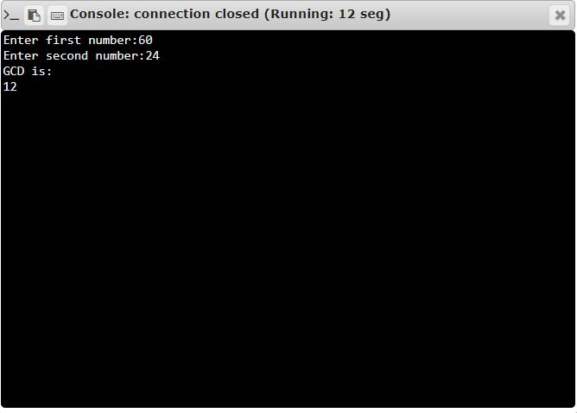

**RESULT:**

The GCD of the given integers is printed successfully.