**EX.NO:** 13  **APPAREL SHOP MANAGEMENT**

**DATE:** 23.11.2020

**AIM:**

To write a Python program to print the desired price in apparel shop

**PROGRAM:**

class Apparel:

counter = 100

def __init__(self, price, item_type):

Apparel.counter += 1

self.__item_id = item_type[0] + str(Apparel.counter)

self.__price = price

self.__item_type = item_type

def calculate_price(self):

self.__price += self.__price * 0.05

def get_price(self):

return self.__price

def set_price(self, price):

self.__price = price

return self.__price

class Cotton(Apparel):

def __init__(self, price, discount):

super().__init__(price, 'C')

self.__discount = discount

def calculate_price(self):

super().calculate_price()

price = self.get_price()

price -= price * (self.__discount / 100)

price += price * 0.05

self.set_price(price)

return price

class Silk(Apparel):

def __init__(self, price):

super().__init__(price, 'silk')

self.__points = None

def calculate_price(self):

super().calculate_price()

if (self.get_price() > 10000):

self.__points = 10

else:

self.__points = 10

return self.set_price(self.get_price() + (self.get_price() * 0.1))

silk = int(input())

cotton = int(input())

discount = int(input())

a = Silk(silk)

print(a.calculate_price())

b = Cotton(cotton, discount)

print(b.calculate_price())

**LINK:** <http://103.53.53.18/mod/vpl/forms/edit.php?id=328&userid=1789#>

**OUTPUT:**

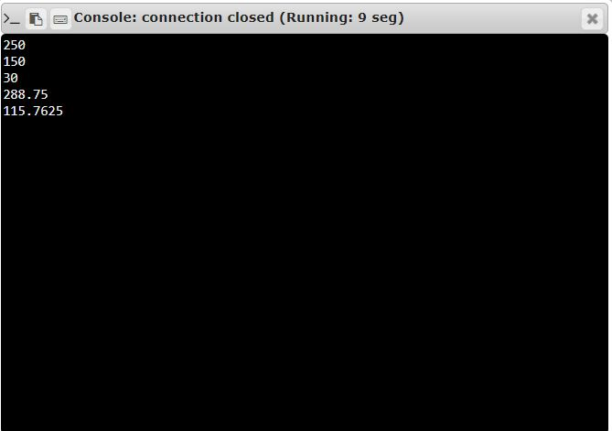

**RESULT:**

The Desired price is calculated and printed successfully.