**EX.NO:** 14  **VALIDITY OF A STRING**

**DATE :** 21.11.2020 **OF PARENTHESES**

**AIM:**

To write a Python program to find validity of a string of parentheses

**PROGRAM:**

def areBracketsBalanced(expr):

stack=[0,0,0]

opened=[0,0,0]

for i in expr:

if i=='(' :

stack[0]+=1

opened[0]=1

if i=='[' :

stack[1]+=1

opened[1]=1

if i=='{' :

stack[2]+=1

opened[2]=1

if i==')' and opened[0]==1 :

stack[0]-=1

if i==']' and opened[1]==1 :

stack[1]-=1

if i=='}' and opened[2]==1 :

stack[2]-=1

if stack[0]==0 and stack[1]==0 and stack[2]==0 :

return True

else:

return False

if __name__=="__main__":

expr=input()

if areBracketsBalanced(expr):

print("valid")

else:

print("invalid")

**LINK:** [http://103.53.53.18/mod/vpl/forms/edit.php?id=327&userid=1789#](http://103.53.53.18/mod/vpl/forms/edit.php?id=327&userid=1789)

**OUTPUT:**

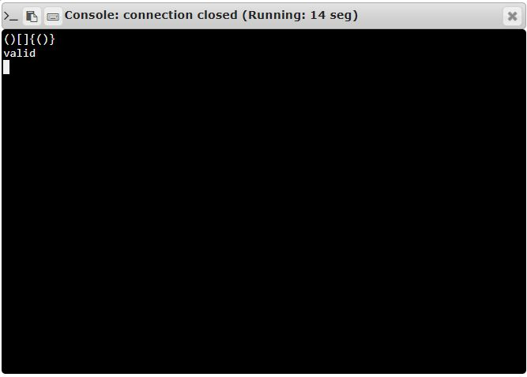

**RESULT:**

The Validity of a string of a parentheses is checked successfully.