**EX.NO:** 2 **COUNT THE OCCURRENCE FOR GIVEN**

**DATE:**13.10.2020 **NUMBER IN A LIST**

**AIM:**

To write a Python program to count the number of occurrence of the given number in a given list

**PROGRAM:**

def countX(lst,x) : return lst.count(x)

lst,x=[],0

n=int(input())

for i in range(0,n) : x = int(input()); lst.append(x)

x=int(input())

print(countX(lst,x))

**LINK:** <http://103.53.53.18/mod/vpl/forms/edit.php?id=230&userid=1789#>

**OUTPUT:**

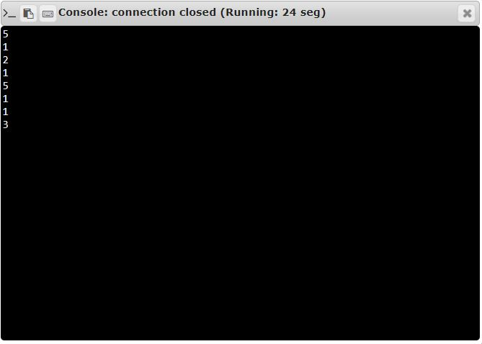

**RESULT:**

The Python Program to count the occurrence of number is executed successfully.