**EX.NO:** 3 **REMOVE AND PRINT EVERY SECOND**

**DATE:**13.10.2020 **NUMBER FROM A LIST**

**AIM:**

To write a Python program to remove and print every second number from a list.

**PROGRAM:**

def removeThirdNumber(list1) :

list2,x = [],0

for i in range(0,len(list1)) : x = (x+1) % len(list1); num = list1.pop(x); list2.append(num)

return list2

n = int(input())

list1 = []

for i in range(0,n) : a = int(input()); list1.append(a)

print(removeThirdNumber(list1))

**LINK:** [http://103.53.53.18/mod/vpl/forms/edit.php?id=231&userid=1789#](http://103.53.53.18/mod/vpl/forms/edit.php?id=231&userid=1789)

**OUTPUT:**

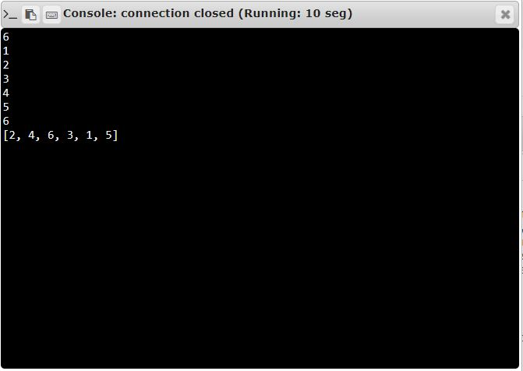

**RESULT:**

Every Second number from a list until list becomes empty is obtained successfully.