**EX.NO:** 4 **SWAP AND PRINT THE CHARACTER**

**DATE:**13.10.2020 **FROM TWO SET OF STRINGS**

**AIM:**

To write a Python program to print a string by swapping first two characters of two set of strings.

**PROGRAM:**

def StrSwap(a,b) : return ( b[:2] + a[2:] ) + ' ' + ( a[:2] + b[2:] )

x=str(input())

y=str(input())

x=x.strip()

y=y.strip()

if len(x) < 2 or len(y) < 2 :

print("Invalid")

else :

print(StrSwap(x,y))

**LINK:** [http://103.53.53.18/mod/vpl/forms/edit.php?id=234&userid=1789#](http://103.53.53.18/mod/vpl/forms/edit.php?id=234&userid=1789)

**OUTPUT:**

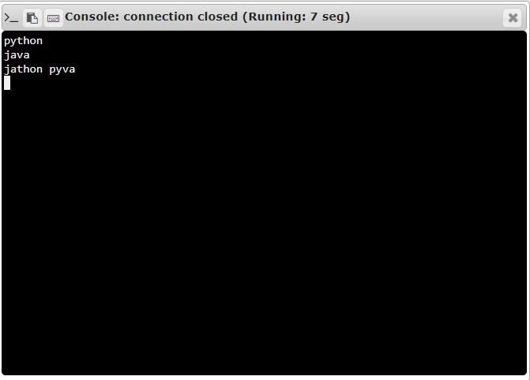

**RESULT:**

The First two characters of two set of string is swapped and printed as single string successfully.