**EX.NO:** 5 **PRINT THE MISSING CHARACTERS**

**DATE:**14.10.2020 **TO MAKE STRING PANGRAM**

**AIM:**

To write a Python program to print missing characters to make a string pangram.

**PROGRAM:**

s1 = input()

s1 = s1.lower()

s1 = set(s1.strip())

s2 = set("abcdefghijklmnopqrstuvwxyz")

s = list(s2.difference(s1))

s.sort()

print("".join(s))

**LINK:** <http://103.53.53.18/mod/vpl/forms/edit.php?id=235&userid=1789#>

**OUTPUT:**

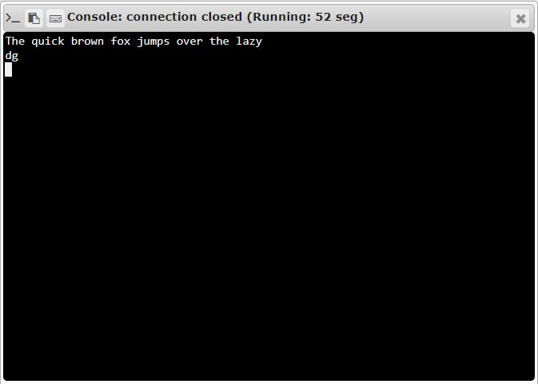

**RESULT:**

The Program to print the missing characters to make string pangram is executed successfully.