**EX.NO:** 8  **SORTING THE LIST**

**DATE :** 23.11.2020 **OF TUPLES**

**AIM:**

To write a Python program to print the sorted list of tuple

**PROGRAM:**

n,list1,list2=int(input()),[],[]

for i in range(0,n):

m=int(input())

list1.append(m)

for i in range(0,n):

t=(list1[i],(list1[i]**3))

list2.append(t)

print(list2)

list2.sort()

print(list2)

**LINK:** [http://103.53.53.18/mod/vpl/forms/edit.php?id=317&userid=1789#](http://103.53.53.18/mod/vpl/forms/edit.php?id=317&userid=1789)

**OUTPUT:**

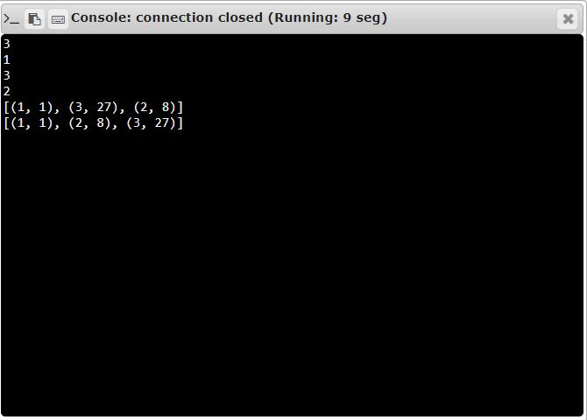

**RESULT:**

The Sorted list of tuples is printed successfully.