Question 1

**package** day_3;

**import** java.util.*;

**public** **class** question_1 {

**public** **static** **void** main(String[] args) {

Scanner num = **new** Scanner(System.***in***);

System.***out***.println("enter marks");

**int** marks = num.nextInt();

**if**( marks < 101 && marks >= 0) {

String result = marks > 40 ? "Pass" : "Fail";

System.***out***.println("Result :" + result);

}

**else** {

System.***out***.println("Invalid");

}

}

}

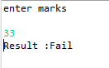

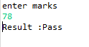

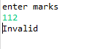

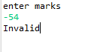

Question 2

**package** day_3;

**import** java.util.*;

**public** **class** question_2 {

**public** **static** **void** main(String[] args) {

Scanner num = **new** Scanner(System.***in***);

System.***out***.println("enter a number");

**float** number = num.nextFloat();

String result;

**if**( number == 0) {

result = "neither";

}

**else**{

result = number > 0 ? "Positive Number" : "Negative Number";

}

System.***out***.println("Result :" + result);

}

}



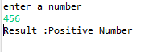

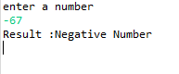

Question 3

**package** day_3;

**import** java.util.*;

**public** **class** question_3 {

**public** **static** **void** main(String[] args) {

Scanner employee = **new** Scanner(System.***in***);

System.***out***.println("enter name,age,salary (give first and last name and separate categories by space)");

System.***out***.println("name :" + employee.next() + " " + employee.next() + "\n" + "age :" + employee.next() + "\n" + "salary :" + employee.next());

employee.close();

}

}

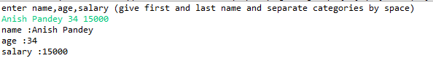

Question 4

**package** day_3;

**import** java.util.*;

**public** **class** question_4 {

**public** **static** **void** main(String[] args) {

Scanner numbers = **new** Scanner(System.***in***);

System.***out***.println("enter two numbers (separate them with single space)");

**float** number_1 = numbers.nextFloat();

**float** number_2 = numbers.nextFloat();

**if**(number_1 > number_2) {

System.***out***.println("greater number is " + number_1);

}

**else** **if**(number_1 == number_2) {

System.***out***.println("number is " + number_1 + ". They are equal.");

}

**else** {

System.***out***.println("greater number is " + number_2);

}

numbers.close();

}

}

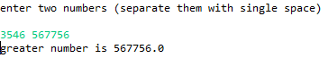

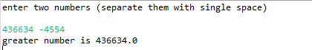

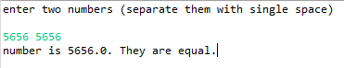

Question 5

**package** day_3;

**import** java.util.*;

**public** **class** question_5 {

**public** **static** **void** main(String[] args) {

Scanner p_name = **new** Scanner(System.***in***);

System.***out***.println("enter product name");

String product = p_name.nextLine();

Scanner price = **new** Scanner(System.***in***);

System.***out***.println("enter price(positive numeric value)");

**double** product_price = price.nextDouble();

**if** (product_price > 2000) {

**double** discounted_price = product_price * 0.9;

System.***out***.println("product name : " + product + "\n");

System.***out***.println("product price : " + discounted_price);

}

**else** **if** (product_price <= 2000 && product_price > 0) {

**double** discounted_price = product_price * 0.93;

System.***out***.println("product name : " + product + "\n");

System.***out***.println("product price : " + discounted_price);

}

**else** {

System.***out***.println("invalid price");

}

p_name.close();

price.close();

}

}

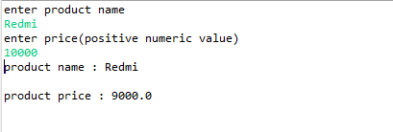

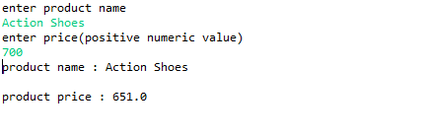

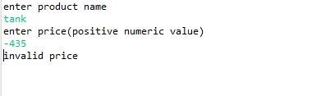

Question 6

**package** day_3;

**import** java.util.*;

**public** **class** question_6 {

**public** **static** **void** main(String[] args) {

Scanner numb_1 = **new** Scanner(System.***in***);

System.***out***.println("enter first number");

**float** number_1 = numb_1.nextFloat();

Scanner numb_2 = **new** Scanner(System.***in***);

System.***out***.println("enter second number");

**float** number_2 = numb_2.nextFloat();

**float** number_3 = number_1;

number_1 = number_2;

number_2 = number_3;

System.***out***.println("number 1 :" + number_1 + "\n" );

System.***out***.println("number 2 :" + number_2 + "\n" );

numb_1.close();

numb_2.close();

}

}

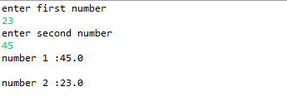

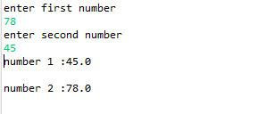

Question_7

**package** day_3;

**import** java.util.*;

**public** **class** question_7 {

**public** **static** **void** main(String[] args) {

Scanner numb_1 = **new** Scanner(System.***in***);

System.***out***.println("enter first number");

**float** number_1 = numb_1.nextFloat();

Scanner numb_2 = **new** Scanner(System.***in***);

System.***out***.println("enter second number");

**float** number_2 = numb_2.nextFloat();

number_1 = number_1 + number_2;

number_2 = number_1 - number_2;

number_1 = number_1 - number_2;

System.***out***.println("number 1 :" + number_1 + "\n" );

System.***out***.println("number 2 :" + number_2 + "\n" );

numb_1.close();

numb_2.close();

}

}

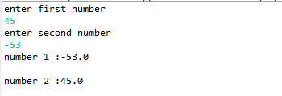

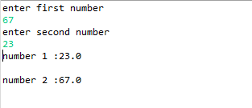

Question_8

**package** day_3;

**import** java.util.*;

**public** **class** question_8 {

**public** **static** **void** main(String[] args) {

Scanner num = **new** Scanner(System.***in***);

System.***out***.println("enter a number");

**int** number = num.nextInt();

String result;

result = (number % 2) == 0 ? "Even Number" : "Odd Number";

System.***out***.println("Result :" + result);

num.close();

}

}

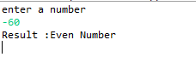

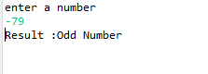

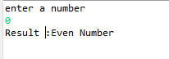

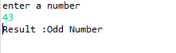

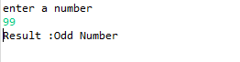

Question 9

**package** day_3;

**import** java.util.*;

**public** **class** question_9 {

**public** **static** **void** main(String[] args) {

Scanner num = **new** Scanner(System.***in***);

System.***out***.println("enter marks");

**float** marks = num.nextFloat();

**char** grade;

**if**(marks >= 50 && marks <= 100 ) {

grade = *sixty*(marks);

System.***out***.println("Grade :" + grade);

}

**else** **if** ( marks < 50 && marks >= 0) {

grade = *fortyfive*(marks);

System.***out***.println("Grade :" + grade);

}

**else** {

System.***out***.println("Invalid marks");

}

num.close();

}

**public** **static** **char** sixty(**float** k) {

**if** ( k < 60) {

**return** 'C';

}

**else** {

**char** grade = *eighty*(k);

**return** grade;

}

}

**public** **static** **char** eighty(**float** k) {

**if** ( k < 80) {

**return** 'B';

}

**else** {

**return** 'A';

}

}

**public** **static** **char** fortyfive(**float** k) {

**if** ( k >= 45) {

**return** 'D';

}

**else** {

**char** grade = *twentyfive*(k);

**return** grade;

}

}

**public** **static** **char** twentyfive(**float** k) {

**if** ( k >= 25) {

**return** 'E';

}

**else** {

**char** grade = 'F';

**return** grade;

}

}

}

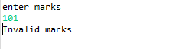 

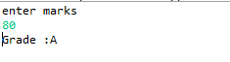 

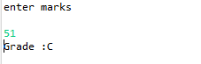 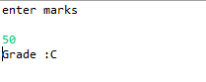

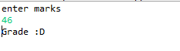 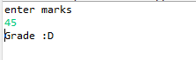

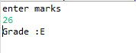 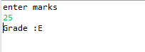

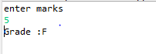

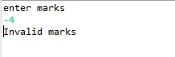

Question 10

**package** day_3;

**import** java.util.*;

**public** **class** question_10 {

**public** **static** **void** main(String[] args) {

Scanner numbers = **new** Scanner(System.***in***);

System.***out***.println("enter three numbers (separate them with single space)");

**float** number_1 = numbers.nextFloat();

**float** number_2 = numbers.nextFloat();

**float** number_3 = numbers.nextFloat();

**float** greatest = (number_1 >= number_2) ? ( (number_1 >= number_3) ? number_1 : number_3 ) : ( (number_2 >= number_3) ? number_2 : number_3);

System.***out***.println("Greatest Number: " + greatest);

numbers.close();

}

}

