**Exp:5**

**27.03.2025**

**DATA SMOOTHING AND AGGREGATION**

**Aim:**

To develop a python program for data smoothing and aggregation.

**1. Importing Required Libraries**

import pandas as pd

import numpy as np

import matplotlib.pyplot as plt

**Explanation:**

We import numpy (np) is used for numerical operations, pandas (pd) for data manipulation, matplotlib.pyplot (plt) for plotting.

Adfuller for stationary check

**2. Loading the Dataset**

file_path = "/mnt/data/gold.csv"

df = pd.read_csv(file_path)

**Explanation:**

We use pd.read_csv() to load a CSV file containing Gold data.

**3. Display the first few rows to understand the structure**

df.head()

**4.Preprocessing: Convert 'Date' to datetime and set as index**

df['Date'] = pd.to_datetime(df['Date'])

df.set_index('Date', inplace=True)

**5.** **Smoothing: Apply 7-day moving average**

df_smoothed = df.rolling(window=7).mean()

**6.** **Aggregation: Aggregate by month**

df_monthly = df.resample('M').mean()

**7.Plotting the Data**

# Plot original data

axes[0].plot(df.index, df['USD (AM)'], label='USD (AM)', color='blue')

axes[0].plot(df.index, df['USD (PM)'], label='USD (PM)', color='green')

axes[0].set_title('Original Gold Prices (USD)')

axes[0].legend()

# Plot smoothed data

axes[1].plot(df_smoothed.index, df_smoothed['USD (AM)'], label='USD (AM) - Smoothed', color='blue')

axes[1].plot(df_smoothed.index, df_smoothed['USD (PM)'], label='USD (PM) - Smoothed', color='green')

axes[1].set_title('Smoothed Gold Prices (7-day Moving Average)')

axes[1].legend()

# Plot aggregated data

axes[2].plot(df_monthly.index, df_monthly['USD (AM)'], label='USD (AM) - Monthly Average', color='blue')

axes[2].plot(df_monthly.index, df_monthly['USD (PM)'], label='USD (PM) - Monthly Average', color='green')

axes[2].set_title('Monthly Aggregated Gold Prices')

axes[2].legend()

plt.tight_layout()

plt.show()

**outputs:**

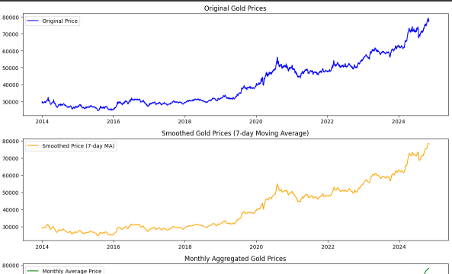

**Result:**

Thus the Program for Data Smoothing and aggregating has been executed successfully.