**Exp:6**

**27.03.2025**

**Moving Average Smoothing for Data Preparation and Time Series forecasting**

**Aim:**

To develop a python program for Moving Average Smoothing for DataPreparation and Time Series forecasting.

**1. Importing Required Libraries**

import pandas as pd

import numpy as np

import matplotlib.pyplot as plt

from statsmodels.tsa.seasonal import seasonal_decompose

**Explanation:**

We import numpy (np) is used for numerical operations, pandas (pd) for data manipulation, matplotlib.pyplot (plt) for plotting.

Adfuller for stationary check

**2. Loading the Dataset**

file_path = "/mnt/data/gold.csv"

df = pd.read_csv(file_path)

**Explanation:**

We use pd.read_csv() to load a CSV file containing Gold data.

**3. Display the first few rows to understand the structure**

df.head()

**4.** **Apply 7-day moving average smoothing**

df['USD_AM_Smoothed'] = df['USD (AM)'].rolling(window=7).mean()

df['USD_PM_Smoothed'] = df['USD (PM)'].rolling(window=7).mean()

**5.** **Decompose the time series to extract trend, seasonality, and residuals**

decomposition_am=seasonal_decompose(df['USD_AM_Smoothed'].dropna(), model='additive', period=30)

decomposition_pm=seasonal_decompose(df['USD_PM_Smoothed'].dropna(), model='additive', period=30)

**6.Plot the decomposition**

fig, axes = plt.subplots(2, 4, figsize=(16, 10))

**7.** **AM decomposition**

axes[0, 0].set_title('USD (AM) - Original')

axes[0, 0].plot(df['USD (AM)'], label='Original')

axes[0, 0].legend()

axes[0, 1].set_title('USD (AM) - Trend')

axes[0, 1].plot(decomposition_am.trend, label='Trend')

axes[0, 1].legend()

axes[0, 2].set_title('USD (AM) - Seasonality')

axes[0, 2].plot(decomposition_am.seasonal, label='Seasonality')

axes[0, 2].legend()

axes[0, 3].set_title('USD (AM) - Residual')

axes[0, 3].plot(decomposition_am.resid, label='Residual')

axes[0, 3].legend()

**8.PM decomposition**

axes[1, 0].set_title('USD (PM) - Original')

axes[1, 0].plot(df['USD (PM)'], label='Original')

axes[1, 0].legend()

axes[1, 1].set_title('USD (PM) - Trend')

axes[1, 1].plot(decomposition_pm.trend, label='Trend')

axes[1, 1].legend()

axes[1, 2].set_title('USD (PM) - Seasonality')

axes[1, 2].plot(decomposition_pm.seasonal, label='Seasonality')

axes[1, 2].legend()

axes[1, 3].set_title('USD (PM) - Residual')

axes[1, 3].plot(decomposition_pm.resid, label='Residual')

axes[1, 3].legend()

plt.tight_layout()

plt.show()

**outputs:**

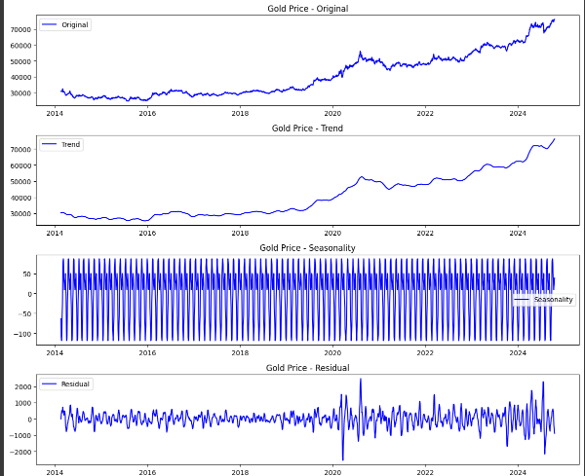

**Result:**

Thus the Program for Data Smoothing and aggregating has been executed successfully.