**Exercise 3: Stored Procedures**

Scenario 1: The bank needs to process monthly interest for all savings accounts.

Question: Write a stored procedure ProcessMonthlyInterest that calculates and updates the balance of all savings accounts by applying an interest rate of 1% to the current balance.

**Schema to be created:**

CREATE TABLE Customers (

CustomerID NUMBER PRIMARY KEY,

Name VARCHAR2(100),

DOB DATE,

Balance NUMBER,

LastModified DATE

);

CREATE TABLE Accounts (

AccountID NUMBER PRIMARY KEY,

CustomerID NUMBER,

AccountType VARCHAR2(20),

Balance NUMBER,

LastModified DATE,

FOREIGN KEY (CustomerID) REFERENCES Customers(CustomerID)

);

CREATE TABLE Transactions (

TransactionID NUMBER PRIMARY KEY,

AccountID NUMBER,

TransactionDate DATE,

Amount NUMBER,

TransactionType VARCHAR2(10),

FOREIGN KEY (AccountID) REFERENCES Accounts(AccountID)

);

CREATE TABLE Loans (

LoanID NUMBER PRIMARY KEY,

CustomerID NUMBER,

LoanAmount NUMBER,

InterestRate NUMBER,

StartDate DATE,

EndDate DATE,

FOREIGN KEY (CustomerID) REFERENCES Customers(CustomerID)

);

CREATE TABLE Employees (

EmployeeID NUMBER PRIMARY KEY,

Name VARCHAR2(100),

Position VARCHAR2(50),

Salary NUMBER,

Department VARCHAR2(50),

HireDate DATE

);

Example Scripts for Sample Data Insertion

INSERT INTO Customers (CustomerID, Name, DOB, Balance, LastModified)

VALUES (1, 'John Doe', TO_DATE('1985-05-15', 'YYYY-MM-DD'), 1000, SYSDATE);

INSERT INTO Customers (CustomerID, Name, DOB, Balance, LastModified)

VALUES (2, 'Jane Smith', TO_DATE('1990-07-20', 'YYYY-MM-DD'), 1500, SYSDATE);

INSERT INTO Accounts (AccountID, CustomerID, AccountType, Balance, LastModified)

VALUES (1, 1, 'Savings', 1000, SYSDATE);

INSERT INTO Accounts (AccountID, CustomerID, AccountType, Balance, LastModified)

VALUES (2, 2, 'Checking', 1500, SYSDATE);

INSERT INTO Transactions (TransactionID, AccountID, TransactionDate, Amount, TransactionType)

VALUES (1, 1, SYSDATE, 200, 'Deposit');

INSERT INTO Transactions (TransactionID, AccountID, TransactionDate, Amount, TransactionType)

VALUES (2, 2, SYSDATE, 300, 'Withdrawal');

INSERT INTO Loans (LoanID, CustomerID, LoanAmount, InterestRate, StartDate, EndDate)

VALUES (1, 1, 5000, 5, SYSDATE, ADD_MONTHS(SYSDATE, 60));

INSERT INTO Employees (EmployeeID, Name, Position, Salary, Department, HireDate)

VALUES (1, 'Alice Johnson', 'Manager', 70000, 'HR', TO_DATE('2015-06-15', 'YYYY-MM-DD'));

INSERT INTO Employees (EmployeeID, Name, Position, Salary, Department, HireDate)

VALUES (2, 'Bob Brown', 'Developer', 60000, 'IT', TO_DATE('2017-03-20', 'YYYY-MM-DD'));

**Program:**

CREATE OR REPLACE PROCEDURE ProcessMonthlyInterest IS

BEGIN

FOR acc IN (

SELECT AccountID, Balance

FROM Accounts

WHERE AccountType = 'Savings'

) LOOP

UPDATE Accounts

SET Balance = acc.Balance * 1.01,

LastModified = SYSDATE

WHERE AccountID = acc.AccountID;

END LOOP;

COMMIT;

DBMS_OUTPUT.PUT_LINE('Interest applied to all savings accounts.');

END;

/

**To run:**

BEGIN

ProcessMonthlyInterest;

END;

/

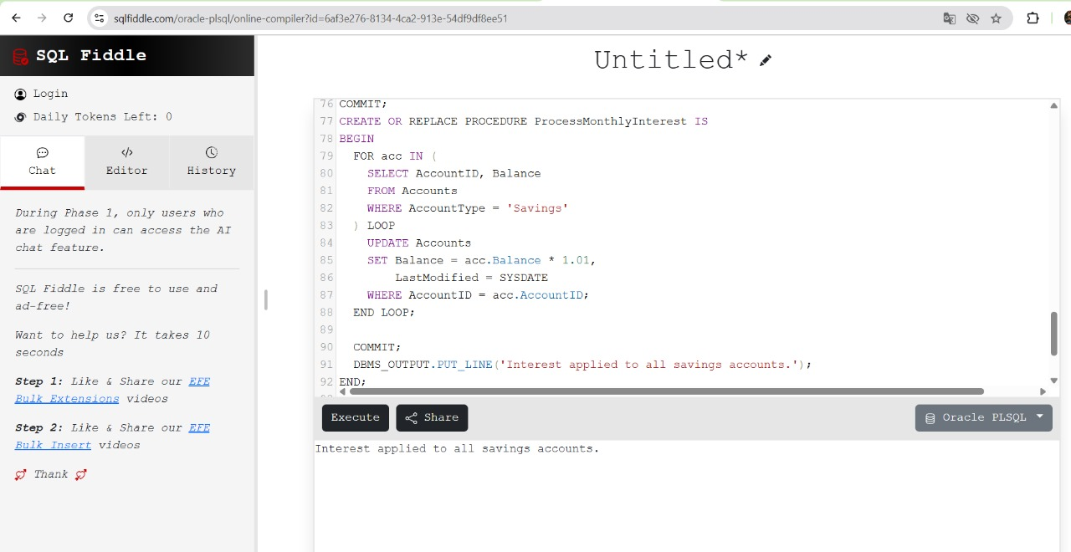

Scenario 2: The bank wants to implement a bonus scheme for employees based on their performance.

Question: Write a stored procedure UpdateEmployeeBonus that updates the salary of employees in a given department by adding a bonus percentage passed as a parameter.

**Program:**

CREATE OR REPLACE PROCEDURE UpdateEmployeeBonus (

dept_name IN VARCHAR2,

bonus_percent IN NUMBER

) IS

BEGIN

UPDATE Employees

SET Salary = Salary + (Salary * bonus_percent / 100)

WHERE Department = dept_name;

COMMIT;

DBMS_OUTPUT.PUT_LINE('Bonus applied to department: ' || dept_name);

END;

/

**To run:**

BEGIN

UpdateEmployeeBonus('IT', 10); -- Adds 10% bonus to IT department salaries

END;

/

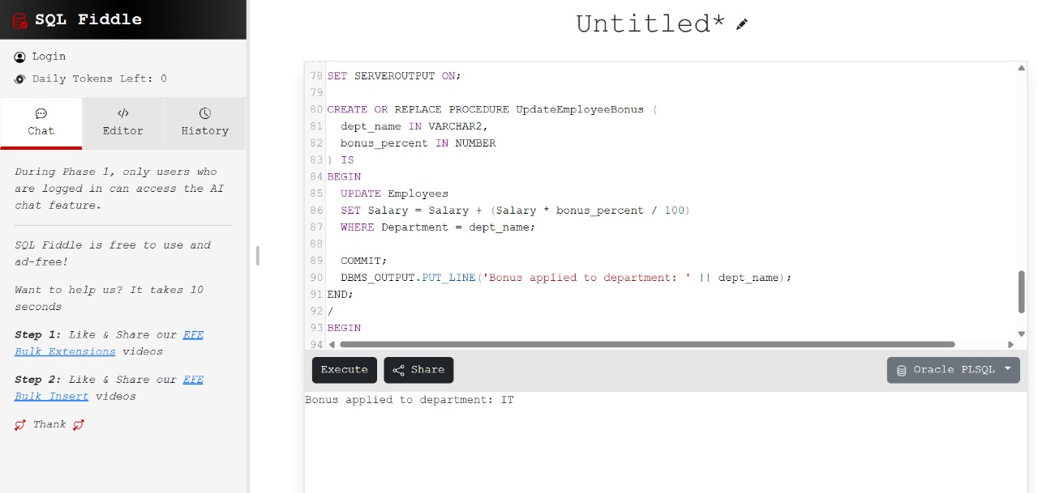

Scenario 3: Customers should be able to transfer funds between their accounts.

Question: Write a stored procedure TransferFunds that transfers a specified amount from one account to another, checking that the source account has sufficient balance before making the transfer.

**Program:**

CREATE OR REPLACE PROCEDURE TransferFunds (

from_account_id IN NUMBER,

to_account_id IN NUMBER,

transfer_amount IN NUMBER

) IS

insufficient_balance EXCEPTION;

src_balance Accounts.Balance%TYPE;

BEGIN

-- Get source balance

SELECT Balance INTO src_balance FROM Accounts WHERE AccountID = from_account_id FOR UPDATE;

-- Check balance

IF src_balance < transfer_amount THEN

RAISE insufficient_balance;

END IF;

-- Deduct from source

UPDATE Accounts

SET Balance = Balance - transfer_amount,

LastModified = SYSDATE

WHERE AccountID = from_account_id;

-- Add to destination

UPDATE Accounts

SET Balance = Balance + transfer_amount,

LastModified = SYSDATE

WHERE AccountID = to_account_id;

COMMIT;

DBMS_OUTPUT.PUT_LINE('Transfer of $' || transfer_amount || ' completed from Account ' || from_account_id || ' to Account ' || to_account_id);

EXCEPTION

WHEN insufficient_balance THEN

DBMS_OUTPUT.PUT_LINE('Transfer failed: insufficient funds in Account ' || from_account_id);

ROLLBACK;

WHEN NO_DATA_FOUND THEN

DBMS_OUTPUT.PUT_LINE('Transfer failed: one of the account IDs not found.');

ROLLBACK;

END;

/

**To run:**

BEGIN

TransferFunds(1, 2, 100); -- Transfers $100 from Account 1 to 2

END;

/

