# **SpeakUP— Market Research Report (2025)**

# **1) Target User Group Profile**

**Who they are.** Primary users are undergraduate and graduate students at U.S. colleges/universities; secondary users are instructors/TAs who field questions and moderate threads. There are ~19.3 million undergraduates in the U.S. (Fall 2024) with signs of rebound after years of decline; NCES reported the first overall enrollment uptick in over a decade in 2023, and the National Student Clearinghouse saw +3.2% YoY in Spring 2025. [Education Data Initiative+2National Center for Education Statistics+2](https://educationdata.org/college-enrollment-statistics?utm_source=chatgpt.com)

**Key behaviors & pain points.**

* Many students hesitate to speak in front of the whole class. A peer-reviewed study of undergraduates found **~51%** reported being discouraged from asking questions publicly (fear of negative evaluation/self-esteem dynamics were key). [PMC](https://pmc.ncbi.nlm.nih.gov/articles/PMC7802933/?utm_source=chatgpt.com)
* Students do want channels to ask during and **after** class; anonymity options measurably increase participation (reflected in established tools’ best-practice docs). [Piazza](https://piazza.com/product/best_practices?utm_source=chatgpt.com)
* Instructors want **structured, centralized** Q&A with moderation, deduplication, and the ability to follow up post-class without derailing live lecture time. University teaching centers endorse persistent Q&A platforms for this use. [Center for Teaching and Learning](https://ctl.stanford.edu/academic-tech/software/piazza?utm_source=chatgpt.com)

**Usage contexts.** Live lectures, recitations, and labs; hybrid/online sessions; and “asynchronous office hours” post-class. The same pattern also appears in conferences and corporate trainings (a helpful adjacent segment for future expansion).

## **2) Market Size & Opportunity**

**Core demand (education).** The reachable U.S. higher-ed market is large and stable/rising:

* ~19.3M undergrads (Fall 2024), with overall enrollment trending upward since 2023. Even single-digit penetration within medium/large institutions yields meaningful adoption. [Education Data Initiative+1](https://educationdata.org/college-enrollment-statistics?utm_source=chatgpt.com)

**Category demand (audience engagement/Q&A tools).** Vendors and analysts track “Audience Response Software/Systems” (live Q&A, polls, quizzes) across education + enterprise. Recent estimates place the market around **$1.2B in 2024**, projecting roughly **~$2.5B by early 2030s** (high-single-digit CAGR). These are directional (vendor-reported) but show a healthy, growing category. [Verified Market Reports+1](https://www.verifiedmarketreports.com/product/audience-response-system-market/?utm_source=chatgpt.com)

**Problem intensity.** Students’ reluctance to ask questions publicly is persistent and well-documented; tools that enable **anonymous, upvoted, threaded** questions (during and after class) directly map onto this pain. [PMC](https://pmc.ncbi.nlm.nih.gov/articles/PMC7802933/?utm_source=chatgpt.com)

**Why now.** Post-pandemic teaching mixes in-person and online, making **hybrid-friendly engagement** a default expectation; instructors increasingly adopt digital Q&A to keep lectures flowing and handle deeper replies afterward. [Center for Teaching and Learning](https://ctl.stanford.edu/academic-tech/software/piazza?utm_source=chatgpt.com)

**3) Competitor Analysis**

Below are the closest comparables you’ll run up against on campus. (There are also broader “engagement” apps like Mentimeter/Kahoot/Vevox, but these three best reflect your Q&A use case.)

### **Slido (Cisco)**

* **Core fit:** Live Q&A with **anonymous** questions and **upvoting**; integrates with Google Slides/PowerPoint/Zoom; widely used in meetings and classes. Free tier: **up to 100 participants per event**; unlimited Q&A, limited polls (3 per event). [Slido+2Software Advice+2](https://www.slido.com/?utm_source=chatgpt.com)
* **Strengths:** Very high ease-of-use scores and strong integrations (live events, analytics). [G2](https://www.g2.com/compare/poll-everywhere-vs-slido)
* **Gaps for your niche:** Oriented to **live sessions**; less emphasis on **asynchronous, threaded “after-class”** workflows.

### **Poll Everywhere**

* **Core fit:** Live polls and Q&A; **anonymous** responses supported; broad LMS/slide integrations. Free/Intro tier typically caps at **~25 responses per activity**; higher caps on paid tiers. [Poll Everywhere+2support.polleverywhere.com+2](https://www.polleverywhere.com/plans?utm_source=chatgpt.com)
* **Strengths:** Mobile compatibility; long-standing brand in education; LMS integrations. [G2](https://www.g2.com/compare/poll-everywhere-vs-slido)
* **Gaps for your niche:** Similar to Slido—**live-first**. Post-class discussion, dedupe, and “answer later” workflows are not the central product story.

### **Piazza (course Q&A forum)**

* **Core fit:** **Persistent, course-centric** Q&A with **anonymity options** (“anonymous to classmates” and configurable broader anonymity). Strong for **after-class** threads. [Piazza+2tuftsedtech.screenstepslive.com+2](https://support.piazza.com/support/solutions/articles/48000574395-instructors-disable-anonymity-and-private-posting?utm_source=chatgpt.com)
* **Strengths:** Asynchronous depth; instructor endorsements at many universities. [Center for Teaching and Learning](https://ctl.stanford.edu/academic-tech/software/piazza?utm_source=chatgpt.com)
* **Gaps for your niche:** Piazza is forum-like; **real-time in-lecture** capture/upvoting UX is less slick compared to Slido/Poll Everywhere. Some instructors toggle anonymity off due to moderation preferences. [Piazza](https://support.piazza.com/support/solutions/articles/48000574395-instructors-disable-anonymity-and-private-posting?utm_source=chatgpt.com)

**Quick head-to-head takeaways (what you can exploit):**

* **Live vs. After-class:** Slido/PollEv win the live moment; Piazza wins after-class. Few tools nail **both** elegantly in one flow.
* **Anonymity with control:** Everyone offers anonymity, but instructors want **fine-grained controls** (toggle by activity, identity reveal to instructor only, audit trail). Piazza shows demand for this; event tools keep it simpler. [Piazza](https://support.piazza.com/support/solutions/articles/48000574395-instructors-disable-anonymity-and-private-posting?utm_source=chatgpt.com)
* **Deduplication & summarization:** “We’re answering the same question 10 times” is a frequent complaint—**AI-powered merging, clustering, and summary replies** are still light across incumbents.

## **4) SpeakUp— Unique Value Proposition (UVP)**

**“Ask freely, learn fully — in class and after.”**

1. **One continuous Q&A stream per session → course** Questions start **live** (anonymous, upvoted, projector-friendly), then persist into a **threaded space** post-lecture for official answers, resources, and follow-ups. This bridges the Slido↔Piazza split.
2. **Anonymity that instructors trust** Default anonymous-to-peers, with **role-based controls**: instructor can (optionally) view identity, enable/disable anonymity per activity, and require honor-code prompts for sensitive posts. This balances participation with accountability, directly addressing the 51% hesitation driver. [PMC](https://pmc.ncbi.nlm.nih.gov/articles/PMC7802933/?utm_source=chatgpt.com)
3. **AI-assisted moderation & answers**
   * **Auto-dedupe** similar questions into clusters.
   * **Answer-later** drafts and **AI summaries** per cluster to post after class.
   * **Suggested tags/chapters** to build a searchable knowledge base by week/unit.
4. **Campus-grade integrations & data** Plug-ins for LMS (Canvas/Blackboard), Slides/PowerPoint, and SSO; analytics on question topics, engagement over time, and “what to reteach.”

## **5) Visualization (free-tier limits: live Q&A tools)**

Here’s a quick snapshot of free-tier participation caps for two popular live tools instructors compare against. It helps position your free tier and pilot strategy when selling into departments.

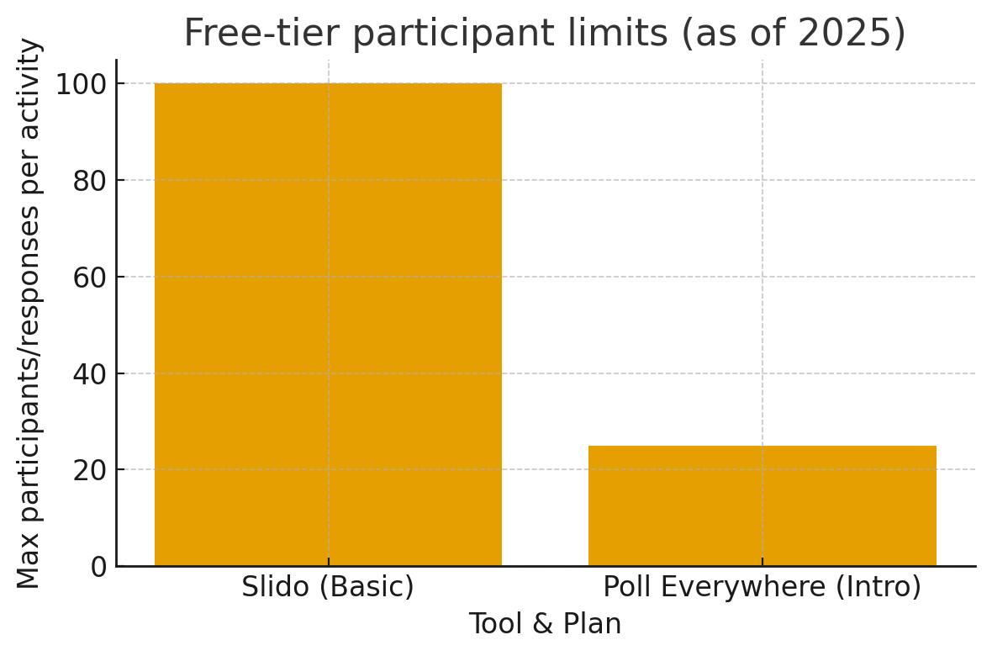

## **6) Go-to-Market Notes (quick, actionable)**

* **Beachhead:** Mid/large lecture courses (Gen-Ed, STEM gateways) where public questioning is hardest; instructors already using slides & LMS daily.
* **Pilot design:** Offer **free department pilots** with higher free-tier caps than PollEv and a cleaner in-lecture → after-class handoff than Slido/Piazza. Use AI dedupe/summaries as the signature delight.
* **Buying centers:** Department chairs, teaching & learning centers, instructional designers; student governments (for campus-wide licenses).
* **Adjacencies:** Conferences and training workshops reuse the same flow (live intake → post-event answers).

### **Sources (selected)**

U.S. enrollment levels & trends: EducationData.org summary (Mar 17 2025), NCES press release (Jan 7 2025), National Student Clearinghouse (May 22 2025). [Education Data Initiative+2National Center for Education Statistics+2](https://educationdata.org/college-enrollment-statistics?utm_source=chatgpt.com)

Student hesitation to ask questions: Nadile et al., *BMC Med Educ* / NIH PMC (2021) — ~51% discouraged. [PMC](https://pmc.ncbi.nlm.nih.gov/articles/PMC7802933/?utm_source=chatgpt.com)

Teaching center endorsements for course Q&A: Stanford CTL page on Piazza. [Center for Teaching and Learning](https://ctl.stanford.edu/academic-tech/software/piazza?utm_source=chatgpt.com)

Anonymity & settings in Piazza: Piazza support/docs and university guides. [Piazza+](https://support.piazza.com/support/solutions/articles/48000574395-instructors-disable-anonymity-and-private-posting?utm_source=chatgpt.com)[2tuftsedtech.screenstepslive.com](http://2tuftsedtech.screenstepslive.com)[+2](https://support.piazza.com/support/solutions/articles/48000574395-instructors-disable-anonymity-and-private-posting?utm_source=chatgpt.com)

Live engagement tools (features, reviews, pricing): G2 comparison (2025), SoftwareAdvice (Slido & PollEv), vendor pricing/support pages. [Poll Everywhere+4G2+4Software Advice+4](https://www.g2.com/compare/poll-everywhere-vs-slido)

Market size (directional): Verified Market Reports; other analyst estimates broadly in the ~$1–2B 2024 range with high-single-digit CAGR. [Verified Market Reports+1](https://www.verifiedmarketreports.com/product/audience-response-system-market/?utm_source=chatgpt.com)

**7) AI Use Section:**

* Used ChatGPT model with prompt asking to do a research about this topic. Fact checked by going to all links and verifying correct information