SpeakUP— Market Research Report (2025)

1) Target User Group Profile
Who they are. Primary users are undergraduate and graduate students at U.S. colleges/universities; secondary users are instructors/TAs who field questions and moderate threads. There are ~19.3 million undergraduates in the U.S. (Fall 2024) with signs of rebound after years of decline; NCES reported the first overall enrollment uptick in over a decade in 2023, and the National Student Clearinghouse saw +3.2% YoY in Spring 2025. Education Data Initiative+2National Center for Education Statistics+2
Key behaviors & pain points.
- Many students hesitate to speak in front of the whole class. A peer-reviewed study of undergraduates found ~51% reported being discouraged from asking questions publicly (fear of negative evaluation/self-esteem dynamics were key). PMC
- Students do want channels to ask during and after class; anonymity options measurably increase participation (reflected in established tools’ best-practice docs). Piazza
- Instructors want structured, centralized Q&A with moderation, deduplication, and the ability to follow up post-class without derailing live lecture time. University teaching centers endorse persistent Q&A platforms for this use. Center for Teaching and Learning
Usage contexts. Live lectures, recitations, and labs; hybrid/online sessions; and “asynchronous office hours” post-class. The same pattern also appears in conferences and corporate trainings (a helpful adjacent segment for future expansion).

2) Market Size & Opportunity
Core demand (education). The reachable U.S. higher-ed market is large and stable/rising:
- ~19.3M undergrads (Fall 2024), with overall enrollment trending upward since 2023. Even single-digit penetration within medium/large institutions yields meaningful adoption. Education Data Initiative+1
Category demand (audience engagement/Q&A tools).
Vendors and analysts track “Audience Response Software/Systems” (live Q&A, polls, quizzes) across education + enterprise. Recent estimates place the market around $1.2B in 2024, projecting roughly ~$2.5B by early 2030s (high-single-digit CAGR). These are directional (vendor-reported) but show a healthy, growing category. Verified Market Reports+1
Problem intensity. Students’ reluctance to ask questions publicly is persistent and well-documented; tools that enable anonymous, upvoted, threaded questions (during and after class) directly map onto this pain. PMC
Why now. Post-pandemic teaching mixes in-person and online, making hybrid-friendly engagement a default expectation; instructors increasingly adopt digital Q&A to keep lectures flowing and handle deeper replies afterward. Center for Teaching and Learning
3) Competitor Analysis
Below are the closest comparables you’ll run up against on campus. (There are also broader “engagement” apps like Mentimeter/Kahoot/Vevox, but these three best reflect your Q&A use case.)

Slido (Cisco)
- Core fit: Live Q&A with anonymous questions and upvoting; integrates with Google Slides/PowerPoint/Zoom; widely used in meetings and classes. Free tier: up to 100 participants per event; unlimited Q&A, limited polls (3 per event). Slido+2Software Advice+2
- Strengths: Very high ease-of-use scores and strong integrations (live events, analytics). G2
- Gaps for your niche: Oriented to live sessions; less emphasis on asynchronous, threaded “after-class” workflows.

Poll Everywhere
- Core fit: Live polls and Q&A; anonymous responses supported; broad LMS/slide integrations. Free/Intro tier typically caps at ~25 responses per activity; higher caps on paid tiers. Poll Everywhere+2support.polleverywhere.com+2
- Strengths: Mobile compatibility; long-standing brand in education; LMS integrations. G2
- Gaps for your niche: Similar to Slido—live-first. Post-class discussion, dedupe, and “answer later” workflows are not the central product story.

Piazza (course Q&A forum)
- Core fit: Persistent, course-centric Q&A with anonymity options (“anonymous to classmates” and configurable broader anonymity). Strong for after-class threads. Piazza+2tuftsedtech.screenstepslive.com+2
- Strengths: Asynchronous depth; instructor endorsements at many universities. Center for Teaching and Learning
- Gaps for your niche: Piazza is forum-like; real-time in-lecture capture/upvoting UX is less slick compared to Slido/Poll Everywhere. Some instructors toggle anonymity off due to moderation preferences. Piazza
Quick head-to-head takeaways (what you can exploit):
- Live vs. After-class: Slido/PollEv win the live moment; Piazza wins after-class. Few tools nail both elegantly in one flow.
- Anonymity with control: Everyone offers anonymity, but instructors want fine-grained controls (toggle by activity, identity reveal to instructor only, audit trail). Piazza shows demand for this; event tools keep it simpler. Piazza
- Deduplication & summarization: “We’re answering the same question 10 times” is a frequent complaint—AI-powered merging, clustering, and summary replies are still light across incumbents.

4) SpeakUp— Unique Value Proposition (UVP)
“Ask freely, learn fully — in class and after.”
- One continuous Q&A stream per session → course
Questions start live (anonymous, upvoted, projector-friendly), then persist into a threaded space post-lecture for official answers, resources, and follow-ups. This bridges the Slido↔Piazza split.
- Anonymity that instructors trust
Default anonymous-to-peers, with role-based controls: instructor can (optionally) view identity, enable/disable anonymity per activity, and require honor-code prompts for sensitive posts. This balances participation with accountability, directly addressing the 51% hesitation driver. PMC
- AI-assisted moderation & answers
  - Auto-dedupe similar questions into clusters.
  - Answer-later drafts and AI summaries per cluster to post after class.
  - Suggested tags/chapters to build a searchable knowledge base by week/unit.
- Campus-grade integrations & data
Plug-ins for LMS (Canvas/Blackboard), Slides/PowerPoint, and SSO; analytics on question topics, engagement over time, and “what to reteach.”

5) Visualization (free-tier limits: live Q&A tools)
Here’s a quick snapshot of free-tier participation caps for two popular live tools instructors compare against. It helps position your free tier and pilot strategy when selling into departments.
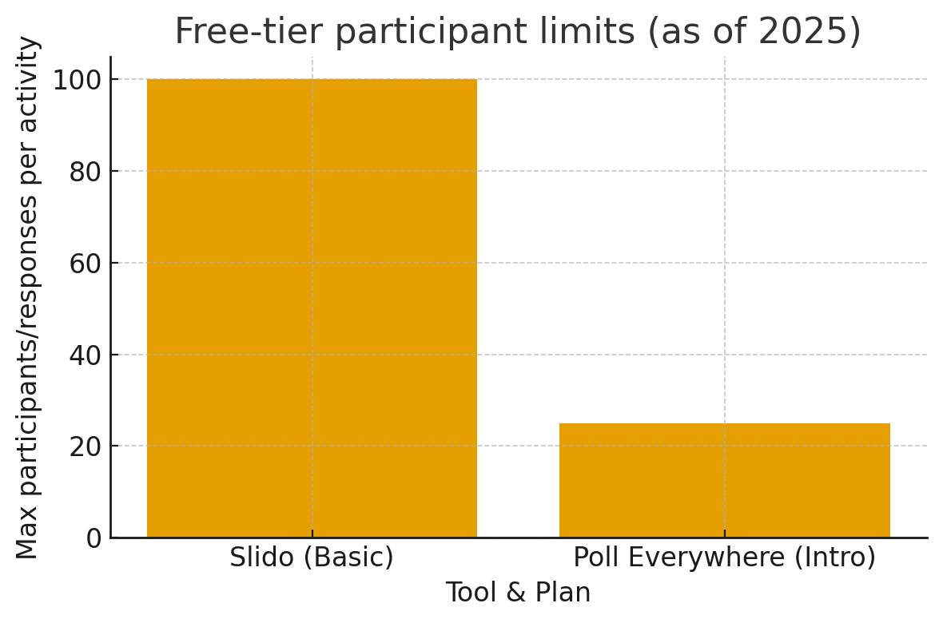

6) Go-to-Market Notes (quick, actionable)
- Beachhead: Mid/large lecture courses (Gen-Ed, STEM gateways) where public questioning is hardest; instructors already using slides & LMS daily.
- Pilot design: Offer free department pilots with higher free-tier caps than PollEv and a cleaner in-lecture → after-class handoff than Slido/Piazza. Use AI dedupe/summaries as the signature delight.
- Buying centers: Department chairs, teaching & learning centers, instructional designers; student governments (for campus-wide licenses).
- Adjacencies: Conferences and training workshops reuse the same flow (live intake → post-event answers).

Sources (selected)
U.S. enrollment levels & trends: EducationData.org summary (Mar 17 2025), NCES press release (Jan 7 2025), National Student Clearinghouse (May 22 2025). Education Data Initiative+2National Center for Education Statistics+2
Student hesitation to ask questions: Nadile et al., BMC Med Educ / NIH PMC (2021) — ~51% discouraged. PMC
Teaching center endorsements for course Q&A: Stanford CTL page on Piazza. Center for Teaching and Learning
Anonymity & settings in Piazza: Piazza support/docs and university guides. Piazza+2tuftsedtech.screenstepslive.com+2
Live engagement tools (features, reviews, pricing): G2 comparison (2025), SoftwareAdvice (Slido & PollEv), vendor pricing/support pages. Poll Everywhere+4G2+4Software Advice+4
Market size (directional): Verified Market Reports; other analyst estimates broadly in the ~$1–2B 2024 range with high-single-digit CAGR. Verified Market Reports+1
7) AI Use Section:
- Used ChatGPT model with prompt asking to do a research about this topic. Fact checked by going to all links and verifying correct information

