**Control Engineering Assignment**

|  |  |  |  |
| --- | --- | --- | --- |
| **Name** | **Section** | **B. N** | **ID** |
| **Karim Mahmoud Kamal** | **2** | **10** | **9203076** |
| **Omar Fareed** | **2** | **4** | **9202968** |
| **Mustafa Mahmoud Hamada** | **2** | **25** | **9203519** |

Supervised by

**Dr. Meena Elia Samouil Girgis**

**Eng. Youssef Hassan Mohamed**

MAY 2023

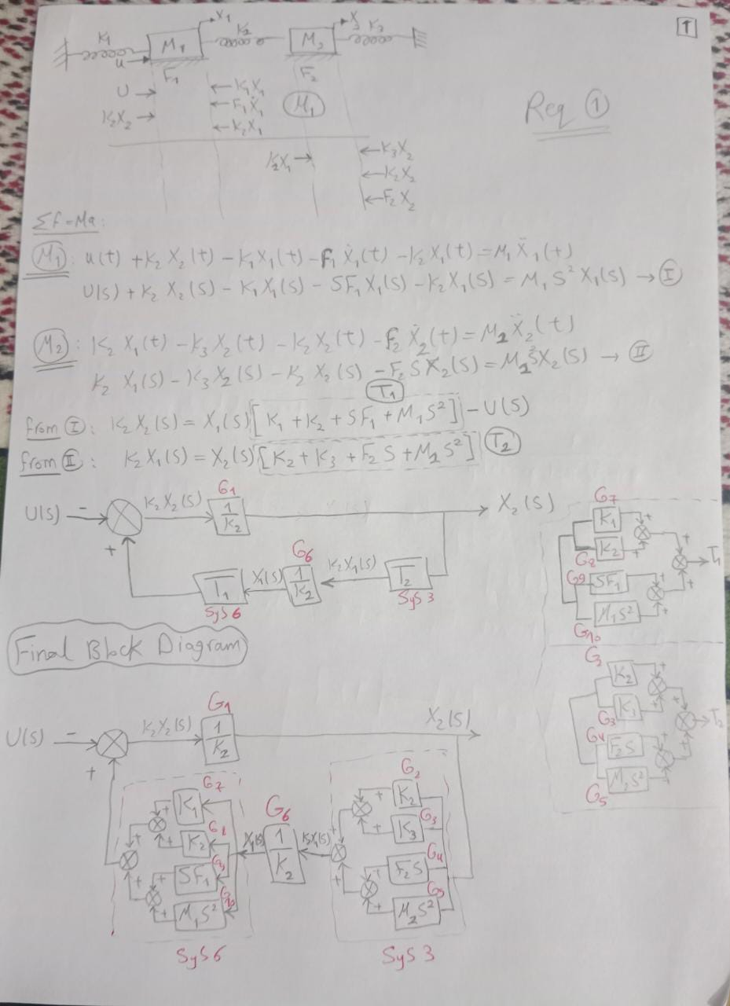**Requirement 1:** **The dynamic equations and the block diagram of the system**

Figure : Handwritten analysis

**Requirement 2:**

**X1_over_u = 0.01 s^2 + 0.01 s + 0.0055**

**s^4 + 2 s^3 + 2.1 s^2 + 1.1 s + 0.0525**

**-------------------------------------------------------------------------------------------------------------------------------**

**X2_over_u = 0.005**

**s^4 + 2 s^3 + 2.1 s^2 + 1.1 s + 0.0525**

**Requirement 3:**

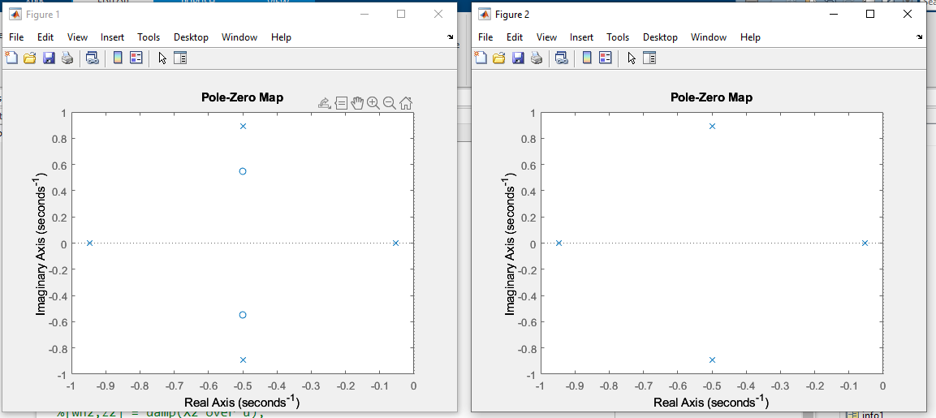

Figure : Poles of the two transfer functions X1, X2

As shown in Fig 2, For both of X1 and X2 all the poles are in the left half plane and no poles in the right half plane, so the system is stable.

**Requirement 4:**

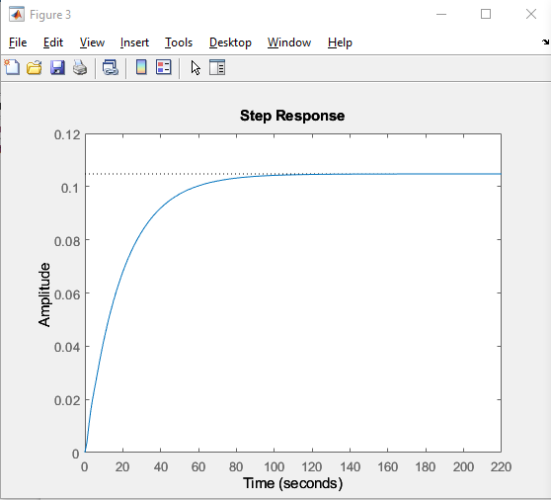

Figure : Response of X1 for input 1N

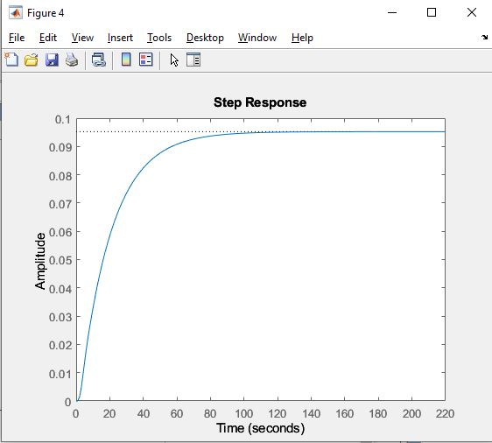

Figure : Response of X2 for input 1N

|  |  |
| --- | --- |
| **Steady State Values for X1** | **Steady State Values for X2** |
| RiseTime: 41.7004  TransientTime: 74.3184  SettlingTime: 74.3184  SettlingMin: 0.0946  SettlingMax: 0.1048  Overshoot: 0  Undershoot: 0  Peak: 0.1048  PeakTime: 199.7833  **Steady State error X1:** 0.895 | RiseTime: 41.5076  TransientTime: 76.1248  SettlingTime: 76.1248  SettlingMin: 0.0860  SettlingMax: 0.0952  Overshoot: 0  Undershoot: 0  Peak: 0.0952  PeakTime: 138.7141  **Steady State error X2:** 0.905 |

**Requirement 5:**

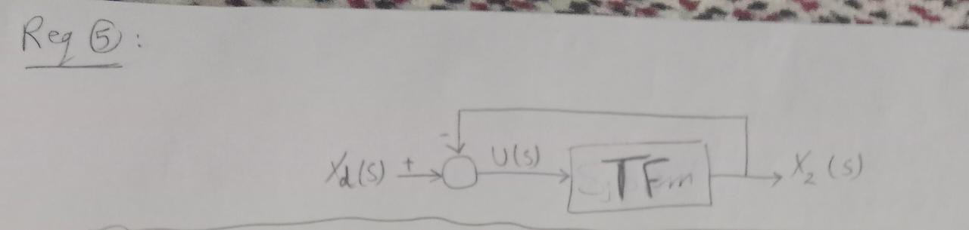

Figure : System modification such that Xd is input.

**Requirement 6:**

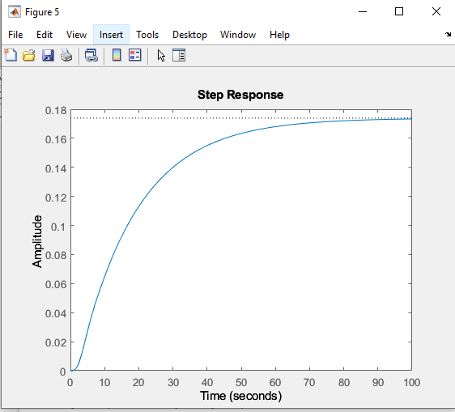

Figure : Response of the system for input Xd = 2

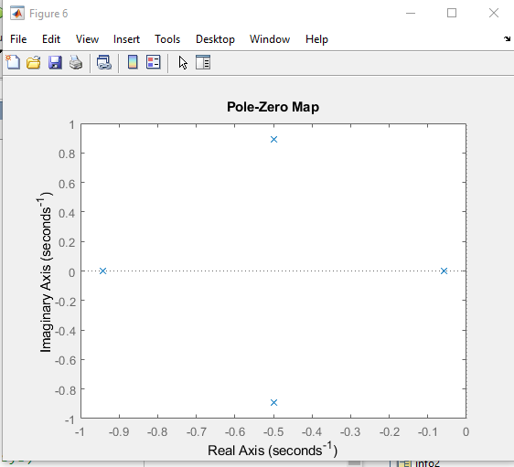**Requirement 7:**

Figure : Poles of the system

As show in Fig 7, the system is stable as all the poles are in the negative side.

**Steady State error**: 1.827

* System Information:
* RiseTime: 37.4676
* TransientTime: 68.9668
* SettlingTime: 68.9668
* SettlingMin: 0.0784
* SettlingMax: 0.0869
* Overshoot: 0
* Undershoot: 0
* Peak: 0.0869
* PeakTime: 125.293

**Requirement 8:**

**Kp value = 1**

**The stability of the system:**

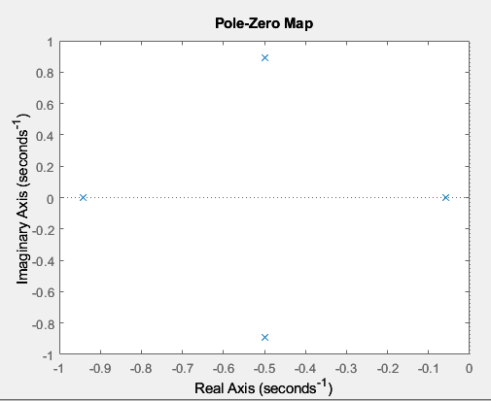

All poles are in left half plane, so the system is stable.

**The response of the system:**

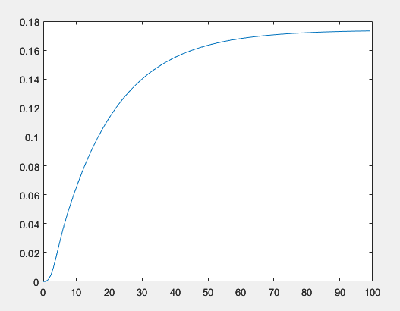

**Kp value = 10**

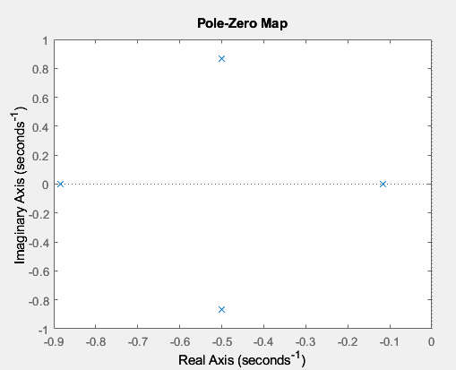

All poles are in left half plane, so the system is stable.

**The response of the system:**

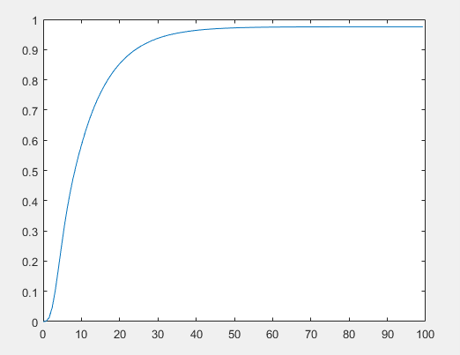

**Kp value = 100**

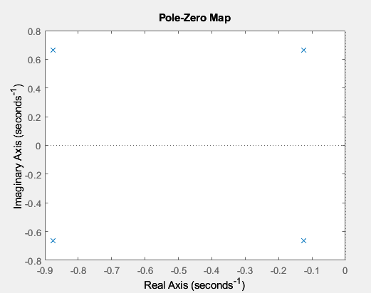

All poles are in left half plane, so the system is stable.

**The response of the system:**

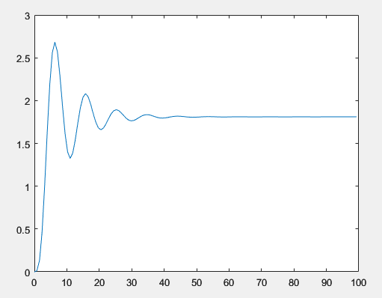

**Kp value = 1000**

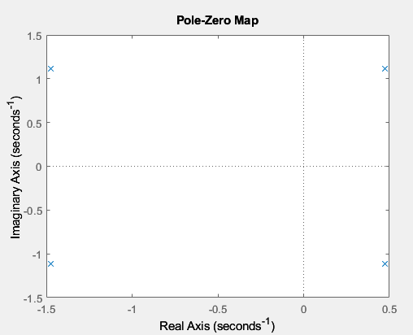

There are some poles in the right half plane, so the system is unstable.

**The response of the system:**

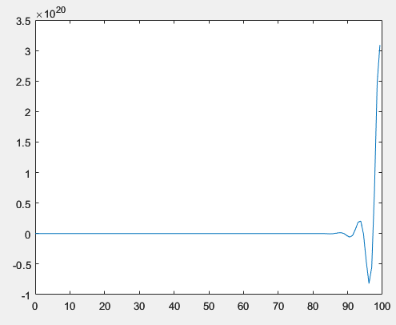

|  |  |  |  |
| --- | --- | --- | --- |
| **Kp value = 1** | **Kp value = 10** | **Kp value = 100** | **Kp value = 1000** |
| RiseTime: 37.4676  TransientTime: 68.9668  SettlingTime: 68.9668  SettlingMin: 0.0784  SettlingMax: 0.0869  Overshoot: 0  Undershoot: 0  Peak: 0.0869  PeakTime: 125.2935 | RiseTime: 18.8465  TransientTime: 35.7815  SettlingTime: 35.7815  SettlingMin: 0.4393  SettlingMax: 0.4873  Overshoot: 0  Undershoot: 0  Peak: 0.4873  PeakTime: 61.3895 | RiseTime: 2.2180  TransientTime: 31.0141  SettlingTime: 31.0141  SettlingMin: 0.6622  SettlingMax: 1.3416  Overshoot: 48.2520  Undershoot: 0  Peak: 1.3416  PeakTime: 6.3068 | RiseTime: NaN  SettlingTime: NaN  SettlingMin: NaN  SettlingMax: NaN  Overshoot: NaN  Undershoot: NaN  Peak: Inf  PeakTime: Inf |
| Steady State error : 1.82667805 | Steady State error : 1.02440233 | Steady State error: 0.19004232 | Steady State error : 308984905426371084288 |
| **The system is stable.** | **The system is stable.** | **The system is stable.** | **The system is not stable.** |

**Comments:**

* Increasing the proportional controller gain Kp can improve the system's accuracy in reaching the desired output value (ess decreases) and speed up its response, resulting in a decreased rise time and settling time.
* However, this improvement is only observed up to a certain point (Kp = 1000), after which the system becomes unstable, and the rise time and settling time become NaN. High gains cause instability, which can affect the system's peak time.
* As Kp increases, the peak time decreases, and the overshoot increases. Therefore, there is a tradeoff between accuracy, speed, and stability when increasing Kp.

**Requirement 9:**

**No, we cannot obtain a steady state error less than 0.01 m using proportional-only controller, because the system will not be stable ( There are some poles in the right half plane ).**

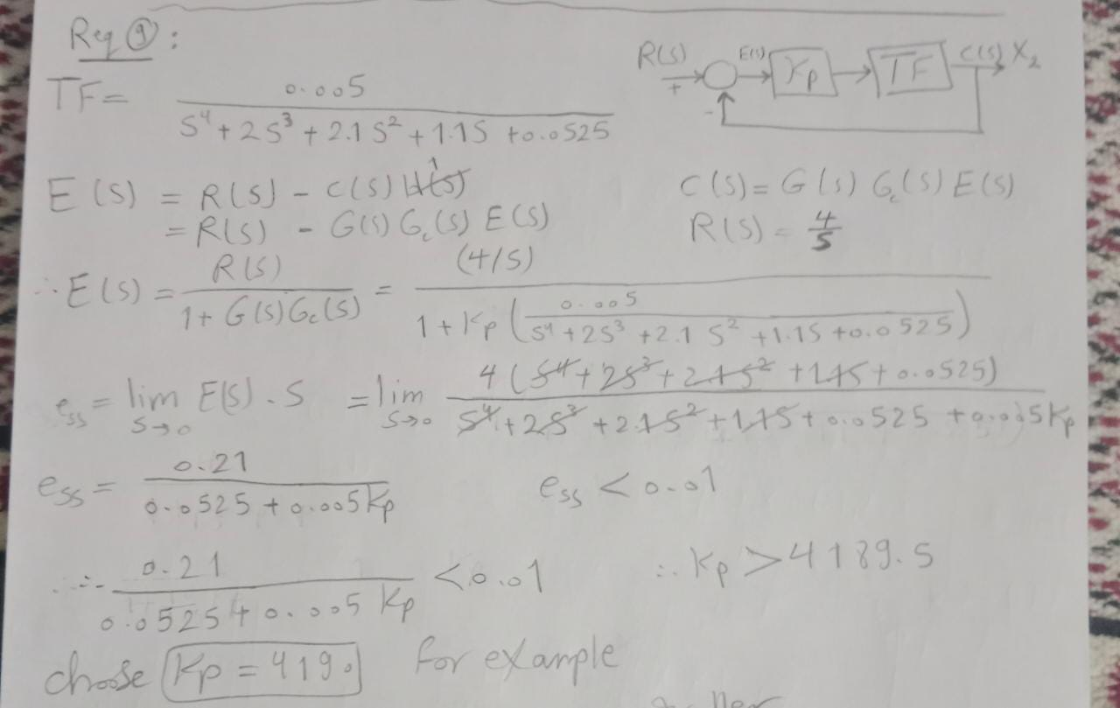

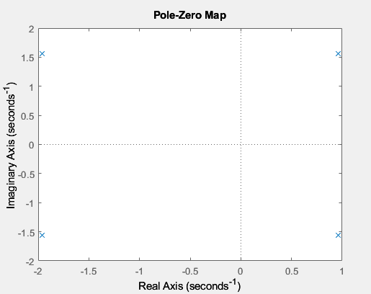

**Requirement 10:**

**Kp = 150**

**Ki = 9.7**

we got these values by try and error.

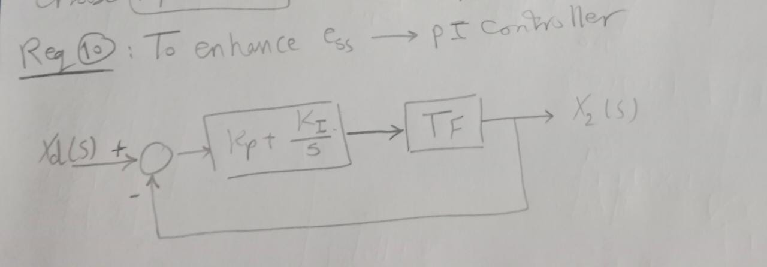

**The system response:**

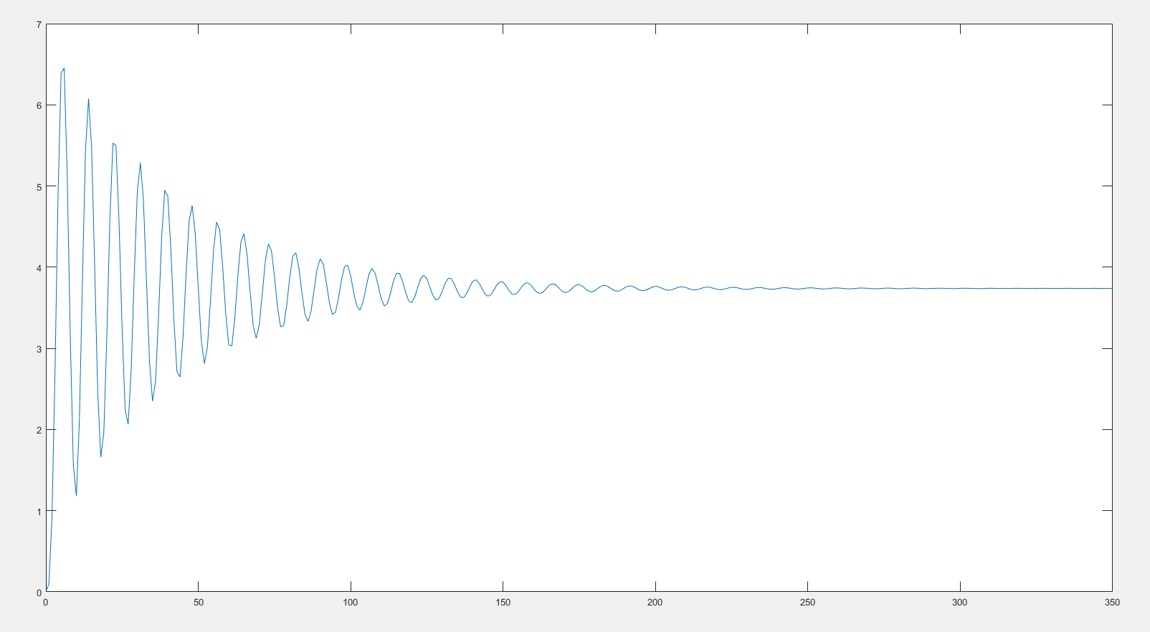

**The stability of the system:**

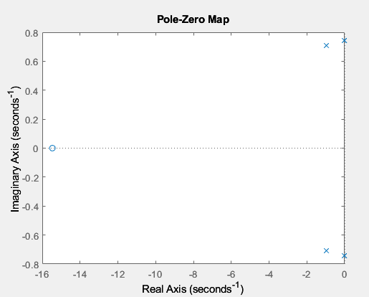

**As shown in the last Figure, the system is stable ( all poles are in the left half plane even the 2 poles on the right that seems to be on the zero axis but they are not on the zero, they really on the left half plane ).**