**Assignment -2**

|  |  |
| --- | --- |
| Assignment Date | 24 September 2022 |
| Student Name | Ms. Pavithra A |
| Student Roll Number | 952819104038 |
| Maximum Marks | 2 Marks |
| Team ID | PNT2022TMID50561 |

1. Write a flask program which should display Name , Email, phone and it should display the same details once we hit submit

Index.html

<html>

<head>

<title>Assignment2</title>

</head>

<body>

<form action="/login" method="POST" name ="f">

<p>Enter name:</p>

<p><input type="text" name="nm"/></p>

<p>Email:</p>

<p><input type="email" name="em"/></p>

<p>Phone number:</p>

<p><input type="number" name="pn"/></p>

<p><input type="submit" value="submit"/></p>

</form>

<b>{{y}}</b>

</body>

</html>

app.py

from flask import Flask,render_template,request app=Flask( name , template_folder='template')

@app.route('/') def home():

return render_template("index.html")

@app.route('/login', methods=["POST"]) def login():

if request.method == "POST": name=request.form["nm"]

mail=request.form["em"]

user=request.form["pn"]

return render_template("index.html",y=name) if name ==(' main '):

app.run(debug = True)

OUTPUT

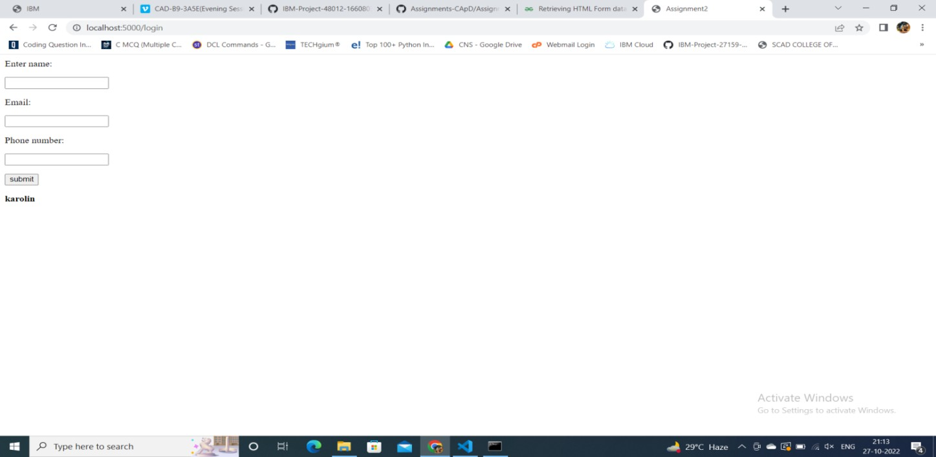

1. Write a flask program which should cover cookies, sessions

# Index.html

<html>

<body>

<form action = "/setcookie" method =

"POST">

<p><h3>Enter userID</h3></p>

<p><input type = 'text' name = 'nm'/></p>

<p><input type = 'submit' value =

'Login'/></p>

</form>

</body>

</html>

**App.py**

from flask import Flask, render_template, redirect, request app = Flask( name )

@app.route('/') def home():

return render_template('index.html') @app.route('/setcookie', methods = ['POST', 'GET']) def setcookie():

if request.method == 'POST': user = request.form['nm']

resp = make_response(render_template('readcookie.html'))

resp.set_cookie('userID', user)

return resp @app.route('/getcookie')

def getcookie():

name = request.cookies.get('userID') return '<h1>welcome ' + name + '</h1>'

OUTPUT

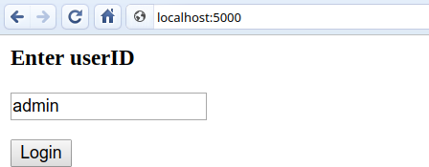

1. Write a flask program which should display resume details and also have upload resume option by using file uploading

Uploadfile.html

<html>

<body>

<form action ="/uploader" method="POST" enctype="multipart/form-data">

<p>Enter name:</p>

<p><input type="text" name="nm"/></p>

<p>Email:</p>

<p><input type="email" name="em"/></p>

<p>Phone number:</p>

<p><input type="number" name="pn"/></p>

<input type="file" name="file"/>

<input type="submit"/>

</form>

</body>

</html>

Upload.py

from flask import Flask,render_template,request from werkzeug.utils import secure_filename

app=Flask( name , template_folder='template') @app.route('/')

def upload_file():

return render_template('uploadfile.html')

@app.route('/uploader',methods =['GET','POST']) def flask_upload():

if request.method =='POST':

f=request.files['file'] f.save(secure_filename(f.filename)) return 'file upload successfully'

if name ==(' main '): app.run(debug = True)

OUTPUT

