TITLE: - GITHUB MERGING EXCERCISE

AIM: -
To perfrom Github merging exercise.
DESCRIPTION:
Start by creating a new repo.
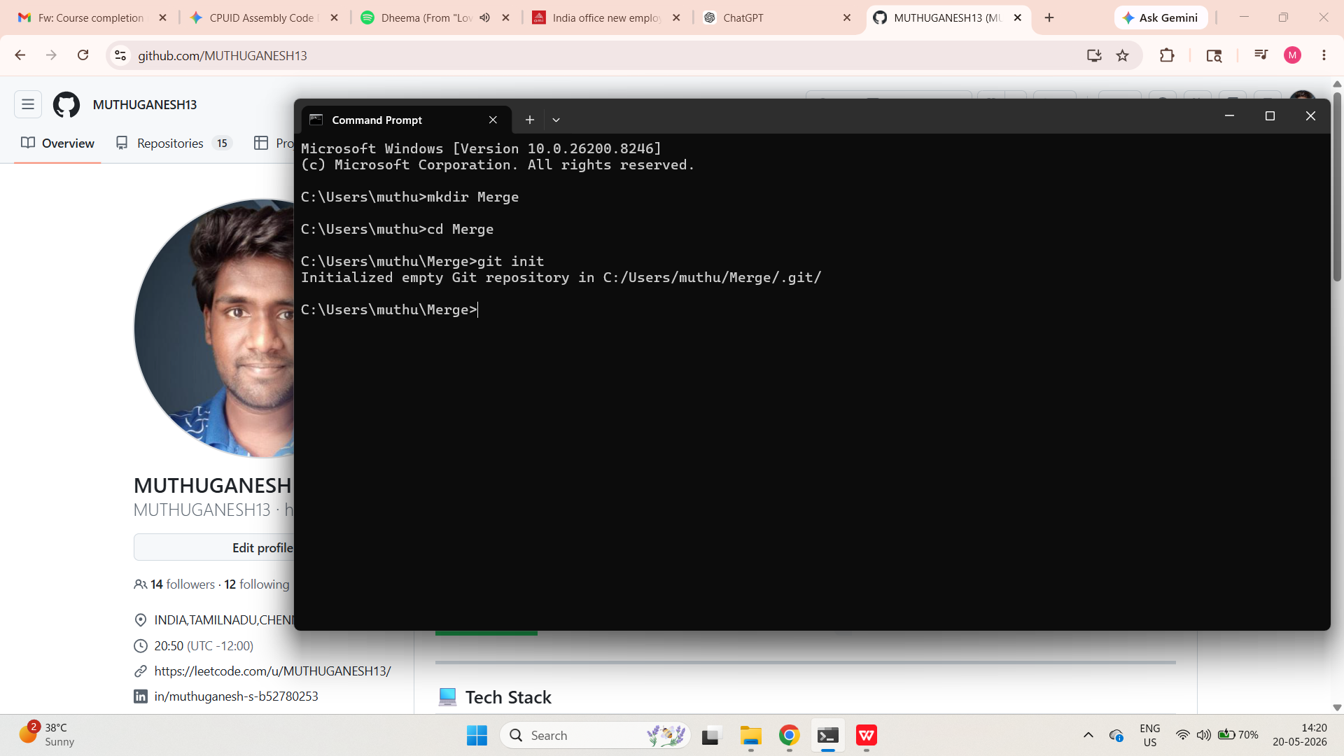

Make a file or two in the repo for you to work on.
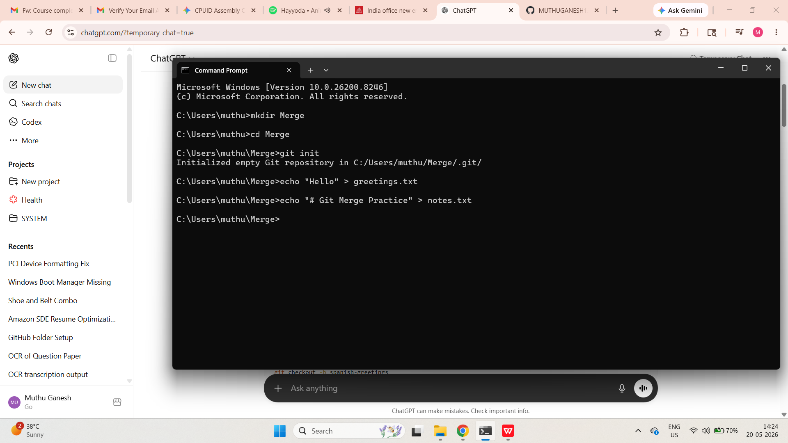

If you need some inspiration...I'll be working in a file called greetings.txt It will contain greetings in different languages.
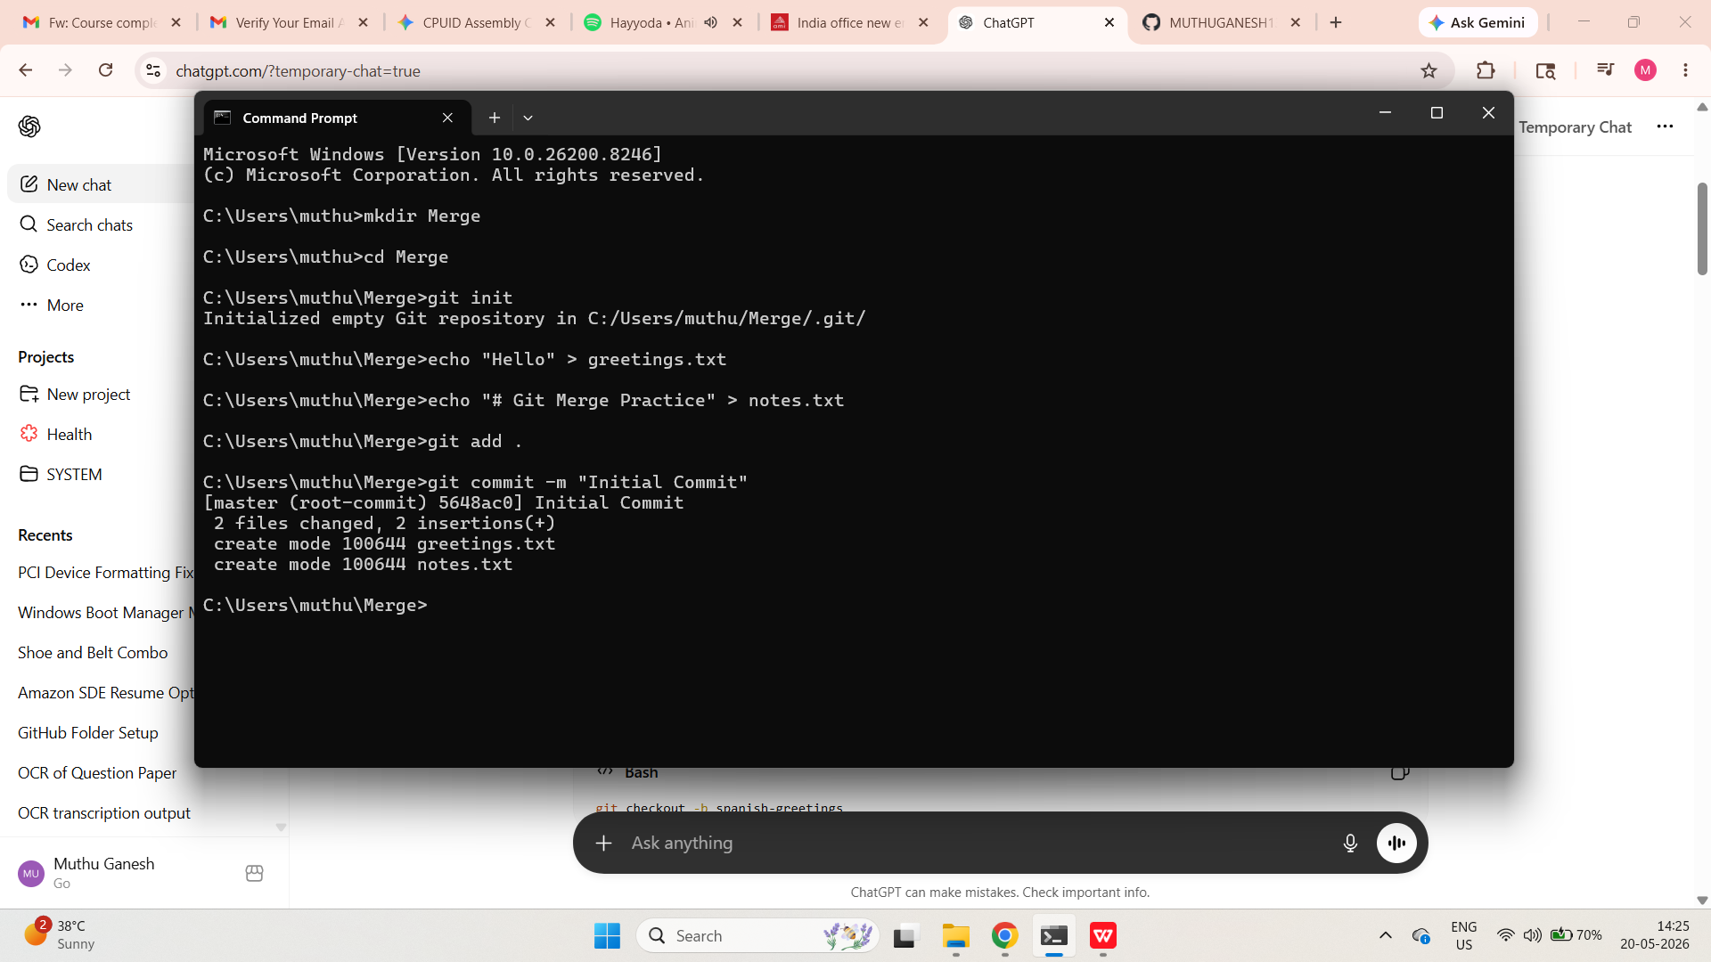

Part 1: Fast Forward Merge
Your goal is to generate a fast forward merge. Demonstrate that you understand how FF merges work by creating one on your own!
Make a new branch. Do some work in the repo such that when you merge the new branch into master, it results in a fast forward merge. Merge that branch into master and see if you were right!
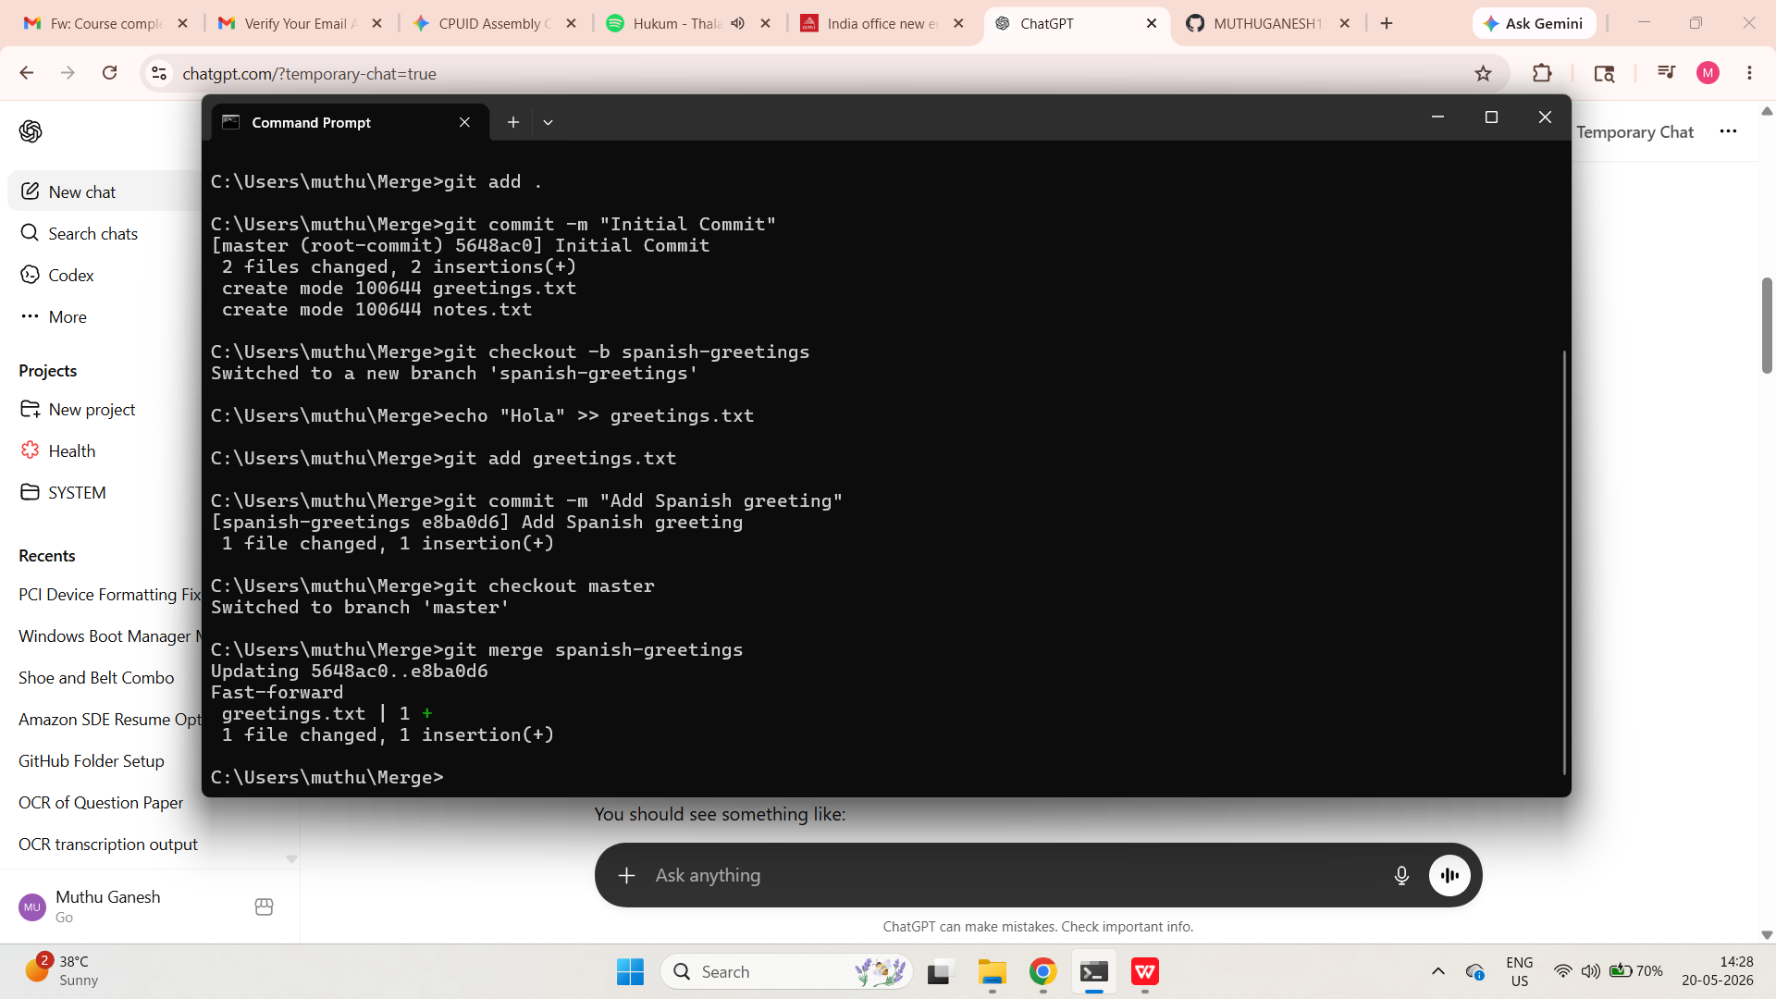

Part 2: Merge Commit (No Conflicts)
Your goal is to generate a merge commit with NO MERGE CONFLICTS.
Create a new branch. Make some changes to the repo such that when you merge the new branch into master, it results in a merge commit. The merge should not result in any conflicts. Merge that branch into master and see if you were right!
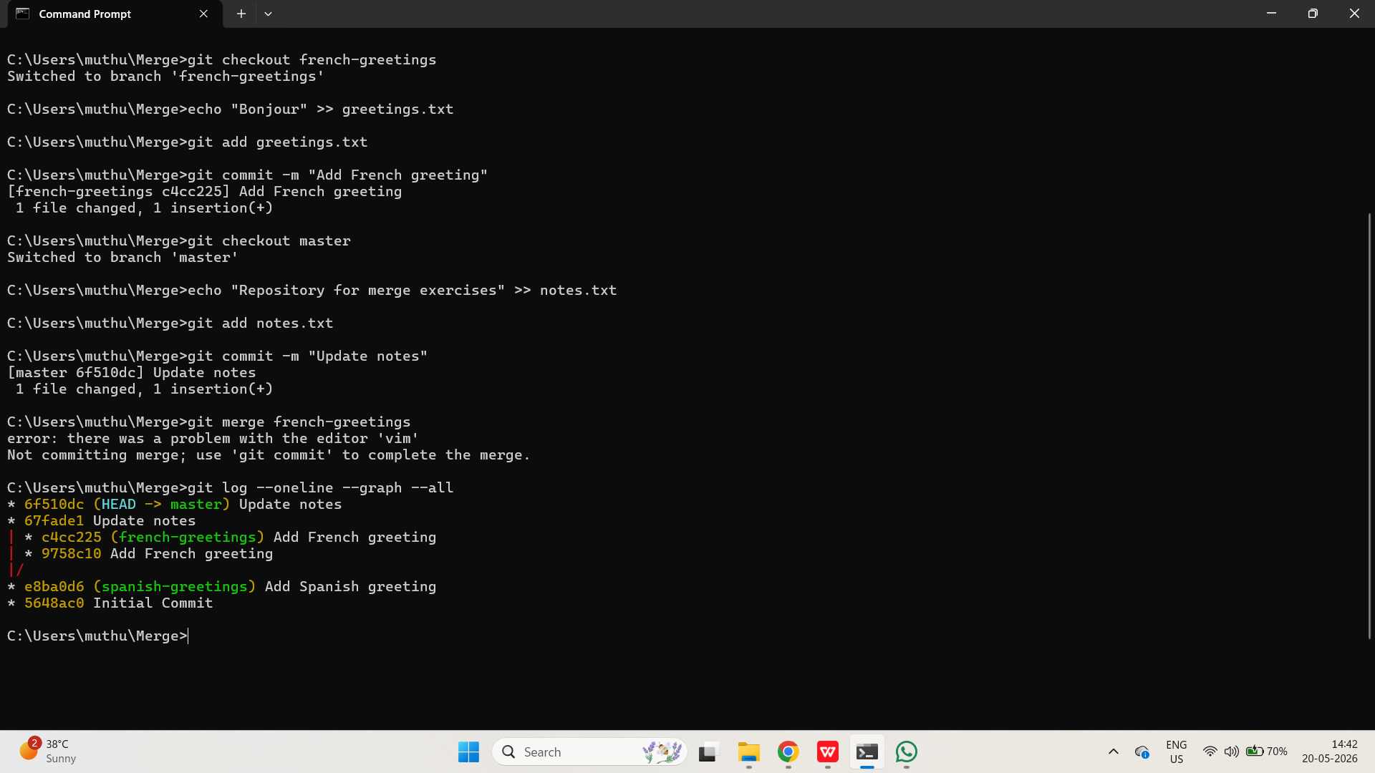

Part 3: Conflicts!
Your goal is to generate merge a conflict!
Create a new branch. Make some changes to the repo such that when you merge the new branch into the master branch, it results in a merge conflict. Merge that branch into master and see if you were right! Resolve the conflict!
