TITLE: - BASICS EXCERCISE

AIM: -
To perform some basics exercise in github
DESCRIPTION:
- Create a new repository locally on your machine.
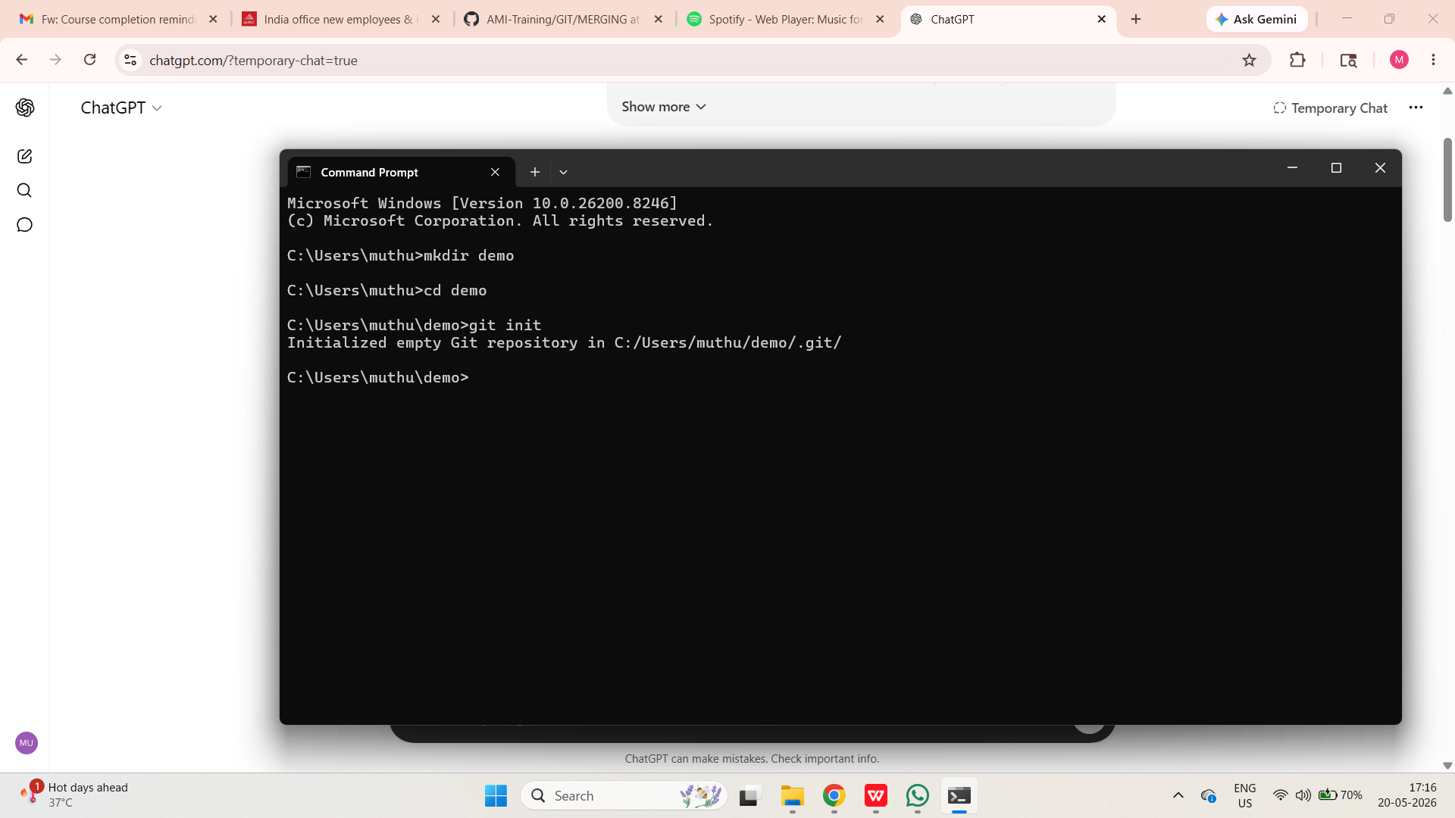
- Create a new Github repository. Name it whatever you want.
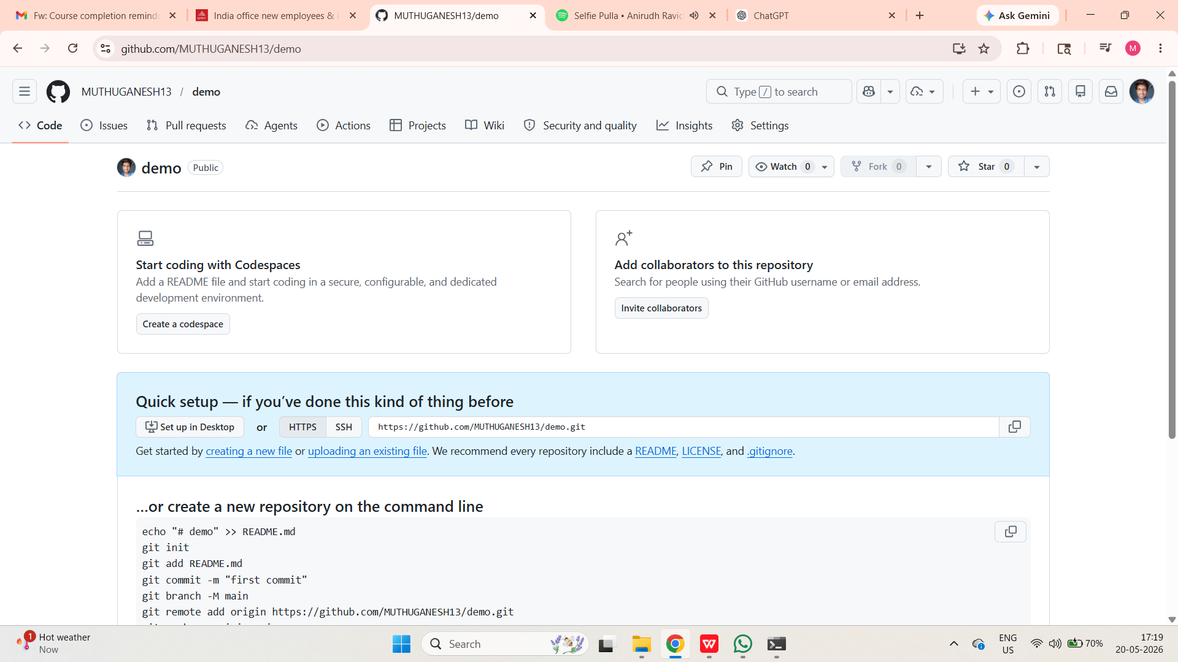
- Connect your local repo to the Github repo.
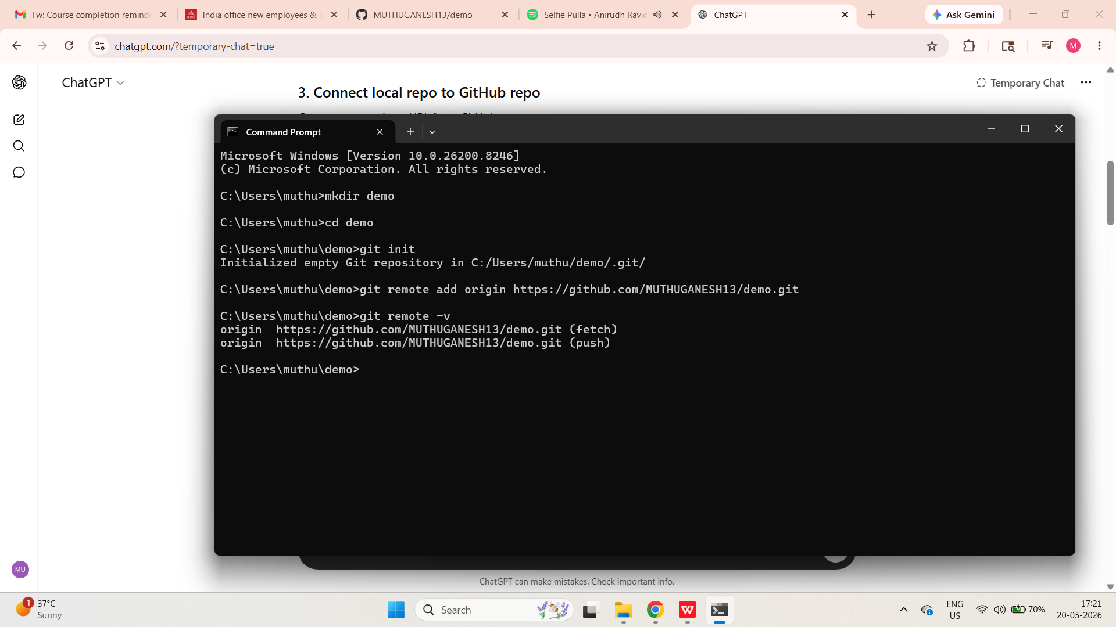
- Optional: rename the default branch from master to main.
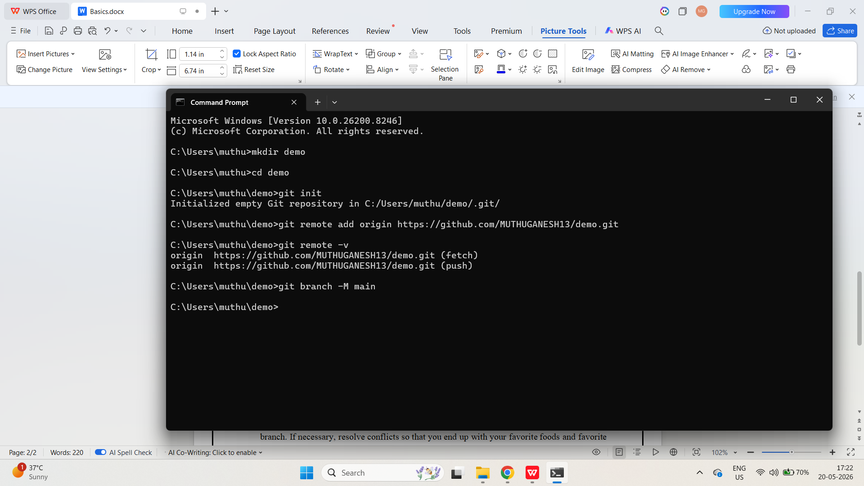
- Make a new file called favorites.txt Leave it empty. Make your first commit on the main branch.
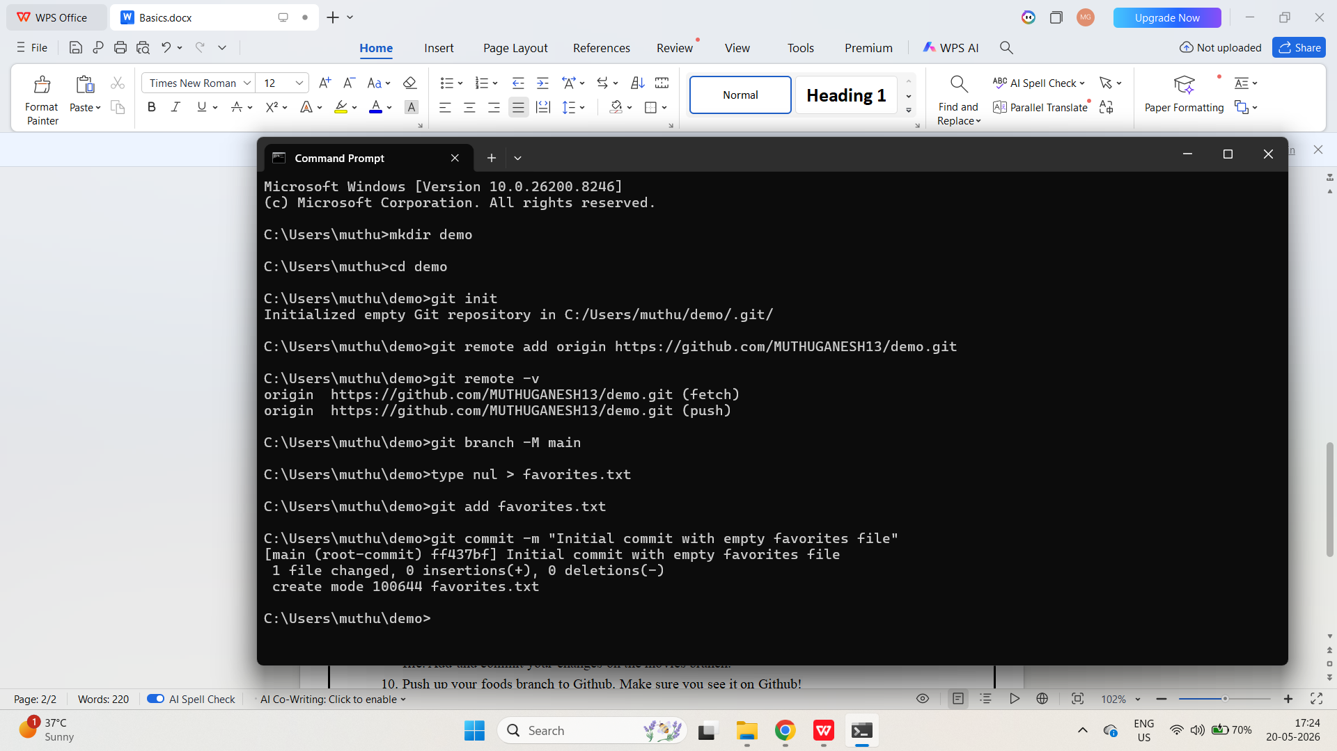
- Push up your main branch to Github! Make sure you see your empty favorites.txt file on Github.
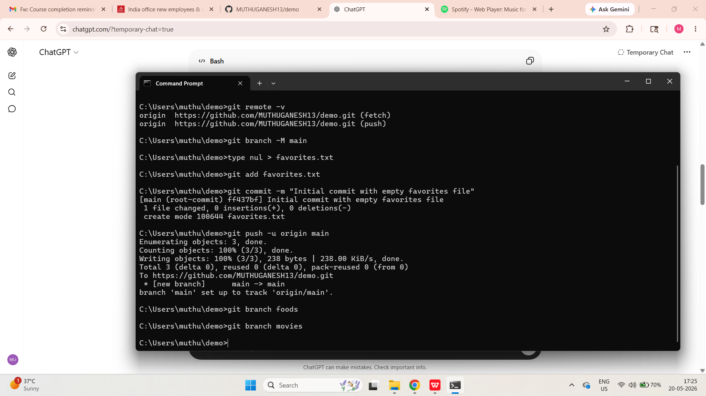
- Next, create two branches: foods and movies

- Switch to the foods branch. Add three (or more) of your favorite foods to the favorites.txt file. Add and commit your changes on the foods branch.
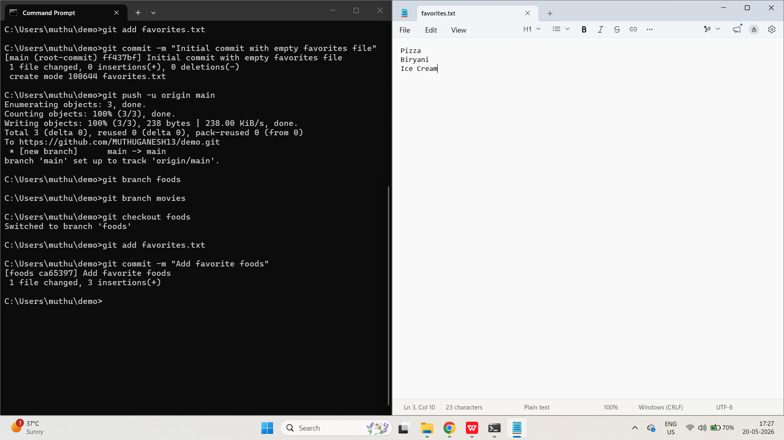

- Switch to the movies branch and add three or more of your favorite movies to the favorites.txt file. Add and commit your changes on the movies branch.
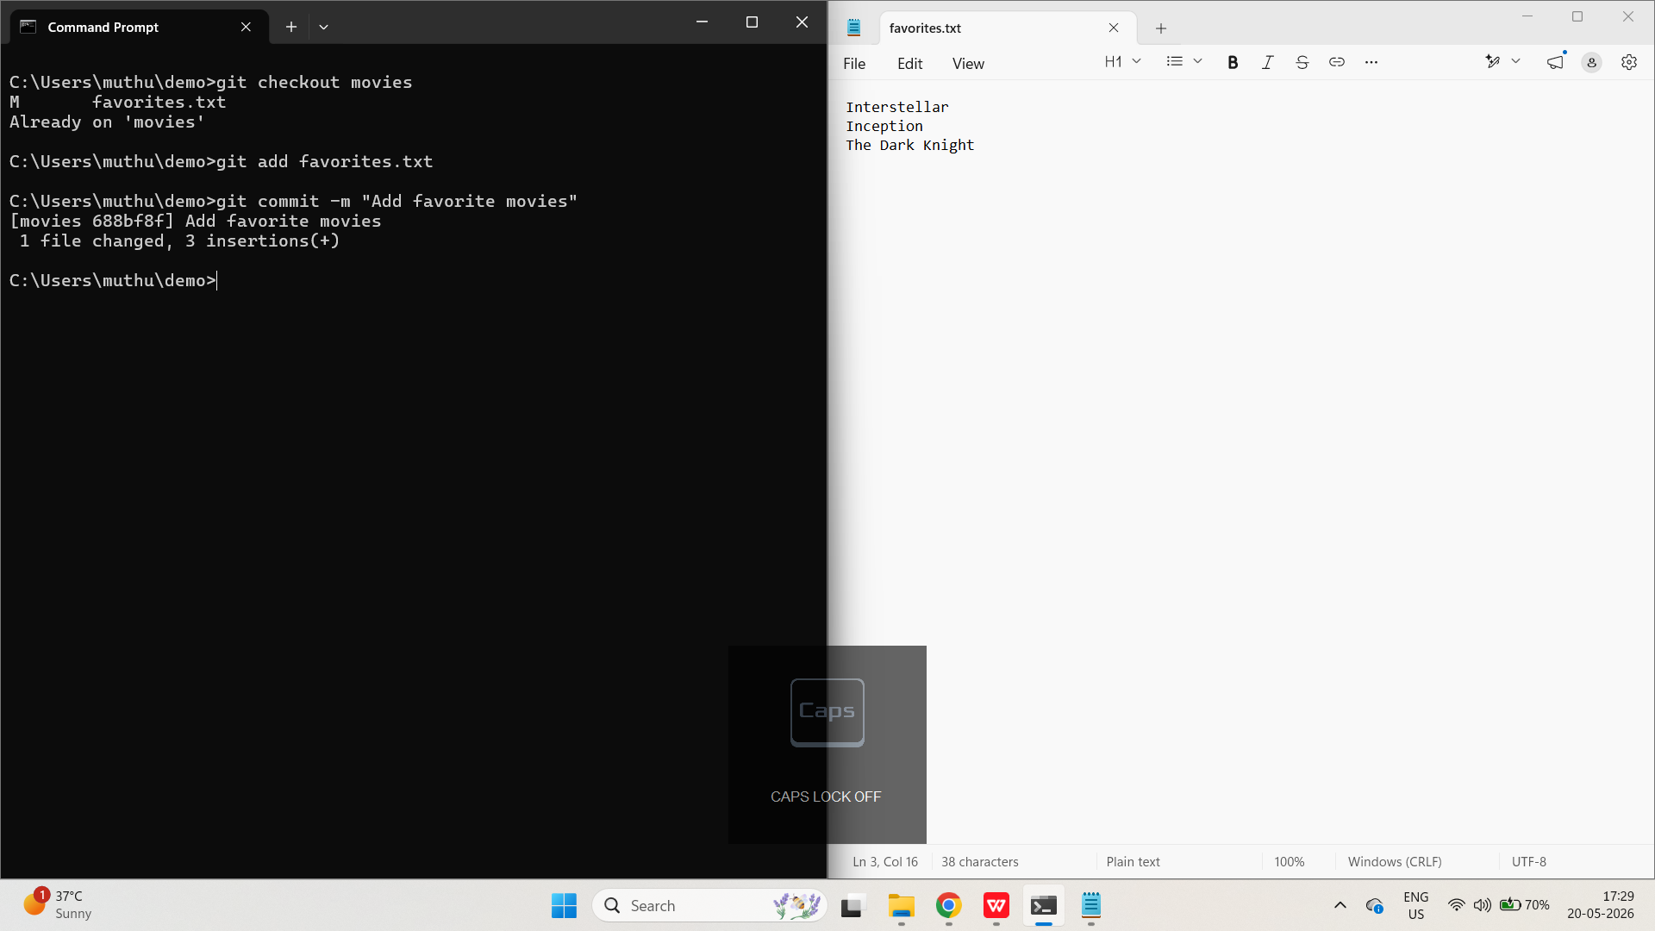
- Push up your foods branch to Github. Make sure you see it on Github!
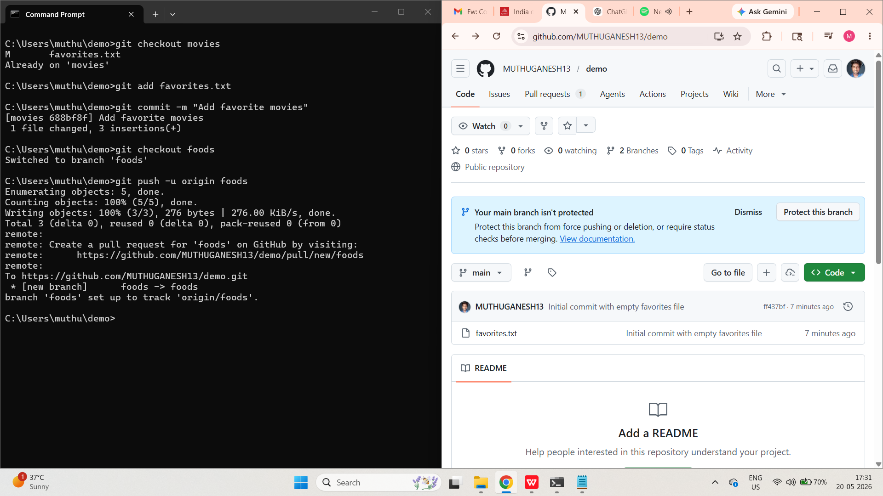

- Push up your movies branch to Github. Make sure you see it on Github!
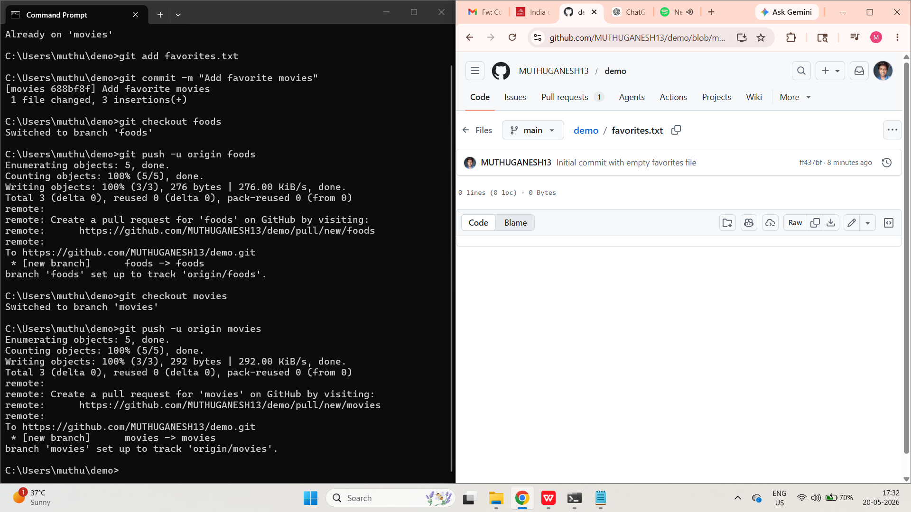
- Merge the foods branch into the main branch. Then merge the movies branch into the main branch. If necessary, resolve conflicts so that you end up with your favorite foods and favorite movies in the same favorites.txt file.
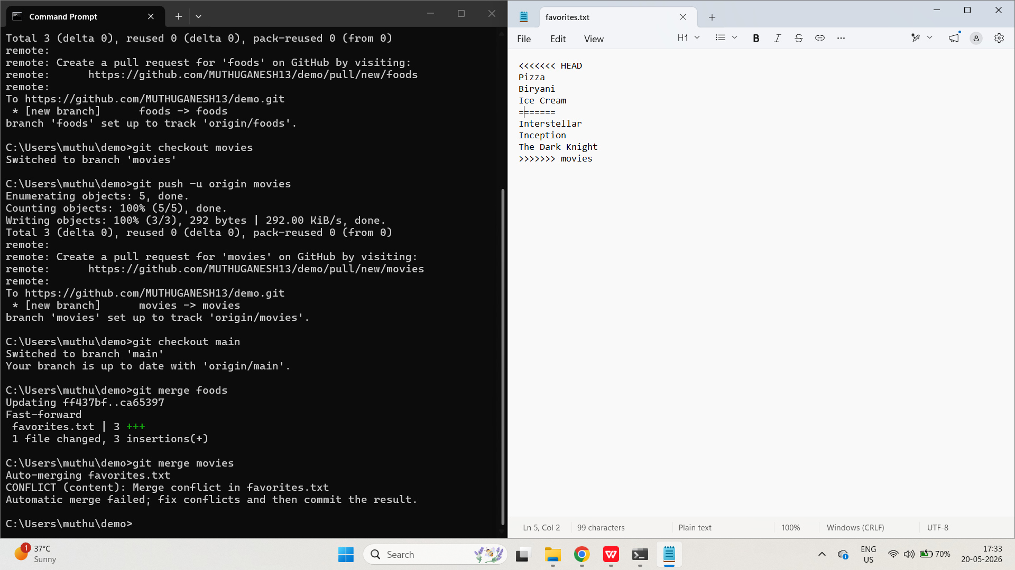
- Push up the latest work on your main branch to Github.
