1.NUMBER TO WORD

AIM:

To convert the number to words without using fuctions and array by only using loops,decision statements and operators.

PROCEDURE:
· stdio.h is included to use input and output functions.
· Integer variables are created to store the number, reversed number, and zero counters.
· The user enters an integer number between 0 and 9999.
· The entered number is checked to see if it is within the given range.
· The number is processed digit by digit to create its reverse.
· Zeros at the end of the number are counted while reversing.
· The reversed number is used to keep the original digit order.
· Each digit is extracted from the reversed number one by one.
· A switch statement is used to convert each digit into its word form.
· The word of each digit is printed on the screen.
· The reversed number is reduced by removing the last digit each time.
· After all digits are printed, the counted zeros are printed.
· The complete number in words is displayed.
· The program ends after showing the result.
PROGRAM:
/*
* Program to convert a given number into words using operators,loops and decision statements
* Author : MUTHUGANESH S
* Date : 15/01/2026
* Filename : NumberToWords.c
* retval : void
*/

#include <stdio.h>

int main(void){
int Number,ReversedNumber=0;
int ZeroFlag=0,ZeroCount=0;
printf("Enter an integer number (0-9999): ");
scanf("%d",&Number);

printf("\nNumber %d in words: ",Number);

if(Number<0||Number>9999){
printf("Out of range! Please enter a number between 0 and 9999.\n");
return 0;
}
//Reverse the number to maintain the order of digits
while (Number>0)
{
if(ZeroFlag==0 && Number%10==0){
ZeroCount++;
}
else{
ZeroFlag=1;
}
//Extract the last digit and build the reversed number
ReversedNumber = (ReversedNumber * 10) + (Number % 10);
Number /= 10;
}

//Loop to extract each digit and convert to words
while(ReversedNumber>0){
//Extract the last digit
int digit=ReversedNumber%10;

//Convert digit to word using switch case
switch(digit){

case 0:{
printf("Zero ");
break;
}
case 1:{
printf("One ");
break;
}
case 2:{
printf("Two ");
break;
}
case 3:{
printf("Three ");
break;
}
case 4:{
printf("Four ");
break;
}
case 5:{
printf("Five ");
break;
}
case 6:{
printf("Six ");
break;
}
case 7:{
printf("Seven ");
break;
}
case 8:{
printf("Eight ");
break;
}
case 9:{
printf("Nine ");
break;
}

}

//Remove the last digit
ReversedNumber/=10; //Assignment operator
}

//Print the trailing zeros
for(int i=0;i<ZeroCount;i++){
printf("Zero ");
}

return 0;
}
OUTPUT:
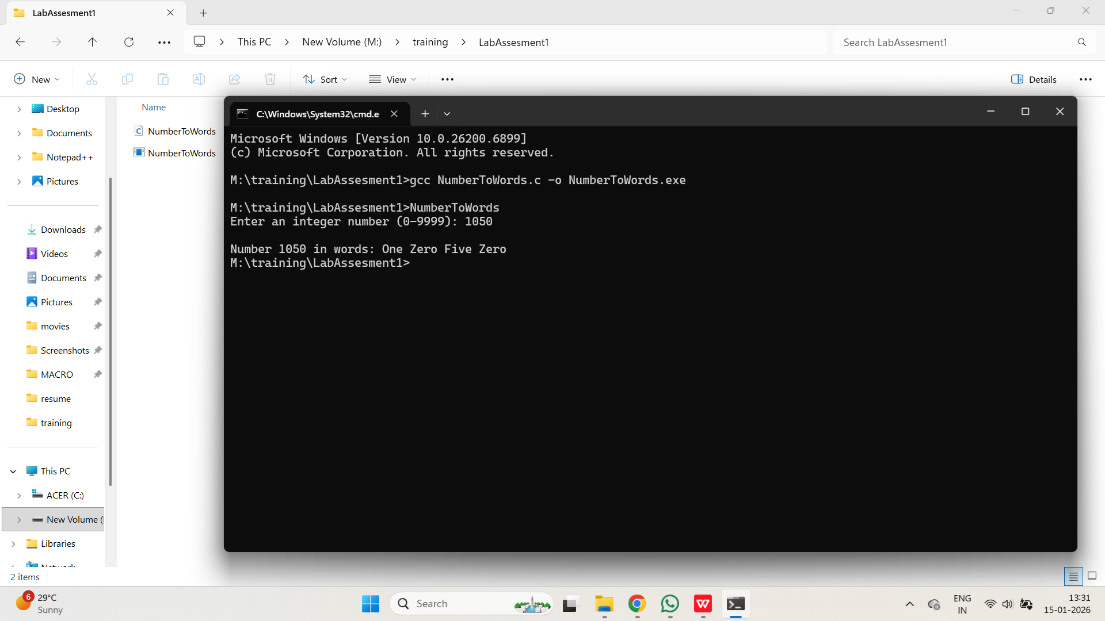

2.PROGRAM USING MACROS
AIM:
To define the ingnition status using the an integer reading and make use macros and display the result.
PROCEDURE:
· stdio.h is included to perform input and output operations.
· Macros are defined to read, set, and clear individual bits in a variable.
· Macros ON and OFF are defined to represent logic values.
· An unsigned character variable Input is declared to store the 8-bit value.
· A number between 0 and 255 is read from the user and stored in Input.
· Bit D0 is read as the ignition switch.
· Bit D1 is read as the right indicator switch.
· Bit D2 is read as the left indicator switch.
· Bits D5, D6, and D7 are cleared to reset output status.
· Ignition status bit D6 is set if the ignition switch is ON.
· Right indicator status bit D5 is set if the right indicator switch is ON.
· Left indicator status bit D7 is set if the left indicator switch is ON.
· Both indicator status bits are set when parking condition is met.
· Ignition status is printed based on bit D6.
· Indicator status is printed based on bits D5 and D7.
· The final modified input value is displayed in decimal form.
· Program execution ends.

PROGRAM:
/*
* Program to demonstrate the Indicator using Macros
* Author : MUTHUGANESH S
* Date : 15/01/2026
* Filename : MacroProgram.c
* retval : void
*/

//header file
#include <stdio.h>

//macro
#define READBIT(VAR,POS) ((VAR >> POS) & 1)
#define SETBIT(VAR,POS) (VAR |= (1 << POS))
#define CLEARBIT(VAR,POS) (VAR &= ~(1 << POS))
#define ON 1
#define OFF 0
int main(){
unsigned char Input;
printf("Enter an integer (0-255): ");
scanf("%hhu", &Input);

//Read Switches
unsigned char IgnitionSwitch=READBIT(Input,0);
unsigned char RightIndicatorSwitch=READBIT(Input,1);
unsigned char LeftIndicatorSwitch=READBIT(Input,2);

CLEARBIT(Input,5);//Right Indicator Status
CLEARBIT(Input,6);//Ignition Status
CLEARBIT(Input,7);//Left Indicator Status

if(IgnitionSwitch==ON){
SETBIT(Input,6); //Ignition ON

if(RightIndicatorSwitch==ON && LeftIndicatorSwitch==OFF){
SETBIT(Input,5); //Right Indicator ON
SETBIT(Input,7); //Left Indicator ON
}
else if(RightIndicatorSwitch==ON){
SETBIT(Input,5); //Left Indicator ON
}
else if(LeftIndicatorSwitch==ON){
SETBIT(Input,7); //Right Indicator ON
}
}

if(READBIT(Input,6)==ON){
printf("Ignition Status: ON\n");
}
else{
printf("Ignition Status: OFF\n");
}

if(READBIT(Input,5)==ON && READBIT(Input,7)==ON){
printf("Parking On\n");
}
else if(READBIT(Input,5)==ON){
printf("Right Indicator ON\n");
}
else if(READBIT(Input,7)==ON){
printf("Left Indicator ON\n");
}
else{
printf("Indicators OFF\n");
}

printf("Output Status (in decimal): %d\n", Input);
return 0;

}
OUTPUT:
