Simple Code

Aim:

To Write a simple code to get two variable one as integer and another as float. Display the given value as output also print the size of both the variables. Perform all stages of compilation process one by one (preprocessing, Compiling, assembling, linking)

Program:

//Documentation Section

/*
* Simple Code to Get INTEGER and FLOAT and Size of both
* Author : MUTHUGANESH S
* Date : 07/01/2026
* File name: SimpleCode.c
* retval : void
*/

//Preprocessor Section
#include <stdio.h>

//Main Section
int main() {
//variable declaration
int IntValue;
float FloatValue;

printf("Enter an integer value: ");
scanf("%d", &IntValue);
printf("Enter a float value: ");
scanf("%f", &FloatValue);

printf("You entered integer: %d\n", IntValue);
printf("You entered float: %f\n", FloatValue);

printf("Size of integer: %zu bytes\n", sizeof(IntValue));
printf("Size of float: %zu bytes\n", sizeof(FloatValue));

return 0;
}

Output:
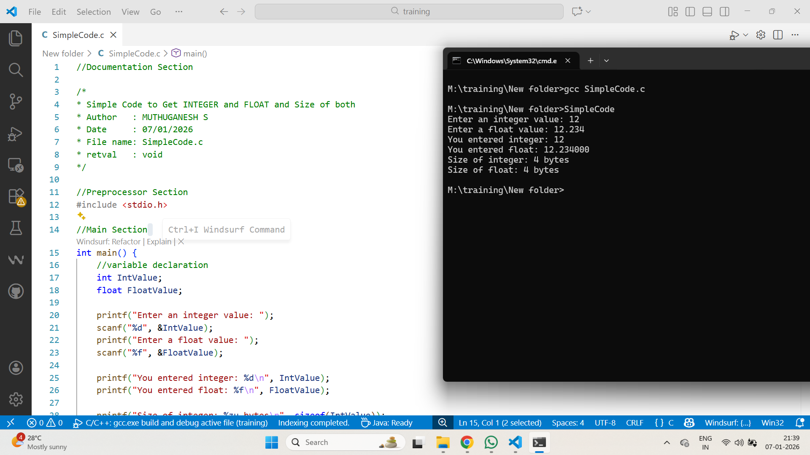
Step by Step:

1.For compiling

M:\training\New folder>gcc SimpleCode.c

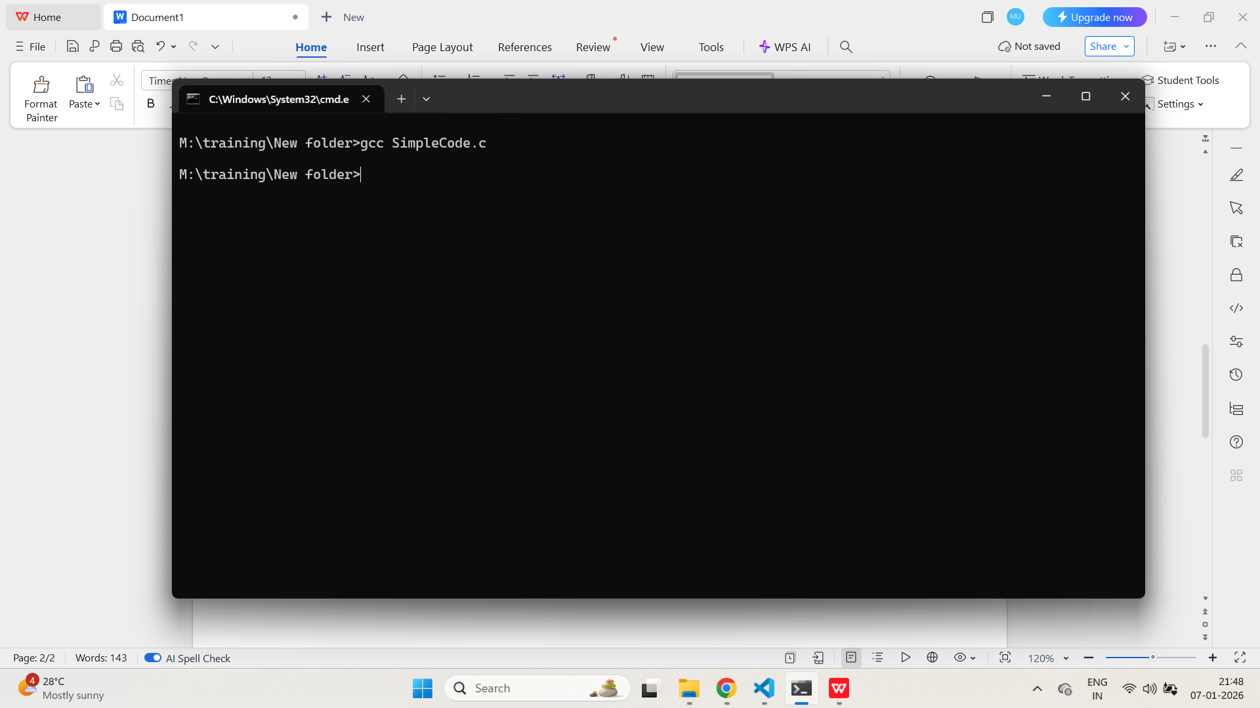

Now we can see the exe file with a

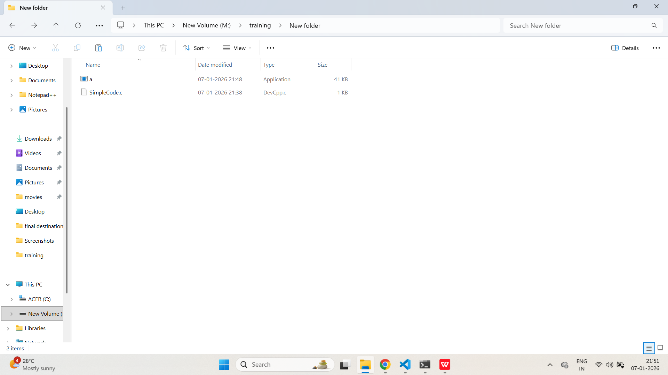

- For Linking

M:\training\New folder>gcc SimpleCode.c -o SimpleCode.exe

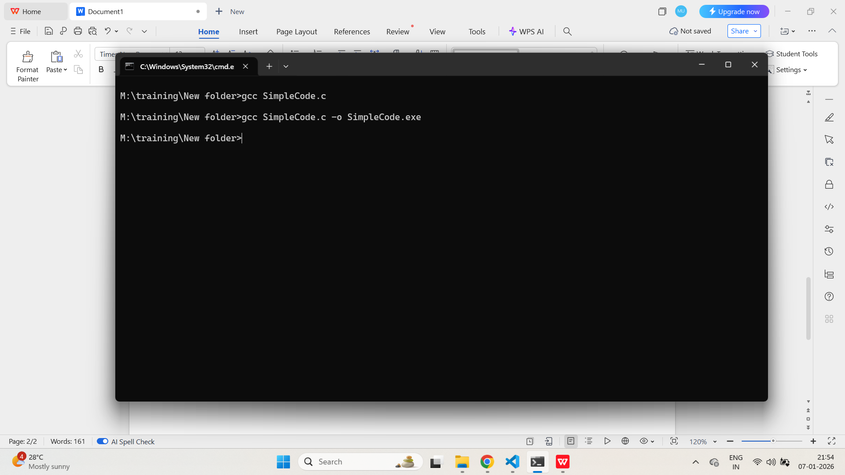

Now we can see with the name

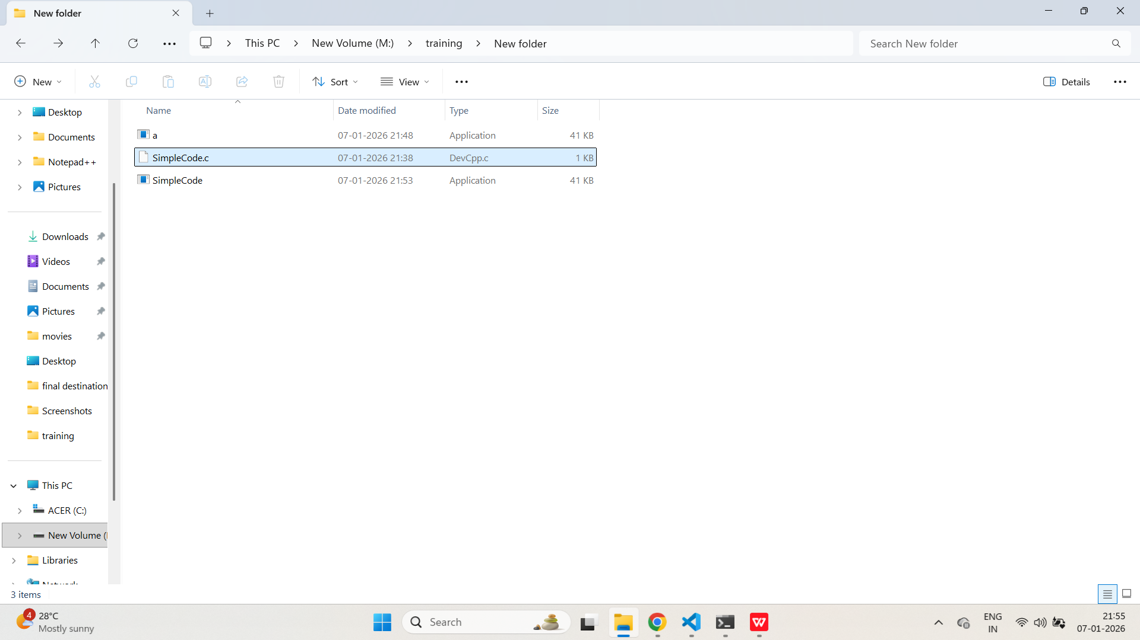

M:\training\New folder>SimpleCode

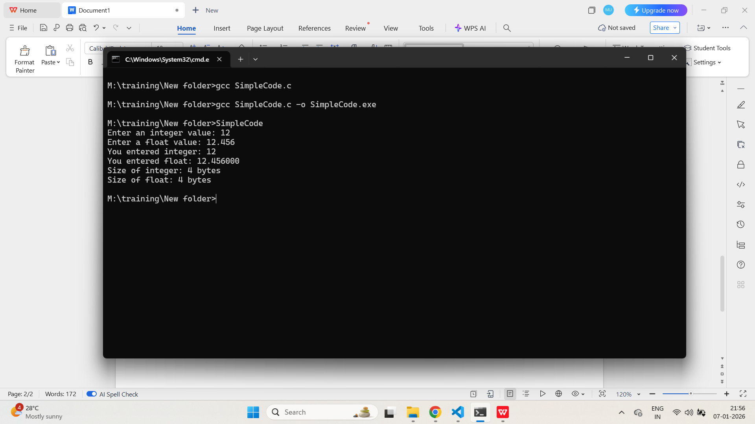

- For showing the warning

M:\training\New folder>gcc -Wall SimpleCode.c

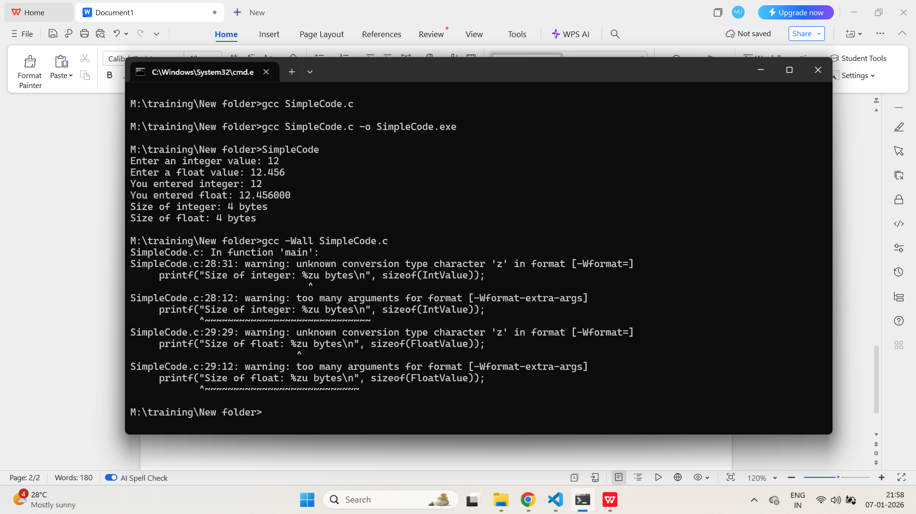

- For Preprocessor Stage

M:\training\New folder>gcc -E SimpleCode.c -o SimpleCode.I

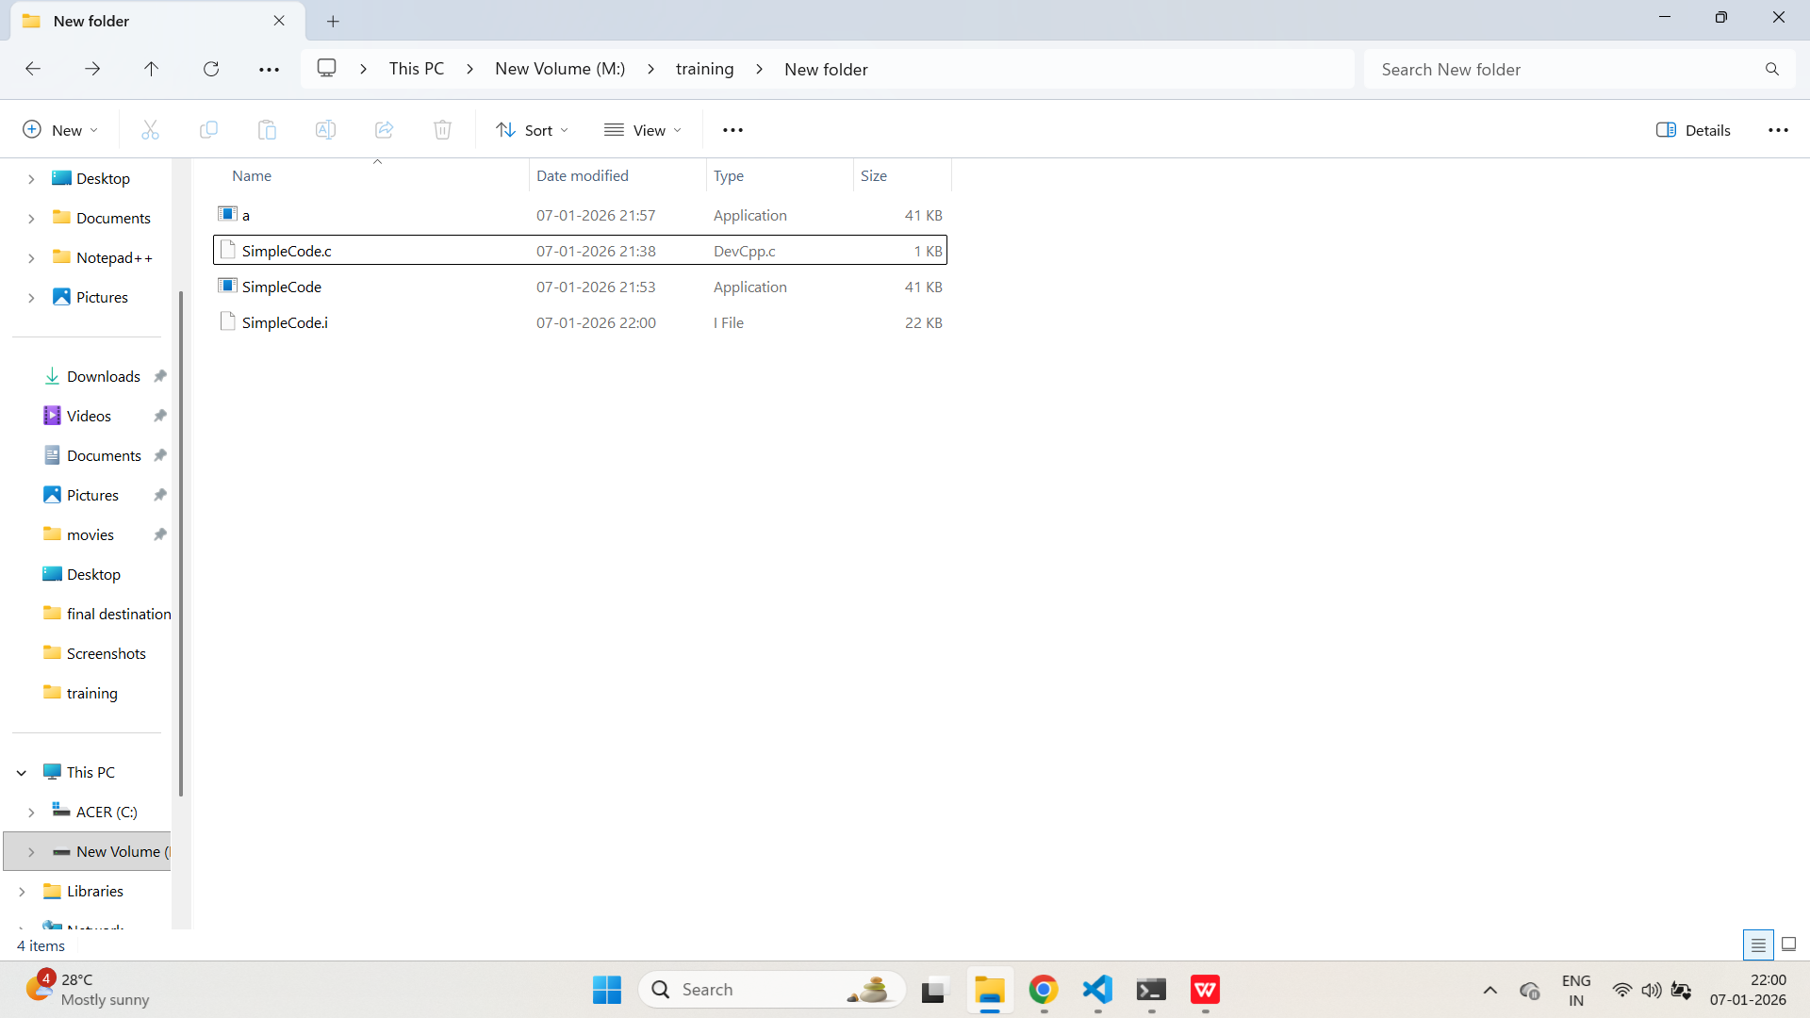

- For compilation Stage

M:\training\New folder>gcc -S SimpleCode.c -o SimpleCode.s

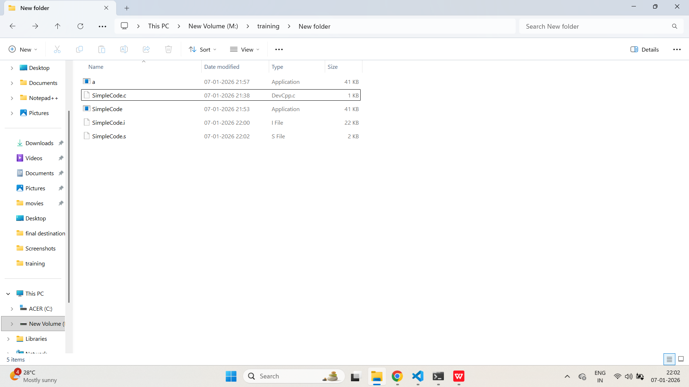

- For Assembly Stage

M:\training\New folder>gcc -C SimpleCode.c -o SimpleCode.o

