DFA TO REGULAR GRAMMAR CONVERSION REPORT

1. Introduction
This report demonstrates the conversion of a DFA into an equivalent Regular Grammar using JFLAP.

2. DFA Diagram
The DFA constructed in JFLAP is shown below:
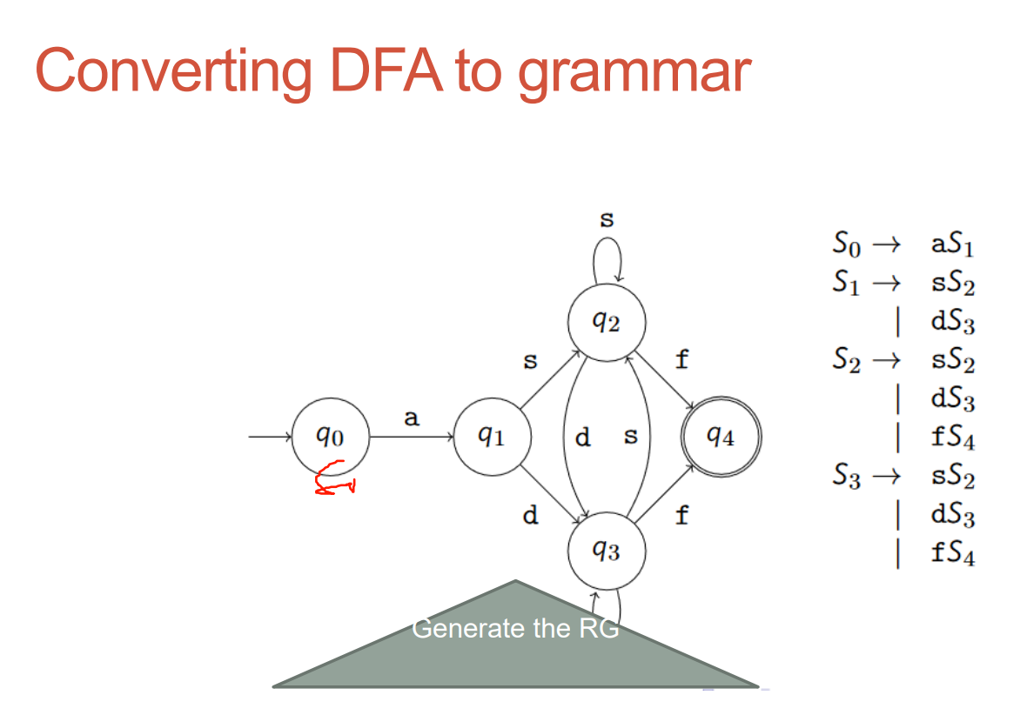

3. Grammar Conversion (JFLAP Output)
The grammar and derivation in JFLAP:
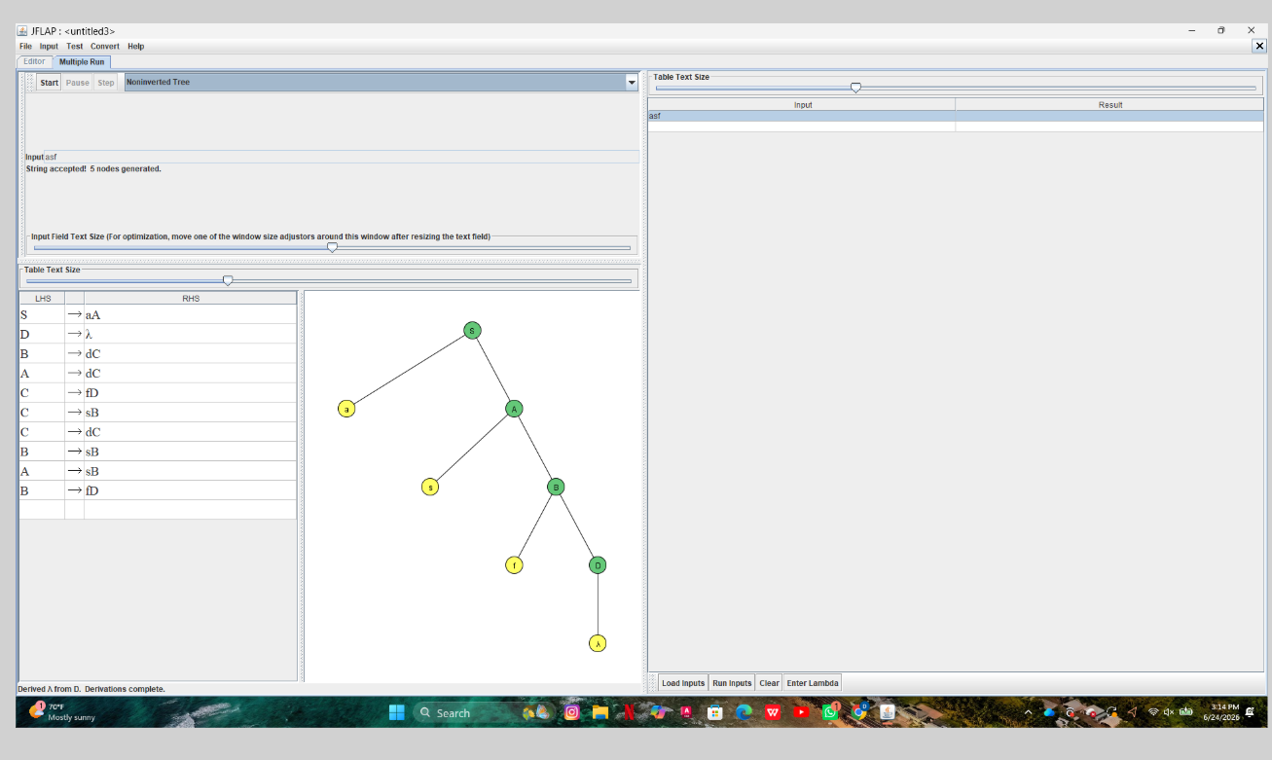

4. Equivalent Grammar
S → aA
A → sB | dC
B → sB | dC | fD
C → sB | dC | fD
D → ε

5. Sample Derivation
S ⇒ aA ⇒ asB ⇒ assB ⇒ assfD ⇒ assf

6. Conclusion
The DFA was successfully converted into a right-linear grammar.

