PROJECT REPORT DEMONSTRATION

1 INTRODUCTION

OVERVIEW

Create a business card

PURPOSE

The Project assigned that the skills of using technology to create the you tube thumbnail using Canva with help of canva application

2. PROBLEM DEFINITIONS AND DESIGNIN THINKING

EMPATHY MAP

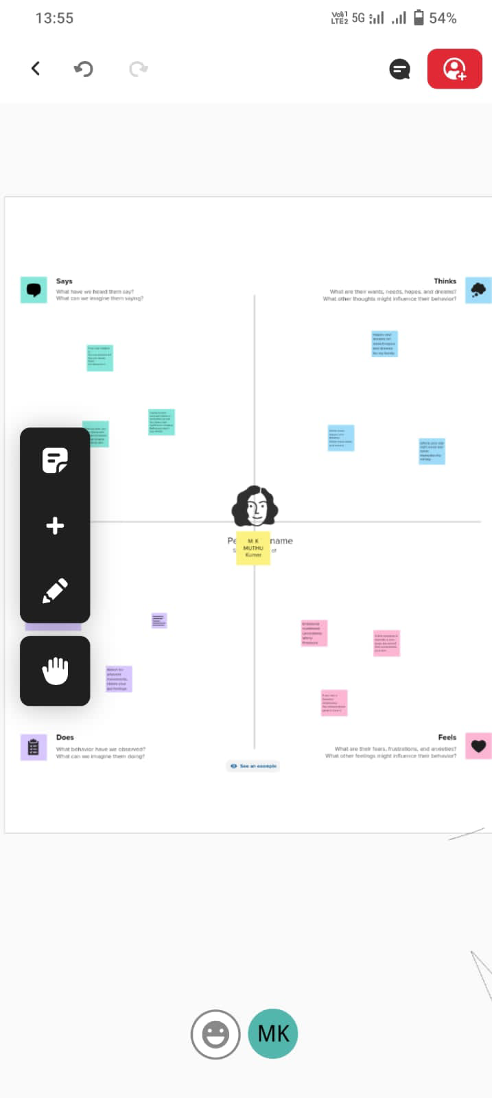

BRAINSTORMING MAP

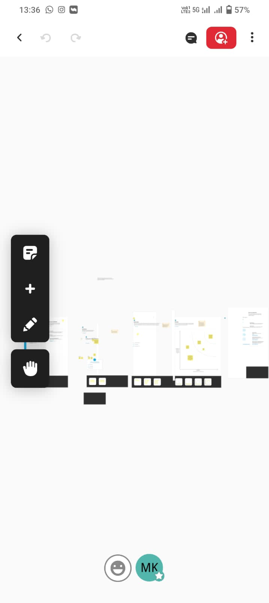

3. RESULTS

PROJECT NAME DESIGN INFRAGRAPHIS USING CANVA



4. ADVANTAGES AND DISADVANTAGES

|  |  |
| --- | --- |
| . ADVANTAGES | DISADVANTAGES |
| 1. It is used effectively in communication 2. It is economical 3. It is User-Friendly 4. In Canva There are a lot of activities for presentation | 1.Some logo ,images,designs are so costly  2. E-mail Id is mandatory |
|  |  |

5 APPLICATION

THE CANVA Application is very useful to create my project easily . it helps with new templates

It will be useful in my future.

6 CONCLUSION

In NAAN MUDHALVAN SCHEME I am a student in Government Arts and Science College vedasandur, assigned my project to be done with help of Canva Application.I have learned that usage of canva App well and It is very user-friendly.

**Presented by**

**Muthukumar**