NAME: MUZAMIL SULEMAN

SECTION: BCS-2J

ID: 24K-1023

(LAB TASKS)

**TASK 1:**

#include <iostream>

int event1_count = 0;

int event2_count = 0;

using namespace std;

int main(){

string event1_participant[5];

string event2_participant[5];

int choice;

while(!(event1_count >= 5 && event2_count >= 5)){

int isContinue=1;

cout<<"REGISTER FOR EVENT (1/2): ";

cin>>choice;

switch(choice){

case 1:

while(event1_count <=5 && isContinue == 1){

cout<<"ENTER NAME FOR MEMBER " << event1_count+1<< ": ";

cin>>event1_participant[event1_count];

event1_count++;

cout<<"DO YOU WANT TO CONTINUE (1/0): ";

cin>>isContinue;

}

isContinue = 1;

break;

case 2:

while(event2_count <=5 && isContinue == 1){

cout<<"ENTER NAME FOR MEMBER " << event2_count+1<< ": ";

cin>>event2_participant[event2_count];

event2_count++;

cout<<"DO YOU WANT TO CONTINUE (1/0): ";

cin>>isContinue;

}

isContinue = 1;

break;

}

}

}

**OUTPUT:**

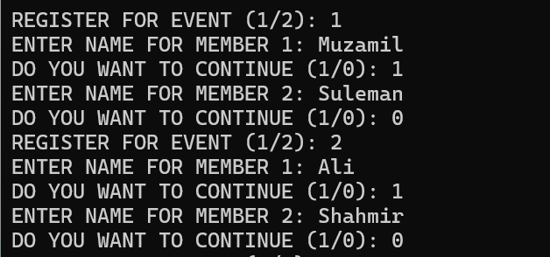

**TASK 2**:

#include <iostream>

int event1_count = 0;

int event2_count = 0;

using namespace std;

int main(){

string event1_participant[5];

string event2_participant[5];

int choice = 1;

while(choice > 0 && choice < 4){

int isContinue=1;

cout<<"REGISTER FOR EVENT (1/2) OR CHECK ATTENDANCE (3) ";

cin>>choice;

switch(choice){

case 1:

while(event1_count <=5 && isContinue == 1){

cout<<"ENTER NAME FOR MEMBER " << event1_count+1<< ": ";

cin>>event1_participant[event1_count];

event1_count++;

cout<<"DO YOU WANT TO CONTINUE (1/0): ";

cin>>isContinue;

}

break;

case 2:

while(event2_count <=5 && isContinue == 1){

cout<<"ENTER NAME FOR MEMBER" << event2_count+1<< ": ";

cin>>event2_participant[event2_count];

event2_count++;

cout<<"DO YOU WANT TO CONTINUE (1/0): ";

cin>>isContinue;

}

break;

case 3:

string name;

int found = 0;

cout<<"ENTER THE NAME FOR MEMBER: ";

cin>>name;

for(int i=0; i<5; i++){

if(event1_participant[i] == name){

cout<<name<<" IS REGISTERED IN EVENT 1\n";

found = 1;

break;

} else if (event2_participant[i] == name){

cout<<name<<" IS REGISTERED IN EVENT 2\n";

found = 1;

break;

}

}

if(found == 0){

cout<<"NOT FOUND!\n";

}

break;

}

}

}

OUTPUT:

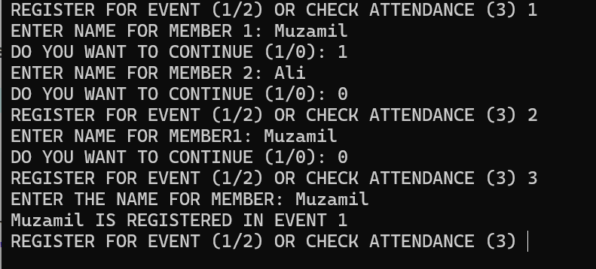

TASK 3:

#include <iostream>

int event1_count = 0;

int event2_count = 0;

int total_donations = 0;

using namespace std;

int main(){

string event1_participant[5];

string event2_participant[5];

int choice=1;

while(choice > 0 && choice < 4){

int isContinue=1;

cout<<"REGISTER FOR EVENT (1/2) OR TOTAL DONATIONS (3) ";

cin>>choice;

switch(choice){

case 1:

while(event1_count <=5 && isContinue == 1){

cout<<"ENTER NAME FOR MEMBER " << event1_count+1<< ": ";

cin>>event1_participant[event1_count];

event1_count++;

cout<<"DO YOU WANT TO CONTINUE (1/0): ";

cin>>isContinue;

}

break;

case 2:

while(event2_count <=5 && isContinue == 1){

cout<<"ENTER NAME FOR MEMBER" << event2_count+1<< ": ";

cin>>event2_participant[event2_count];

event2_count++;

cout<<"DO YOU WANT TO CONTINUE (1/0): ";

cin>>isContinue;

}

break;

case 3:

total_donations = (event1_count + event2_count) * 10;

cout<<"TOTAL DONATIONS FOR BOTH EVENTS: "<<total_donations<<endl;

break;

}

}

}

OUTPUT:

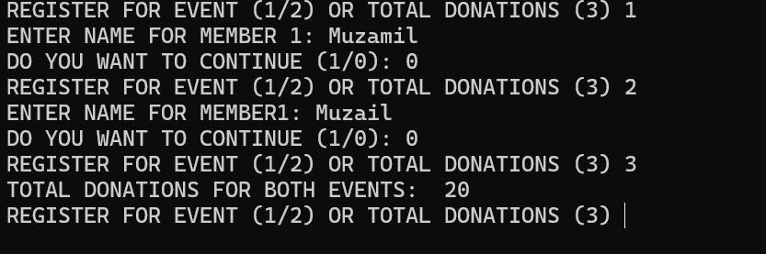

TASK 4:

#include <iostream>

int event1_count = 0;

int event2_count = 0;

int total_donations = 0;

using namespace std;

int main(){

string event1_participant[5];

string event2_participant[5];

int choice;

while(1){

int isContinue=1;

cout<<"REGISTER FOR EVENT (1/2) OR MEMBERS IN REVERSE ORDER (3) ";

cin>>choice;

switch(choice){

case 1:

while(event1_count <=5 && isContinue == 1){

cout<<"ENTER NAME FOR MEMBER " << event1_count+1<< ": ";

cin>>event1_participant[event1_count];

event1_count++;

cout<<"DO YOU WANT TO CONTINUE (1/0): ";

cin>>isContinue;

}

break;

case 2:

while(event2_count <=5 && isContinue == 1){

cout<<"ENTER NAME FOR MEMBER " << event2_count+1<< ": ";

cin>>event2_participant[event2_count];

event2_count++;

cout<<"DO YOU WANT TO CONTINUE (1/0): ";

cin>>isContinue;

}

break;

case 3:

cout<<endl<<"PARTICIPANTS IN (EVENT 1) : "<<endl<<endl;

for(int i=event1_count-1;i>=0;i--){

cout<<event1_participant[i]<<endl;

}

cout<<endl<<"PARTICIPANTS IN (EVENT 2) : "<<endl<<endl;

for(int i=event2_count-1;i>=0;i--){

cout<<event2_participant[i]<<endl;

}

break;

}

}

}

OUTPUT:

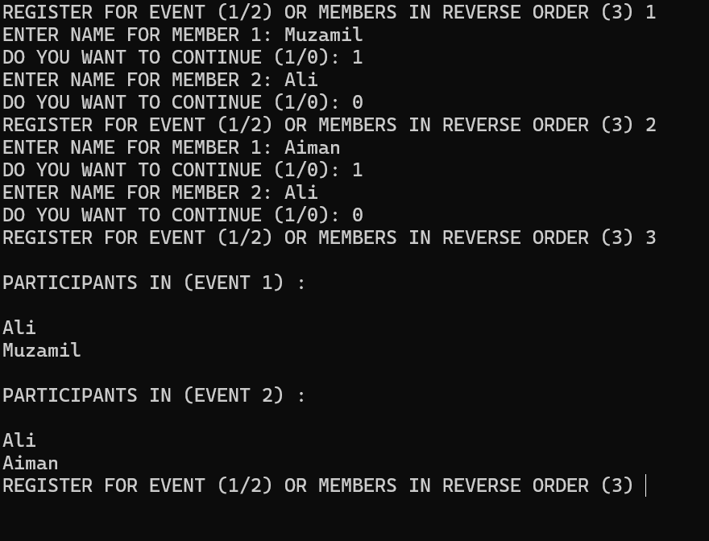

TASK 5:

#include <iostream>

using namespace std;

int event1_count = 0;

int event2_count = 0;

void barChart(int participants_count,int event){

cout<<"EVENT "<<event<<": ";

for(int i=0;i<participants_count;i++){

cout<<"*";

}

cout<<endl;

}

int main(){

string event1_participant[5];

string event2_participant[5];

int choice;

while(!(event1_count >= 5 && event2_count >= 5)){

int isContinue=1;

cout<<"REGISTER FOR EVENT (1/2) OR EVENT POPULARITY BAR CHART (3): ";

cin>>choice;

switch(choice){

case 1:

while(event1_count <=5 && isContinue == 1){

cout<<"ENTER NAME FOR MEMBER " << event1_count+1<< ": ";

cin>>event1_participant[event1_count];

event1_count++;

cout<<"DO YOU WANT TO CONTINUE (1/0): ";

cin>>isContinue;

}

isContinue = 1;

break;

case 2:

while(event2_count <=5 && isContinue == 1){

cout<<"ENTER NAME FOR MEMBER " << event2_count+1<< ": ";

cin>>event2_participant[event2_count];

event2_count++;

cout<<"DO YOU WANT TO CONTINUE (1/0): ";

cin>>isContinue;

}

isContinue = 1;

break;

case 3:

barChart(event1_count,1);

barChart(event2_count,2);

}

}

}

OUTPUT:

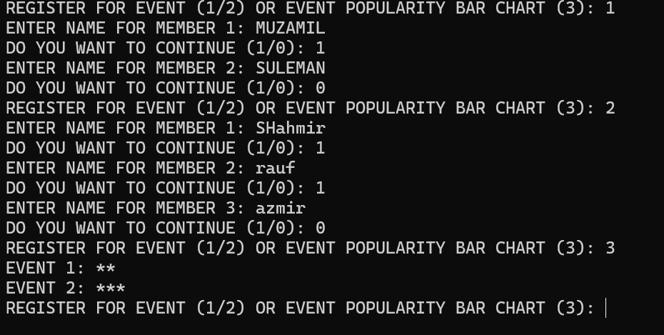

(TAKE HOME TASKS)

TASK 1:

#include<iostream>

using namespace std;

float average_week(int AQI[4][7],int cityIndex){

float avg = 0;

for(int i =0;i<7;i++){

avg = avg +AQI[cityIndex][i];

}

return avg/7.0;

}

int main(){

int AQI[4][7];

for(int i=0;i<4;i++){

cout<<endl<<"CITY "<<i+1<<": "<<endl;

for(int j=0;j<7;j++){

cout<<"DAY "<<j+1<<": ";

cin>>AQI[i][j];

}

}

int week_averages[4] = {0};

for(int i=0;i<4;i++){

cout<<"CITY "<<i+1<<" AVERAGE: "<<average_week(AQI,i)<<endl;

week_averages[i] = average_week(AQI,i);

}

int maxAverageIndex = 0;

for(int i=0;i<4;i++){

if(week_averages[maxAverageIndex]<week_averages[i]){

maxAverageIndex = i;

}

}

cout<<"HIGHEST AQI CITY : "<<maxAverageIndex+1;

return 0;

}

OUTPUT:

USING THIS DATASET:

int AQI[4][4][7] = {

{ // City 1

{85, 367, 361, 409, 251, 147, 70}, // Week 1

{384, 413, 354, 40, 372, 339, 158}, // Week 2

{496, 7, 352, 239, 307, 19, 500}, // Week 3

{61, 237, 116, 206, 43, 69, 150} // Week 4

},

{ // City 2

{309, 248, 377, 268, 347, 377, 389}, // Week 1

{61, 364, 473, 11, 10, 103, 31}, // Week 2

{175, 46, 426, 162, 63, 359, 186}, // Week 3

{461, 155, 79, 8, 193, 391, 92} // Week 4

},

{ // City 3

{30, 64, 385, 363, 462, 347, 165}, // Week 1

{195, 437, 486, 345, 339, 42, 428}, // Week 2

{433, 76, 311, 382, 441, 366, 241}, // Week 3

{209, 435, 313, 477, 27, 177, 443} // Week 4

},

{ // City 4

{144, 493, 253, 239, 175, 197, 283}, // Week 1

{299, 435, 473, 400, 86, 310, 410}, // Week 2

{171, 99, 377, 55, 149, 468, 274}, // Week 3

{292, 422, 32, 157, 119, 413, 483} // Week 4

}

};

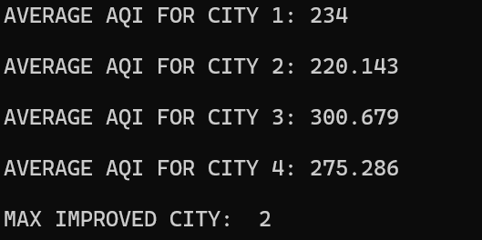

**TASK 5:**

#include <iostream>

using namespace std;

float weekly_avg(int AQI[4][4][7], int cityIndex, int weekIndex)

{

    float avg = 0;

    for (int i = 0; i < 7; i++)

    {

        avg += AQI[cityIndex][weekIndex][i];

    }

    return avg / 7.0;

}

void minmax(int AQI[4][4][7], int minmaxValues[2])

{

    int max = AQI[0][0][0];

    int min = max;

    for (int i = 0; i < 4; i++)

    {

        for (int j = 0; j < 4; j++)

        {

            for (int k = 0; k < 7; k++)

            {

                if (max < AQI[i][j][k])

                {

                    max = AQI[i][j][k];

                }

                if (min > AQI[i][j][k])

                {

                    min = AQI[i][j][k];

                }

            }

        }

    }

    minmaxValues[0] = min;

    minmaxValues[1] = max;

}

int main()

{

    int AQI[4][4][7];

    for (int i = 0; i < 4; i++)

    {

        cout << endl

             << "CITY " << i + 1 << ":" << endl;

        for (int j = 0; j < 4; j++)

        {

            for (int k = 0; k < 7; k++)

            {

                cout << "DAY " << 7 * j + (k + 1) << ": ";

                cin >> AQI[i][j][k];

            }

        }

    }

    cout << endl

         << "\t====WEEKLY AVERAGE====" << endl;

    for (int i = 0; i < 4; i++)

    {

        cout << endl

             << "CITY " << i + 1 << ":" << endl;

        for (int j = 0; j < 4; j++)

        {

            cout << "WEEK " << j + 1 << ": " << weekly_avg(AQI, i, j) << endl;

        }

    }

    cout << endl

         << "\t====CRTIICAL POLLUTION DAYS=====" << endl;

    for (int i = 0; i < 4; i++)

    {

        cout << endl

             << "CITY " << i + 1 << ":" << endl

             << endl;

        for (int j = 0; j < 4; j++)

        {

            for (int k = 0; k < 7; k++)

            {

                if (AQI[i][j][k] > 150)

                {

                    cout << "DAY " << 7 * j + (k + 1) << ": " << AQI[i][j][k] << endl;

                }

            }

        }

    }

    int minmaxValues[2] = {0};

    minmax(AQI, minmaxValues);

    cout << "MINIMUM FOR MONTH: " << minmaxValues[0] << endl;

    cout << "MAXIMUM FOR MONTH: " << minmaxValues[1] << endl;

    return 0;

}

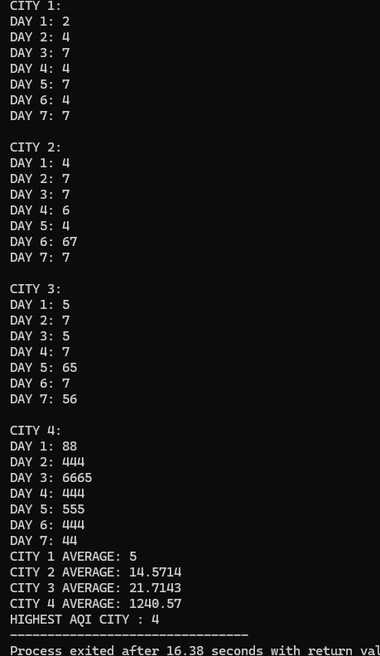

TASK 2:

#include<iostream>

using namespace std;

int main() {

int AQI[4][7];

for(int i=0;i<4;i++){

cout<<endl<<"CITY "<<i+1<<": "<<endl;

for(int j=0;j<7;j++){

cout<<"DAY "<<j+1<<": ";

cin>>AQI[i][j];

}

}

cout<<"CRITICAL POLLUTIONS DAYS: "<<endl;

for(int i=0; i<4; i++) {

cout<<endl<<"CITY "<<i+1<<": "<<endl;

for(int j=0; j<7; j++) {

if(AQI[i][j] > 150){

cout<<"DAY "<<j+1<<" : "<<AQI[i][j]<<endl;

}

}

}

return 0;

}

OUTPUT:

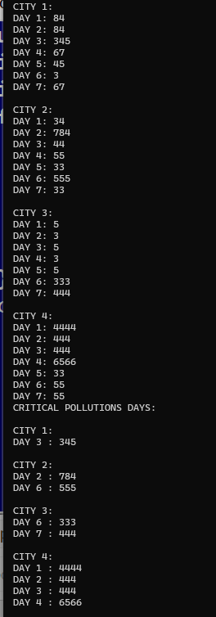

TASK 3:

#include<iostream>

using namespace std;

int main(){

int AQI[4][7];

for(int i=0;i<4;i++){

cout<<endl<<"CITY "<<i+1<<": "<<endl;

for(int j=0;j<7;j++){

cout<<"DAY "<<j+1<<": ";

cin>>AQI[i][j];

}

}

int stars;

for(int i=0;i<4;i++){

cout<<endl<<endl<<"CITY "<<i+1<<": "<<endl;

for(int j=0;j<7;j++){

cout<<endl<<"DAY "<<j+1<<": ";

stars = AQI[i][j]/50;

for(int k=0;k<stars;k++){

cout<<"*";

}

}

}

return 0;

}

OUTPUT:

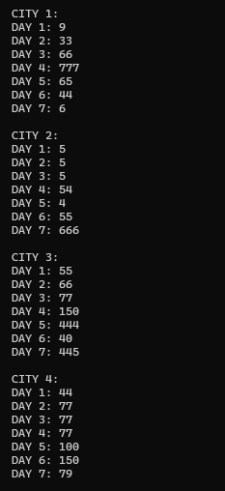

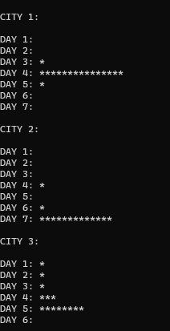

TASK 4:

#include<iostream>

float month_average(int AQI[4][4][7],int cityIndex) {

float avg=0;

for(int i=0; i<4; i++) {

for(int j=0; j<7; j++) {

avg+=AQI[cityIndex][i][j];

}

}

return avg/28.0;

}

float improvement_calc(int AQI[4][4][7],int cityIndex) {

float improvement =0;

float weeks_avg[2] = {0};

int weeks_index[2] = {0,3};

for(int i=0; i<2; i++) {

for(int j=0; j<7; j++) {

improvement+=AQI[cityIndex][weeks_index[i]][j];

}

weeks_avg[i] = improvement/7.0;

improvement = 0;

}

improvement = weeks_avg[0] - weeks_avg[1];

if(improvement > 0){

return improvement;

}

return 0;

}

using namespace std;

int main() {

int AQI[4][4][7];

for(int i=0;i<4;i++){

cout<<"CITY "<<i+1<<" :"<<endl;

for(int j=0;j<4;j++){

for(int k=0;k<7;k++){

cout<<"DAY "<<7*j+(k+1)<<" : ";

cin>>AQI[i][j][k];

}

}

}

// for average of month

for(int i=0; i<4; i++) {

cout<<"AVERAGE AQI FOR CITY "<<i+1<<": "<<month_average(AQI,i)<<endl<<endl;

}

//improved city

float improved_cities[4] = {0};

for(int i=0;i<4;i++){

improved_cities[i] = improvement_calc(AQI,i);

}

int max_improved_city = 1;

float temp = improved_cities[0];

for(int i=0;i<4;i++){

if(temp < improved_cities[i]){

temp = improved_cities[i];

max_improved_city = i+1;

}

}

cout<<"MAX IMPROVED CITY: "<<max_improved_city<<endl;

return 0;

}

OUTPUT:

USING THIS DATASET:

int AQI[4][4][7] = {

{ // City 1

{85, 367, 361, 409, 251, 147, 70}, // Week 1

{384, 413, 354, 40, 372, 339, 158}, // Week 2

{496, 7, 352, 239, 307, 19, 500}, // Week 3

{61, 237, 116, 206, 43, 69, 150} // Week 4

},

{ // City 2

{309, 248, 377, 268, 347, 377, 389}, // Week 1

{61, 364, 473, 11, 10, 103, 31}, // Week 2

{175, 46, 426, 162, 63, 359, 186}, // Week 3

{461, 155, 79, 8, 193, 391, 92} // Week 4

},

{ // City 3

{30, 64, 385, 363, 462, 347, 165}, // Week 1

{195, 437, 486, 345, 339, 42, 428}, // Week 2

{433, 76, 311, 382, 441, 366, 241}, // Week 3

{209, 435, 313, 477, 27, 177, 443} // Week 4

},

{ // City 4

{144, 493, 253, 239, 175, 197, 283}, // Week 1

{299, 435, 473, 400, 86, 310, 410}, // Week 2

{171, 99, 377, 55, 149, 468, 274}, // Week 3

{292, 422, 32, 157, 119, 413, 483} // Week 4

}

};

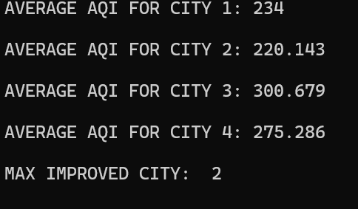

TASK 5:

#include <iostream>

using namespace std;

float weekly_avg(int AQI[4][4][7], int cityIndex, int weekIndex)

{

    float avg = 0;

    for (int i = 0; i < 7; i++)

    {

        avg += AQI[cityIndex][weekIndex][i];

    }

    return avg / 7.0;

}

void minmax(int AQI[4][4][7], int minmaxValues[2])

{

    int max = AQI[0][0][0];

    int min = max;

    for (int i = 0; i < 4; i++)

    {

        for (int j = 0; j < 4; j++)

        {

            for (int k = 0; k < 7; k++)

            {

                if (max < AQI[i][j][k])

                {

                    max = AQI[i][j][k];

                }

                if (min > AQI[i][j][k])

                {

                    min = AQI[i][j][k];

                }

            }

        }

    }

    minmaxValues[0] = min;

    minmaxValues[1] = max;

}

int main()

{

    int AQI[4][4][7];

    for (int i = 0; i < 4; i++)

    {

        cout << endl

             << "CITY " << i + 1 << ":" << endl;

        for (int j = 0; j < 4; j++)

        {

            for (int k = 0; k < 7; k++)

            {

                cout << "DAY " << 7 * j + (k + 1) << ": ";

                cin >> AQI[i][j][k];

            }

        }

    }

    cout << endl

         << "\t====WEEKLY AVERAGE====" << endl;

    for (int i = 0; i < 4; i++)

    {

        cout << endl

             << "CITY " << i + 1 << ":" << endl;

        for (int j = 0; j < 4; j++)

        {

            cout << "WEEK " << j + 1 << ": " << weekly_avg(AQI, i, j) << endl;

        }

    }

    cout << endl

         << "\t====CRTIICAL POLLUTION DAYS=====" << endl;

    for (int i = 0; i < 4; i++)

    {

        cout << endl

             << "CITY " << i + 1 << ":" << endl

             << endl;

        for (int j = 0; j < 4; j++)

        {

            for (int k = 0; k < 7; k++)

            {

                if (AQI[i][j][k] > 150)

                {

                    cout << "DAY " << 7 * j + (k + 1) << ": " << AQI[i][j][k] << endl;

                }

            }

        }

    }

    int minmaxValues[2] = {0};

    minmax(AQI, minmaxValues);

    cout << "MINIMUM FOR MONTH: " << minmaxValues[0] << endl;

    cout << "MAXIMUM FOR MONTH: " << minmaxValues[1] << endl;

    return 0;

}

OUTPUT:

USING THIS DATASET

int AQI[4][4][7] = {

{ // City 1

{85, 367, 361, 409, 251, 147, 70}, // Week 1

{384, 413, 354, 40, 372, 339, 158}, // Week 2

{496, 7, 352, 239, 307, 19, 500}, // Week 3

{61, 237, 116, 206, 43, 69, 150} // Week 4

},

{ // City 2

{309, 248, 377, 268, 347, 377, 389}, // Week 1

{61, 364, 473, 11, 10, 103, 31}, // Week 2

{175, 46, 426, 162, 63, 359, 186}, // Week 3

{461, 155, 79, 8, 193, 391, 92} // Week 4

},

{ // City 3

{30, 64, 385, 363, 462, 347, 165}, // Week 1

{195, 437, 486, 345, 339, 42, 428}, // Week 2

{433, 76, 311, 382, 441, 366, 241}, // Week 3

{209, 435, 313, 477, 27, 177, 443} // Week 4

},

{ // City 4

{144, 493, 253, 239, 175, 197, 283}, // Week 1

{299, 435, 473, 400, 86, 310, 410}, // Week 2

{171, 99, 377, 55, 149, 468, 274}, // Week 3

{292, 422, 32, 157, 119, 413, 483} // Week 4

}

};

OUTPUT:

